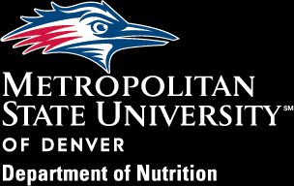

Nutrition Website | Instagram | Facebook | LinkedIn

Alumni Newsletter
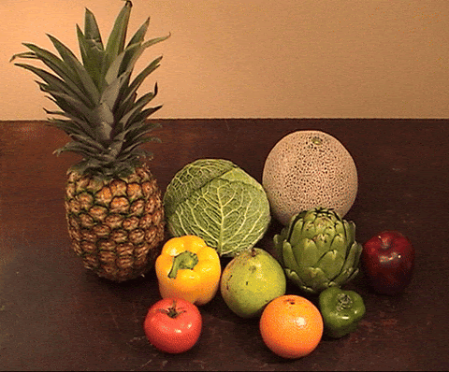

——————————————————————————————————-
Important Dates
Admission Dates
August 1 — Early Deadline - MSN/ BS to MS Programs Application Spring 2027
September 15 — Priority Deadline - MSN/ BS to MS Programs Application Spring 2027
November 1 — Final Deadline - MSN/ BS to MS Programs Application Spring 2027

Event Dates
September 20 — Annual 2026 Roadrunner 5k
October 10 — MSU Denver Open House
November 9 — MSU Denver Coordinated Program/DICAS Prep Open House
December 4 — Nutrition Research Day/End of Year Celebration!
December 11 — Commencement
——————————————————————————————————-
Upcoming Events
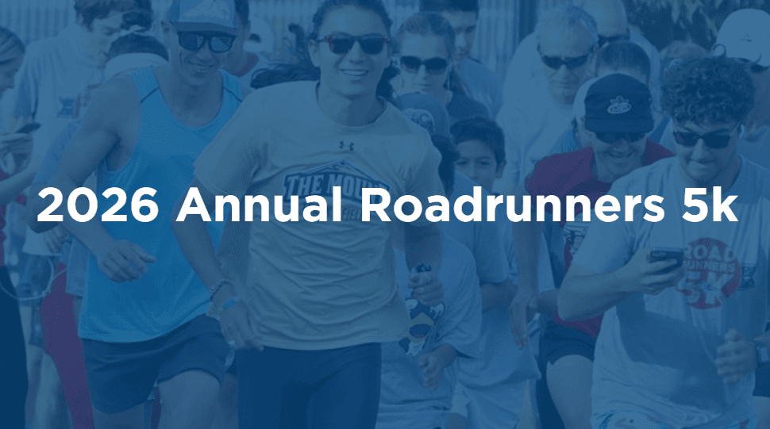

Get ready to lace up and show your Roadrunner pride at the Annual Roadrunners 5k our favorite Homecoming tradition! Whether you’re a speedster, a stroller, or somewhere in between, everyone’s welcome to join this fun run, jog, or walk weaving through the beautiful Auraria Campus
SPECIAL PRICE for Alumni and The Department of Nutrition staff/faculty will be in attendance!
September 20, 2026, 8 am


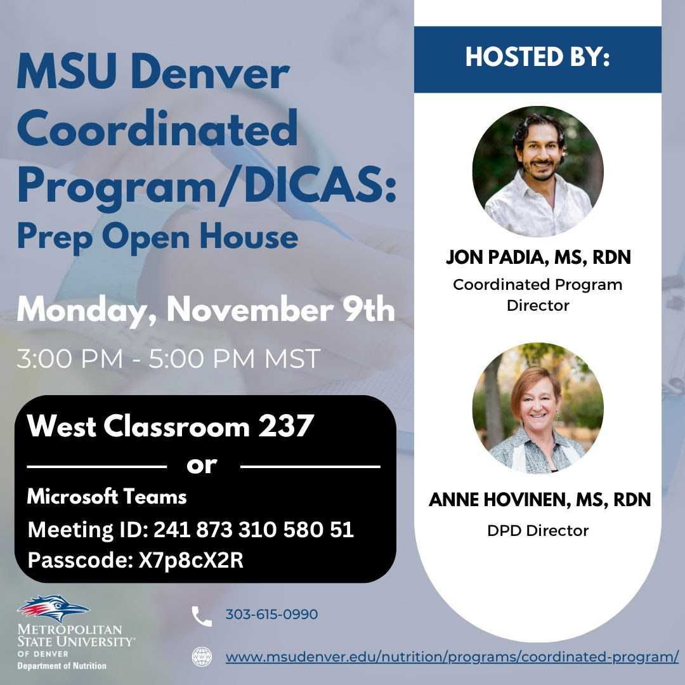

Interested in applying for the Coordinated Program? Join us on November 9th at 3:00 pm MDT in West Classroom or Microsoft Teams to hear from Jon and Anne about the Coordinated Program/DICAS and to get your questions answered. If you are a MSU Denver student, you can apply to the MSU Denver’s Coordinated Program early to secure your spot. Information will also be provided about navigating DICAS and applying to internships. We hope to see you there!
November 9th, 2026 | 3:00pm MDT
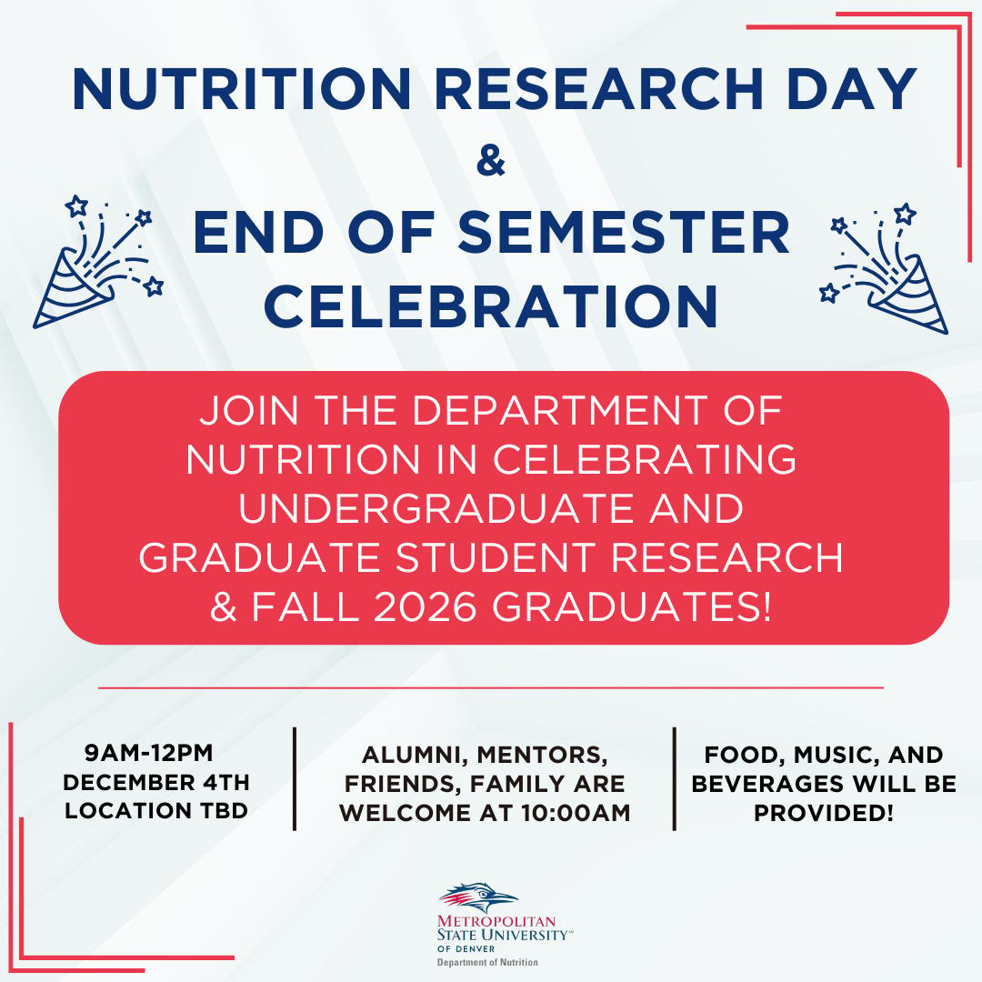

——————————————————————————————————-
Job Opportunities
Nutrition Services Executive Chef
Adams 12 is hiring for a Nutrition Services Executive Chef. This is a Nutrition Services Leadership/Admin role. Application deadline is August 17th. See down below for more info!
Colorado Pace
Part-time position open for a Diet Aide at Colorado PACE. Hours are Monday-Friday, 11:00-3:00 (flexibility for students), with pay up to $20/hour. This is a great opportunity to fix meals, create recipes and provide menu analysis!
Please email intent to apply to John Simmons jsimmons@coloradopace.org


 |  | 
  Career Preparation and Opportunities - MSU Denver
  Where do you want to go in the field of nutrition and dietetics? Learn about possible career opportunitities here.
  www.msudenver.edu/nutrition/career-opportunities/?utm_source=codys-newsletter-b8ac91.beehiiv.com&utm_medium=newsletter&utm_campaign=alumni-newsletter-department-of-nutrition-fa-25&_bhlid=fb0a19b3008818e3f5191900adf176ef43bc1aab#job-board

——————————————————————————————————
Spotlights
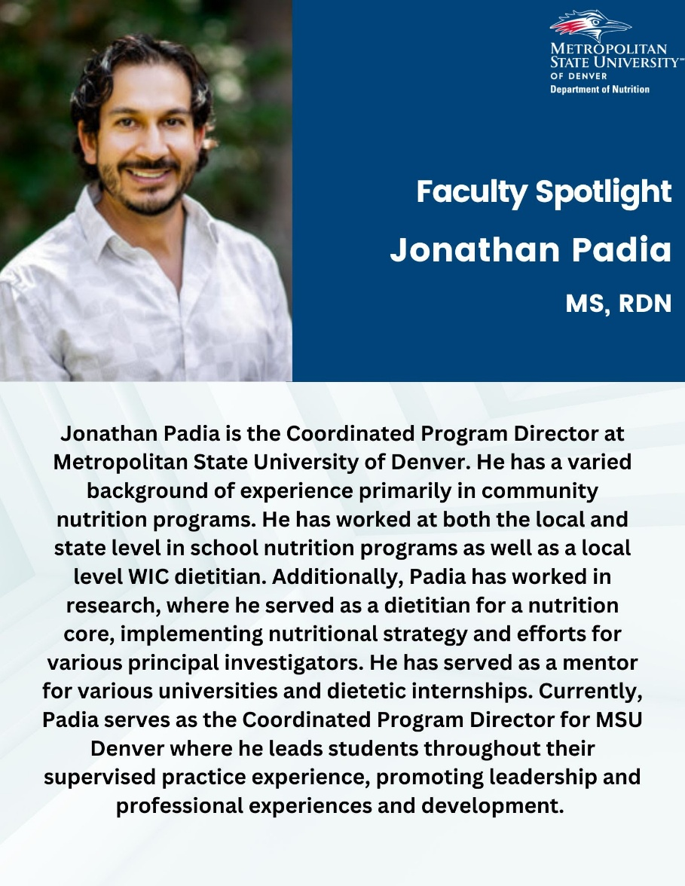

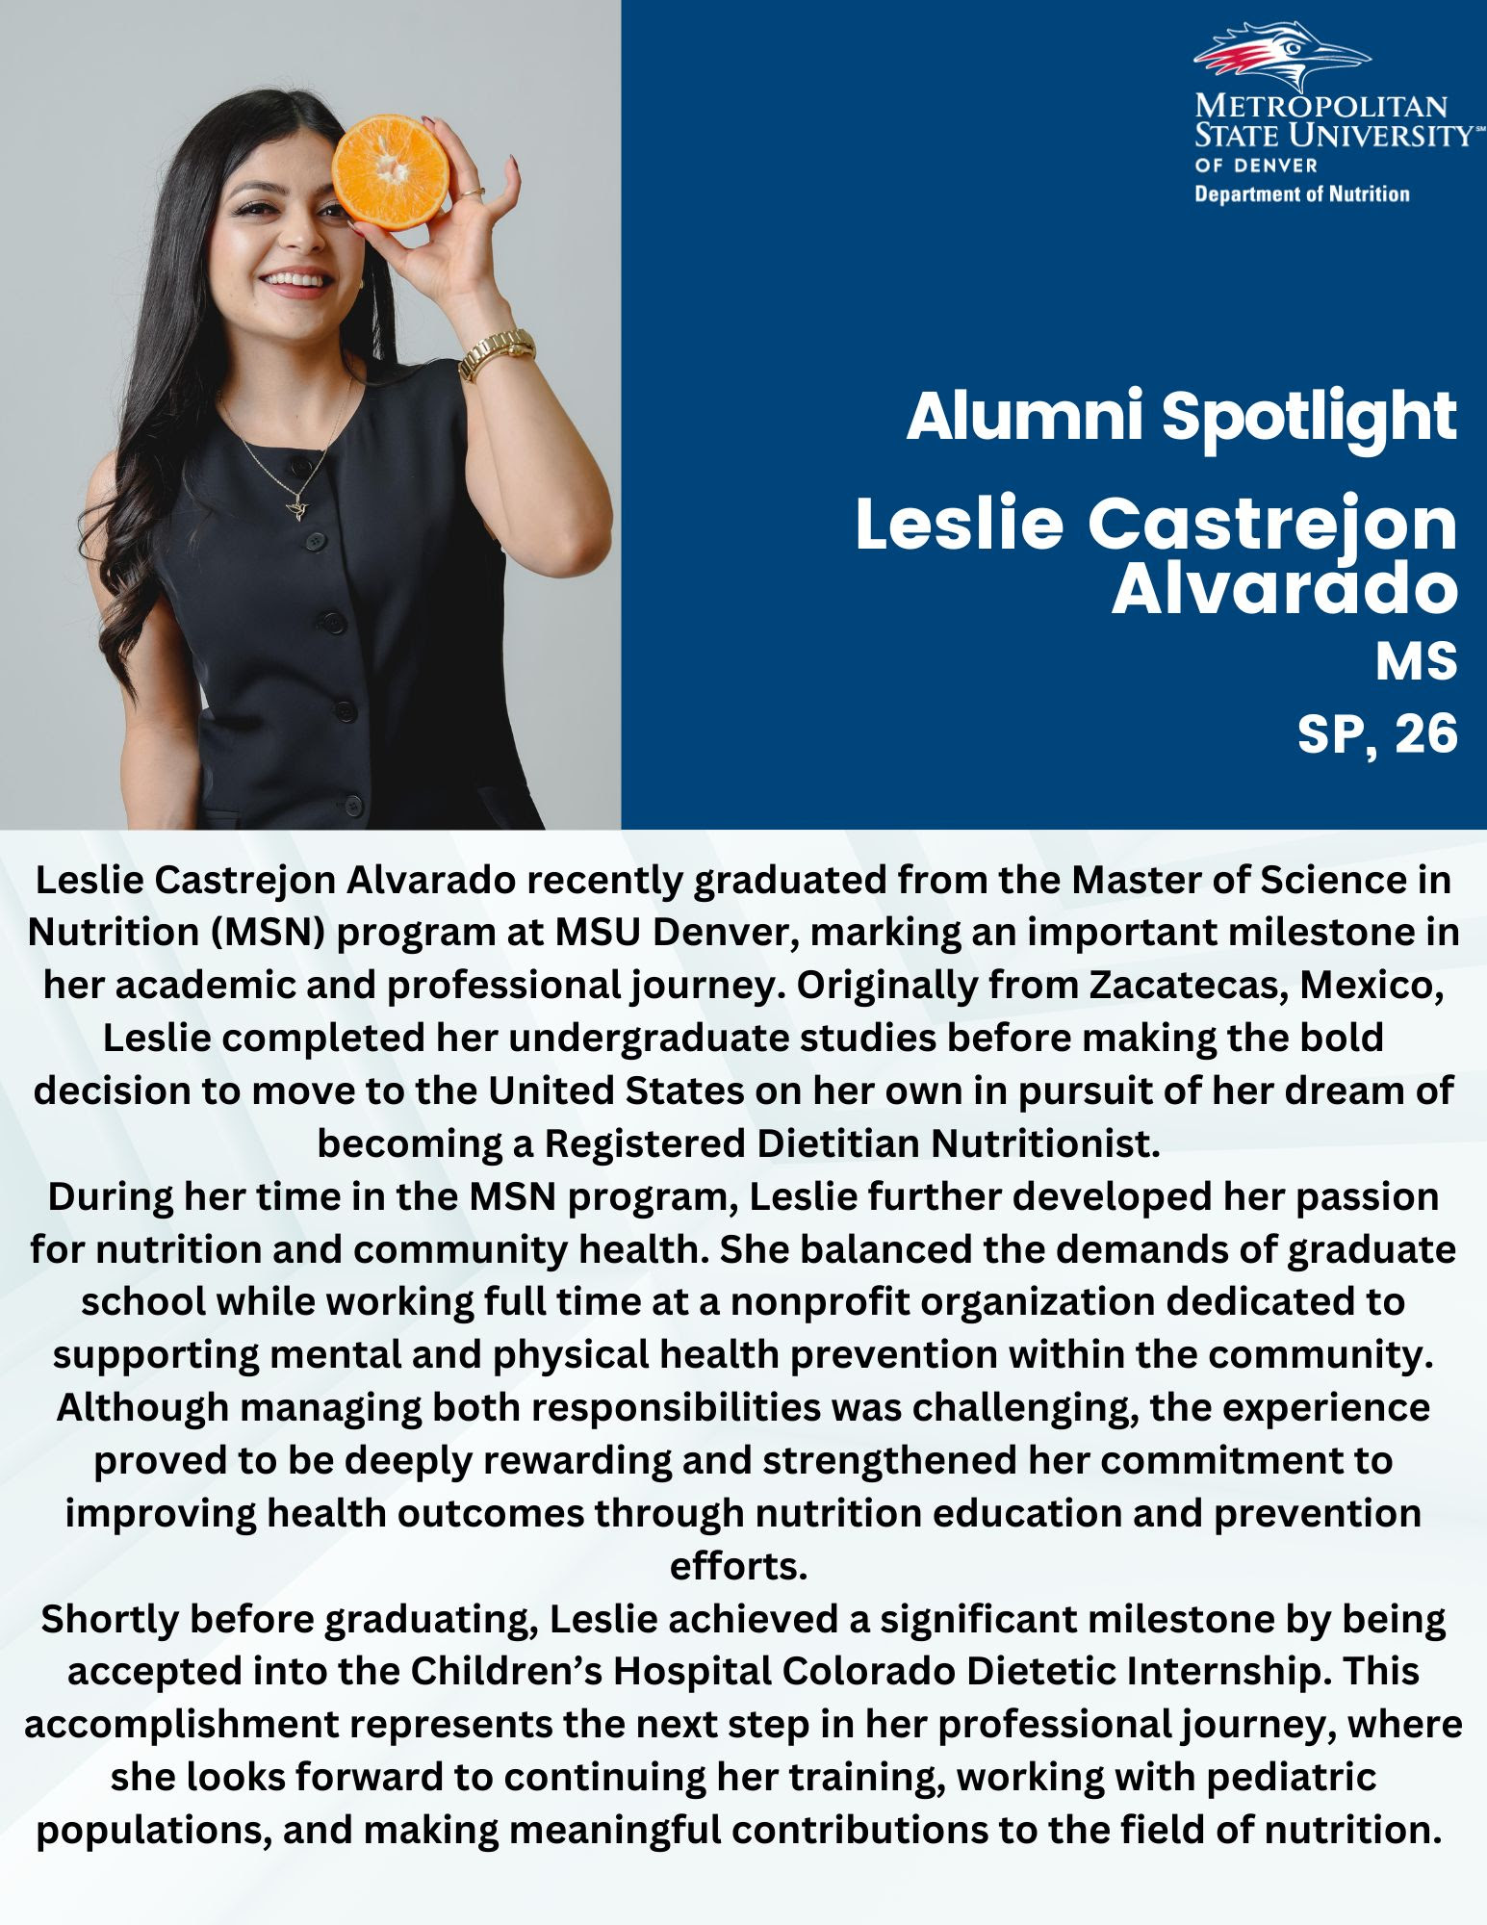

——————————————————————————————————
Nutrition Programs
MSN/Accelerated BS to MS Programs
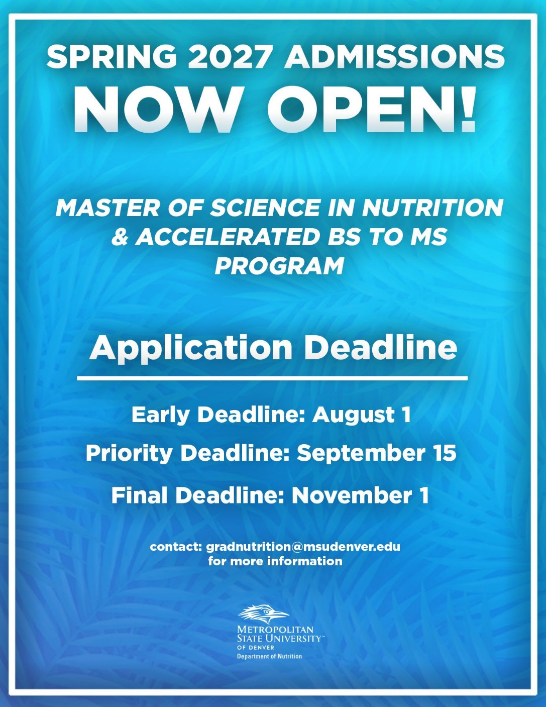

——————————————————————————————————
Involvement


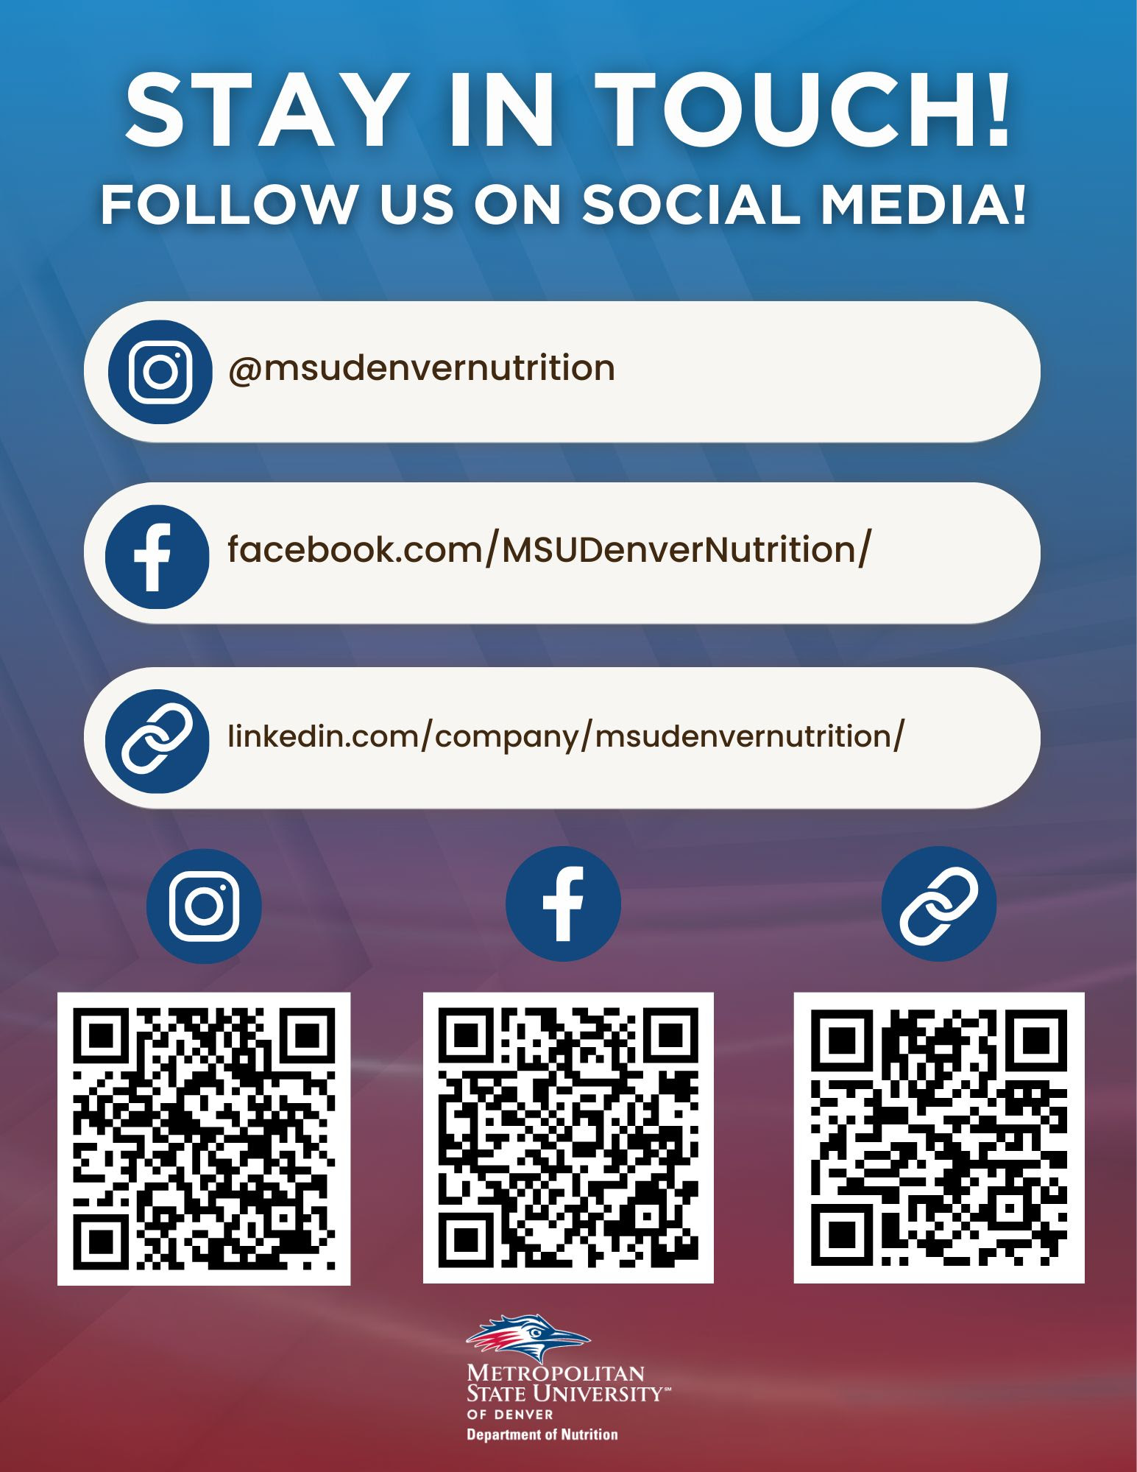

——————————————————————————————————-
Resources
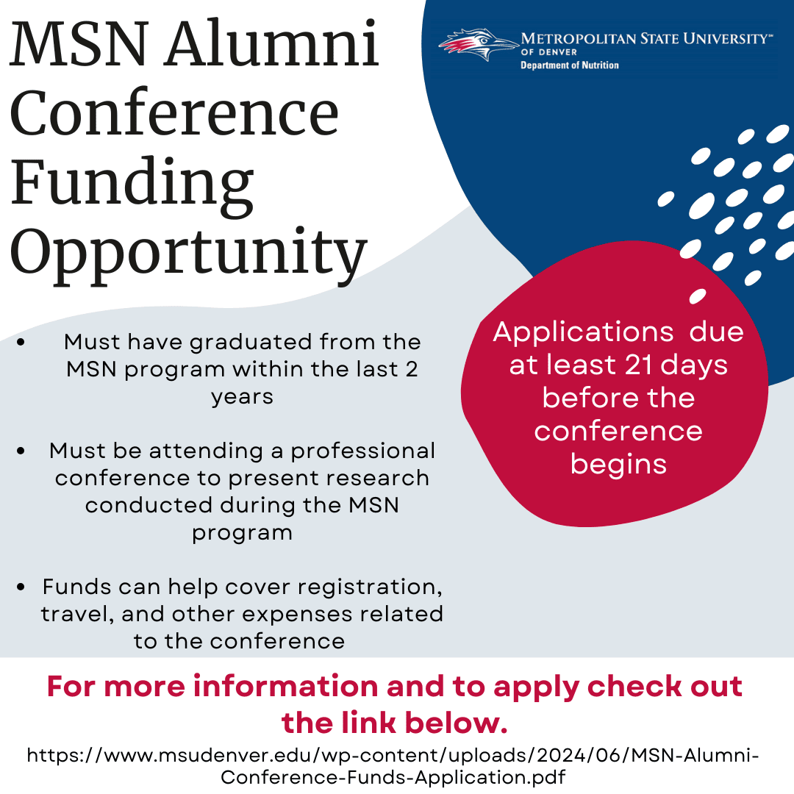

Roadrunner Alumni
Check out our Roadrunner Alumni opportunities here:
 |  | 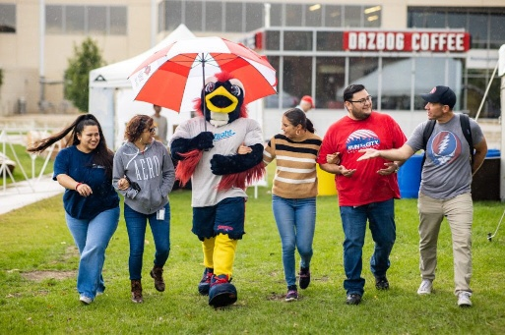
  MSU Denver Alumni and Friends - MSU Denver
  MSU Denver’s Office of Alumni Relations connects over 105,000 alumni to each other, the University and the greater MSU Denver community. MSU Denver Alumni can reach MSU Denver Career Services and volunteer with MSU Denver through the office of Alumni Relations.
  www.msudenver.edu/alumni

——————————————————————————————————-
Did you miss our last Alumni Newsletter?
Check out our Archive Here:
 |  | 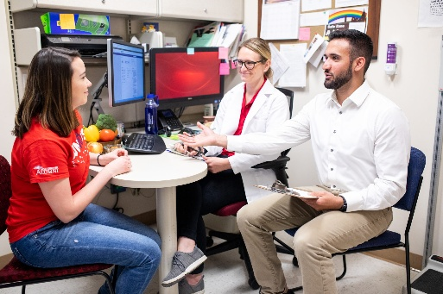
  Alumni and Friends - MSU Denver
  Connect with fellow alumni for updates on department events, networking and opportunities to contribute to your alma mater!
  www.msudenver.edu/nutrition/alumni-and-friends/#alumni-newsletter-archive



Update your email preferences or unsubscribe here
© 2026 MSU Denver Department of Nutrition Alumni Newsletter
228 Park Ave S, #29976, New York, New York 10003, United States
Powered by beehiiv

Terms of Service

