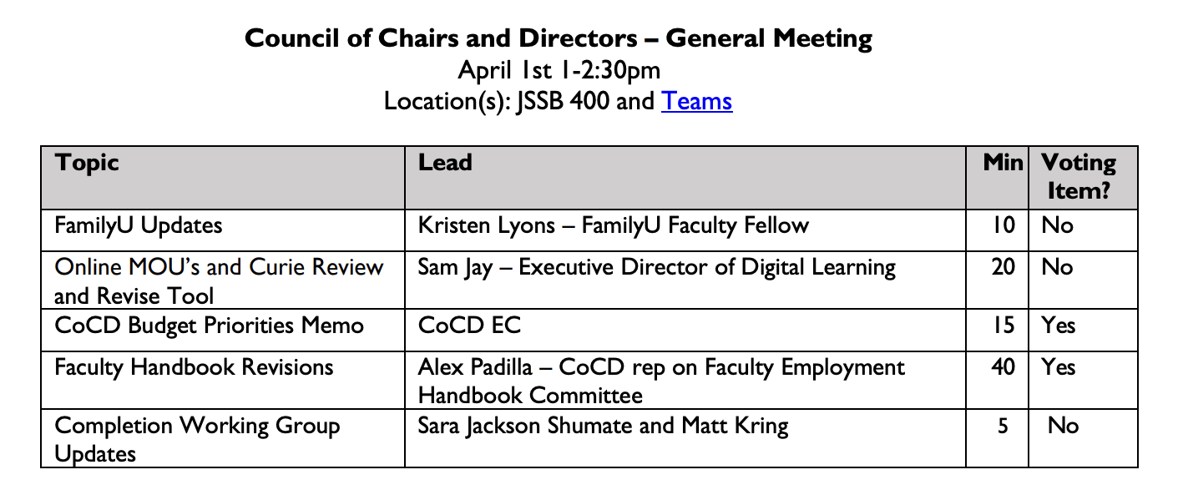
NOTES:
FamilyU:
- Kristen Lyons - klyons7@msudenver.edu
- https://www.msudenver.edu/student-engagement-and-well-being/parents/
- OEO: https://www.msudenver.edu/equal-opportunity/

- Please visit the site or email Kristen if you have questions about:
- Upcoming events
- Support systems for students who are parents
- Procedures and Policies regarding pregnancy and children in the classroom

Online MOU’s and Curie Review and Revise Tool:
- Sam Jay - sjay@msudenver.edu
- OOL
- Overview below:

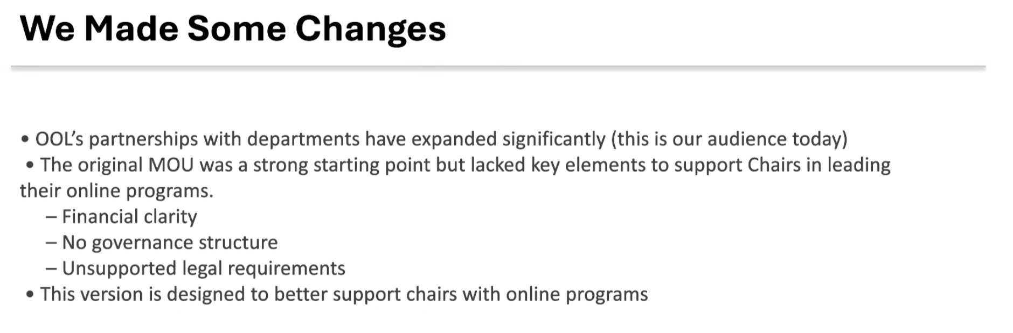
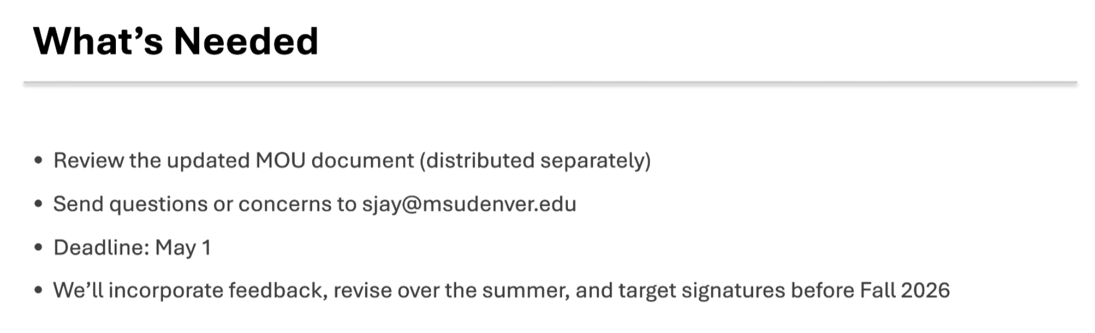
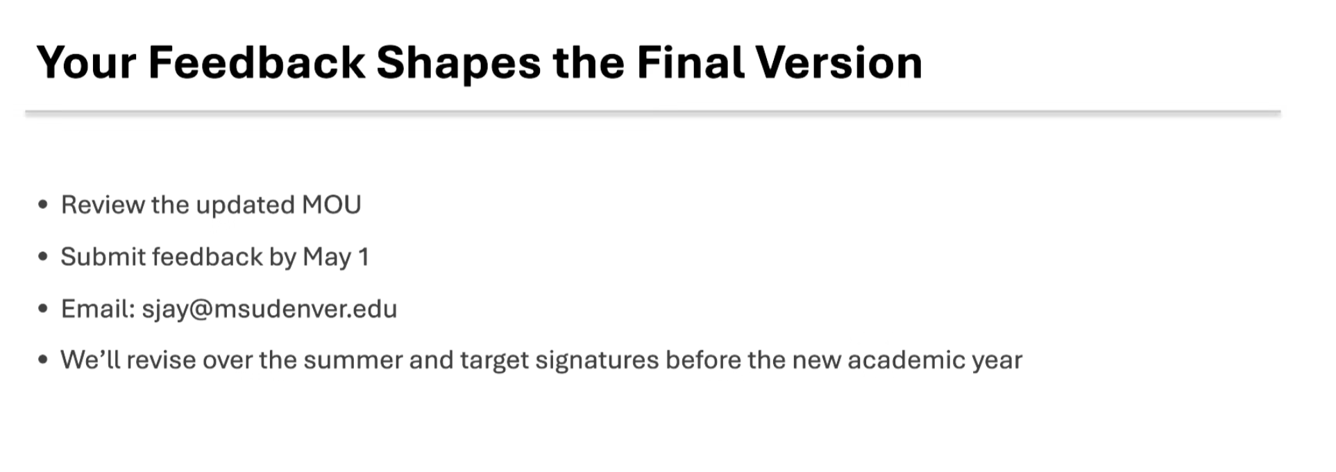
- Action for Chairs:
  - Be sure to communicate with the instructors or leads of any online programs in your department about this.
  - Reach out to Sam Jay if you have questions.
    - sjay@msudenver.edu

CoCD Budget Priorities Memo (*Copied below)
Table below shows the results of the poll that was distributed to all chairs. The purpose of the poll was to determine the priorities for funding (listed below).
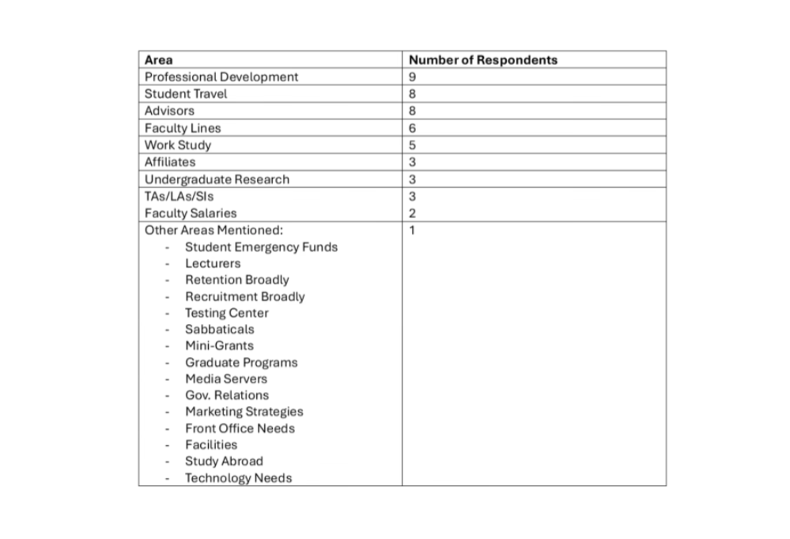
- Discussion:
  - Questions were raised about the selection and the consideration for other priorities.
  - Note to add information about:
    - PD – rationale about receiving Tenure and Promotion
    - Advising – add information about retention

Voting Item
I am in support of submitting the CoCD budget memo to Matt and Will
Yes
100% (27)
No
0% (0)
Abstain
0% (0)
27 responses

*


To: University Planning and Budget Advisory Committee (UPBAC)
From: Council of Chairs and Directors (CoCD)
Date: April 2, 2026
cc: Dr. Matt Makley and Dr. Will Simpkins
The Council of Chairs and Directors (CoCD) recognize that the 2026–2027 budget cycle is unfolding amidst a shifting and uncertain budgetary landscape at the State level. The priorities listed below are contingent upon state funding and student enrollment remaining flat. Should funding cuts be deeper or enrollment decrease, our priorities would shift to protecting core academic capacity including retaining faculty and staff positions and keeping programs open.
AY 2026-2027 Budget Priorities
- Professional Development Funds – Sustained investment in faculty and staff professional development is critical for ensuring high-quality instruction, innovative and impactful research and scholarship, and effective academic leadership.

- Student Travel Funds - Funding for student travel—including research presentations and field-based learning—directly impacts student engagement, retention, and post-graduate success.

- Professional Advisors - Professional advisors (including robust training) are essential for improving student navigation through academic programs and ensuring consistent, high-quality advising. Efforts to reduce turn-over within these positions is also crucial for program success.

The CoCD appreciates the complexities of the upcoming budget cycle and remains committed to collaborating with university partners to navigate the changing landscape ahead. In addition to the priorities listed above, other areas of importance that emerge within our group include maintaining faculty lines and ensuring student work-study positions continued.
Our recommendations reflect investments that strengthen student success and the academic mission of MSU Denver and align with the 2030 Strategic plan. We remain ready to meet the budgetary challenges ahead with thoughtful and careful allocations of the resources we are trusted with to run our departments and programs.

Faculty Handbook Revisions:
- Key changes showcased below:
  - Technical Corrections proposed are showcased below:
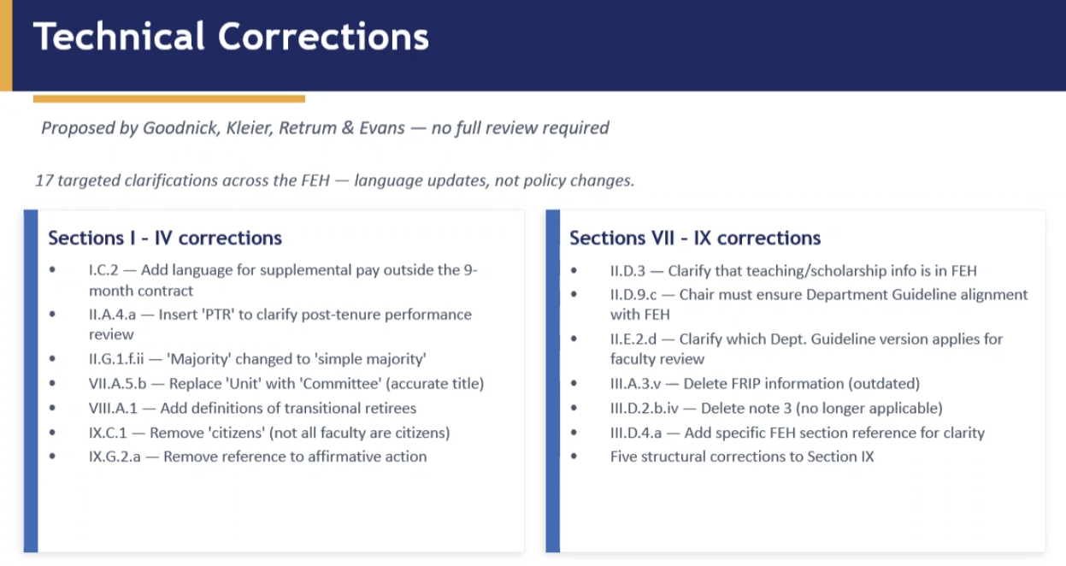

  - Proposed College/School Guidelines are showcased below:
    - Purpose: to make sure that department guidelines
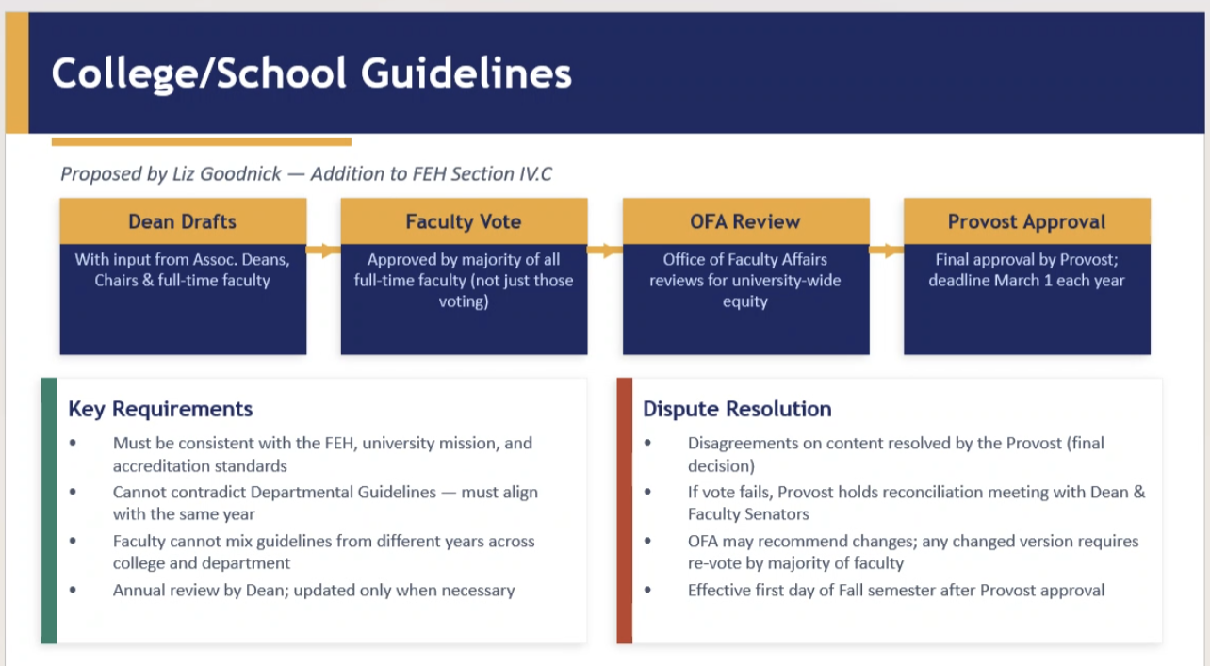

Discussion:
- Inquiries about:
  - Purposes
  - Challenges
  - Additional oversight
Voting Item
I support the FEH revision on adding the college/school guidelines (above)
Yes
76% (20)
No
19% (5)
Abstain
3% (1)
26 responses

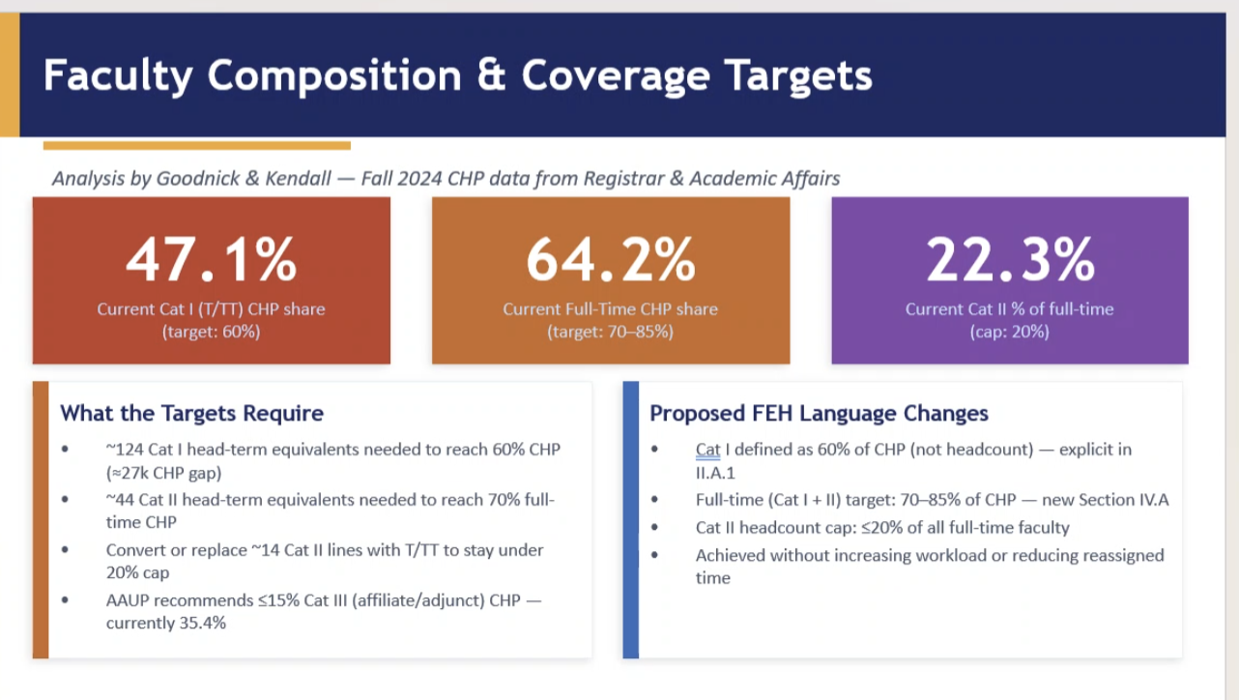
Discussion:
- What is this intending to do?
- This is unclear
- Protection for full-time positions
- Leverage to hire full-time vs. part-time
Voting Item
I support the FEH revision changing/ clarifying the full-time/Cat II etc.. targets (above)
Yes
46% (12)
No
46% (12)
Abstain
7% (2)
26 responses

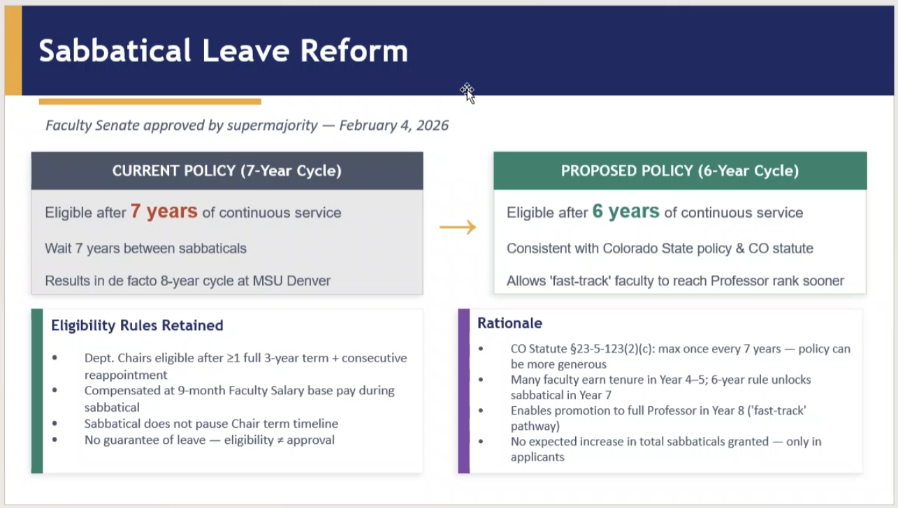

Discussion:
- We are out of compliance on this.
Voting Item
I support the sabbatical FEH change from 7 to 6 year cycle (above)
Yes
100% (26)
No
0% (0)
Abstain
0% (0)
26 responses

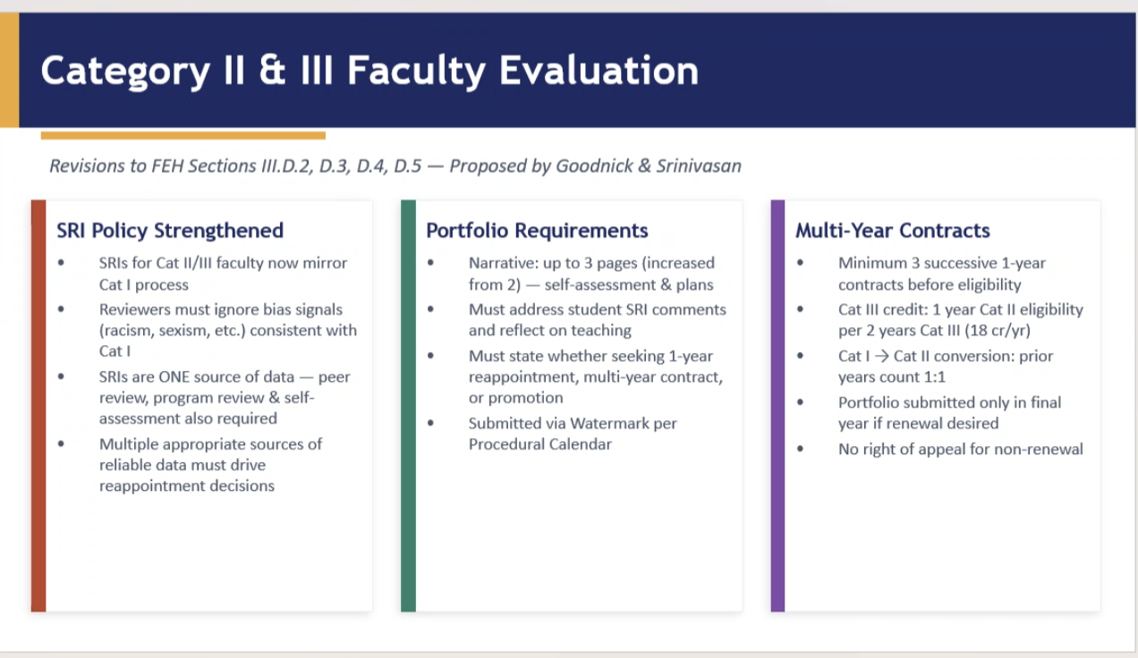

Discussion:
- This is to make expectations the same for CAT II as they are for CAT I.
Voting Item
I support the FEH changes on CAT II SRI and portfolio requirements (above)
Yes
96% (25)
No
3% (1)
Abstain
0% (0)
26 responses

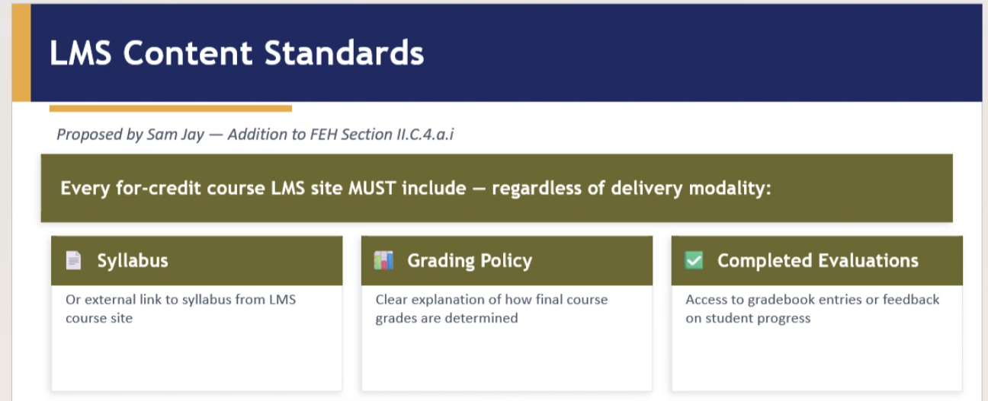

Discussion: clarification of the requirements above
Voting Item
I support the FEH change that requires syllabus, grading policy and gradebook in online class (above)
Yes
100% (23)
No
0% (0)
Abstain
0% (0)
23 responses

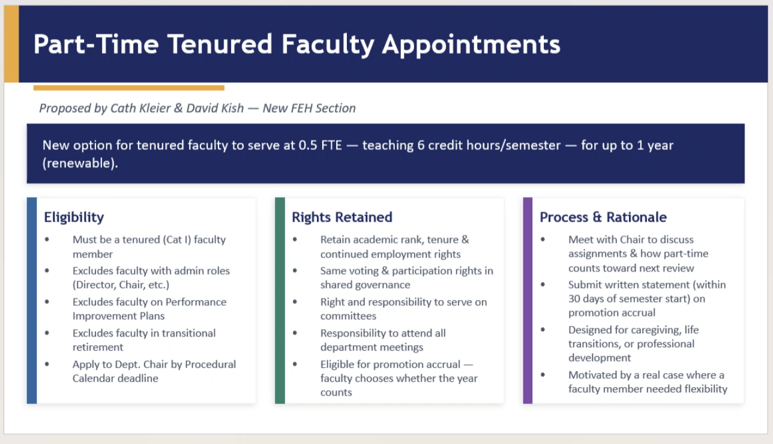

Discussion:
- Managing this?
- Taking advantage of this
Voting Item
I support the FEH change on part-time- tenured faculty status (above)
- Yes
- 48% (13)
- No
- 33% (9)
- Abstain
- 18% (5)
- 27 responses

Completion Working Groups Update:
