Council of Chairs and Directors – General Meeting
March 4th 1-2:30pm
Location(s): JSSB 400 and Team

Topic | Lead | Min | Voting Item?
September 2026 HLC Visit | Paige Vercelline - Special Assistant for Academic Affairs | 20 | No
Student Travel Updates | Dave Bourassa – _Associate Director for Student Experiential & Professional Development | 20 | No
CoCD Budget Priorities Memo | CoCD EC | 45 | ?(maybe

Welcome:

HLC:
- Paige Vercelline - Special Assistant for Academic Affairs
- pvercel1@msudenver.edu

Peer Review Process
- See:
  - HLC Powerpoint sent through email
  - * Key Information below

Faculty Actions/Responsibilities:
- Review your credentials in Workday
  - See email from the Provost on the expectation and process
  - Transcripts and Tested Experience should be accurate

* Key Information:
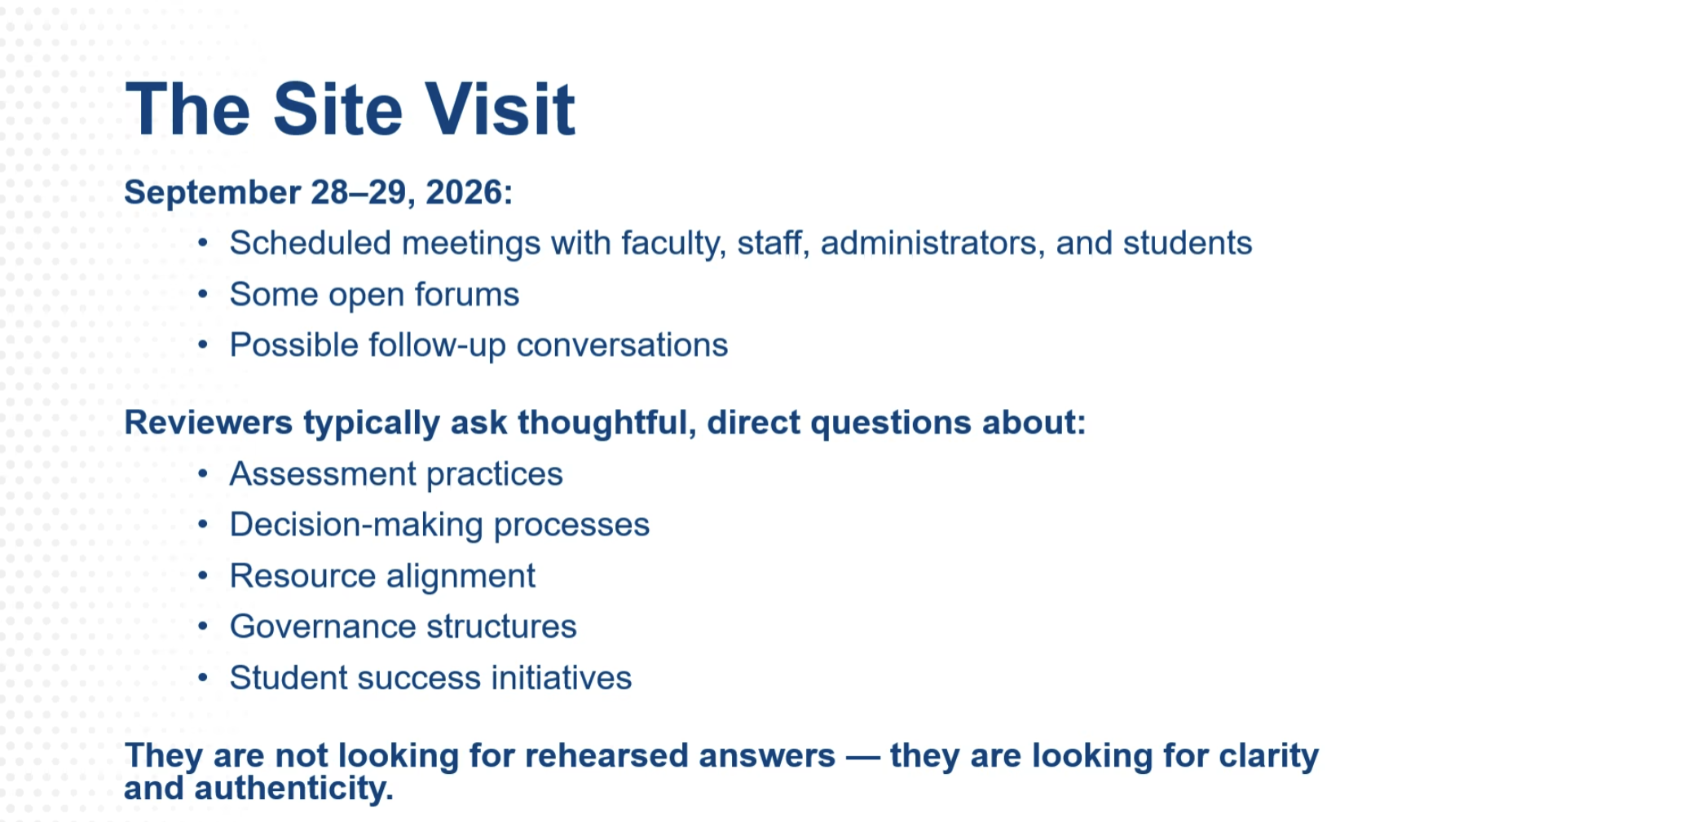

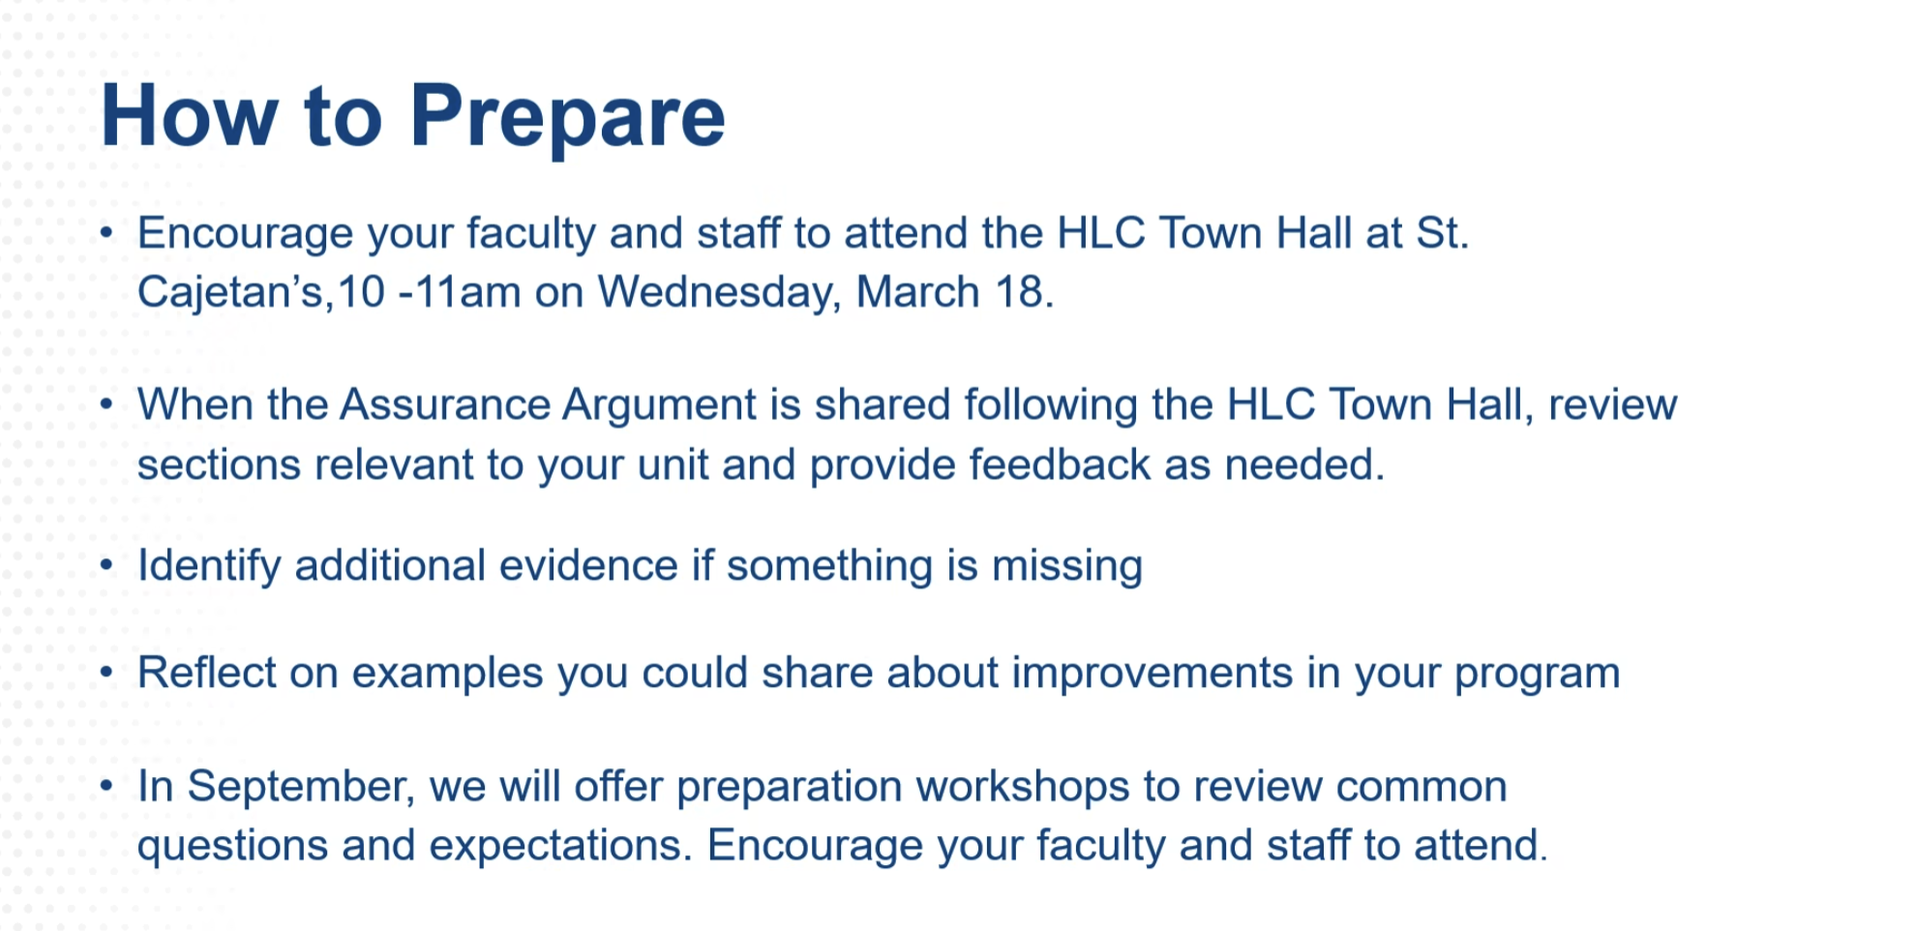

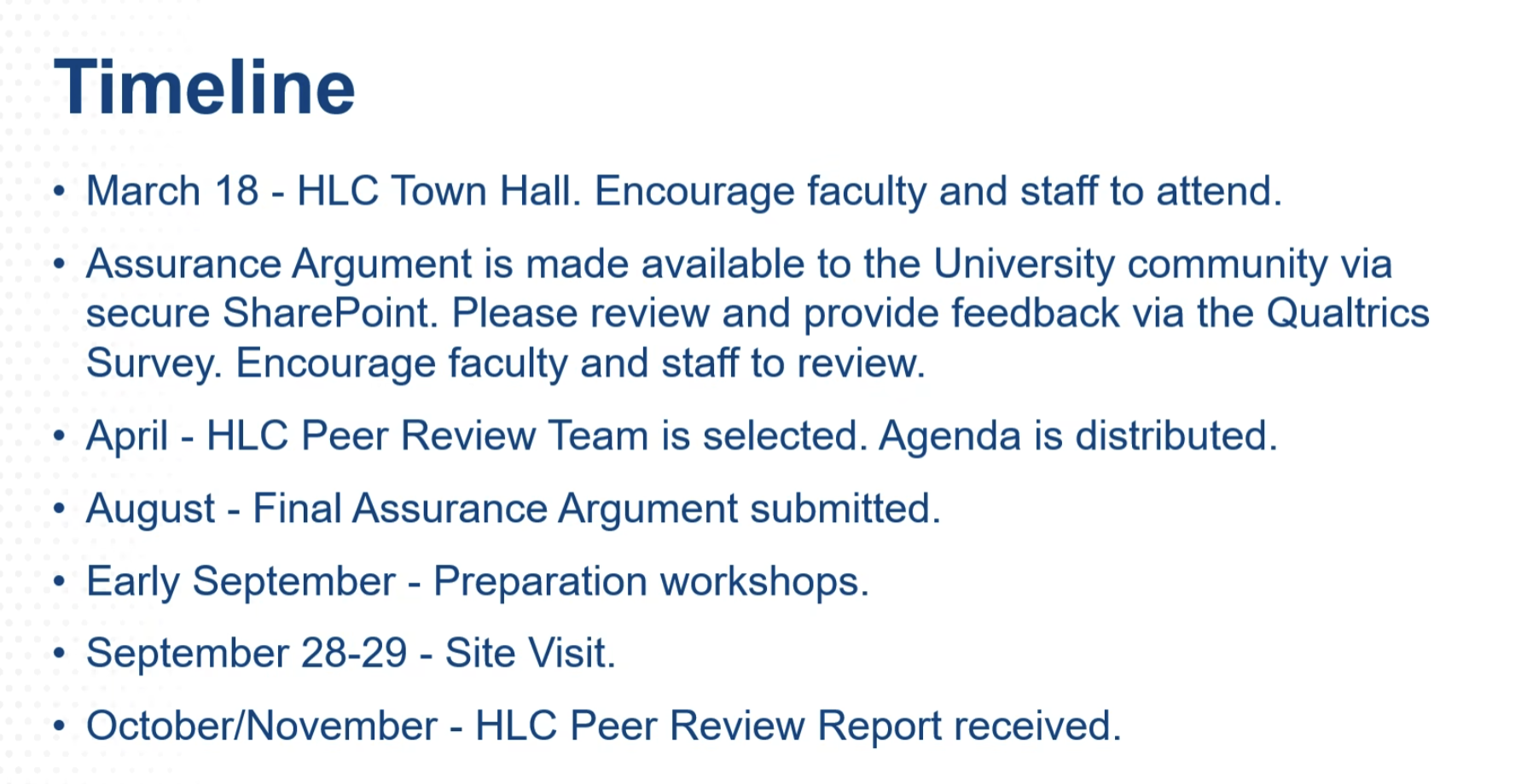
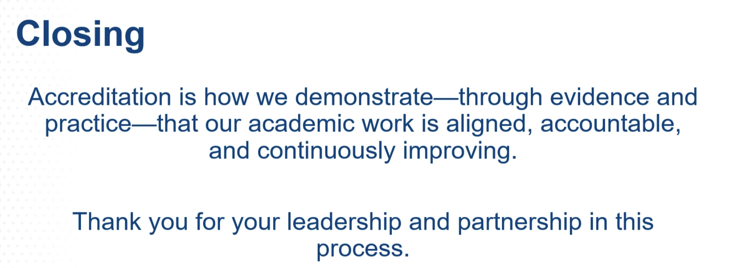

Questions posed:
    - What is the role of the chair?
      - Ensure compliance
        - Inspire faculty to review provide correct information
        - Check faculty information
        - Check your own information
    - What other resources do we focus on and include?
      - Program Evaluations
      - Any Program assessments completed
      - General Studies
ALERT:
    - Make sure the website information has been checked and updated if necessary.
      - Be sure to be very thorough on the website review and update work.
        - All website material is being audited.

Student Travel Updates:
- Dave Bourassa – Associate Director for Student Experiential & Professional Development
  - C2 HUB
  - dbourass@msudenver.edu
  - https://www.msudenver.edu/classroom-to-career-hub/faculty/
  - C2 HUB Student Resources

- 100% student fee funded
Fund Limitations:
    - Current budget is very limited
    - Funding has dropped from roughly 90% level to 50%
Reach out for more information:
    - c2hub@msudenver.edu or call us at 303-615-1133
Questions and Comments:
    - Consider the creation of Student Organizations
      - Requires 3 students to acquire money for the startup
        - Funding is limited
Incentivizing Funding:
    - Plan to prioritize funding for students presenting

CoCD Budget Priorities Memo:
Comment: “We might need to formalize our hierarchy of program funding.” ~ Lisa Badenes
ACTION:
- Collect information from your faculty about the priorities for funding.
- Qualtrics survey will be sent out to capture department views.

Proposed Handbook Changes
- Cath Kleier
  - cakleier@msudenver.edu
  - Faculty Employment Handbook
- See List Below
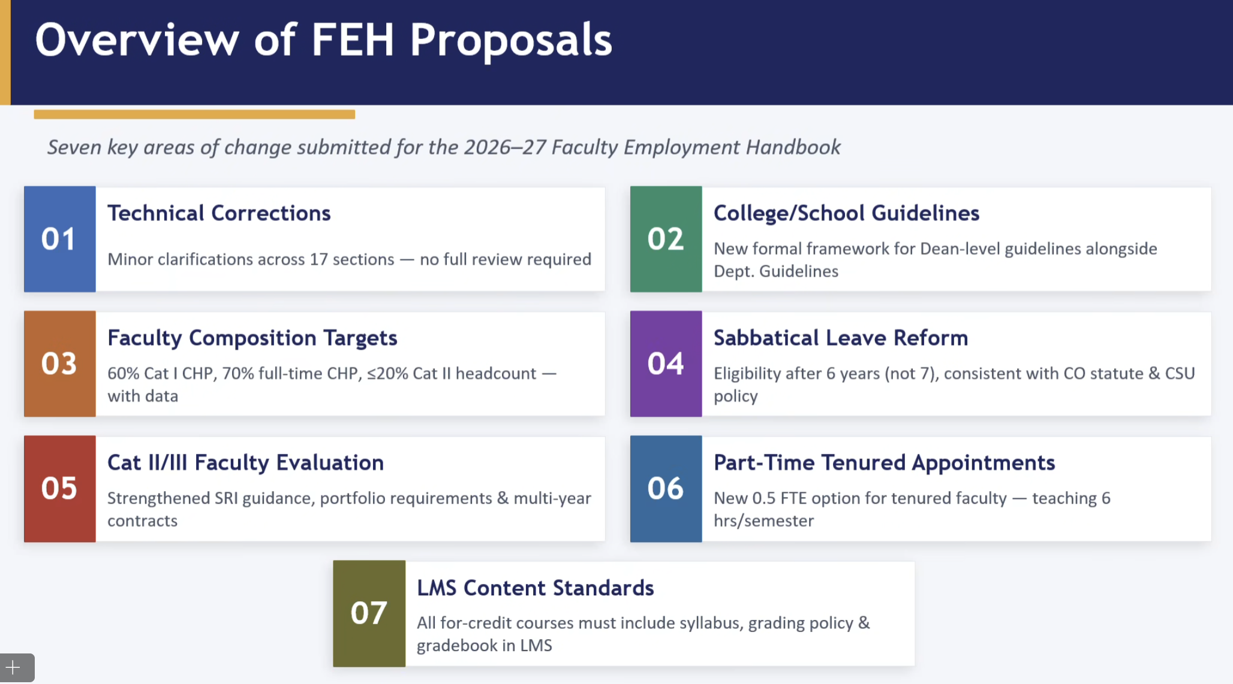

Focus on particular changes below:
    - Change
    - Followed by Considerations and Details
03
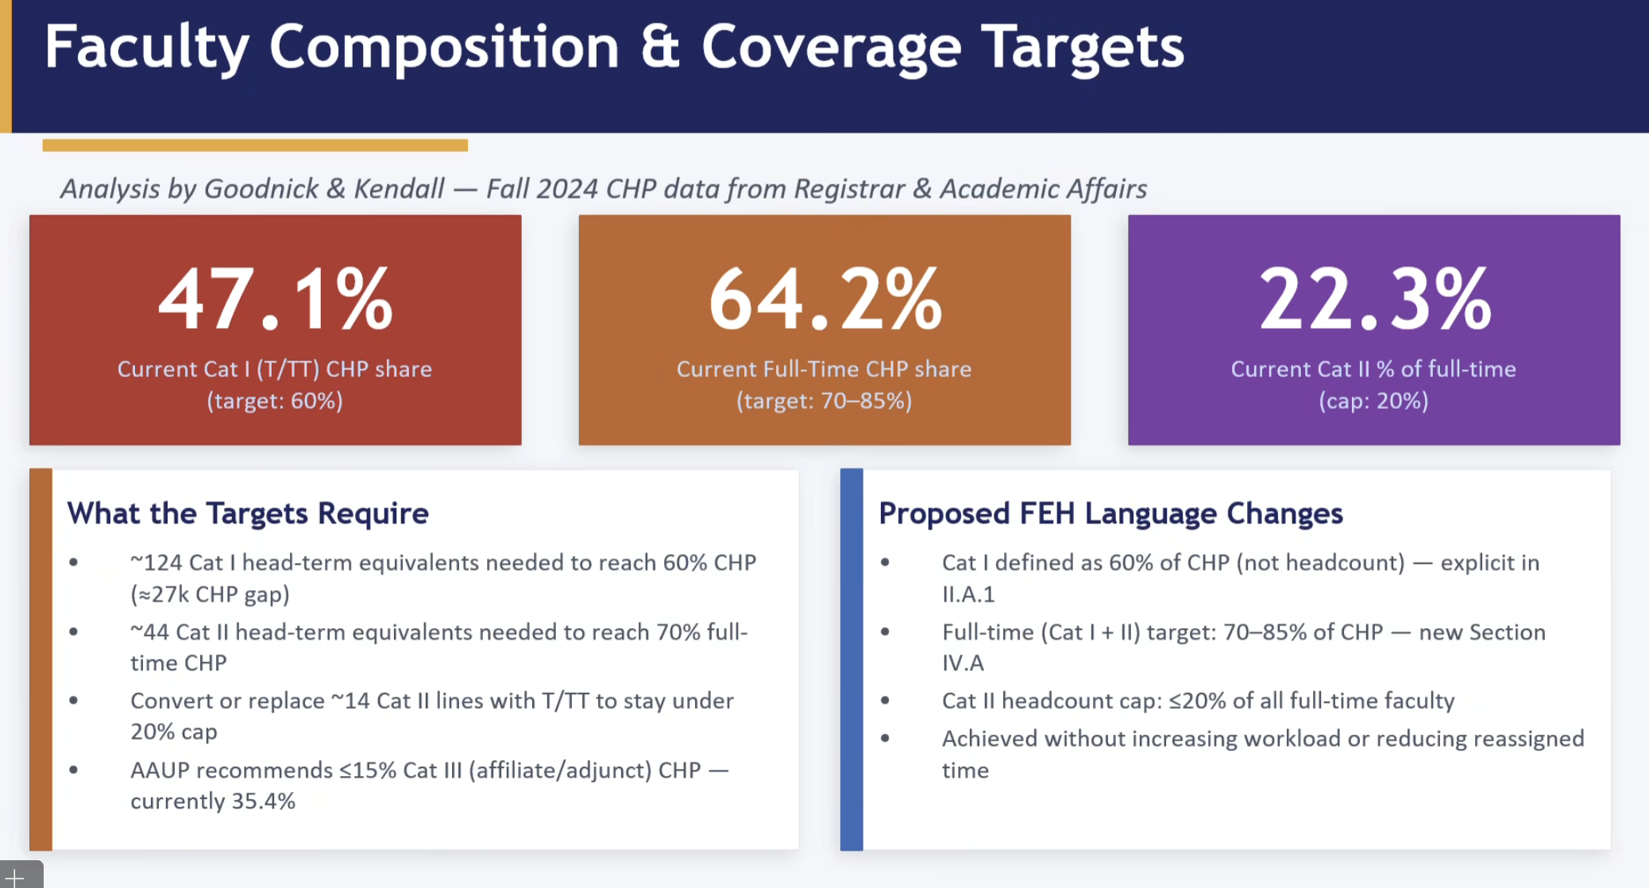

Concerns:
    - What might be the unintended burden on affiliate faculty?
    - Might hiring leaders put preference on hiring CAT II for budgetary purposes?
    - What strain might be put on the scholarship and service of departments due to an increase in CAT IIs?

04

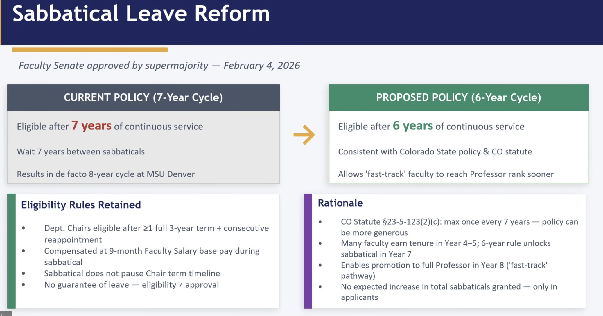

Considerations:
    - With earlier opportunity to take sabbatical, might we need to increase the budget for them?

05

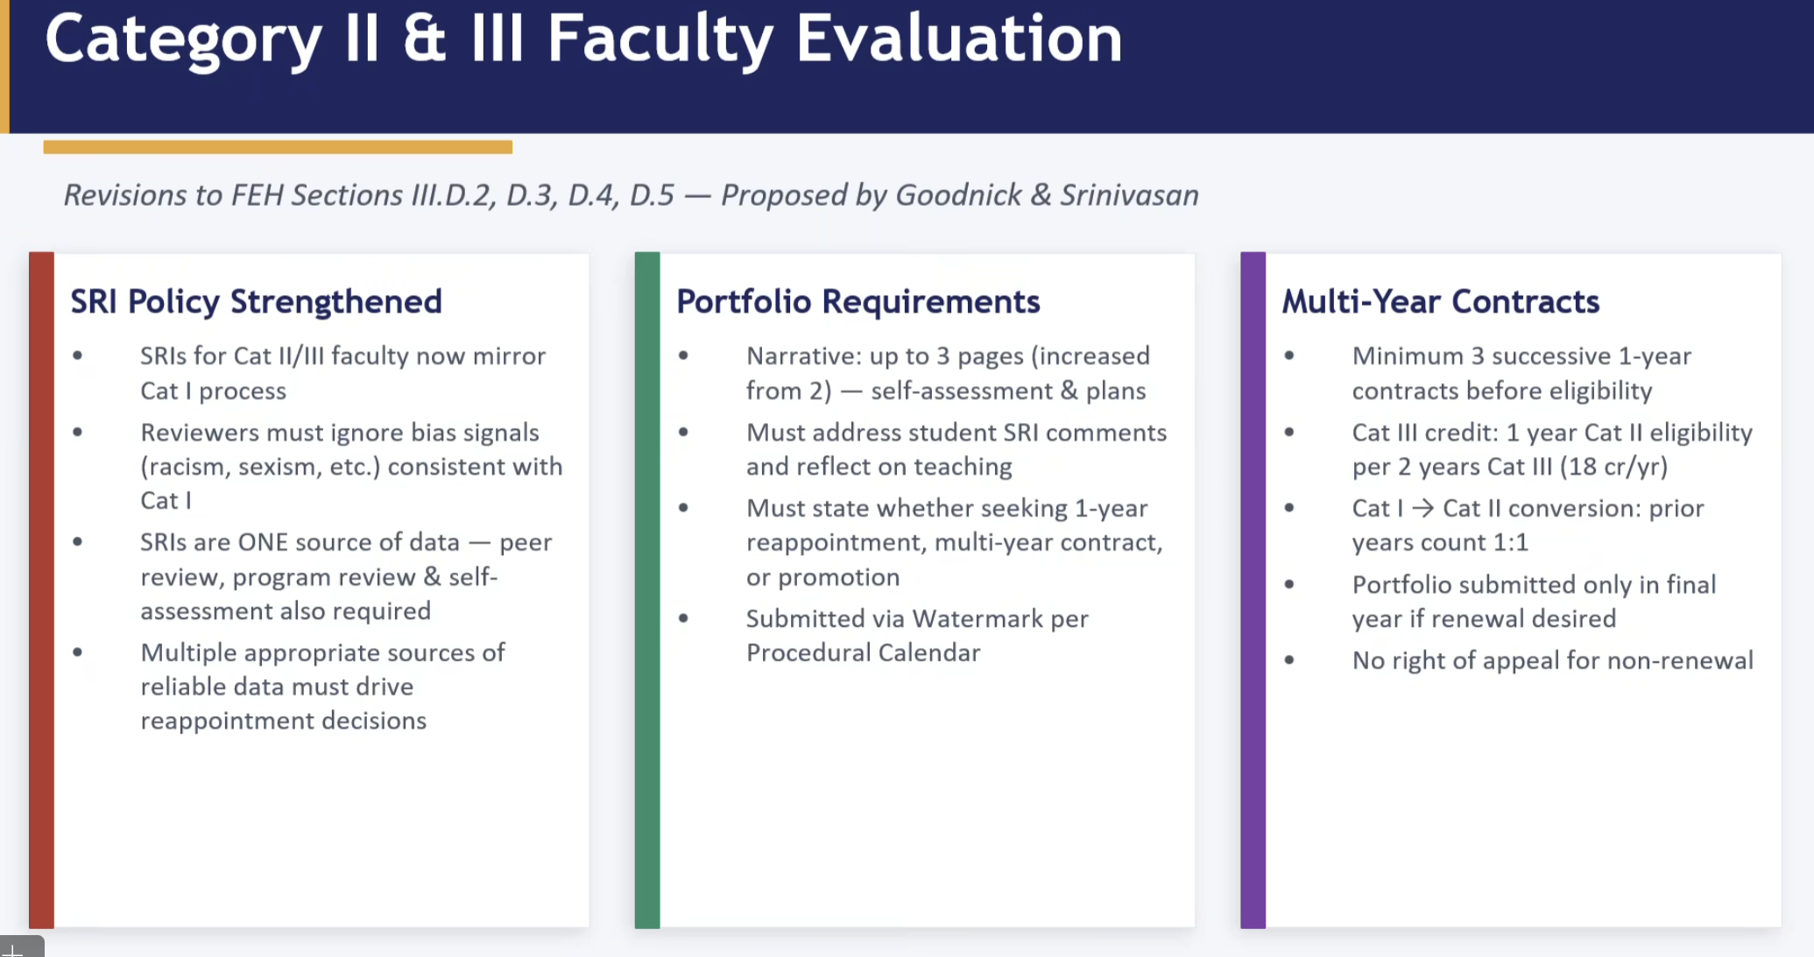

Consideration:
    - This aligns the teaching valuation with CAT I.

06

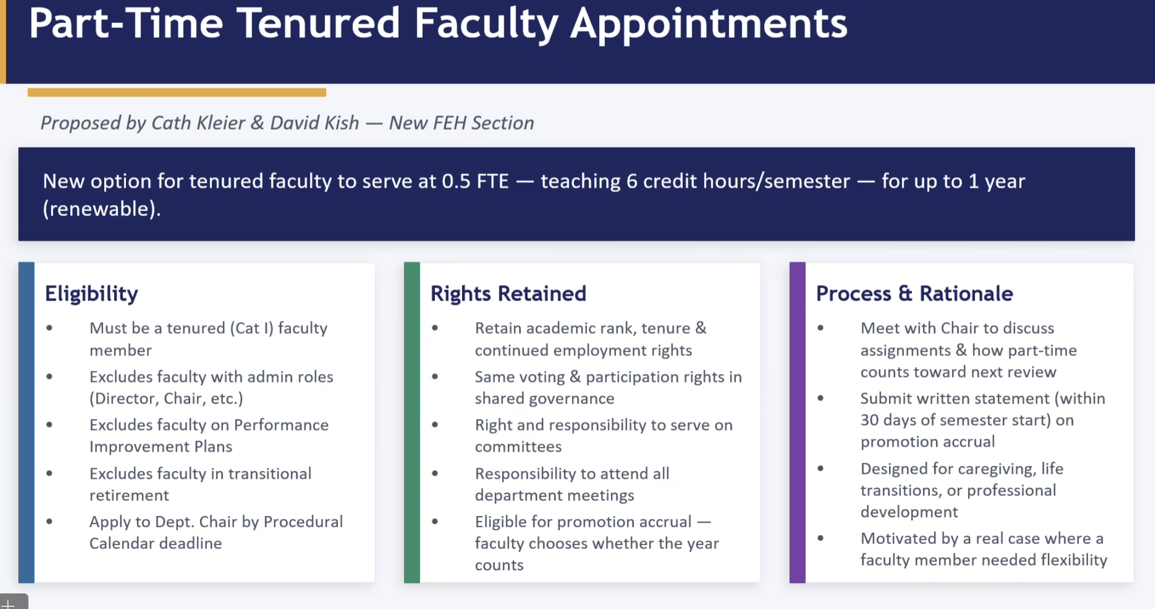

This allows faculty to become part-time for up to 1-year (renewable).
Considerations:
    - Criteria?
    - Inequities?
    - What might be done about those taking advantage of this?
    - Might this support those who need more time to take off after FMLA for personal/family reasons?
    - Might folks take advantage of this to capitalize on scholarship opportunities?
    - Is there going to be a clear and transparent process for this?
    - Is this proposed to be 6 hours?
      - Yes.
    - This might not work for all departments.
      - ARTE example
    - This creates and supports a “Culture of Care”.
    - Who decides, Chair, or the Dean?
    - Does pay go down with this?
      - Yes, it decreases to half pay.
    - Might we strike “professional development” from it?
    - Might the PD part allow faculty to actually focus on recruitment of students for instance?
    - Might we ensure that the Deans are the ones deciding on the final confirmation?
    - Might we also apply this to CAT II, CAT III?

07

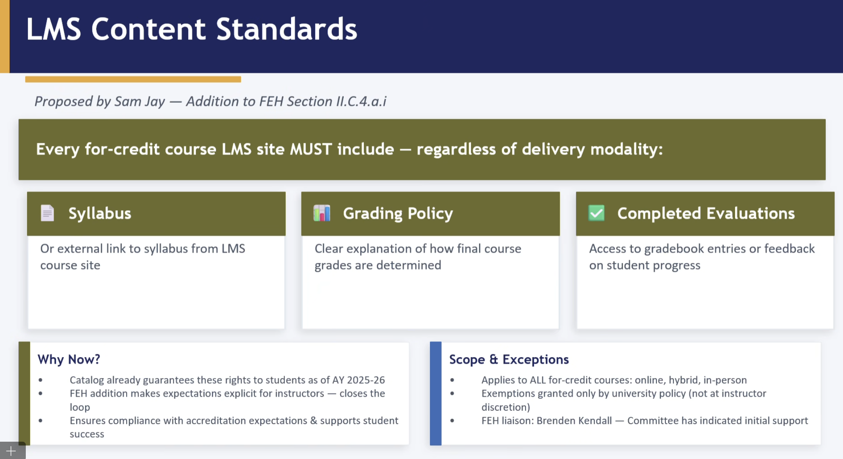

No discussion on this one.

