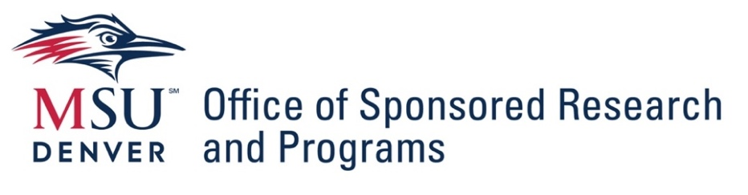
Intent to Submit an External Grant or Contract Proposal
Completion of this form is requested for all MSU Denver faculty or staff members planning to prepare and submit a grant or contract proposal to any governmental sponsor (federal, state, local), or any research proposal to a private funder. The information provided in this form will be used to coordinate resources for support of your proposal development.

Principal Investigator (PI) / Project Director (PD) Name: _______________________________
Has PI completed the OSRP PI Certification Training? Y___ N___
College or School: __________________ Department: _______________________________
Email Address: ______________________________________
Alternate Contact Names (ie: College or School Grants Administrator, Department Chair, etc.)
___________________________________________________________________________
Name of sponsor and title/opportunity number for selected grant program

Link to Funding Opportunity: _____________________________________________________

Submission Deadline: ________ Anticipated start date:_______ Anticipated end date: _______

Estimated amount of funding request: _________ Cost share required? Y___ N____ % ______

Is this a proposal for a subaward? Y___ N____
If “yes” to subaward, name of Lead Institution: _______________________________________

Will any of the following activities be involved?

Subawards/subcontracts: Y___ N___
Human Subjects Research: Y___ N___
Animal Subjects Research: Y___ N___
Patents or Copyrights: Y___ N___
Intellectual Property Rights: Y___ N___
Hazardous Materials: Y___ N___
Foreign Participants: Y___ N___

Have you completed the CITI trainings?

Behavioral Science Y___ N___ Conflict of Interest Y___ N___ Research Misconduct Y___ N___

For NSF, NIH, DOD research proposals: Have you completed the Research Security Trainings? Y__ N __

Do you have additional related attachments? (Draft budget, RFP/NOFO, Etc.)
Attachments Filenames: ________________________________________________________

Please email this completed form with any related attachments to OSRP Associate Director Kristin Schneider Baldwin kschne18@msudenver.edu Upon receipt an OSRP Proposal Development Specialist will contact you for next steps.

