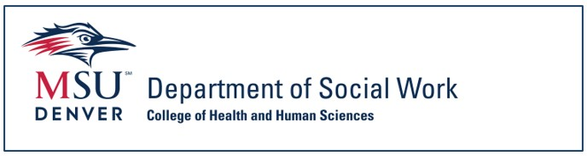

Sonia Guide for Students

Introduction
The Department of Social Work and the Office of Social Work Internships are excited to welcome you to the MSU Denver internship process. Sonia is a third-party database, used to collect student and internship details, and expedite the internship process by providing a framework for student and agency contact interaction. We use it to keep track of all our students, contacts, Faculty Internship Liaisons (FILs), sites, forms, internship descriptions, and documents in one convenient place.

By the end of this process, students should be prepared to use Sonia to search and preference internships, fill out forms, schedule meetings with their Internship Navigator, accept an internship offer, and complete the required Learning Agreement and Internship Evaluation forms during their internships.

Note that the Office of Social Work Internships (OSWI) messages students throughout the calendar year, including summer months. Communication is through your MSU Denver email, so it’s imperative that you check your student email regularly all year as you prepare for and move through your internship.

Table of Contents
SONIA BASICS
- Logging in and Navigation Within Sonia
  - Page 6 - Sonia Login Instructions
    - Page 8 – Accessibility Settings in Sonia
  - Page 8 - Sonia Navigation Tabs INTERNSHIP SEARCH PROCESS
- Structure of the Search Process
  - Page 13 - Search Process Overview
- Initial Search Steps
  - Page 15 - Internship Information Session
  - Page 15 – Internship Application Form
  - Page 17 – Scheduling an Internship Search Meeting with your Internship Navigator
  - Page 18 – Preferencing/Selecting Agencies in Sonia
- Continuing Search Steps
  - Page 22 – Preparing Application Materials
  - Page 22 - Applying to Agencies
  - Page 24 - Accepting or Declining an Internship Offer
  - Page 26 – Completing the Internship Confirmation Form
THE LEARNING AGREEMENT AND INTERNSHIP EVALUATION FORMS
  - Page 30 – Identifying Forms that Require Completion
- The Learning Agreement
  - Page 32 - Function and Structure of the Learning Agreement
  - Page 33 – Accessing the Learning Agreement
  - Page 34 – Completing the Learning Agreement
- The Internship Evaluation
  - Page 38 - Function and Structure of the Internship Evaluation
  - Page 39 - Accessing the Internship Evaluation
  - Page 40 – Completing the Internship Evaluation
  - Page 42 - Internship Evaluation Conference and Final Form Submission

SONIA BASICS

Logging in and Navigation Within Sonia

Sonia Login Instructions
The Sonia login page can be found here or by going to https://metro.sonialive.com/School.aspx We recommend you bookmark the Sonia login page.
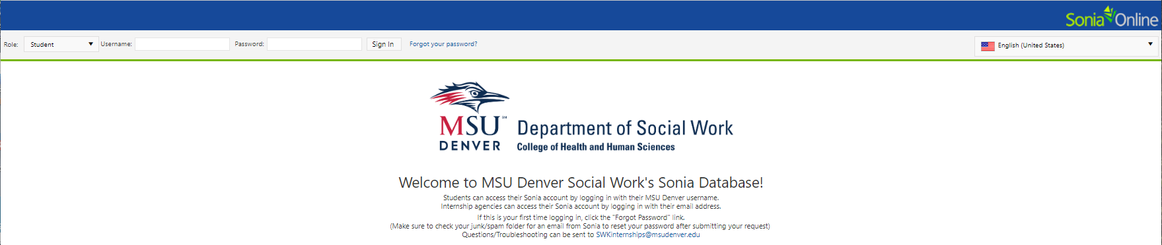

You may wish to review this brief Introduction to Sonia video in addition to following the written instructions below. Direct video link: https://msudenver.yuja.com/V/Video?v=12065387&node=52285245&a=202463836

For your first login, you will set your password using the Forgot your Password button at the top of the page.
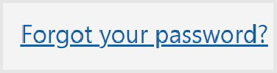

On the password reset screen, the Role of “Student” should be displayed. If not, select it from the dropdown options.
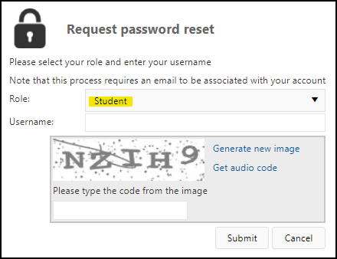

Your username is the first part of your MSU Denver email address, everything before @msudenver.edu. (e.g.: John Smith’s email address is jsmith@msudenver.edu. John’s Username is jsmith)

Complete the password captcha, which requires all capital letters.

Press the Submit button.
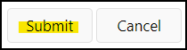

Your automatic confirmation email, which will be sent from DoNotReply@metro.sonialive.com, can take up to ten minutes to arrive to your @msudenver.edu email. Check your junk folder and if it doesn’t arrive, please email us at SWKinternships@msudenver.edu for assistance.

The automatic confirmation email will look similar to this and will include a link you will use to set/reset your password.
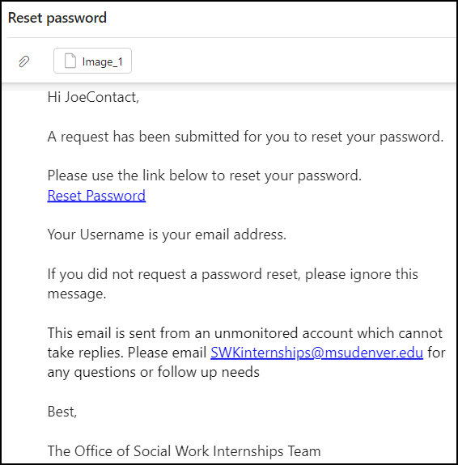

Once you have set your password, you may login on the Sonia homepage:
The default Role in Sonia is set to Student, so you’ll just need to enter your Username and your password each time you sign in.

You may reset your password at any time once you’re logged into Sonia by using the gear-shaped Settings icon in the top right corner of the screen.


Accessibility Settings in Sonia

For those using a screen reader, please go to Account Settings in Sonia by clicking on the Settings/gear icon in the top right corner of any tab:

In the General section at the top of the screen, click on the Enhanced Accessibility option:
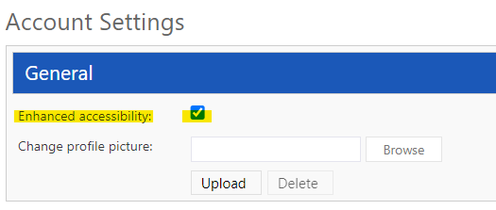

Click on any tab at the top of the screen to exit the Settings page.

Sonia Navigation Tabs
The top-of-screen ribbon in your Sonia account lists navigation tabs.

Note that on the Home landing page there are sections on the right side of the screen for Documents and Links. You will find here resources that MSU Denver provides not only for support but also regarding student and university expectations and requirements, as well as information to help you navigate the internship search process and more.
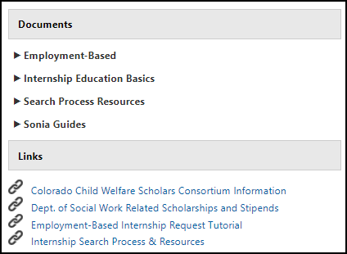

The Home/landing page also lists important information and announcements that change throughout the academic year, so please check these whenever you login.

The tabs which you will primarily use are as follows:
- 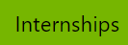 The Internship tab will show the internship group you’re in (BSSW, MSW Foundation, or MSW Concentration). This is also where you’ll be able to search for and preference approved internship agencies during the internship search cycle. You will collaborate with your Internship Navigator, who will support you through the search process.
- 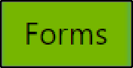 The Forms tab will house the forms you’ll need to complete as you move through the search process and during your internship. You’ll find your Internship Application, Internship Confirmation form, Learning Agreement, Internship Evaluation, and more in this location. The Office of Social Work Internships will place the required forms in this section at the appropriate times.
- 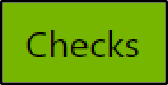 The Checks tab contains a convenient outline of steps needed to complete your internship search. You will work through the steps from top to bottom, again collaborating with your Internship Navigator. Each check must be marked as Cleared/Completed as the process moves forward.
- 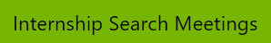 The Internship Search Meetings tab will be visible/available only during the search process and is where you will schedule an appointment to meet with your Internship Navigator. Meeting with an Internship Navigator is optional for continuing MSW Concentration students. Advanced Standing and all other students are required to have at least one Internship Navigator meeting.
- 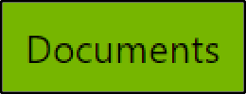 The Documents tab is where you can reference emails sent to you from the Office of Social Work Internships via the Sonia database.
- 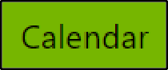 Deadlines and important dates can be found on this tab. Use the arrows near the top left corner of the screen to navigate through weeks.
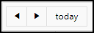
You may set the view using the Day/Week/Month option in the top right corner:
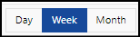

Sign out of Sonia by clicking the exit icon (the rectangle with the right arrow) on the top right corner of the screen in any tab.


INTERNSHIP SEARCH PROCESS

Structure of the Search Process

Search Process Overview
The Office of Social Work Internships (OSWI) partners with several hundred approved agencies at which students may complete their internship. Agency partners are screened to ensure that students will have the opportunity to practice the nine social work competencies as identified by the Council on Social Work Education.

Students will use Sonia to identify potential agencies to which they may apply for their August – May internship. Sonia allows students to search using filters (agency location, hours, population served, paid or stipend offered, etc.). Every student is matched with an Internship Navigator from OSWI. Your Internship Navigator will offer support and insight as you work within Sonia to locate an internship.
These are the basic steps of the internship search process; details are included in this guide:
- Attend an Information Session and mark as completed in the Checks tab in your Sonia account if it’s not already designated as completed.
- Complete the Internship Application in the Forms tab in Sonia.
- Use the Internship Meetings tab in Sonia to schedule an Internship Search Meeting with your Internship Navigator.
- Prior to meeting with your Internship Navigator, review and preference/select up to five agencies in the Internships tab in Sonia. These are agencies to which you would like to apply. NOTE: Continuing MSW Concentration students are not required to meet with their Internship Navigator before having their preferences approved. All other students must schedule a mandatory meeting in order to be able to apply to agencies.
- Prepare your application materials (cover letter, resumé, etc.).
- Your Internship Navigator will refer you to agencies within Sonia. You may begin applying on the date set by OSWI.
- Interview with agencies.
- Once offered by an agency, accept an internship offer in the
Internships tab in Sonia.
- Complete the Internship Confirmation form in the Forms tab in Sonia. This must be done by the deadline set by the Office of Social Work Internships.

Keep in mind that the Checks tab in Sonia serves as guide for next steps as you move through the search process. Refer to the Checks tab often.

Initial Search Steps

Internship Information Session
The mandatory Internship Information Session is a virtual event designed to give students a comprehensive overview of the internship experience and search process details. Students are required to attend an Information Session, after which access to Sonia will be granted. The Office of Social Work Internships will notify all students of the scheduled Internship Information Sessions via their MSU Denver student email.
OSWI offers several dates/times for students to attend an Information Session while allowing several months for the search process. If a student is unable to attend a scheduled session, they may contact our office at SWKinternships@msudenver.edu to discuss options.
After attending a live remote Information Session, the Office of Social Work Internships will mark the first step in your Checks tab as complete.
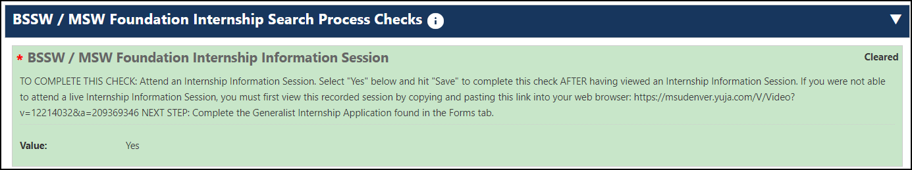

This will trigger an automated message to your MSU Denver email outlining your next step, which is the Internship Application form.

Internship Application Form
The next task in your Checks tab in Sonia is the Internship Application form.
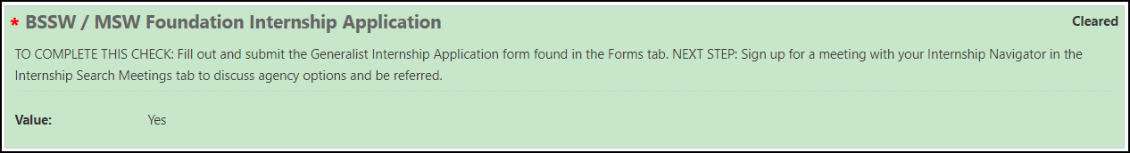
The Application form is found in the Forms tab in your Sonia account, and must be submitted to the Office of Social Work Internships prior to your meeting with your Internship Navigator. This form is used only by the OSWI team and allows your Internship Navigator to have some background information about you and the types of agencies in which you are interested.

To Access the Internship Application Form:
- Click on Forms Tab in Sonia.
- Locate the Internship Application form for the appropriate academic year and click on the red Edit button.
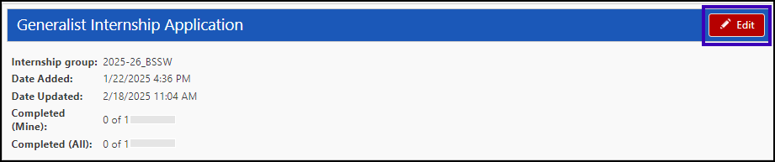
- The form will open up in another tab in your browser. Fill out the form to the best of your ability. All fields with a red asterisk (*) must be completed or the form will not submit. You may choose “Save Draft” if you need to pause and come back to the form. Click “SUBMIT” when you have completed the form.
- After clicking the “SUBMIT” button, at the bottom of the form you should see “Form successfully actioned by [your name] on [date] at [time]” in green text. If a required field was not answered, this will be indicated in red text below the ‘Save’ button. You must ensure all required fields are completed and click SUBMIT again.
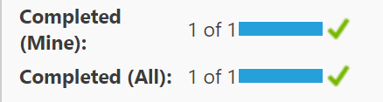
- In the Forms tab, the Internship Application will appear with both Completed (Mine) and Completed (All) marked as ‘1 of 1’ once you’ve successfully submitted the form.

In the Checks tab the Value for the General Internship Application should show as “Yes” once the form has been submitted.
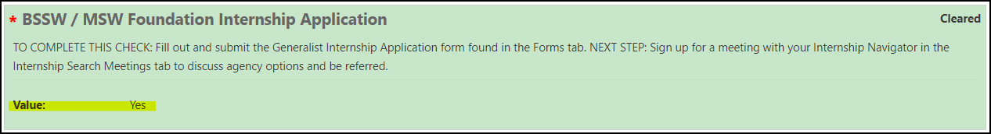

Scheduling an Internship Search Meeting With Your Internship Navigator
After completing the Internship Application, you will sign up for a meeting with your Internship Navigator. For quick reference, your Internship Navigator is listed on your Sonia home page in the top right corner.
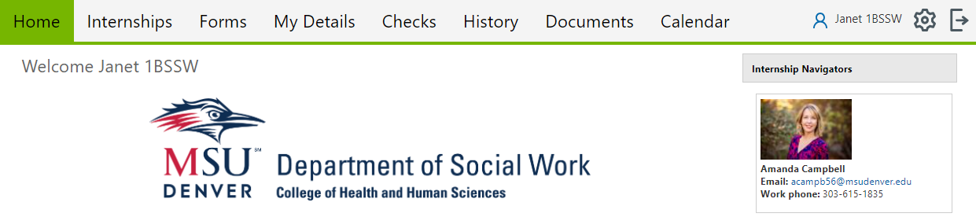
Note that continuing MSW Concentration students are not required to meet with their Internship Navigator prior to applying to agencies. All other students, including Advanced Standing students, are required to schedule an Internship Meeting with their Internship Navigator.

To schedule your Internship Search Meeting:
- Click on the Internship Meetings tab in your Sonia account.
- You will see all available meeting times listed by date.
- Click the Select button for the meeting that you would like to schedule with your Internship Navigator.
- The meeting will appear on the right side of the page. Please review the saved meeting for important details (e.g.: Zoom link, etc.).
- You may make appointments up to 24 hours before the scheduled meeting time and may only cancel the meeting through Sonia up to 24 hours prior to the scheduled meeting time. Any need to cancel a meeting inside of 24 hours will need to be communicated via email directly to your Navigator. Their email is listed in the top right corner of the Home tab in your Sonia account.
- Please contact your Internship Navigator if you have any questions or concerns about your Internship Meeting.

Preferencing/Selecting Agencies in Sonia

You will be notified by the Office of Social Work Internships when you may begin using Sonia to research potential agencies and preference (select) the top agencies in which you are interested. Save your preference list prior to your Internship Navigator meeting so that you and your Navigator can review and approve your preferences. You can begin applying to the agencies only after you have been referred to them by your Internship Navigator.

To preference/select agencies within Sonia:
- Click on the Internships tab in Sonia.
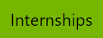
- Click on the Preferences button. This button will be visible once preferencing is available to you.

- A list of agencies will populate.
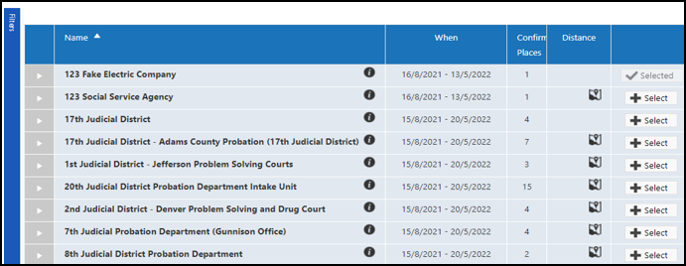
- Agency details can be accessed by clicking on the arrow icon to the left of the agency’s name. 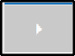
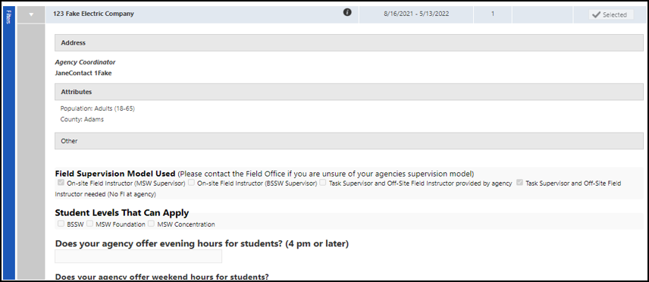
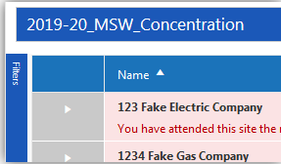
- To search for agencies with specific criteria, click on the Filters bar on the left-hand side of the screen. Note: Not all filters are used by our program; the most effective filters to utilize to begin to narrow your search are county, site type and population. You may “dock” the filter section by clicking on the pin button. This will adjust the page so you can view both the list of agencies and the filter section.
- To preference/select an agency as one which you are interested in discussing with your Internship Navigator and to which you’d like to apply, click on the “Select” button on the agency’s row.
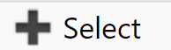
- The agency will be added to the Preference list that is on the right- hand side of the screen. You can drag and drop to move agencies on this list to better reflect your top five agencies in order of preference.

MAKE SURE TO SAVE before exiting the Internships tab.

You will be sent an email after your Internship Navigator meeting notifying you when your top three agencies have been approved. This is when you may begin to apply to your preferenced agencies.
- Please contact your Internship Navigator if you update your preferences list.

After your Internship Search meeting, your Internship Navigator will mark the Agency Referrals Approved – Ready to Apply check on your Checks tab as complete.
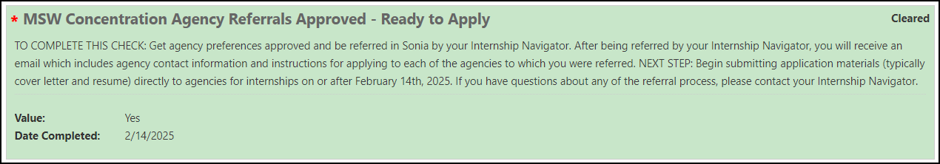

When you have completed these initial steps of the internship search process most steps in the Checks tab should show a value of Yes. The only check you will be unable to complete at this stage is the one titled Student Allocated to Agency AND Internship Confirmation Form Submitted. The Internship Confirmation form will be required and available to you on the Forms tab after you have accepted an internship offer with an agency. This check will be cleared/completed once you have submitted the Internship Confirmation form.

If you have any questions about the internship search process, please reach out to your assigned Internship Navigator. If you have questions about the Sonia database system, message SWKinternships@msudenver.edu.

Continuing Search Steps

Preparing Application Materials

Once you have met with your Internship Navigator and been referred to your top agencies within Sonia, you will receive an email detailing your next steps in the process.

Take some purposeful time to start preparing your resumé and cover letter if you have not done so already.
You may want to connect with the MSU Denver Writing Center at https://www.msudenver.edu/writing- center/student-resources/ for assistance.

MSU Denver’s Classroom to Career Hub/C2Hub also offers resumé support. Useful links can be foundhttps://www.msudenver.edu/classroom-to-career-hub/student-resources/#career-prep-resources. (NOTE: While C2Hub can help with internship search resources for other majors, all social work internship students are required to conduct their internship search through the specialized assistance of our Office of Social Work Internships and within our Sonia database.)

Applying to Agencies
You will receive an email from the Office of Social Work Internships that contains contact information for the agencies to which you may begin applying. Students may begin applying to agencies for internships only after notification from the Office of Social Work Internships.

To review your preferenced agencies and begin the agency application process:
- Click on the Internships tab in your Sonia account.
- Locate the internship group/your student level for the appropriate academic year and click on the red Details button on the right.

- The agencies to which you were referred by your Internship Navigator will be listed on this screen. The status will show as Referred.
- Click on the Internships tab again, then click on the purple Preferences button.

- You will see the agencies list. To the left of the list, click on the Filters bar then type in the name of an agency to which you’ve been referred.
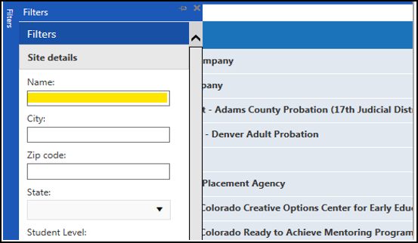
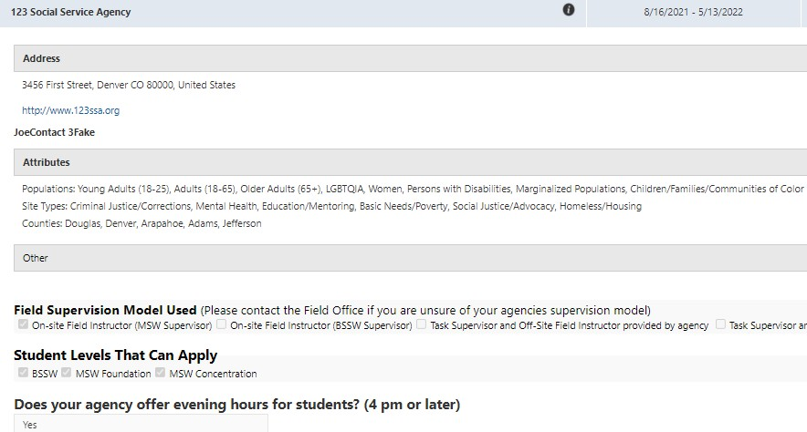
- The agency will appear to the right of the Filters tab. Click on the agency profile to see the internship information they have listed so you can tailor your resumé, cover letters, and interview preparations for their specifications. Repeat this process for each agency to which you will apply/have been referred.

As a reminder, the Office of Social Work Internships will notify you of the date on which you may begin applying to the agencies where you have been referred. The agencies’ contact information will be included in an email sent by your Internship Navigator.

Unless otherwise indicated, you will apply to each of the agencies by emailing your resumé and cover letter to the agency contact. You may ONLY contact agencies that you have been referred to through your Internship Search Meeting. Agencies will NOT be able to offer you an internship position through Sonia unless you have been referred to them by your Internship Navigator. If the internship is not offered and accepted within Sonia, you will not be allocated to an agency for your internship. If you would like to modify the list of agencies to which you’ve been referred, you MUST contact your Internship Navigator.

After you have contacted an agency and submitted your resumé and cover letter, each agency should communicate with you regarding their next required steps in the application process (setting up an interview, etc.).

Accepting or Declining an Internship Offer
Once you have interviewed with agencies, you can expect to start receiving offers for suitable internship positions. Agencies will communicate with you directly via phone or email to offer you a position.

After you have accepted an offer at an agency either verbally or in writing/via email, the agency contact will then send you an internship offer through Sonia. This process is mandatory as it tracks internships, supervisors, mandatory forms, and more that will be needed during your internship.

An internship allocation is not finalized unless and until the offer process is completed in Sonia; the agency must first extend the offer then you must accept the offer in your respective Sonia accounts.

To accept an agency’s offer:
- Click on the Internships tab in your Sonia account.
- Locate the internship group/your student level for the appropriate academic year and click on the red Details button on the right.
- Locate the agency that is offering you an internship and you will see that your status has been changed from “Referred” to “Agency - offers pending student decision.”
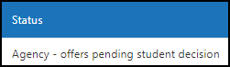
- To accept the offer, click the “Student – confirms accepted internship” button to allocate you to the agency as an intern.
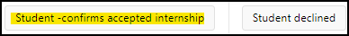
- Alternately, if you receive an offer through Sonia and you have already accepted an offer with another agency or choose to decline the offer, please first communicate directly with the agency contact to inform them of your decision to not accept their offer. After you have communicated this to the agency, you will then also designate this in Sonia by actioning the “Student declined” button.
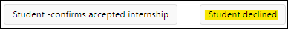

Some important notes about internship offers:

- Once you have committed to an agency by accepting an internship offer, you may not accept an offer from another agency afterwards. This is considered unprofessional and can damage both your professional reputation as well as that of MSU Denver’s Social Work Department in the social work community.
- It is especially important that students communicate with agencies even if they do not wish to accept an internship offer. It is not considered professional or acceptable to “ghost” an agency that has extended an internship offer to you. Your Internship Navigator can help if you need assistance before you communicate with an agency to decline their offer.
- If you are unsure whether you wish to accept a specific offer or need help with how to speak to an agency during this process, your Internship Navigator can help you to gain clarity for your next steps.

Please contact the Office of Social Work Internships at SWKinternships@msudenver.edu if you have any questions about the required processes in Sonia.

Completing the Internship Confirmation Form
Once you have accepted an offer from an agency you must complete the Internship Confirmation form in Sonia. This will not only officially complete the internship search process, it will also inform the Office of Social Work Internships who your designated Social Work Supervisor and/or Task Supervisor will be.

To Complete your Internship Confirmation Form:
- In your Sonia account, click on the Forms tab.
- Select the Internship Confirmation form for the appropriate student level/academic year.
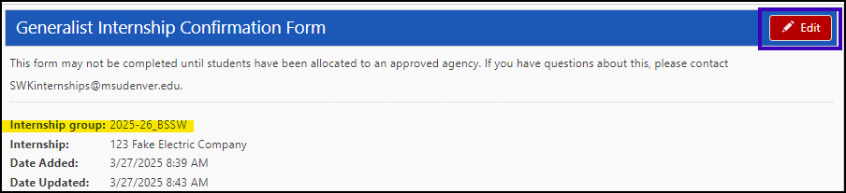
- Click the red “Edit” button to access the form.

*If you are unable to click on the red Edit button/the button is grayed out, it means you have not been allocated to your agency. You must accept the internship offer from an agency in Sonia to be allocated to the agency. If you have accepted an offer from your agency in Sonia and are still unable to edit the form, please contact SWKinternships@msudenver.edu.
- Fill out the Internship Confirmation form.
The Internship Confirmation form contains the following sections:
  - Student Information
  - Special Circumstances
  - Workers’ Compensation
  - Agency Information – Please be sure to add any site- specific agency information if necessary
  - Social Work Supervisor Information
  - Task Supervisor Information (if applicable)
  - Agreements

You may only edit fields with a pencil icon next to them.

If you do not yet know the information for your Social Work Supervisor and/or Task Supervisor, you may leave this information blank and submit to your agency by clicking on the “STUDENT SUBMIT TO AGENCY” button:
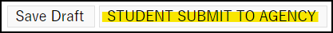

After you click SUBMIT to Agency, the primary contact at your agency will automatically receive an email alerting them to complete the form. This email will be sent to the contact person listed in the Agency section of the form, populated by the information the agency has provided to our office. This person may or may not be the one you’ve been communicating with, but they can forward the email to other contacts at the agency for completion if needed.
- Agency completes their portion of the Internship Confirmation form.
The agency MUST review and submit your Confirmation form before the deadline set and communicated by the Office of Social Work Internships.
The agency will make any needed edits and click “Agency SUBMIT”:
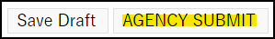
You will receive an email notifying you that the agency has completed the form. Please review the form for accuracy and message SWKinternships@msudenver.edu if there are any errors.
If your agency will not know who your Social Work Supervisor and/or Task Supervisor will be by the deadline that will be shared by the Office of Social Work Internships, please communicate this to your Internship Navigator and/or email SWKinternships@msudenver.edu to notify us.

** Edits to any supervisor names or emails made AFTER the Internship Confirmation form is submitted by the agency will NOT update the Sonia database. These updates MUST be made manually by our office, so please email any supervisor changes to SWKinternships@msudenver.edu as soon as possible. This will ensure that your supervisor(s) will have access to your required forms and receive pertinent communications from the Office of Social Work Internships.

THE LEARNING AGREEMENT AND INTERNSHIP EVALUATION FORMS

Identifying Forms That Require Completion
When reviewing the forms in your Forms tab, Sonia makes it simple to tell which forms have been completed and which still require completion.

Simply look at the Completed (Mine) and Completed (All) details located beneath a form name. If Completed (Mine) shows zero of any number of steps, this indicates that you have a step you must complete. Completed (All) shows how many steps are required for a form and the total number of steps completed at any given time.

In this example, both Completed (Mine) and Completed (All) show zero steps completed for a form with only one step. This indicates that you need to open the form using the red Edit button, then complete and submit your portion of the form.
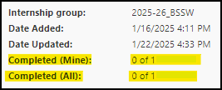 

This sample shows the Completed (Mine) status at 1 of 1, meaning you have one step to complete for the form and you’ve already submitted it. The Completed (All) information shows at 1 of 2, indicating that the form has two total steps and there is one more step of the form that needs to be completed by someone else (usually your supervisor or an agency contact).
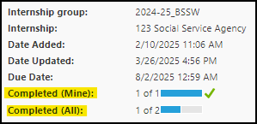
Some forms will have more than two steps, and that will be indicated in the Completed (All) details. This can be a helpful way to know if your supervisor has submitted their portion of a form, or if you still need to complete yours.

The Learning Agreement

Function and Structure of the Learning Agreement
The Learning Agreement is a form that students, agency supervisors, and Faculty Internship Liaisons (FILs) sign to ensure that all parties understand the expectations of the student internship. The Learning Agreement contains the Council on Social Work Education’s nine social work competencies and the corresponding practice behaviors that students are expected to exhibit throughout their internship. Students will write out their example learning activities that they plan to complete in order to meet the listed practice behaviors.

Note that students will complete the Learning Agreement in both the Fall semester and the Spring semester. As each semester nears its end, the Learning Agreement will be converted to the Internship Evaluation form. Both forms will be completed by following the same process.

Students will complete the Learning Agreement in one of two ways:
- The student will complete the Learning Agreement with their supervisor(s).
- The student will complete the Learning Agreement on their own then discuss the learning activities with their supervisor(s) so that they are agreed upon, making edits as needed.

Agency supervisors and FILs can use their Sonia accounts to access the Learning Agreement to review changes saved by the student and/or make suggestions to the Learning Agreement activities. Students, agency supervisors, and FILs will maintain communication to ensure that any edits to the Learning Agreement activities meet the required practice behaviors. All parties will also communicate in order to complete submission of the Learning Agreement by the stated deadline, which will be sent from the Office of Social Work Internships.

Accessing the Learning Agreement
Shortly after the start of each fall and spring semester, the Office of Social Work Internships (OSWI) will notify students and supervisors when the Learning Agreement is available and when it is due. The Learning Agreement is a four-step process, with students responsible for submitting steps one and three.

To access your Learning Agreement:
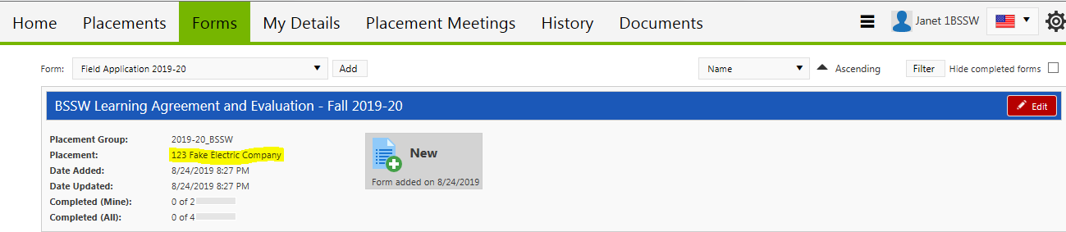
After logging into your Sonia account, click on the Forms tab. Locate the Learning Agreement and Evaluation form for the appropriate/current semester and click the red "Edit" button to open your Learning Agreement.

Note: Double check that your correct internship site is listed. If your current internship agency is not listed, please contact the Office of Social Work Internships at SWKinternships@msudenver.edu for assistance.
** Please remember that if there is a change to your agency supervisor (Social Work Supervisor or Task Supervisor), you must contact the Office of Social Work Internships at SWKinternships@msudenver.edu and send the updated information. These changes must be made on the back end in Sonia, and the Office of Social Work Internships is happy to assist. If students do not notify our office, notifications and forms will not be available to the new supervisors. Simply updating the Learning Agreement will NOT update Sonia and will NOT route forms to new supervisor(s).

Completing the Learning Agreement
The Learning Agreement contains the nine competencies from the Council on Social Work Education and the associated practice behaviors that students are expected to exhibit throughout their internship.

Under each competency, you will write out the proposed Learning Activities and Verifications that you will design to meet the listed practice behaviors at your internship. These will help you and your supervisor(s) in completing the Internship Evaluation later in the semester.

Instructions for completing and submitting the Learning Agreement are outlined near the top of the form.
Enter all applicable information in fields that have a pencil icon next to them on the form. Pay special attention to mandatory fields marked with a red asterisk *. If you do not complete all required fields/fields with an asterisk, the form will not be able to be submitted. It will only be saved as a draft.

Refer to the description for each of the nine competencies as well as the individual Practice Behaviors to develop your Learning Activities and Verifications.

Note that Competency 1(a) includes instructions and examples for both Learning Activities and Verifications. If needed, students may refer back to Competency 1(a) for help completing all other Learning Activities and Verifications for all other competencies.
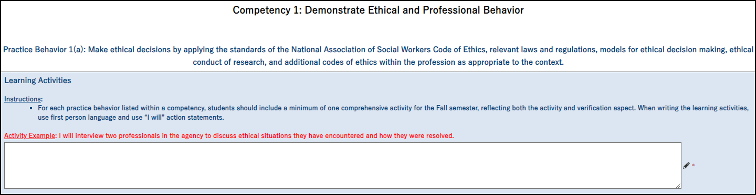
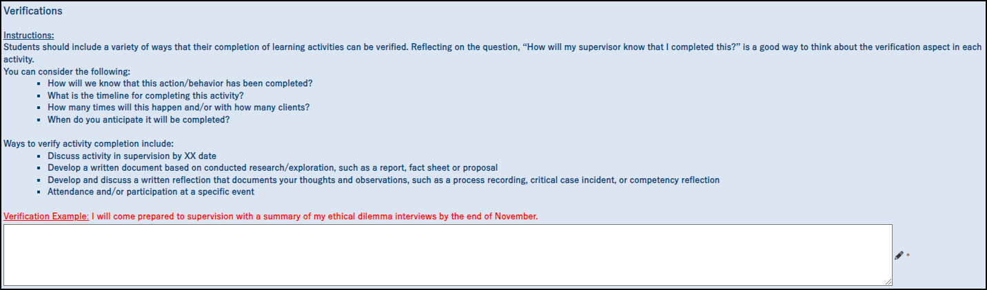

Make sure to communicate clearly with your supervisor(s) as to how you plan to complete your portion of the Learning Agreement. Some supervisors and students agree to meet together to review and complete the Learning Agreement. Others prefer students to complete their portion of the form first, then submit it for supervisory review and approval. Everyone who has access to the Learning Agreement is able to view edits in real time, whether a step of the form has been submitted or not.

However you choose to proceed, both the student and the supervisor(s) will need to complete and submit their portions of the form.

After you’ve finished entering the Learning Activities, click on the “Student First Submit” button.
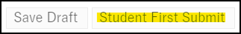

This will send an automated email to your supervisor(s) so that they may complete and submit the agency portion of the Learning Agreement. For students who have more than one supervisor (e.g.: a Social Work Supervisor and a Task Supervisor), the supervisors must communicate with one another regarding form completion and submission. The first supervisor to review the form will use the “Save Draft” button so the second supervisor may also review the form. The final supervisor to review/edit the form will action the “Agency Supervisor Submit” button.
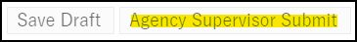

This will trigger an automated email to your MSU Denver student email address. You will then return to the Learning Agreement to review it and make any updates requested by your supervisor(s), if applicable. Once you’ve completed this, you will click the “Student Final Submit” button.
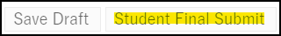

This will notify your FIL that the form is ready for their review and submission.

The Internship Evaluation

Function and Structure of the Internship Evaluation
As we approach the end of each semester, the Learning Agreement form is converted to the Internship Evaluation form to ensure that the social work competencies have been met. This allows for evaluation and reflection on the part of student as well as their supervisor(s).

The Internship Evaluation is processed by the student and their supervisor(s) in the same way as the Learning Agreement is earlier in the semester. (See previous section, Completing the Learning Agreement, for process details.)

Students, agency supervisors, and FILs will maintain communication to ensure that the Internship Evaluation is completed accurately. All parties will also communicate in order to complete submission of the Evaluation by the stated deadline, which will be sent from the Office of Social Work Internships.

NOTE: In cases where a student has multiple supervisors (e.g.: Social Work Supervisor and Task Supervisor) they are both expected to review and contribute to the student’s Evaluation. The Task Supervisor and Social Work Supervisor each hold different knowledge and awareness of the student’s performance; the Task Supervisor has the most direct observation of the student’s practice, while the Social Work Supervisor holds awareness of professional social work competencies. Therefore, Task Supervisors and Social Work Supervisors will need to coordinate with each other and maintain communication while completing the agency portion of the Internship Evaluation. We have requested that these individuals use initials to indicate who has written which comments, and that they do not delete the other supervisor’s comments. While edits to the form can be seen by all users in real time, if both supervisors are working on the form simultaneously from different accounts, the most recent version of the form will be saved. We request that supervisors coordinate their drafts so that no one’s feedback is left out of the Evaluation.

Accessing the Internship Evaluation
As we approach the end of each fall and spring semester, the Office of Social Work Internships will notify students and supervisors when the Internship Evaluation form is available and when it is due. The Internship Evaluation is a four-step process, with students responsible for submitting steps one and three.

To access your Internship Evaluation:
After logging into your Sonia account, click on the Forms tab. Locate the Learning Agreement and Evaluation form for the appropriate/current semester and click the red “Edit” button to open your Internship Evaluation.

Note: Double check that your correct internship site is listed. If your current internship agency is not listed, please contact OSWI at SWKinternships@msudenver.edu for assistance.

** Please remember that if there is a change to your agency supervisor (Social Work Supervisor or Task Supervisor), you must contact the Office of Social Work Internships at SWKinternships@msudenver.edu and send the updated information. These changes must be made manually in Sonia by the Office of Social Work Internships. If students do not notify OSWI, notifications and forms will not be available to the new supervisors. Simply updating the Internship Evaluation form will not update Sonia and will not route forms to new supervisor(s).

Completing the Internship Evaluation
The Internship Evaluation contains the nine Council on Social Work Education competencies and the listed Practice Behaviors that students are expected to develop/exhibit throughout their internship.

Under each of the nine competencies, you will evaluate your skill level for that competency and the practice behaviors.

Instructions for completing the student portion of the Evaluation are included near the top of the form.
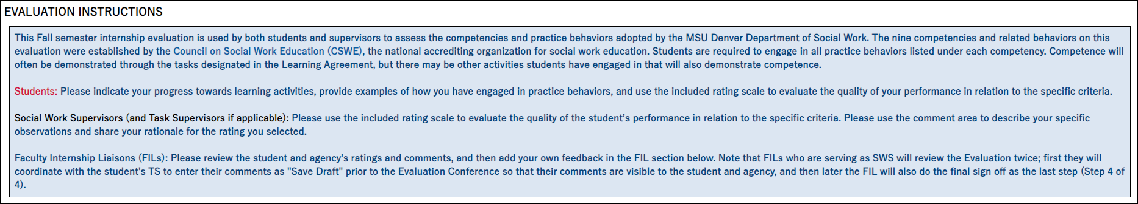

When submitting step one of the Evaluation form, students will enter number of the internship hours that they have completed to date. Students will describe the plan for completing their remaining internship hours before the end of the semester if needed.
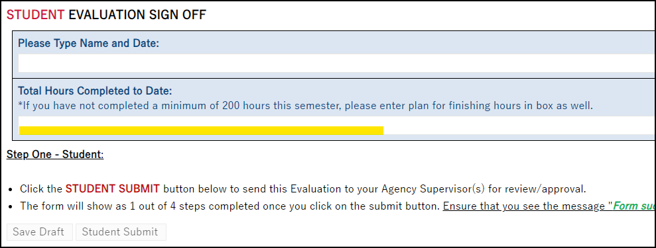

Students will rate themselves on each competency and Practice Behavior and complete all fields on the form that have a pencil icon. Pay special attention to complete all mandatory fields marked with a red asterisk *. Refer to the completed/included Learning Activities and Verifications sections of the document to assess your progress with the nine social work competencies.

Please review the Evaluation Rating Scale at the beginning of the Evaluation form prior to beginning your self-evaluation.
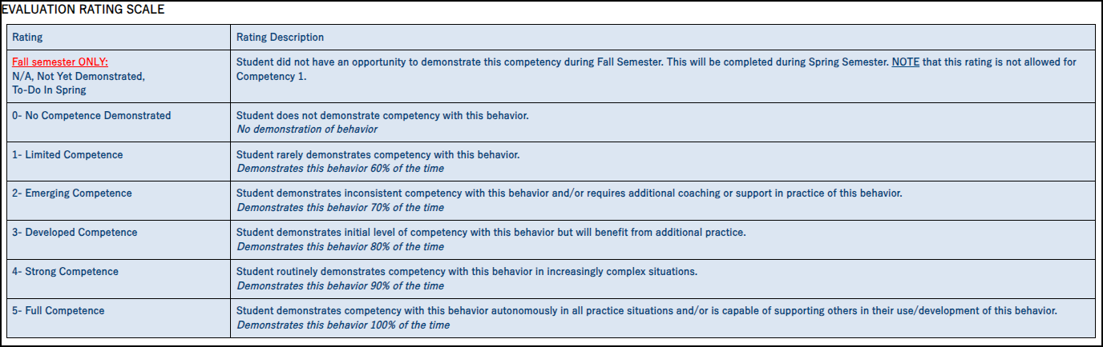

After engaging in self-reflection and rating each Practice Behavior, complete all questions in the section titled Evaluation Narrative Questions, and follow all the instructions listed there.
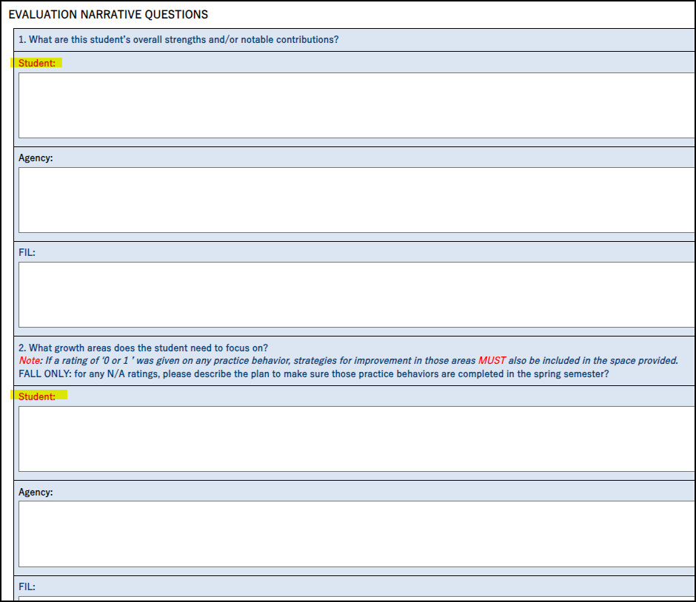
Click on the “Student Submit” button:
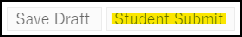

This will send an automated email to your supervisor(s) so that they may complete the agency portion of the Internship Evaluation.

Internship Evaluation Conference and Final Form Submission
Each student and their supervisor(s) will meet for an Evaluation Conference to discuss the results of the Internship Evaluation. If your agency has provided both a Social Work Supervisor and a Task Supervisor, the first supervisor to complete the agency portion of the Evaluation should save the form as a draft.
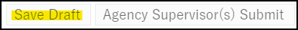
The Evaluation Conference will take place after both supervisors have reviewed your student portion of the Internship Evaluation and submitted the agency portion of the form.
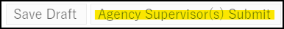

Both the Social Work Supervisor and Task Supervisor are expected to review and contribute to the student’s Evaluation. Please note that edits to the form can be seen by all users in real time.

Supervisor submission of the form automatically sends a notification to your MSU Denver student email. This allows you the opportunity to review the agency portion of the Evaluation in order to prepare for the Evaluation Conference.
Note: If your Faculty Internship Liaison (FIL) also serves as your Social Work Supervisor (SWS), they may not necessarily attend the Evaluation Conference, though they are welcome to do so. Either way they will review the Internship Evaluation Form in their role as FIL, which is the final step of the evaluation process.
After completion of the Evaluation Conference, you will access the Internship Evaluation form in your Sonia account once more so that you may complete the Evaluation Conference Sign Off section and enter your completed hours at the end of the evaluation process (which will most likely be the end of the semester).
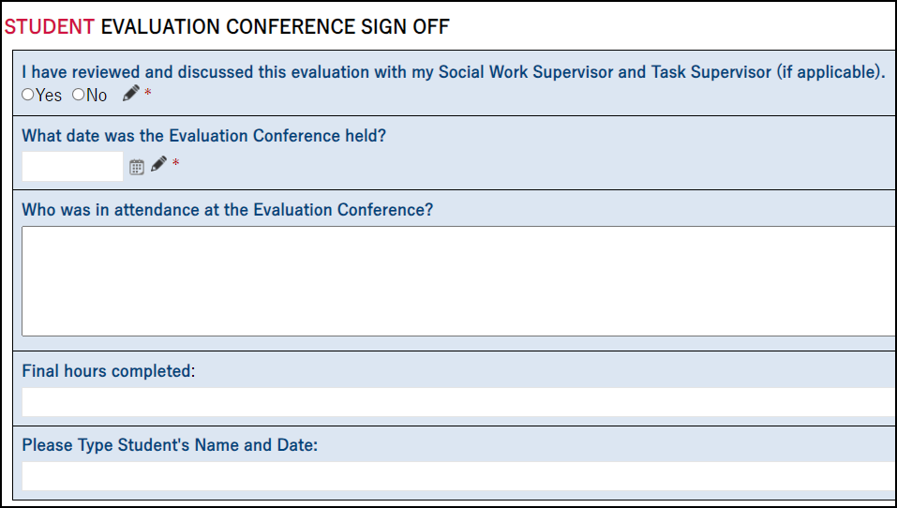

Once you have completed the Evaluation Conference Sign Off section, click on the “Student Final Submit” button to submit the form to your Faculty Internship Liaison (FIL) for review:


DO NOT click on the Student Final Submit button until AFTER your Evaluation Conference and completion of the Evaluation Conference Sign Off.

As the last step of the process, your Faculty Internship Liaison will review the Internship Evaluation form as part of your Field Experience class grade for the semester. Remember that Internship Evaluations are reviewed for a Pass/Fail grade.

You may review your Internship Evaluation at any time by accessing it via the Forms tab in your Sonia account. You can track the progress of the form by looking at the “Completed (All)” tracker located beneath the form name.

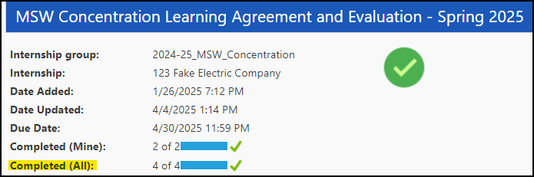

Please contact your Faculty Internship Liaison if you have questions about the evaluation process or your agency supervisor(s). Please contact the Office of Social Work Internships at SWKinternships@msudenver.edu if you have questions or issues with the Internship Evaluation form or with Sonia.

