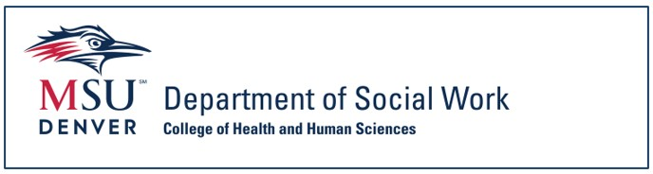

Sonia Guide for Agency Contacts

### Introduction

The Department of Social Work and the Office of Social Work Internships are excited to welcome you to the MSU Denver internship process. Sonia is a third-party database, used to collect student and internship details, and expedite the internship process by providing a framework for student and agency contact interaction. We use it to keep track of all our students, contacts, Faculty Internship Liaisons (FILs), sites, forms, internship descriptions, and documents in one place. By the end of this guide, site contacts should understand the functions of their role in Sonia which may include how to use Sonia to update agency information, extend an offer of internship, and provide feedback on student skill-building.

#### Agency/Site Contact Roles Within Sonia

There are different roles for site contacts within Sonia which give different permissions in terms of functionality.

* The agency’s primary contact has permissions to update agency information and extend an offer of internship to students. The primary contact will also be the individual receiving student application materials during the search process. The primary contact may or may not also serve as a student supervisor.
* Supervisors (Social Work Supervisors/Task Supervisors) are able to complete student learning forms such as the Learning Agreement and Internship Evaluation once assigned to a student in Sonia.

**Special note:**  
We ask that all agency contacts add [SWKinternships@metro.sonialive.com](mailto:SWKinternships@metro.sonialive.com) to their Contacts/Safe Senders list so that automated messages from our Sonia database will be directed to your inbox and not your spam folder. We use this method of communication regularly and want to ensure that you don't miss any important messages from our office.

### Table of Contents

SONIA BASICS

* Logging in and Navigation Within Sonia
  + Page 6 – Sonia Login Instructions
  + Page 9 – Sonia Navigation Tabs AGENCY INFORMATION
* Updating Agency Information Within Sonia
  + Page 13 - Updating Agency and Internship Details OFFERING INTERNSHIPS
* Extending Internship Offers to Students
  + Page 17 – Extending an Internship Offer Within Sonia THE LEARNING AGREEMENT AND INTERNSHIP EVALUATION FORMS
* Using the Filter Function in the Forms Tab
  + Page 23 - Filtering Forms for Ease of Location
* Completing the Learning Agreement
  + Page 26 – Function and Structure of the Learning Agreement
  + Page 28 – Accessing the Learning Agreement
  + Page 30 – Completing the Agency Portion of the Learning Agreement
* Completing the Internship Evaluation
  + Page 33 – Function and Structure of the Internship Evaluation
  + Page 34 – Accessing the Internship Evaluation
  + Page 36 – Completing the Agency Portion of the Internship Evaluation
  + Page 37 - Internship Evaluation Conference and Submitting the Internship Evaluation

# SONIA BASICS

## Logging in and Navigation Within Sonia

### Sonia Login Instructions

The Sonia login page can be found [here](https://metro.sonialive.com/School.aspx) or by going to <https://metro.sonialive.com/School.aspx>. You will likely want to bookmark the Sonia login page.  
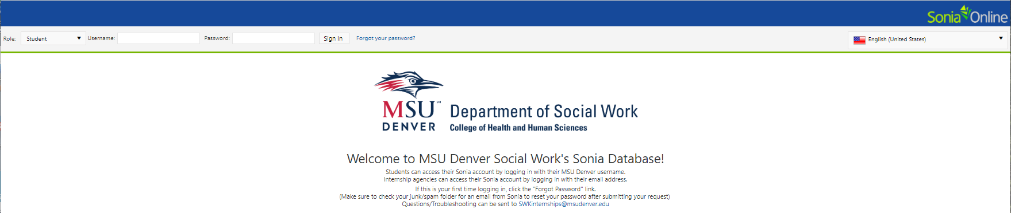

For your first login, you will set your password using the Forgot your Password button at the top of the page.

Forgot your password button on the Sonia login page. 

On the new screen, select your Role as “Site” from the dropdown options.  
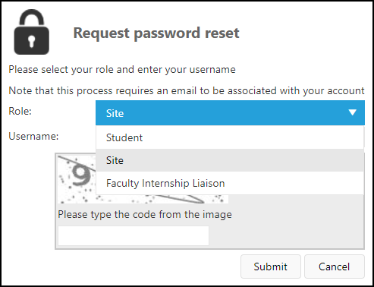

Once you have selected your role as Site, enter your Username. Your Username is the same email that has been provided to the Office of Social Work Internships. *(e.g.: John Smith’s email address is* [*jsmith@msudenver.edu.*](mailto:jsmith@msudenver.edu) *John’s Username is* [*jsmith@msudenver.edu*](mailto:jsmith@msudenver.edu)*)* If your username is different than this, our office will confirm that with you.

Complete the password captcha, which requires **all capital letters.**

Press the Submit button.  
Submit and Cancel buttons on the password request screen. The Submit button is highlighted in  yellow. 

Your automatic confirmation email, which will be sent from [DoNotReply@metro.sonialive.com](mailto:DoNotReply@metro.sonialive.com), can take up to ten minutes to arrive. Check your junk folder and if it doesn’t arrive, please email us at [SWKinternships@msudenver.edu](mailto:SWKinternships@msudenver.edu) for assistance.

The automatic confirmation email will look similar to this:   
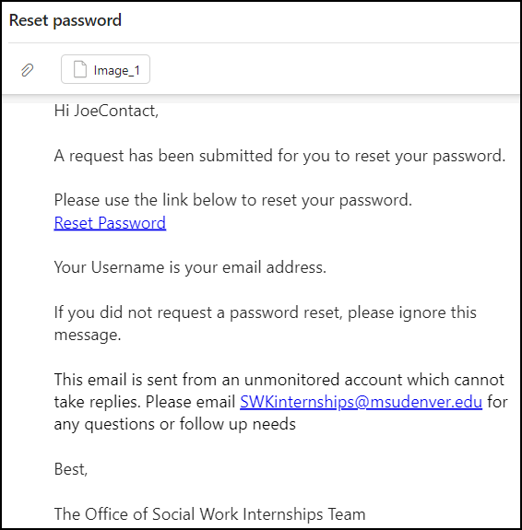

Once you have set your password, you may login on the [Sonia homepage](https://metro.sonialive.com/School.aspx).  


When signing in, remember to **select your Role as “Site”** in the top left corner of the screen. You will need to update this every time you log in.  
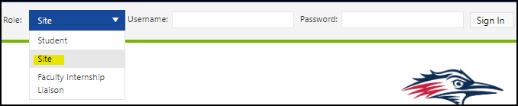

Enter your Username/email address and the password you just created, then click ‘Sign In.’

You may reset your password at any time once you’re logged into Sonia by using the gear-shaped Settings icon in the top right corner of the screen.  
The gear-shaped Settings icon in Sonia.

### Accessibility Settings in Sonia

For those using a screen reader, please go to Account Settings in Sonia by clicking on the Settings/gear icon in the top right corner of any tab:

The gear-shaped Settings icon in Sonia.

In the General section at the top of the screen, click on the Enhanced Accessibility option:

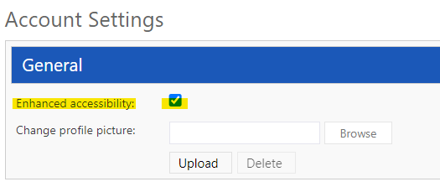

Click on any tab at the top of the screen to exit the Settings page.

### Sonia Navigation Tabs

The top-of-screen ribbon in your Sonia account lists navigation tabs.  
Tabs at the top of the screen in Sonia: Home, Students, Internships, Data, Forms, My Details,  Documents, Site Details, History, and Calendar.

Note that on the Home landing page there are sections on the right side of the screen for Documents and Links. You will find here resources that MSU Denver provides to agency contacts, students, and Faculty Internship Liaisons not only for support but also regarding student and university expectations and requirements. You will also find links to various trainings offered by the Office of Social Work Internships for a given academic year. (Recordings are posted after an event.)

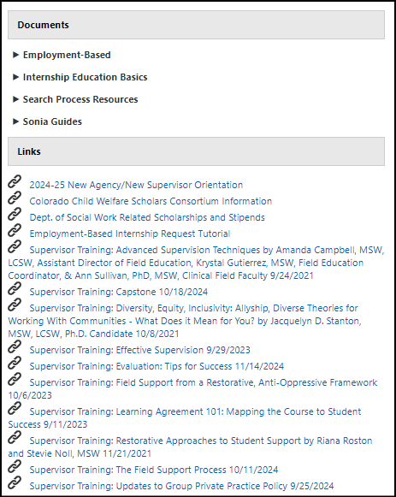

The tabs which you will primarily use are as follows:

* 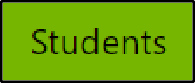 The Students tab displays students placed at your site.
* The Internships tab in Sonia. On the Internships tab you will see the number of students you have requested at each level (BSSW, MSW Foundation, MSW Concentration). This is also where you’ll see students’ referrals to your site, and where agency offers are extended to students.
* 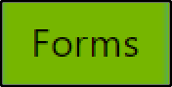 The Forms tab allows you to access forms you have yet to complete as well as review forms you have already submitted.
* 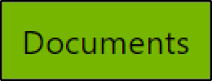 The Documents tab is where you can reference any saved documents or emails from the Office of Social Work Internships.
* 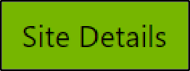 The Site Details tab provides information about your Agency and about the internship(s) you offer. The designated primary contact for the agency may use this section to change or update information about the agency.
* 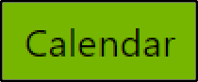 Deadlines and important dates can be found on this tab. Use the arrows near the top left corner of the screen to navigate through weeks:   
  Arrows that allow the user to navigate the  calendar by week.  
  You may set the view using the Day/Week/Month option in the top right corner:  
  Option buttons that control whether the calendar is in Day, Week, or Month view.

Sign out of Sonia by clicking the exit icon (the rectangle with the right arrow) on the top right corner of the screen in any tab.  
The exit icon button used to log out of Sonia. 

# AGENCY INFORMATION

## Updating Agency Information Within Sonia

### Updating Agency and Internship Details

It is important to keep agency and internship details up to date to support students searching for internships and get them connected to your agency. Students start reviewing internship options in January and applying to agencies beginning in February of each year for internships starting in August, so please ensure all information is accurate prior to these dates.

Near the end of each calendar year, the Office of Social Work Internships sends out a Sonia form prior to the search cycle in order to make automated updates to agency information. However, the designated agency primary contact has the ability to change details for your agency or submit an updated internship description, by clicking on the “Site Details” tab on the top-of-the-screen ribbon.  
The Site Details tab in Sonia. 

From this page you can update information that students will see when exploring an internship with your agency.

Sub-tabs on the Site Details tab including General Details, Attributes, Documents and Links, and Associated Users.

#### ****You may edit information on the following tabs:****

**General Details:** This tab will allow you to update information that students will see about your agency and the internship(s) available. You can update information such as:

* Agency address and phone number
* Student levels accepted by the agency
* Social Work Supervisor availability (defined as a supervisor with a social work degree and at least 2 years of post-degree experience)
* Hours offered (eg: weekend, evening hours available?)
* Bilingual ability required/preferred
* Internship description
* Agency description
* Application notes/instructions

**Attributes:** Here you may update agency information for:

* Site Type
* Population(s) served
* County

**Notes:** You may add additional information here about your site that you would like to share with MSU Denver and students.

**Documents and Links:** This tab contains copies of emails/documents shared with your agency by the Office of Social Work Internships. You may upload documents that you wish to share with students, such as a flyer about your agency or internship. Additionally, this section allows you to upload internship descriptions and review your site’s Affiliation Agreement and the applications students send into your site. The Office of Social Work Internships must update some agency information. Please message us at  [SWKinternships@msudenver.edu](mailto:%20SWKinternships@msudenver.edu) if you are unable to update agency information in your Sonia account. We’ll be happy to assist you.

**Please note:** We ask that agencies DO NOT create contacts within Sonia for their supervisors or employees. There are numerous steps our office takes to ensure support for new agency contacts, and we are not notified if an agency creates a contact. For this reason, we ask that you message us at [SWKinternships@msudenver.edu](mailto:SWKinternships@msudenver.edu) and we will be happy to add any new supervisors or contacts to the database on your behalf.

# OFFERING INTERNSHIPS

## Extending Internship Offers to Students

### Extending an Internship Offer Within Sonia

Internship offers must be extended within Sonia. Note that **only the individual designated as the primary contact at an agency is able to access and extend internship offers.** This may not be the same person who meets with or interviews potential student interns. If you are uncertain of the primary contact at your agency, please email us at [SWKinternships@msudenver.edu](mailto:SWKinternships@msudenver.edu) so that we may assist with identifying them for you.

To officially offer a student an internship in Sonia, go to the Internships tab.  
Internships tab in the Sonia database.

Select the internship group for the student to whom you are offering the internship. Pay special attention to select the correct student level (**BSSW, MSW_Foundation, or MSW_Concentration**) and the correct academic year. You may need to scroll down the page to locate the correct student level/academic year. Click on the green “Student Ranking” button to the right of the internship group name.

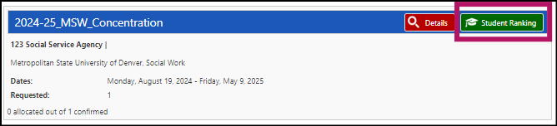

In Student Rankings, you will see a list of students that have been referred to your agency to apply for internship positions.  
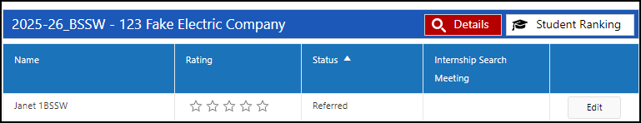

Click on the “Edit” button in the far-right column for the student to whom you would like to offer the internship.  
A closeup view of the Edit button that allows an agency primary contact to extend an internship offer.

A Student Details pop-up screen will appear. Scroll down to where the status of the student is listed. *\*Please note, primary contacts do not need to consider the list of outstanding checks highlighted in the red box. Those are for Office of Social Work Internships internal use only.*

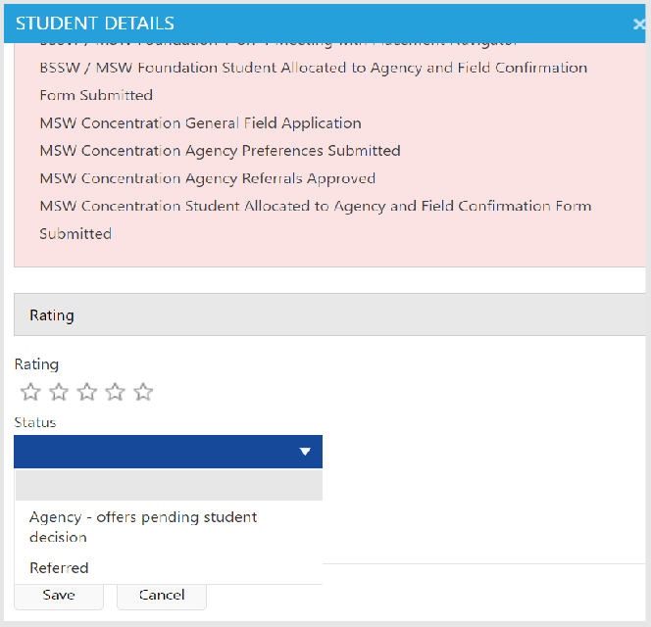

The student’s status should show as “Referred”:  
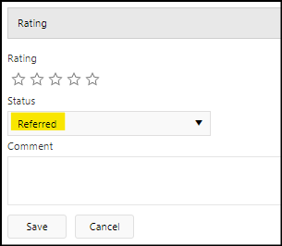

Use the dropdown to change the status to “Agency - offers pending student decision”:  
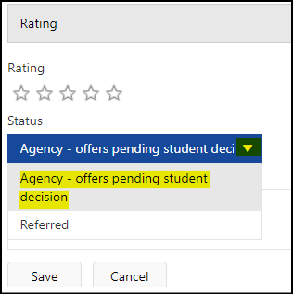

#### ****NOTE: Please do not select any other option in the dropdown menu. The changing of the status to “Agency - offers pending student decision” allows the student to accept the offer from their Sonia account and notifies the Office of Social Work Internships that an internship offer has been made.****

Once you have changed the student’s status to indicate that an offer is pending, you must click the save button on the bottom left-hand corner of the Student Details box.

The Save button, which must be used when extending an internship offer to a student.

When you save the offer in Sonia, an automatic email will be generated to the student that will notify them of your agency’s offer. The student will then access their Sonia account to accept or decline the offer.

If your offer is accepted, the student must complete the Internship Confirmation Form which will be automatically routed to you for completion via an email with a link to the form. **Completion of the Internship Confirmation Form by both student and agency is mandatory** and is due by the announced deadline sent from the Office of Social Work Internships. Alternately, primary contacts may access the Internship Confirmation Form on the Forms tab in their [Sonia](https://metro.sonialive.com/School.aspx) account. You may sort by using filters as outlined in Accessing the Learning Agreement. Use “Internship Confirmation” if you choose to use the Form Name filter instead of the student’s first or last name to filter.

If you have questions or concerns about this process, please contact the Office of Social Work Internships at [SWKinternships@msudenver.edu](mailto:%20SWKinternships@msudenver.edu).

# THE LEARNING AGREEMENT AND INTERNSHIP EVALUATION FORMS

## 

## Using the Filter Function in the Forms Tab

### Filtering Forms for Ease of Location

The Forms tab in Sonia is where you will find all forms that pertain to your students, and/or agency if you are the primary contact.

There are three distinct sections on the Forms tab. They are titled Mine, Students, and Site and they will be populated according to your role and permissions within the Sonia database. **Depending on how much data is in a particular section on your Forms tab, you may need to scroll down to the section you need in order to locate a form you wish to access.**

Gray header bar with the title Mine to designate the Mine section.  Gray header bar with the title Student to designate the Student section.  Gray header bar with the title Site to designate the Site section. 

In the Students section as well as the Site section on the Forms tab, you can use the Hide Completed Internship Groups option to hide previous academic years. This can reduce the amount of data in a particular section if you’ve worked with students in the past and wish to only see the current year’s interns. The Hide Completed (Mine) option will hide all forms for which you have fully completed and submitted your steps.  
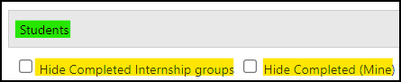  
  
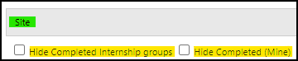

Also in the Students and Site sections, you’ll find helpful filters to assist in easily locating forms. These filter boxes are found under column headers. You can use these to search by Form Name, Category, Internship Group (which is the academic year and student level), Site/agency name (in case you work with more than one of our partner agencies), or Student Name.  
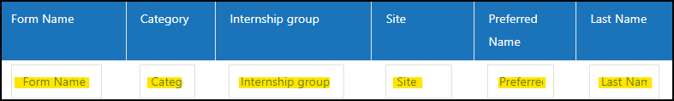

The Completed (Mine) column can be useful to help identify forms that you need to complete. To find forms you need to submit, simply enter a zero in the filter box of the Completed Mine column and the forms with 0 steps completed will populate, allowing you to easily access them for editing and submission.

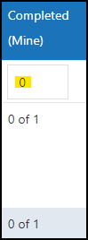

To open a form, simply click on the small paper icon in the far-right column.

The paper icon in the far-right column that opens a form for editing and submission.

The Completed (All) column is a quick indicator of how many steps in the form have been submitted by everyone who needs to do so. This can help you to see if students have submitted their portion of a form, which is generally step one for all forms requiring student submission.

This is a closeup of the Completed (Mine) column followed by the Completed (All) column. The numbers indicate that you have one step to complete in a two-step form where the student has already submitted step one:

A closeup showing the Completed Mine column is at 0 of 1 and the Completed All column is at 1 of 2.

For a fully completed form, these two columns will indicate that all steps have been submitted. The screenshot below shows a form that has 4 total steps. The Completed (Mine) column displays 1 of 1, meaning your one section has been actioned. The Completed (All) column displays 4 of 4, meaning the form has four total steps, and they have all been actioned.

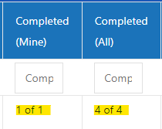

## Completing the Learning Agreement

### Function and Structure of the Learning Agreement

The Learning Agreement is a form that students, agency supervisors, and Faculty Internship Liaisons (FILs) sign to ensure that all parties understand the expectations of the internship. The Learning Agreement contains the Council on Social Work Education’s nine social work competencies and the corresponding practice behaviors that students are expected to exhibit throughout their internship. Students will write out their learning activities that they plan to complete in order to meet the listed practice behaviors.

The Learning Agreement is completed first for both the Fall semester and the Spring semester. As each semester nears its end, the Learning Agreement will be converted to the Internship Evaluation form. Both forms will be completed by following the same process.

Students will complete the Learning Agreement in one of two ways:

1. The student will complete the Learning Agreement with their agency supervisor(s) (Social Work Supervisor and Task Supervisor, if applicable).
2. The student will complete the Learning Agreement on their own then discuss the learning activities with their supervisor(s) so that they are agreed upon, making edits as needed.

Agency supervisors may use the Forms tab in their Sonia accounts to access the Learning Agreement to review changes saved by the student and/or make edits and suggestions to the Learning Agreement activities.

Additionally, an automated email with a link to the Learning Agreement will be sent to supervisors when students complete their first submission of the form. (*Please check your spam folder if you don’t see the email.)

Students, agency supervisors, and FILs will maintain communication to ensure that any edits to the Learning Agreement activities meet the required practice behaviors. All parties will also communicate in order to complete submission of the Learning Agreement by the stated deadline, which will be sent from the Office of Social Work Internships.

**We ask that all agency contacts add** [SWKinternships@metro.sonialive.com](mailto:SWKinternships@metro.sonialive.com) **to their Contacts/Safe Senders list so that automated messages from our Sonia database will be directed to your inbox and not your spam folder. We use this method of communication regularly and want to ensure that you don't miss any important messages from our office, including notifications about Learning Agreements and Internship Evaluations.**

**NOTE*:*** *In cases where a student has multiple supervisors (e.g.: Social Work Supervisor and Task Supervisor) they are both expected to review and contribute to the student’s Learning Agreement. The Task Supervisor and Social Work Supervisor each hold different knowledge and awareness of the student’s performance; the Task Supervisor has the most direct observation of the student’s practice, while the Social Work Supervisor holds awareness of professional social work competencies. Therefore, Task Supervisors and Social Work Supervisors will need to coordinate with each other and maintain communication while completing the agency portion of the Learning Agreement. Please use initials to indicate who has written which comments. Please do not delete another supervisor’s comments. While* ***edits to the form can be seen by all users in real time****, if both supervisors are working on the form simultaneously from different accounts, the most recent version of the form will be saved. Please coordinate your drafts so that no one’s feedback is left out of the Learning Agreement.*

### Accessing the Learning Agreement

There are two ways for supervisors to access a Learning Agreement.

1. When a student clicks on the Student Submit button in their Learning Agreement, a notification will be automatically generated to their Social Work Supervisor and Task Supervisor (if applicable). The notification email will contain a link that will take you directly to the Learning Agreement and will look similar to this:  
   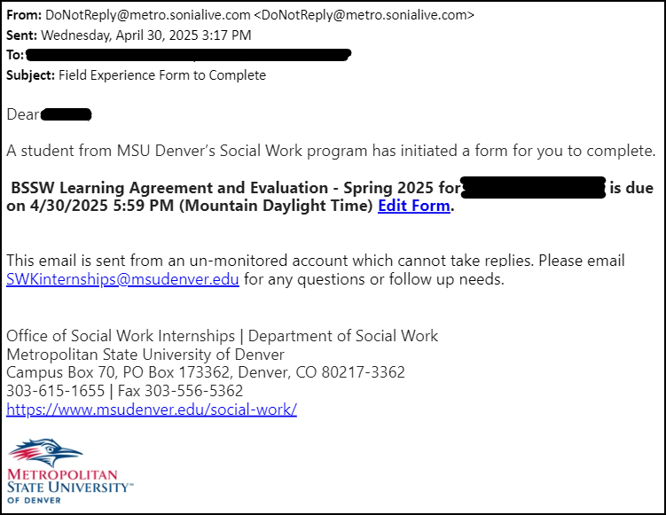
2. Agency contacts may access the Learning Agreement within their Sonia accounts. Simply log into [Sonia](https://metro.sonialive.com/School.aspx) and click on the “Forms” tab.  
   

You will see a list of forms that are associated with each of your students. You can use the Form Name search box to sort by entering Learning Agreement as a filter, then locate a specific student.

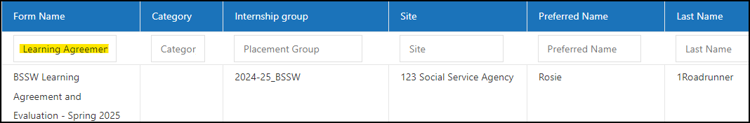

You can also filter to find students by name.  
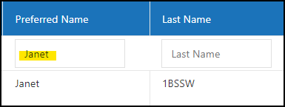

From the resulting list, locate the desired student for the current term.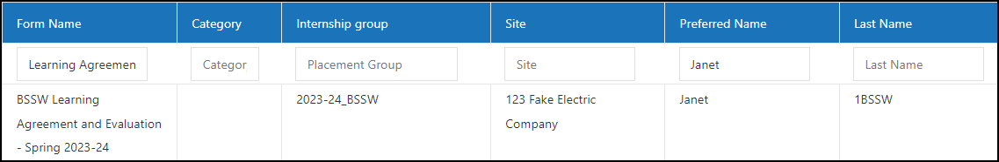

You may track the progress of the Learning Agreement form by looking at the “Completed” columns for any student in the Forms tab. The Completed (All) column shows how many of the total required steps of a form have been completed. If the Completed (Mine) column shows 0 of 1, this means that you have yet to complete your portion of the form, which would be appropriate until the student has made their first submission.

This screenshot shows that one form has been completed by you, with 1 of 1 indicated in the Completed (Mine) column. The second form is listed at 0 of 1, meaning that you have yet to submit your portion of the form. Use the small paper icon in the far-right column to open a form for editing and submission.

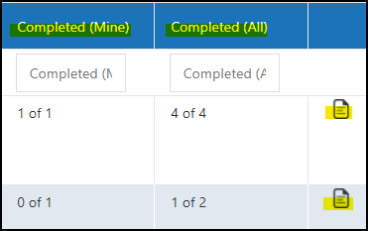  
Learning Agreements may be reviewed at any time from the Forms tab in your Sonia account by clicking on the paper icon in the far-right column.

### Completing the Agency Portion of the Learning Agreement

Whether you use the link sent via email or the Forms tab in your Sonia account, when you open the Learning Agreement, it will look similar to this:  
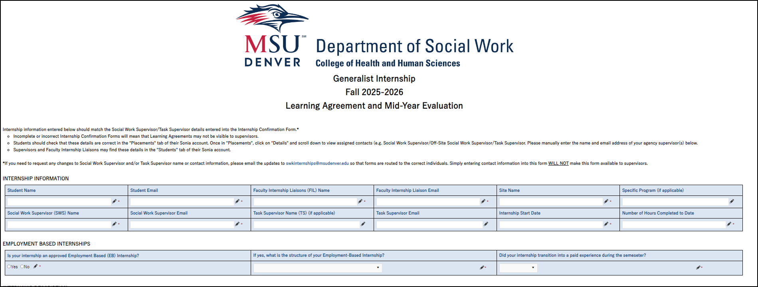

The Learning Agreement contains the nine Council on Social Work Education competencies and the listed practice behaviors that students are expected to exhibit throughout their internship. Under each competency, students will write the proposed learning activities and verifications that they plan to complete to meet the listed practice behaviors. These outlined learning activities will help both the student and you as the supervisor in completing the Internship Evaluation later in the semester.

**If there is more than one supervisor working with a student** (e.g.: a student has both a Social Work Supervisor and a Task Supervisor), supervisors will work together or take turns to review the different learning activities that students have added to the Learning Agreement. **If you are the first supervisor to review the form, please initial after your comments and click on the “Save Draft” button at the bottom of the form so the next supervisor may review it.**

The Save Draft button and the Agency Submit button. The Save Draft button is highlighted yellow for emphasis.

After the Learning Agreement has been reviewed by the supervisor(s) and any desired feedback has been added, you will check off that you have reviewed the form and indicate that you either approve of the form as-is or request the student to make modifications. The AGENCY SUBMIT button must be actioned (the form must be submitted) in order for an automated email to be sent to students to let them know you are requesting updates.

**NOTE:** *Please do not submit the form until* ***both*** *supervisors have had a chance to review it. Once the form is submitted, it is unable to be edited. If this should happen, please message* [*SWKinternships@msudenver.edu*](mailto:SWKinternships@msudenver.edu) *for assistance.*

After the Social Work Supervisor and the Task Supervisor (if applicable) have reviewed and approved the Learning Agreement, the final supervisor to review/add feedback will click the **Supervisor Submit button** to send a notification to the student to review their feedback:

The Save Draft button and the Agency Submit button. The Agency Submit button is highlighted yellow for emphasis.

Please contact the Office of Social Work Internships at  [SWKinternships@msudenver.edu](mailto:field@msudenver.edu) if you have questions or issues with the form.

** Please remember that if there is a change to a student’s agency supervisor (Social Work Supervisor or Task Supervisor), students must contact the Office of Social Work Internships at  [SWKinternships@msudenver.edu](mailto:field@msudenver.edu) and send the updated information. These changes must be made on the back end in Sonia, and the Office of Social Work Internships is happy to assist. If students do not notify our office, notifications and forms will not be available to the new supervisors. Simply **updating details in the Learning Agreement will not update Sonia and will not route forms to new supervisor(s).**

## Completing the

## Internship Evaluation

### Function and Structure of the Internship Evaluation

As we approach the end of each semester, the Learning Agreement form is converted to the Internship Evaluation form to ensure that the social work competencies have been met. This allows for evaluation and reflection on the part of the student as well as their supervisor(s).

The Internship Evaluation is processed by the student and their supervisor(s) in the same way as the Learning Agreement is earlier in the semester. (See previous section, Completing the Learning Agreement, for process details.)

Students, agency supervisors, and FILs will maintain communication to ensure that the Internship Evaluation is completed accurately. All parties will also communicate in order to complete submission of the Internship Evaluation by the stated deadline, which will be sent from the Office of Social Work Internships.

***NOTE:*** *In cases where a student has multiple supervisors (e.g.: Social Work Supervisor and Task Supervisor) they are both expected to review and contribute to the student’s Evaluation. The Task Supervisor and Social Work Supervisor each hold different knowledge and awareness of the student’s performance; the Task Supervisor has the most direct observation of the student’s practice, while the Social Work Supervisor holds awareness of professional social work competencies. Therefore, Task Supervisors and Social Work Supervisors will need to coordinate with each other and maintain communication while completing the agency portion of the Internship Evaluation. Please use initials to indicate who has written which comments. Please do not delete another supervisor’s comments. While* ***edits to the form can be seen by all users in real time****, if both supervisors are working on the form simultaneously from different accounts, the most recent version of the form will be saved. Please coordinate your drafts so that no one’s feedback is left out of the Evaluation.*

### Accessing the Internship Evaluation

There are two ways for supervisors to access the Internship Evaluation.

1. When a student clicks on the Student Submit button in their Internship Evaluation, a notification will be automatically generated to their Social Work Supervisor and Task Supervisor (if applicable). The notification email will contain a link that will take you directly to the Evaluation and will look similar to this:  
   
2. Agency contacts may access the Internship Evaluation within their Sonia accounts. Simply log into [Sonia](https://metro.sonialive.com/School.aspx) and click on the “Forms” tab.  
   

You will see a list of forms that are associated with each of your students. You can use the Form Name search box to sort by entering Evaluation as a filter, then locate a specific student.

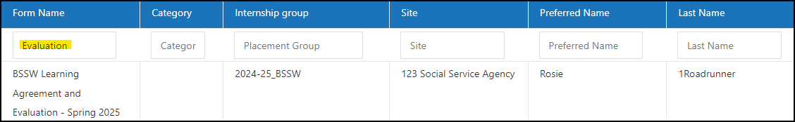

You can also filter to find students by name.  


From the resulting list, find the desired student for the current term.  
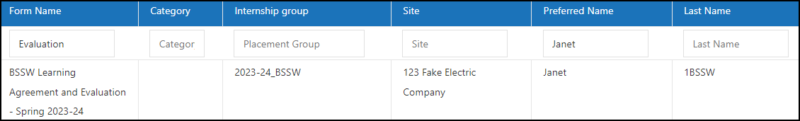

You may track the progress of the Evaluation form by looking at the “Completed” columns for any student in the Forms tab. The Completed (All) column shows how many of the total required steps of a form have been completed. If the Completed (Mine) column shows 0 of 1, this means that you have yet to complete your portion of the form, which would be appropriate until the student has made their first submission.

This screenshot shows that one form has been completed by you, with 1 of 1 indicated in the Completed (Mine) column. The second form is listed at 0 of 1, meaning that you have yet to submit your portion of the form. Use the small paper icon in the far-right column to open a form for editing and submission.

  
The rating legend for the Internship Evaluation is as follows; more details are contained on the form itself:

N/A – Not Yet Demonstrated (Only available in the Fall semester, with a plan to address in the Spring semester.)  
0 – No Competence Demonstrated

1 – Limited Competence

2 – Emerging Competence

3 – Developed Competence

4 – Strong Competence

5 – Full Competence

### Completing the Agency Portion of the Internship Evaluation

Social Work Supervisors and Task Supervisors will use the rating scale to rate the student’s performance on all practice behaviors associated with the nine social work competencies (included in the form) set forth by the Council on social Work Education (CSWE). Comments and observations are shared as rationale for the ratings selected. Specific instructions are contained in the Evaluation Form itself.

If there is more than one supervisor working with a student (e.g., student has both a Social Work Supervisor and Task Supervisor), supervisors will work together or take turns to review the student’s progress on each of the competencies’ practice behaviors.

**NOTE: Please do not click Supervisor Evaluation Submit until both supervisors (if applicable) have had a chance to review the form. Supervisors can continue to use the Save Draft button at the bottom of the form until after the Evaluation Conference with the student.**The Save Draft button and the Agency Submit button. The Save Draft button is highlighted yellow for emphasis.

**Edits to the form can be seen by all users in real time.**\*\* Please remember that if there is a change to a student’s agency supervisor (Social Work Supervisor or Task Supervisor), students must contact the Office of Social Work Internships at  [SWKinternships@msudenver.edu](mailto:field@msudenver.edu) and send the updated information. These changes must be made on the back end in Sonia, and the Office of Social Work Internships is happy to assist. If students do not notify our office, notifications and forms will not be available to the new supervisors. Simply **updating details in the Internship Evaluation will not update Sonia and will not route forms to new supervisor(s).**

### Internship Evaluation Conference and Submitting the Internship Evaluation

The student and their supervisor(s) will meet for an Evaluation Conference to discuss the results of the Internship Evaluation. If a student is working with both a Social Work Supervisor and a Task Supervisor, the Evaluation Conference will take place after both have reviewed the student’s Evaluation. All supervisors should save their review of the Evaluation as a draft until after the Evaluation Conference since actioning the Agency Submit button will not allow for any alterations to the form.

After completion of the Internship Evaluation Conference, the supervisor(s) will click on the “Agency Submit” button to finalize their portion of the Evaluation. This automatically sends a notification to the student to finalize their Evaluation.

#### ****We strongly recommend that supervisors wait until after the Evaluation Conference to click on the Agency Submit button in case they would like to make any changes prior to finalizing their ratings.****

#### The Save Draft button and the Agency Submit button. The Agency Submit button is highlighted yellow for emphasis.

If you have any questions or concerns about the student’s performance, please contact the student’s Faculty Internship Liaison (FIL). If you have any questions or concerns about the Internship Evaluation form or Sonia, please contact  [SWKinternships@msudenver.edu](mailto:field@msudenver.edu).