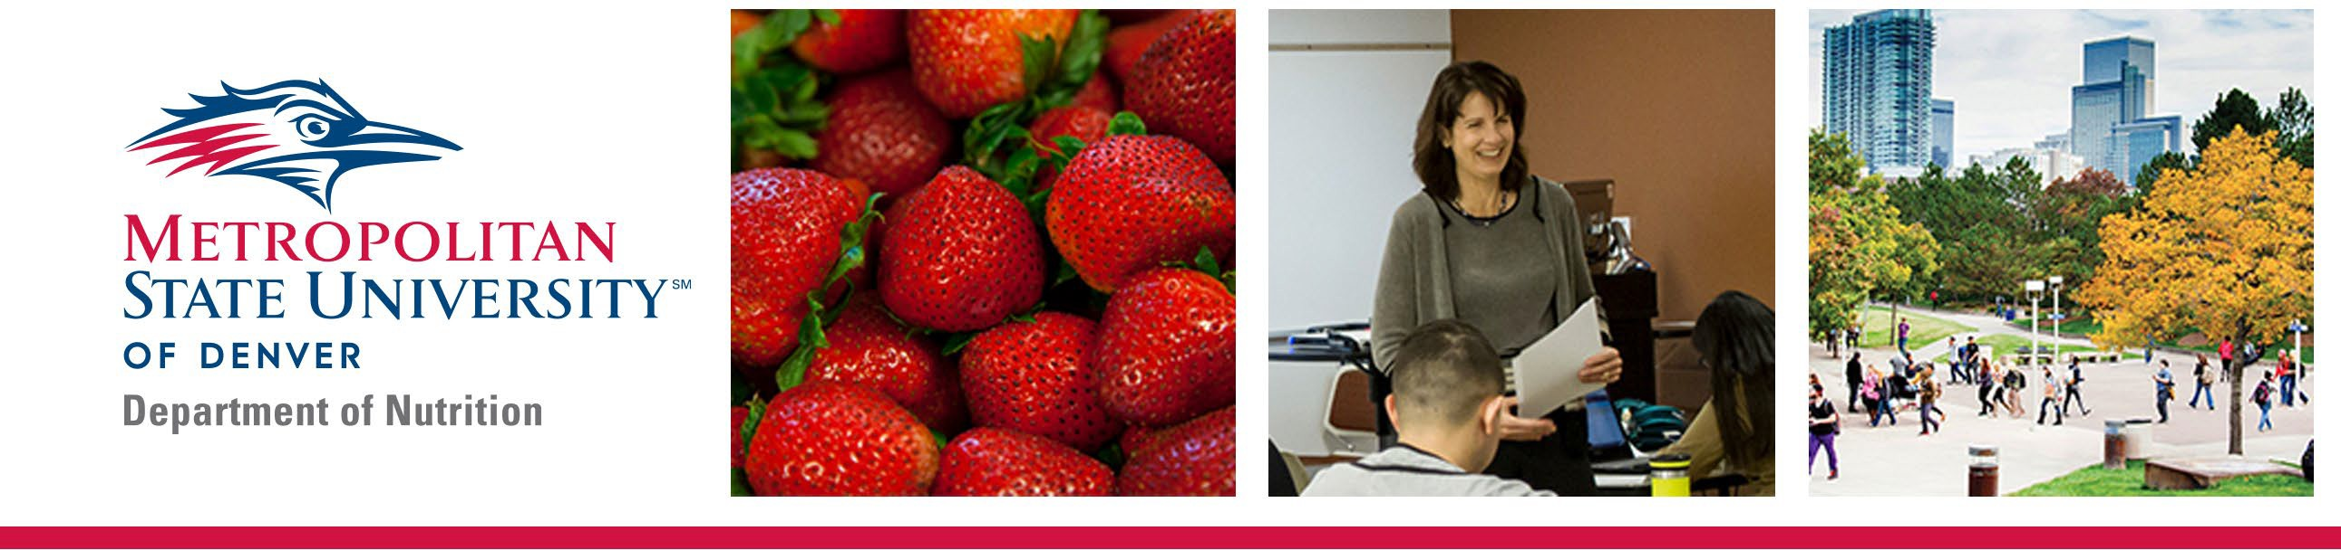Graduate Certificate in Nutrition Science

**Course Offerings & Advising Snapshot**

**Graduate Certificate Coursework**

The Graduate Certificate in Nutrition Science can be obtained through completing 12 credit hours of graduate level nutrition coursework at MSU Denver.

|  |
| --- |
| **Required courses for the Graduate Certificate include (6 credit hours):** |
| NUT 5110 Macronutrients in Health and Disease (3) |
| NUT 5120 Vitamins, Minerals, and Bioactive Compounds in Health and Disease (3) |

|  |
| --- |
| **Elective courses - select two of the following (6 credit hours required):** |
| NUT 5100 Introduction to Nutrition (3) |
| NUT 5130 Advanced Assessment and Intervention in Clinical Nutrition (3) |
| NUT 5140 Advanced Clinical Practice Topics (3) |
| NUT 5150 Lifecycle Nutrition (3) |
| NUT 5160 Empowered Leadership in Nutrition (3) |
| NUT 5170 Nutrition and the Community: Equity, Inclusion and Access (3) |
| NUT 5180 Food Systems and Policy (3) |
| NUT 5500 Global and Cultural Topics in Nutrition (3) |
| NUT 5510 Nutrition Counseling and Communication Strategies (3) |
| NUT 5520 Sports Nutrition (3) |
| NUT 6000 Graduate Nutrition Capstone I (1) |
| NUT 6010 Graduate Nutrition Capstone II (1) |
| NUT 6020 Graduate Nutrition Capstone III (1) |

Metropolitan State University of Denver | Department of Nutrition | WC 254

Phone: 303-615-0990 | Email: [gradnutrition@msudenver.edu](mailto:gradnutrition@msudenver.edu)

Coursework for the Graduate Certificate in Nutrition Science can be completed in as little as 8 months. All coursework must be completed within a 5-year timeframe. Courses completed in the Graduate Certificate in Nutrition Science can be used in the Master of Science of Nutrition, however completing the graduate certificate does not guarantee admissions into the Master of Science in Nutrition.

**Program Curriculum**

Curriculum in the Graduate Certificate in Nutrition Science focuses on providing advanced nutrition education tailored to current RDN's, healthcare professionals, and individuals looking to grow personally or professionally through graduate level study.

Courses are offered in 8-week blocks and delivered in hybrid format. Hybrid format partners the best of online education and face-to-face learning. Engaging in the classroom with peers and faculty members will deepen your learning experience, broaden your perspective, and strengthen your professional network. Completing components of each course online will provide flexibility and allow us to meet your needs as a busy individual.

|  |  |  |  |  |  |  |
| --- | --- | --- | --- | --- | --- | --- |
|  | **Course** | **Title** | **Prerequisite** | **Fall** | **Spring** | **Summer** |
| **Required** | NUT 5100 | Introduction to Nutrition Research |  | **X** | **X** |  |
| NUT 5110 | Macronutrients in Health and Disease |  | **X** | **X** |  |
| NUT 5120 | Vitamins, Minerals, and Bioactive  Compounds in Health and Disease | NUT 5110 | **X** | **X** |  |
| NUT 5130 | Advanced Assessment and Intervention in Clinical Nutrition | NUT 5120 | **X** | **X** |  |
| NUT 5140 | Advanced Clinical Practice Topics | NUT 5130 | **X** | **X** |  |
| NUT 5150 | Lifecycle Nutrition |  | **X** | **X** |  |
| NUT 5160 | Empowered Leadership in Nutrition |  |  |  | **X  (Maymester)** |
| NUT 5170 | Nutrition and the Community: Equity, Inclusion and Access |  | **X** | **X** |  |
| NUT 5180 | Food Systems and Policy* |  | **X** | **X** |  |
| NUT 6000 | Nutrition Research Capstone | NUT 5100 | **X** | **X** |  |
| NUT 6010 | Nutrition Research Capstone II | NUT 6000 | **X** | **X** |  |
| NUT 6020 | Nutrition Research Capstone III | NUT 6010 | **X** | **X** |  |
| **Electives** | NUT 5140 | Advanced Clinical Practice Topics | NUT 5130 | **X** | **X** |  |
| NUT 5180 | Food Systems and Policy |  | **X** | **X** |  |
| NUT 5500 | Global and Cultural Topics in Nutrition |  |  |  | **X  (Even Summers)** |
| NUT 5510 | Nutrition Counseling and Communication Strategies |  |  |  | **X (Odd Summers)** |
| NUT 5520 | Sports Nutrition |  |  |  | **X** |