How to format a successful Early Bird article
The Early Bird operates much like a newspaper, and articles are formatted as new stories. To ensure your messaging aligns with the Early Bird editorial style and connects with readers, we recommend the following formatting:
Headline: Keep it short, direct and compelling.
Subhead: One line of additional information that provides valuable or necessary context, further entices people to read or click.
Example 1:
Hed: Nominations open for Roadrunners Who Soar Awards
Sub: Honorees and their nominators will receive invitations to the spring ceremony, where awardees will be recognized.
Example 2:
Hed: MSU Denver welcomes Camille Torres, J.D., as interim Equal Opportunity director
Sub: Torres specializes in Title IX and workplace policy compliance as well as employment and labor law.
Byline: Generally, Early Bird stories include an author. Stories can include several authors, if necessary, but cannot be attributed to a whole team or department. Please also keep in mind that WordPress limits character count, so identifying just one or two authors is preferred.
Lead paragraph: Please include the most critical info — the who, what, when, where, why and how — within the first 1-2 lines of your article. Ensure all details are confirmed before submission to the Early Bird.
Example 1:
Nominations are being accepted for the 2023 Roadrunners Who Soar Awards and the Team Roadrunner Awards. These awards honor and celebrate outstanding individual employees and leaders as well as cohesive and high-performing teams.
Example 2:
Metropolitan State University of Denver is pleased to welcome Camille Torres, J.D., to the campus community. She will serve as interim director of the Office of Equal Opportunity, Title IX director and Americans With Disabilities Act (ADA) coordinator. Torres replaces Raul Sanchez, who departed last month.
Body: What else is important for readers to know or understand? This is the area to provide quotes or additional details and context.
Read more of Example 1
Read more of Example 2
Additional Info: Generally, the Early Bird uses this space to point readers toward additional resources and information. Ideally, this would be an internal University webpage or sometimes a link to the page of a University partner. This area can also identify a specific contact for more information.
Read more of Example 1
Read more of Example 2

This follows the traditional inverted pyramid structure of journalism:
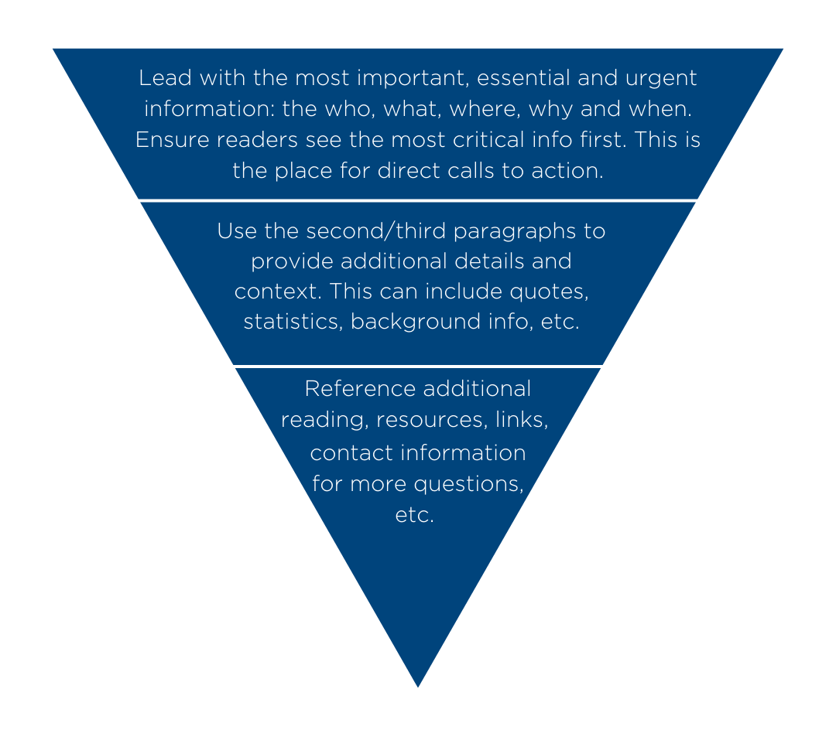Best practices:
- Use plain language, avoid jargon and acronyms.
- Think from the perspective of your audience. Assume they are not familiar with your topic.
- Provide any relevant links and ensure that they are active and lead to correct information.
- If you are submitting on behalf of your team/department/senior leader, make sure the information has been reviewed and approved prior to submittal.
- Please make any requests at least one week before your preferred publishing date, and understand that your request may not be accommodated if the Early Bird calendar is full on a specific date.
Other good examples to reference:

How to survive cold, flu and Covid-19 season

Meet the University Compliance Committee

New reflection space promotes greater inclusion

A new Workday resource for managers

Catch up on MSU Denver policies in the works

