MSU Denver EDW Student Report Catalog

Last Modified: 7/18/2023

If you have any questions, comments, or suggestions
please follow the link to our webpage. You can
request reports and find contact information there.
https://www.msudenver.edu/enterprise-data-warehouse/

Contents
Report Catalog General Information 1
Academic Departments 3
Art: Art Department Accreditation Report 3
Computer Science: CS1050 Placement 5
Computer Science: Other CS/CSS Placement Reports 6
Computer Science: CS2400 Placement (Dr. Zhu) 7
Computer Science: Other CS (Dr. Zhu) Placement Reports 8
Math: Math Pre-Requisite Report by Term 9
Math: MTH1080 Placement 10
Math: Other MTH Placement Reports 11
Theatre: Theatre Accreditation Report 12
Admissions 14
Active Students Not Registered 14
Admission Application Trend 15
Admissions Dashboard 16
Admissions Report (Dashboard Link) 17
Admissions Report_Alternate Registered Term 20
Admitted (Registered) Students Profile 23
Application Weekly Report 24
Application Weekly Report_Detail 29
Application Weekly Report_GR 30
CBUS Graduate Program Admits 33
EAB Final Check – Inactive Students 35
Eligible to Enroll but Not Enrolled 36
New Students Admitted in Last 7 Days Reports 37
New to MSU Denver 38
Orientation Report 39
Advancements 40
CAMP (College Assistance Migrant Program) Report 40
HI Prospecting: Medical Professional Prereq Non-Degree Students_SplitTab 41
Student Prospecting List by Course and Faculty 42
Advising 43
College Transfer Success Tracking 43
Course and Prerequisites 44
English Major Minor Concentration Count 45
English Registered Students Report (1001, 1008, 1009, 1010, 1020, and 1021) 47
First Term GPA vs HS GPA 48
Student Academic Standing by Term – Last 5 Years 49
Student Honor Potential 50
Transfer Repeated Courses 51
Aggregated Data with no Detail 52
Demographics by Degree Program and Low Income 52
Annual Reports 54
CHAS Grant 54
Departmental Data – Credit Hour Production 55
Program Data – Major Code 57
Student Detail List 62
Athletics 64
Graduation Status Description – All Sports 64
Student Athlete Courses and Grades 65
Student Athlete Eligibility Report 66
Student Athlete Majors and Cipcodes 67
Student-Athlete Average Credit Hours 68
Chair Reports and Dashboards 70
Chair Dashboard – Enrollment – 5 Year Trend 70
Chair Dashboard – Program – 5 Year Trend 74
Chair Dashboard – Retention – 5 Year Trend 77
Chair Dashboard – Scheduling – 5 Year Trend 79
CHP-FTES-Headcount 82
7 Year Operational Report - FTES and CHP 82
7 Year Operational Report – Student Headcount 85
Billing Hour Production at Census Date 88
Credit Hour Production at Census Date 89
Credit Hour Production at End of Term 90
I&LL CHP by Term 92
Student Enrollment Count - Census 95
Student Headcount by Major – Date to Date Comparison 97
Student Headcount by Major (Drill to Concentration) 98
Student Headcount by Minor 100
Course Subject and Class 101
Back to Back Classes 101
CBUS Course List by Term 102
Course Coding Audit 103
Course Delivery Method Summary 104
Course Enrollment by Subject 106
Course Info by Class Location 108
Course Overrides by Date 109
Detail Code by Semester 111
Enrollment Details by Course Attribute with Waitlist 112
Enrollment Details by Course with Waitlist 114
Potential Course Demand 116
Seat Availability Report 117
Student Class Lists by Term and Subject 118
Student Listing by Class (Drill to Report) 120
Student Listings by CRN (Drill to Report) 121
Student Withdrawals by Course After Census 122
Student Withdrawals by Course After Census_All Students 123
Student Withdrawals by Course After Census_Student Detail 124
Students That Have Not Taken Course 125
Tuition and Fee Waiver Courses 126
Waitlist Priority Report 127
Denver Scholarship Foundation 128
Campus Advising – Scholarship Foundation 128
Exception Reporting 130
Fall 2017 PS Courses 130
Total Student Counts Exception 131
College: Courses without a Primary Instructor Assigned 132
College: Major Change Report 133
Ellen’s Exceptions: GED & High School with Transfer Information 134
Ellen’s Exceptions: GED with High School Information 135
Ellen’s Exceptions: Grad Courses missing NCOF 136
Ellen’s Exceptions: Major Cd with Incorrect Program Exception 137
Ellen’s Exceptions: Major with Incorrect Degree Type 138
Ellen’s Exceptions: Primary Major with Incorrect College 139
Ellen’s Exceptions: Secondary Curriculum Exception 140
Registrar’s Office: Prerequisites Error and Description Report 141
Grade / Ranking Reports 142
Grade Report with Faculty Tab 142
Grades Report 144
Grades Report – with Course Summary + Unmerged Tabs 146
Grades Report by Delivery Method 149
Grades Report with Course Attributes 150
PLACE / PRAXIS Scores 151
PRAXIS Licensure Test Scores 152
Student Class Listing with Final Grade 154
Student Class Ranking 155
Graduate Programs 156
7 Year Operational Report – FTES and CHP_GR 156
7 Year Operational Report – Student Headcount_GR 159
Admissions Dashboard 161
Admitted (Registered) Students Profile_GR 162
Credit Hour Production at Census Date 163
Graduation Report by Term_GR 164
Registration Dashboard 165
Retention Dashboard 166
Retention Report_GR 167
Graduation 168
Graduation Report by Term 168
Graduation Report by Term for Transfer Students 169
Graduation Report by Term with Student Address 170
Graduation Report by Term with Student Address and Name Split 171
Pending Grads Repeat Courses 173
Honors Program 174
Honors Program – Recruiting (Active Students) 174
Honors Program – Recruiting (New Applications) 175
Honors Program List 177
Master List- Honors Program 179
Registration Dashboard – Honors Program 181
Retention Report - Optional Student Attribute 182
P2P Program 184
P2P Program Report 184
Registration 187
Active Students Not Registered by Term 187
Course Registration Dashboard 188
Drop All and Withdraw All 189
Enrollment by Term w/ Expected Grad Date 190
Registered Students by Credit Hours 191
Registered Students by Credit Hours - UG 192
Registered Students by Credit Hours – UG_less than 12 193
Registered Students by Credit Hours with Total Earned Hours 194
Registered Students by Field of Study 195
Registered Students by Location 196
Registration Activity by Date 197
Registration Dashboard 198
Registration Dashboard – 15 Year Trend 199
Registration Report – Multi-Select Term 201
Registration Report (Dashboard Link) 203
Registration Report with Citizenship_1st Student Type and 1st Term Reg 205
Registration Status by Date 207
Registration Trends by Day (Registration Start, Term Start, Census) 208
School District Student Totals Report 210
Student Hold Status for Registered Term 211
Student Registration Status by Advisor 212
Student Registration Status by Course & Instructor 213
Students by Priority Registration Group 215
Students Registered for an Online Course 216
Test Score Report 217
Transfer Credit Hours – GR 218
Retention 219
Retained Students by Primary Major – Term to Term 219
Retention Dashboard 220
Retention Report 221
Retention Report_Cert_License 224
Retention Students by Primary Major – Term to Term_GR 225
Retention Students by Primary Major – Term to Term_UG 226
Retention Report_GR 227
Retention Report_UG 228
South Campus 229
Welcome Letter Registration Report 229
Student Profile 230
Academic Suspension Appeal Report_NEW 230
Admit Term by Citizenship Type 232
Admitted (Registered) Students Profile 233
CBUS MPAcc Recruitment Report 234
CHAS Graduate Students by Previous Degree 236
Courses with High Enrollment of Students of Color 237
Enrolled Students by Citizenship Type 239
HRSA-HND Grant Report 240
Individual Student Profile 241
Languages Spoken by MSU Denver Students 243
Major Code with Student Class (Time Status) 244
MBA and ACCM Student Profile 249
Non-Online Majors with Online Only Courses in Back to Back Terms 251
Online Program Student Profile 252
Student Attribute 253
Student Profile by High School 254
Student Success Tracking: Courses with Pro-Tips vs Courses without Pro-Tips 260
Students with Active Address (Registered) 262
Students in Education Program by Term 263
Title II 264
Teaching Assistant Program 265
Fall 2020 Teacher Assistant Course Student Retention 265
Fall 2021 Teacher Assistant Course Student Retention 268
Fall Teaching Assistant Retention (Fall 2020, Fall 2021) 270
Spring 2021 Teacher Assistant Course Student Retention 272
Spring 2021 Teaching Assistant Retention 274
Student Email List by CRN 276
TA Course Student Demographics 277
TA Demographics 280
Teaching Assistant and Teacher Assistant Course Student Retention 283
Transfer 285
Official Transfer Evaluation 285
Transfer Catalog by Institution 286
Transfer Courses by Subject and Attributes 288
Transfer Equivalent Course by Institution 289
Transfer Students Report by Transfer School 290
Veteran 291
ArmyIgnitED – Course Enrollment Report 291
ArmyIgnitED – Grades Report 292
SALUTE Eligible Veterans 293
VA 85/15 Report by Term - Sponsored vs Non-Sponsored 294
Veteran Graduates 295
Veteran Graduates with Benefits 296
Veteran Profile – Multiple Terms 297
Veteran Profile Report 299
Veterans Certified Credit Hours 301
Veterans in Modules and Internships 302
Glossary 303

Report Catalog General Information
This catalog was created to provide information on EDW reports that have been developed and put into production.
Prompt Page: For almost every report you run, the first page you will see is the Prompt Page. This page will ask you to set the main parameters for the report you are running. Examples would be Term, Academic Year, etc. If there is an asterisk (*) next to the prompt then it is a required prompt and a value must be entered. If you select the “Refresh Values” button, a list of acceptable values for that specific prompt will be listed. The available parameters for the prompts are listed in each report.
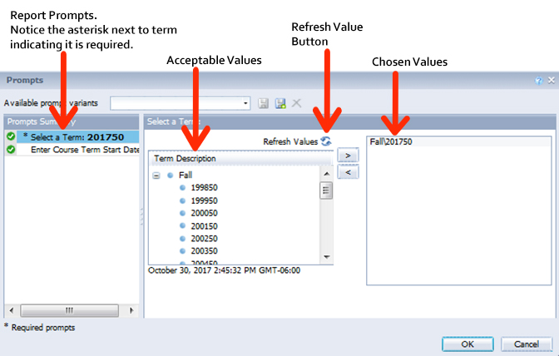
Prompt Input Control: Within the report itself you can still adjust the Prompt variables.
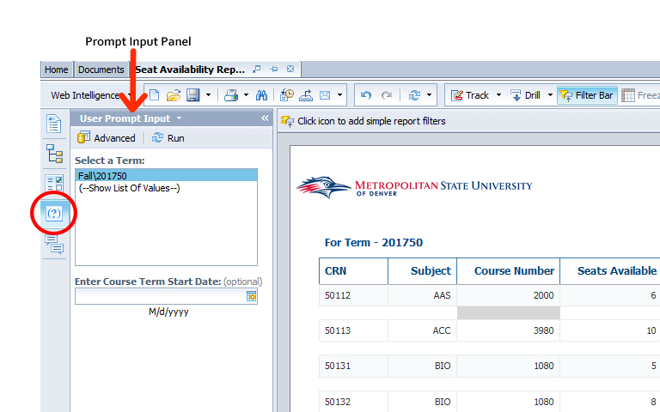
Input Controls: Input controls are located on the left side of the report. These controls allow you to customize certain aspects of the report by being able to select some or all data elements. In the example below, you can put in a specific Student ID, and you can select some or all Fund Cd, Award Status Cd and Fund Type Cd. The Input Controls are listed in each report.
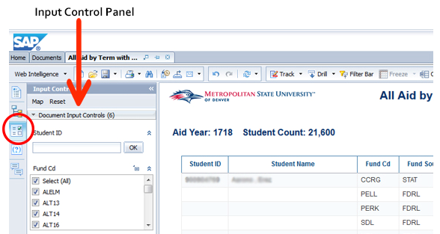
Data Shown in Reports: The data shown in the reports is current as of the Data Refresh Date located in the upper right-hand corner of every report page. For the current term the data shown in the report reflects the data as of the Data Refresh Date. For all past terms, the data shown in the reports is end of term data unless otherwise specified in the report.

Academic Departments

Art: Art Department Accreditation Report
Description: Displays aggregated headcounts and CHP for all active Art Major (ART, ARTE, ARTH, CDES, IND) students. The report contains three tables one for headcounts over two user selected terms displayed by the Degree Code (BA, BFA, or UNDD). Another table which displays the current term's headcount for by Race, Gender and Degree Code. The third table displays CHP for all Art courses (Prefixes: ART, ARTE, ARTH, CDES, and IND) for a user selected academic year by Art Majors and Non-Art Majors. The data in this report is used to enter data in the Art accreditation system.
Data Elements: Primary Major Code, Primary Major, Primary Concentration, Degree Code, Term Code, Race, Gender, Academic Year, Student Count, Credit Hour Production (CHP)
Source: Student Admission and Enrollment Universe
Location: Public Folders Academic Departments Art Art Department Accreditation Report
Prompts Page: Primary Major Code (required), Term Code (required), Academic Year (required)
Input Controls: None
Report Page:
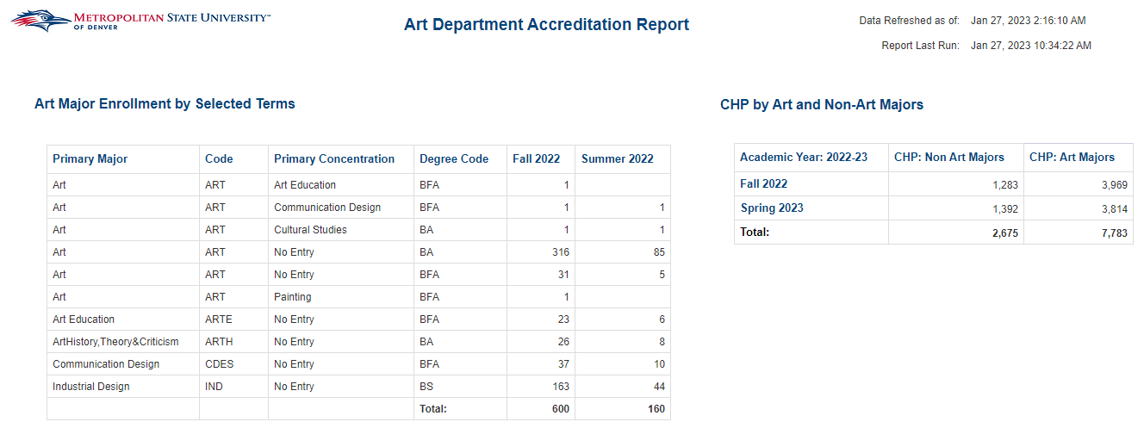
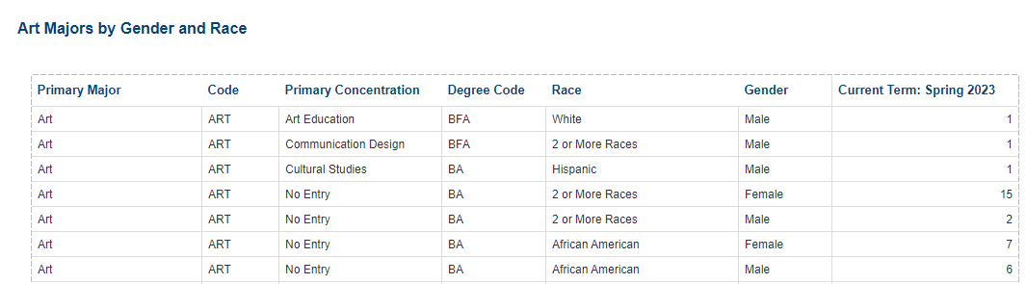
Report Page (Cont.):
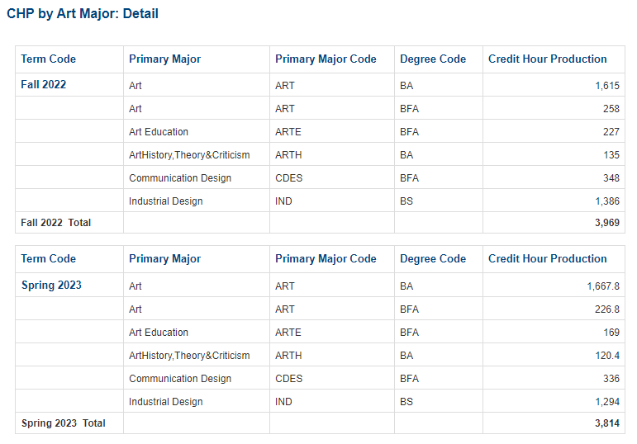

Computer Science: CS1050 Placement
Description: Displays Active Students enrolled in CS1050, and their prerequisites completed in advance of the course. Also includes header information that provides details about the selected course.
Data Elements: Student Name, Student ID, Examinations and/or Classes
Source: Student Admission and Enrollment Universe
Location: Public Folders Academic Departments Computer Science CS1050 Placement
Prompts Page: Term Cd (required)
Input Controls: CRN – Instructor, Student Name
Report Page:
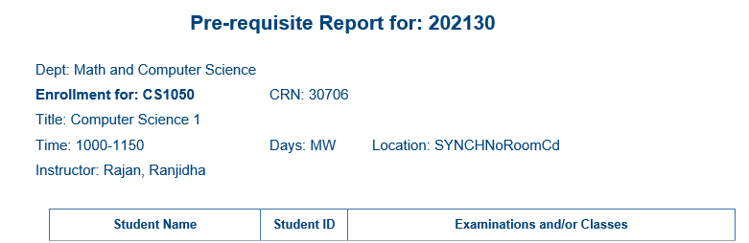

Computer Science: Other CS/CSS Placement Reports
Description: Displays Active Students enrolled in the course specified in the title, and their prerequisites completed in advance of the course. Also includes header information that provides details about the selected course.
Data Elements: Student Name, Student ID, Examinations and/or Classes
Source: Student Admission and Enrollment Universe
Location: Public Folders Academic Departments Computer Science CS#### Placement
Prompts Page: Term Cd (required)
Input Controls: CRN – Instructor, Student Name
Report Page: (From CSS2751 Placement)
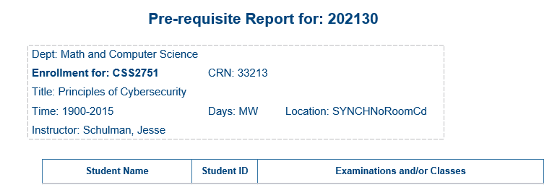

Computer Science: CS2400 Placement (Dr. Zhu)
Description: Displays Active Students enrolled in CS2400, and their prerequisites completed in advance of the course. Also includes header information that provides details about the selected course.
Data Elements: Student Name, Student ID, Gender, Race/Ethnicity, Age at Census, Student Type, Student Class, Primary Major, Primary Minor, Cumulative GPA, Examinations and/or Classes
Source: Student Admission and Enrollment Universe
Location: Public Folders Academic Departments Computer Science CS2400 Placement (Dr. Zhu)
Prompts Page: Term Cd (required)
Input Controls: CRN – Instructor, Student Name
Report Page:
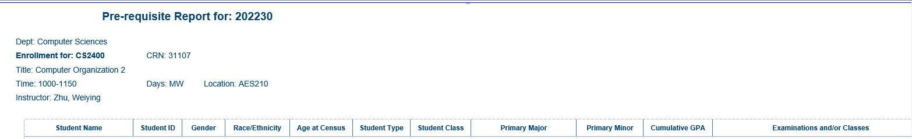

Computer Science: Other CS (Dr. Zhu) Placement Reports
Description: Displays Active Students enrolled in the course specified in the title, and their prerequisites completed in advance of the course. Also includes header information that provides details about the selected course.
Data Elements: Student Name, Student ID, Gender, Race/Ethnicity, Age at Census, Student Type, Student Class, Primary Major, Primary Minor, Cumulative GPA, Examinations and/or Classes
Source: Student Admission and Enrollment Universe
Location: Public Folders Academic Departments Computer Science CS#### Placement (Dr. Zhu)
Prompts Page: Term Cd (required)
Input Controls: CRN – Instructor, Student Name
Report Page: (From CS3750 Placement (Dr. Zhu))
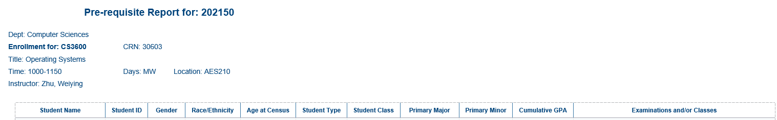

Math: Math Pre-Requisite Report by Term
Description: Displays Active Students enrolled in a specific course, and their prerequisites completed in advance of the course. Also includes header information that provides details about the selected course.
Data Elements: Student Name, Student ID, Coursework
Source: Student Admission and Enrollment Universe
Location: Public Folders Academic Departments Math Math Pre-Requisite Report by Term
Prompts Page: Term Cd (required), CRN
Input Controls: None
Report Page:

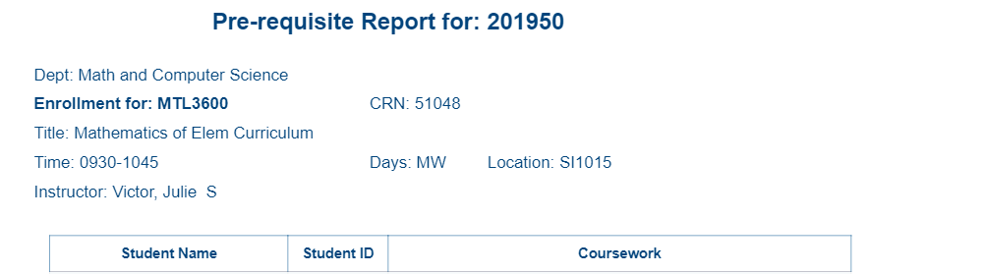

Math: MTH1080 Placement
Description: Displays Active Students enrolled in MTH1080, and their prerequisites completed in advance of the course. Also includes header information that provides details about the selected course.
Data Elements: Student Name, Student ID, Coursework
Source: Student Admission and Enrollment Universe
Location: Public Folders Academic Departments Math MTH1080 Placement
Prompts Page: Term Cd (required), CRN
Input Controls: None
Report Page:

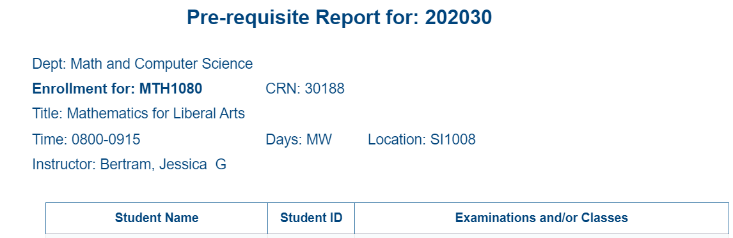

Math: Other MTH Placement Reports
Description: Displays Active Students enrolled in the course specified in the title, and their prerequisites completed in advance of the course. Also includes header information that provides details about the selected course.
Data Elements: Student Name, Student ID, Coursework
Source: Student Admission and Enrollment Universe
Location: Public Folders Academic Departments Math MTH#### Placement
Prompts Page: Term Cd (required), CRN
Input Controls: None
Report Page:

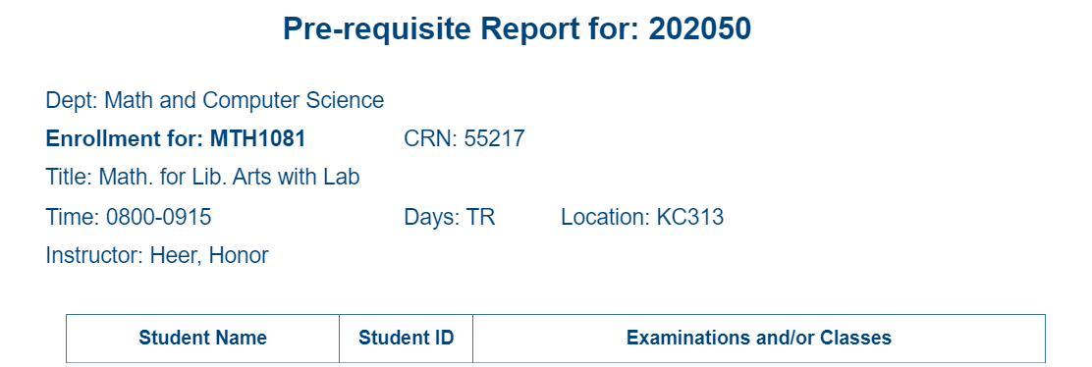

Theatre: Theatre Accreditation Report
Description: Displays aggregated headcounts and CHP for all active Theatre Major students. The report contains three tables one for headcounts over two user selected terms displayed by the Degree Code (BA, BFA, or UNDD). Another table which displays the current terms headcount for by Race, Gender and Degree Code. The third table displays CHP for all Theatre courses for a user selected academic year by Theatre Majors and Non-Theatre Majors. The data in this report is used to enter data in the Theatre accreditation system.
Data Elements: Primary Major Code, Primary Major, Primary Concentration, Degree Code, Term Code, Race, Gender, Academic Year, Student Count, Credit Hour Production (CHP)
Source: Student Admission and Enrollment Universe
Location: Public Folders Academic Departments Theatre Theatre Accreditation Report
Prompts Page: Primary Major Code (required), Term Code (required), Academic Year (required)
Input Controls: None
Report Page:
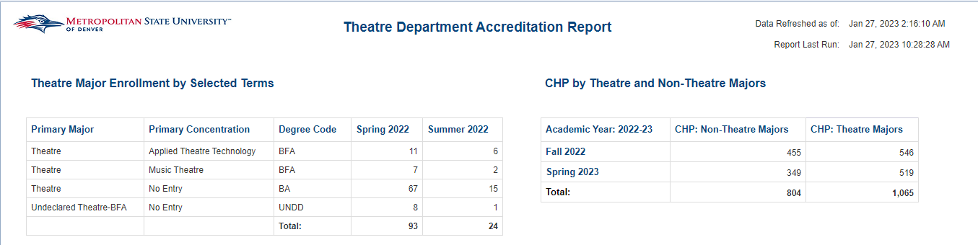

Report Page (Cont.):
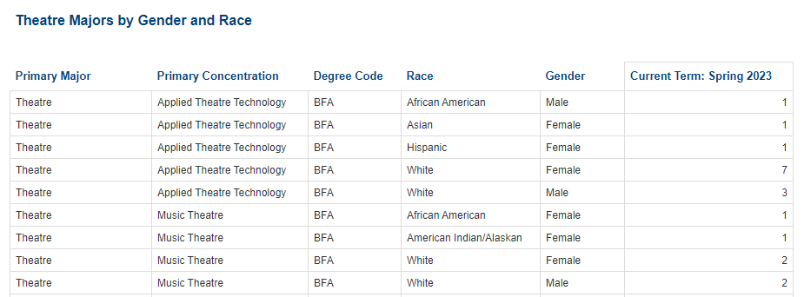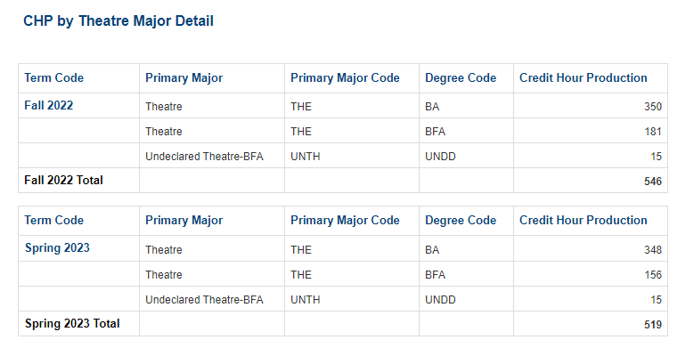

Admissions

Active Students Not Registered
Description: Displays Active Students not yet registered for a specific term. The report is grouped by College and Department and is sorted alphabetically by student. Using the Input Controls (listed below) you can select single or multiple Colleges, Majors, Departments and Student Types.
Data Elements: Student ID, Name, Gender, Race, Student Level, Primary Major, Student Type Group, Residency Status, Registered, Enrolled
Source: Student Admission and Enrollment Universe
Location: Public Folders Admissions Active Students Not Registered
Prompts Page: Term (required)
Input Controls: College, Major, Department, Student Type
Report Page:

Admission Application Trend
Description: This report lists all applied and accepted students for a given term. The report is sorted by Student ID.
Data Elements: Intended Entry Term, Student ID, First Name, Last Name, Race, State, Zip Code, Admission Type, Student Type, High School, Major Code, Major, Decision Code, Decision, Registered Indicator, Application Date
Source: Student Admission and Enrollment Universe
Location: Public Folders Admissions Admission Application Trend
Prompts: Term (required)
Input Controls: College, Major, Student Type, Registered Indicator, High School.
Report Page:

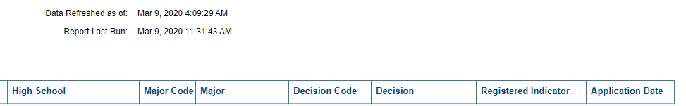

Admissions Dashboard
Description: The dashboard covers Applied, Accepted and Registered Students for a given term.
Data Elements: Applied, Accepted, Registered by College, Department, Major, Admission Type, Student Level, Gender, Race, Age, Residency Status, Financial Aid, High School, High School GPA, ACT & SAT Scores, Transfers from 2 or 4 Year Institutions.
Source: Student Admission and Enrollment Universe
Location: Public Folders Admissions Admission Dashboard
Prompts: None
Input Controls: None
Report Page:
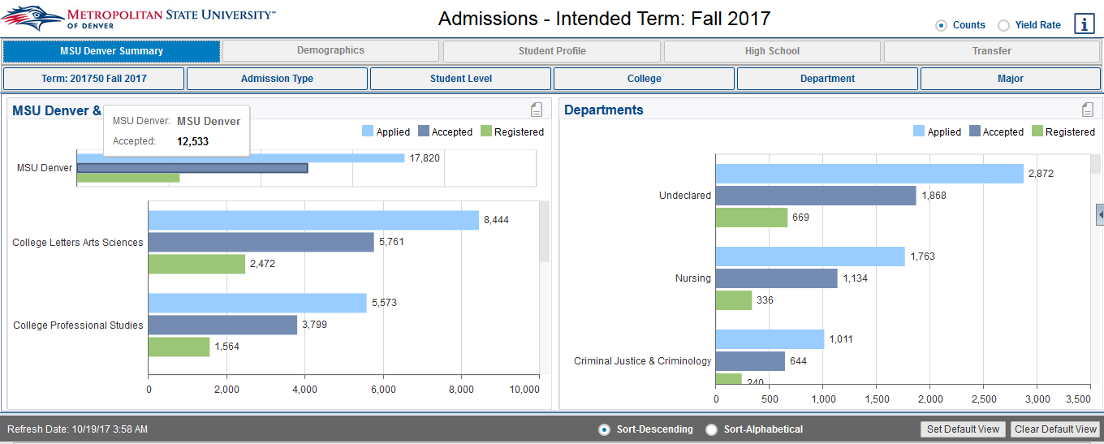

Admissions Report (Dashboard Link)
Description: Displays the number of students that have applied, were accepted and registered for a given entry. There are 7 separate reports: Summary, Demographics, High School, Residency, Transfer, Transfer Credits, and Summary with Alt Email.
Data Elements:
- Summary: Student ID, Student Name, Email, Intended Entry Term, Admission Type, Student Level, College, Department, Major, Last Decision, Applied Indicator, Accepted Indicator, Registered Indicator, Applied, Accepted, Registered
- Demographics: Student ID, Student Name, Intended Entry Term, Admission Type, Student Level, College, Department, Major, Race, Gender, Last Decision, Applied Indicator, Accepted Indicator, Registered Indicator
- High School: Student ID, Student Name, Intended Entry Term, Admission Type, Student Level, College, Department, Major, High School, High School GPA, Test Code, Test Description, Test Score Numeric, Last Decision, Applied Indicator, Accepted Indicator, Registered Indicator
- Residency: Student ID, Student Name, Intended Entry Term, Admission Type, Student Level, College, Department, Major, Residency Classification, Last Decision, Applied Indicator, Accepted Indicator, Registered Indicator
- Transfer: Student ID, Student Name, Intended Entry Term, Last Decision, Applied Indicator, Accepted Indicator, Registered Indicator, Admission Type, Student Level, College, Department, Major, School Location Type, School Type Description, School Name
- Transfer Credits: Student ID, Student Name, Intended Entry Term, Accepted Indicator, Registered Indicator, Major, School Name, Accepted Credit Hours, Cumulative Accepted Credit Hours
- Summary with Alt Email: Student ID, Student Name, MSU Student Email, Student Email – Alt, Intended Entry Term, Admission Type, Student Level, College, Department, Major, Last Decision, Applied Indicator, Accepted Indicator, Registered Indicator, Applied, Accepted, Registered
Source: Student Admission and Enrollment Universe
Location: Public Folders Admissions Admissions Report (Dashboard Link)
Prompts: Intended Entry Term, Admission Type Description, Primary Current Level, College, Department, Primary Major, Student Type
Input Controls: First Term Registered, Admission Type Desc., Student Level, Student Type, College, Department, Major
Report Page: This report has 7 reports
Tab 1 Summary:
Tab 2 Demographics:
Tab 3 HighSchool:
Tab 4 Residency:

Tab 5 Transfer:
Tab 6 Transfer Credits:

Tab 7 Summary with Alt Email:

Admissions Report_Alternate Registered Term
Description: The report compares the number of students that have applied, were accepted and registered for a given entry term to the number of students from the same entry term that registered in subsequent terms. There are 7 separate reports: Summary, Demographics, High School, Residency, Transfer, Transfer Credits, and Summary with Alt Email.
Data Elements: Different repot tabs have
- Summary: Student ID, Student Name, Student Type, Email, Intended Entry Term, First Term Registered, Admission Type, Student Level, College, Department, Major, Last Decision, Applied, Accepted, Registered
- Demographics: Student ID, Student Name, Student Type, Intended Entry Term, First Term Registered, Admission Type, Student Level, College, Department, Major, Race, Gender, Last Decision, Applied, Accepted, Registered
- High School: Student ID, Student Name, Student Type, Intended Entry Term, First Term Registered, Admission Type, Student Level, College, Department, Major, High School, High School GPA, Test Code, Test Description, Test Score Numeric, Last Decision, Applied, Accepted, Registered
- Residency: Student ID, Student Name, Student Type, Intended Entry Term, First Term Registered, Admission Type, Student Level, College, Department, Major, Residency Classification, Last Decision, Applied, Accepted, Registered
- Transfer: Student ID, Student Name, Student Type, Intended Entry Term, First Term Registered, Last Decision, Applied, Accepted, Registered, Admission Type, Student Level, College, Department, Major, School Location Type, School Type Description, School Name
- Transfer Credits: Student ID, Student Name, Student Type, Intended Entry Term, First Term Registered, Accepted Indicator, Registered Indicator, Major, School Name, Accepted Credit Hours, Cumulative Accepted Credit Hours
- Summary with Alt Email: Student ID, Student Name, Student Type, MSU Student Email, Student Email – Alt, Intended Entry Term, First Term Registered, Admission Type, Student Level, College, Department, Major, Last Decision, Applied, Accepted, Registered
Source: Student Admission and Enrollment Universe
Location: Public Folders Admissions Admissions Report_Alternate Registered Term
Prompts: Intended Entry Term, Admission Type Description, Primary Current Level, College, Department, Primary Major, Student Type
Input Controls: First Term Registered, Admission Type Desc., Student Level, Student Type, College, Department, Major
Report Page: This report has 7 reports

Tab 1: Summary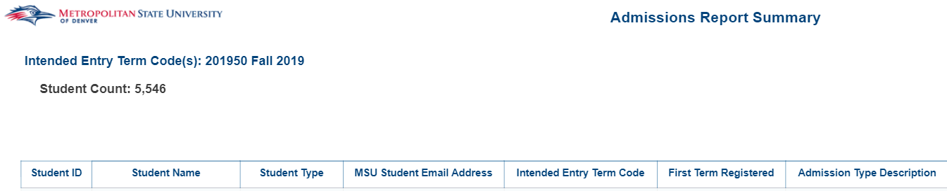
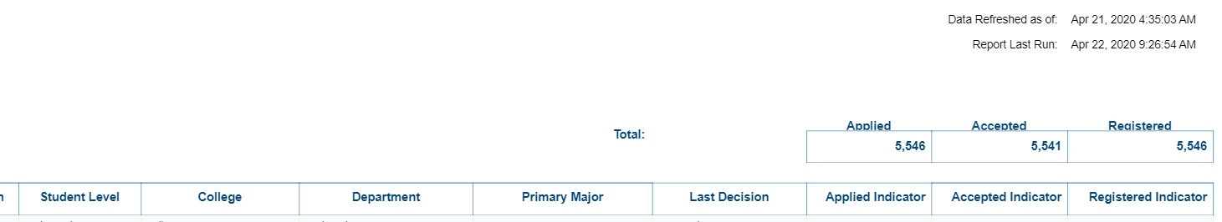
Tab 2: Demographics
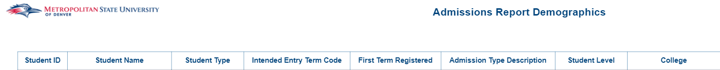
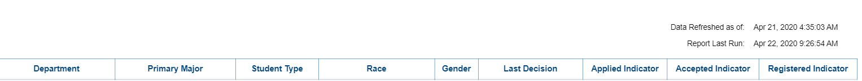

Tab 3: High School
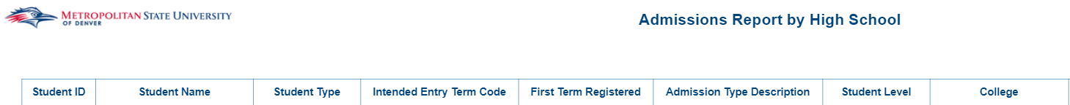
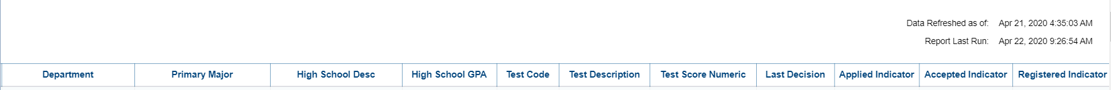
Tab 4: Residency
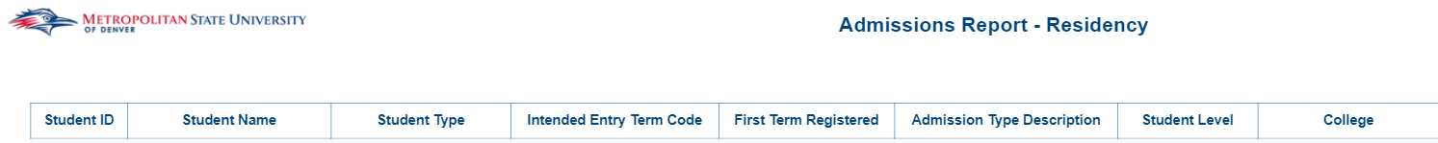
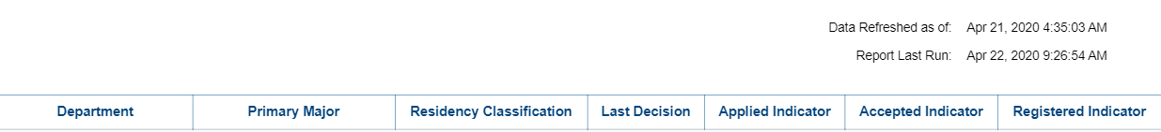
Tab 5: Transfer
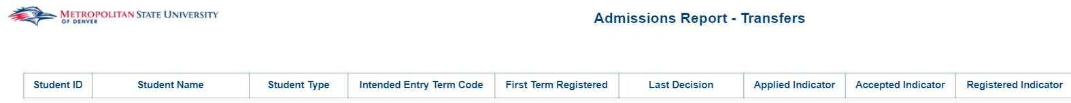
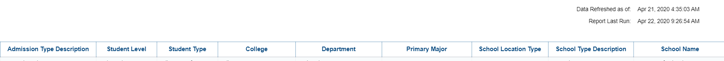
Tab 6: Transfer Credits
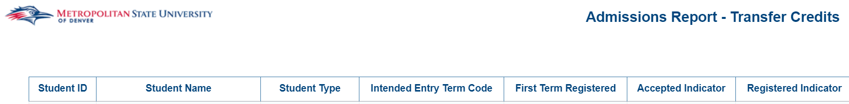
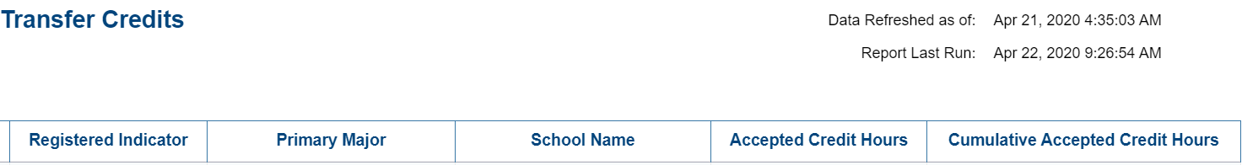
Tab 7: Summary with Alt Email
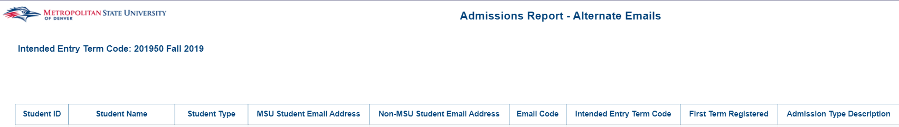
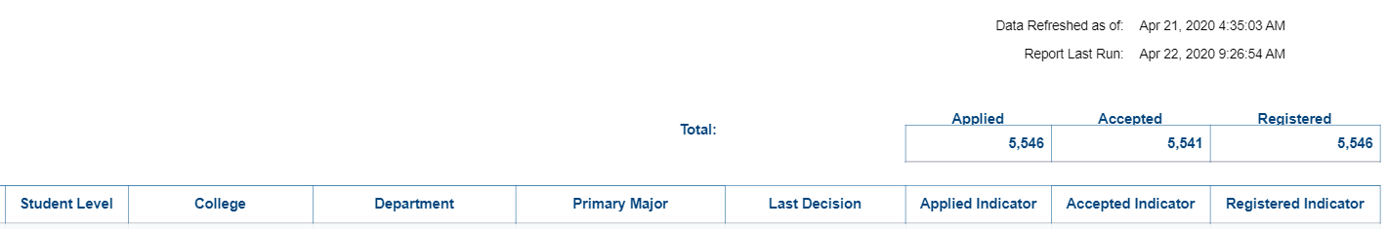

Admitted (Registered) Students Profile
Description: Displays Admitted (Registered) Students for a specific term. The report is grouped by College and Department and is sorted by Student ID. Using the Input Controls (listed below) you can select single or multiple Terms, Colleges, Departments, Majors, or Degrees.
Data Elements: Student ID, Name, Gender, Race, Degree, Major, Minor, Primary Concentration, Program, Student Type, Student Level
Source: Student Admission and Enrollment Universe
Location: Public Folders Admissions Admitted (Registered) Student Profile
Prompts: Term (required)
Input Controls: Term, College, Department, Major, Degree, Minor, Concentration
Report Page:
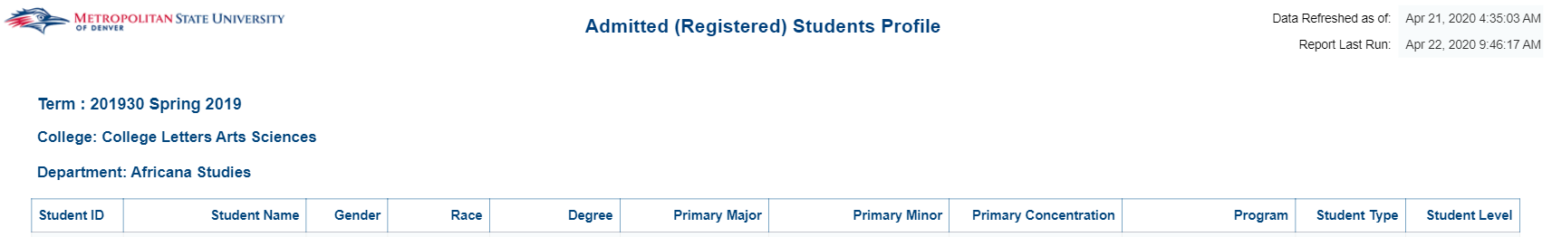

Application Weekly Report
Description: The report compares the number of students that have applied, were accepted, and registered for a given semester vs a previous semester. There are 6 tabs in the report; Summary Report, Count by College, Count by Department, Count by Major, Student List Term 1 and Student List Term 2.
Data Elements:
- Summary: Intended Entry Term, Count of Applied Student, Count of Accepted Students, Count of Registered Students, College, Yield Rate, Difference Applied, % Difference Applied, Difference Accepted, % of Difference Accepted, Difference Registered, % of Difference Registered, Gender, Race, Age Band, Residency Classification, Student Group, Citizenship, Admission Type
- Count by College: Intended Entry Term, Count of Applied Student, Count of Accepted Students, Count of Registered Students, College, Yield Rate, Difference Applied, % Difference Applied, Difference Accepted, % of Difference Accepted, Difference Registered, % of Difference Registered
- Count by Department: Intended Entry Term, Count of Applied Student, Count of Accepted Students, Count of Registered Students, Department, Yield Rate, Difference Applied, % Difference Applied, Difference Accepted, % of Difference Accepted, Difference Registered, % of Difference Registered,
- Count by Major: Intended Entry Term, Count of Applied Student, Count of Accepted Students, Count of Registered Students, Primary Major, Yield Rate, Difference Applied, % Difference Applied, Difference Accepted, % of Difference Accepted, Difference Registered, % of Difference Registered,
- Student List Term 1: Intended Entry Term, Count of Applied Student, Count of Accepted Students, Count of Registered Students, Student ID, Student Type, Student Group, Applied Indicator, Accepted Indicator, Registered Indicator, Full-Time/Part-Time
- Student List Term 2: Intended Entry Term, Count of Applied Student, Count of Accepted Students, Count of Registered Students, Student ID, Student Type, Student Group, Applied Indicator, Accepted Indicator, Registered Indicator, Full-Time/Part-Time
Source: Student Data – Point In Time Universe
Location: Public Folders Admissions Application Weekly Report
Prompts: Term 1, As of Date (Term 1), Term 2, As of Date (Term 2). Enter Current term as Term 1. Enter past term you are wanting to compare to as Term 2.
Input Controls: Student Level, Online Primary Major, College, Department, Student Type, Full-Time/Part-Time, Student Group
Report Page:
Tab 1: Summary
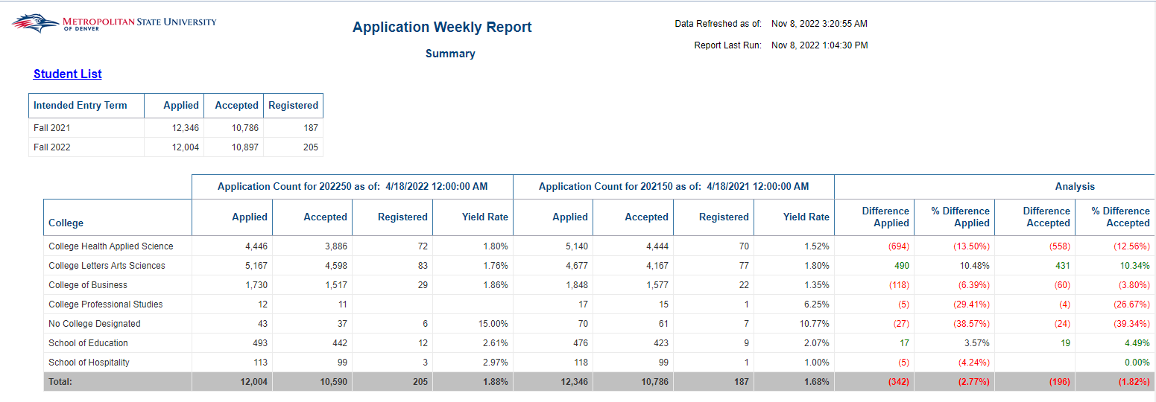
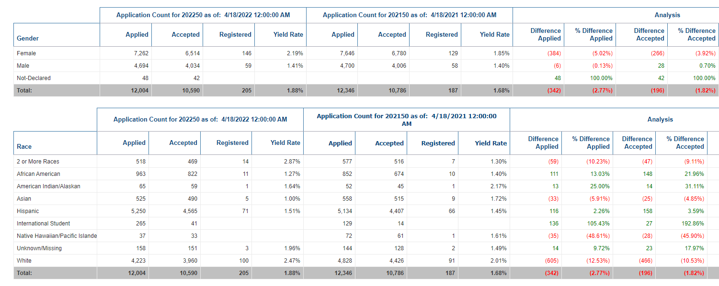
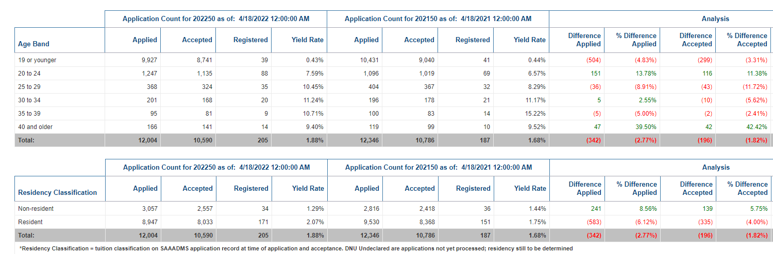
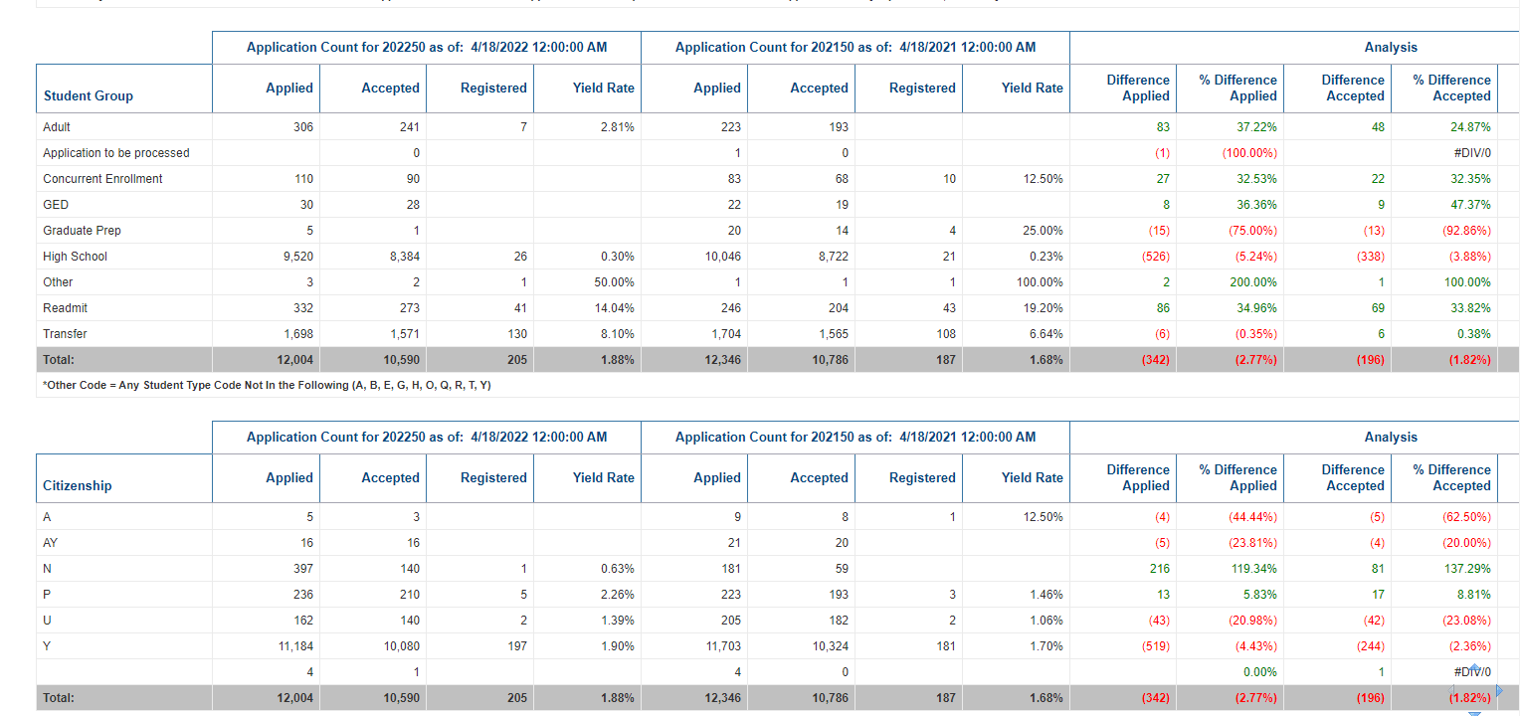
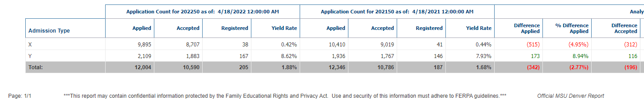
Tab 2: Count by College
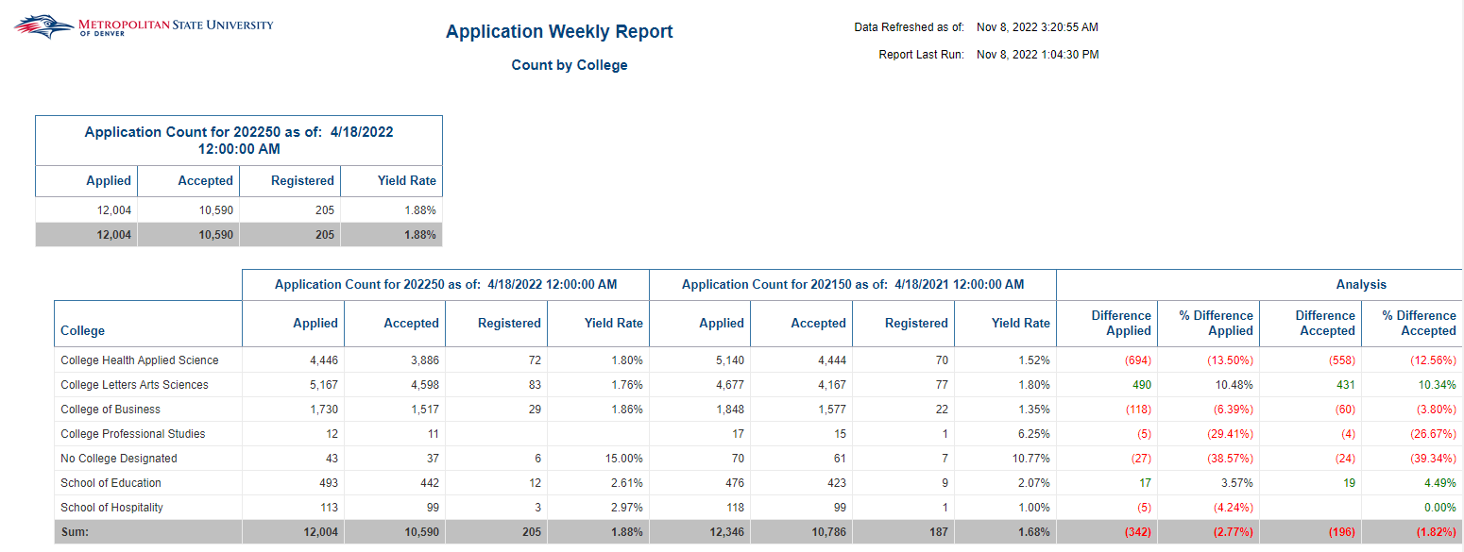

Tab 3: Count by Department
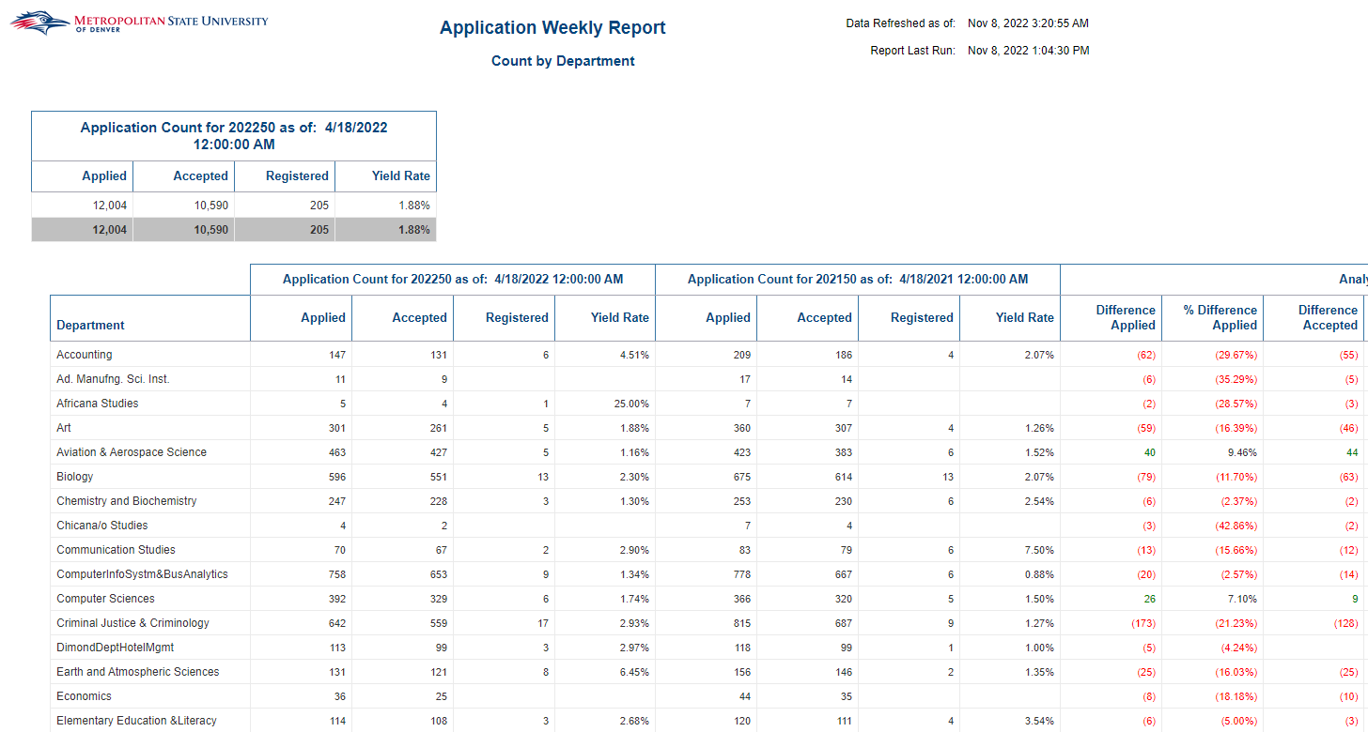
Tab 4: Count by Major
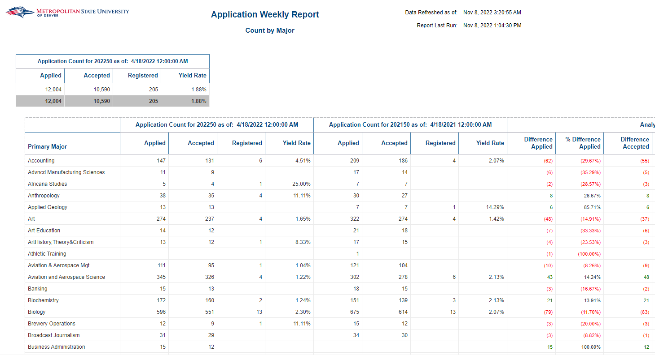

Tab 5: Student List Term 1
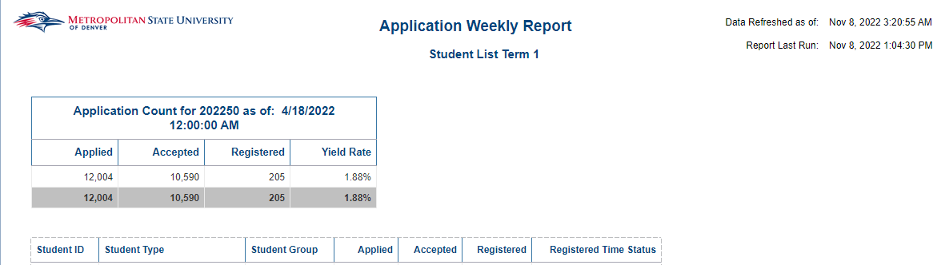
Tab 6: Student List Term 2
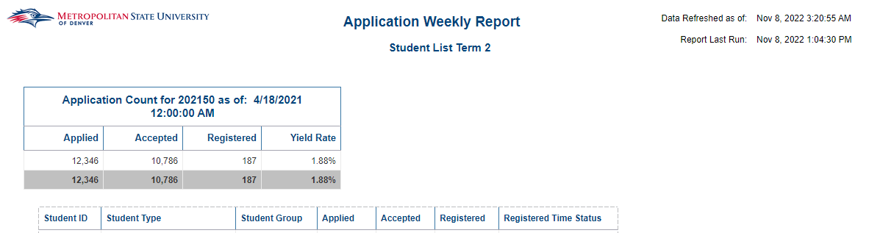

Application Weekly Report_Detail
Description: The report compares the number of graduate students that have applied, were accepted and registered for a given semester. There are 2 tabs in the report: Overview and Student List Term 1.
Data Elements: Applied (Count), Accepted (Count), Registered (Count), Yield Rate, Student ID, First Name, Last Name, Primary Major, Department, MSU Email Address, Non-MSU Email Address, Race, VISA Code, VISA Description, First Generation Code, Student Type Group, Application Source Code, Application Source, Application Source Type, Admission Type Code, Residency Classification, Student Phone Number – AA, Student Phone Number – CE, Full Street Address, City, State Cd, Zip Code, Applied, Accepted, Registered
Source: Student Admission and Enrollment Universe
Location: Public Folders Admissions Application Weekly Report_Detail
Prompts: Term 1, As of Date (Term 1), Term 2, As of Date (Term 2). Enter Current term as Term 1. Enter past term you are wanting to compare to as Term 2.
Input Controls: Student Level, Online Primary Major
Report Page: This report has 2 pages
Tab 1: Overview
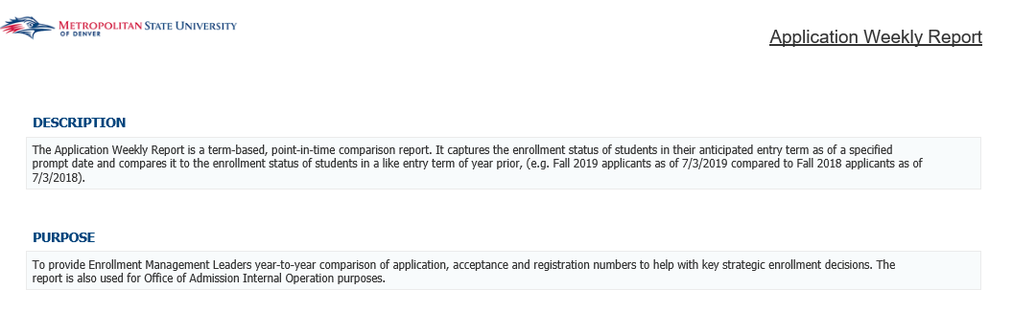
Tab 2: Student List Term 1
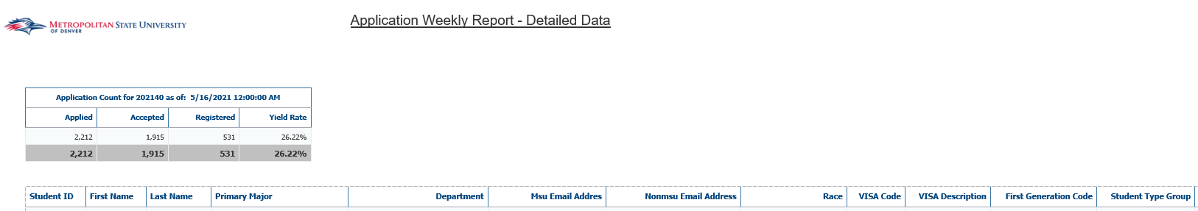

Application Weekly Report_GR
Description: The report compares the number of graduate students that have applied, were accepted and registered for a given semester vs a previous semester. There are 6 separate reports; Summary Report, Count by College, Count by Department, Count by Major, Student List Term 1 and Student List Term 2.
Data Elements: Applied, Accepted, Registered by Term, Gender, Age, Race, Residency, College, Department, Major, Student ID
Source: Student Admission and Enrollment Universe
Location: Public Folders Admissions Application Weekly Report_GR
Prompts: Term 1, Term 1 From Date, Term 1 To Date, Term 2, Term 2 From Date, Term 2 To Date. Enter Current term as Term 1. Enter past term you are wanting to compare to as Term 2.
Input Controls: Student Level
Report Page: This report has 6 reports
Tab 1: Summary
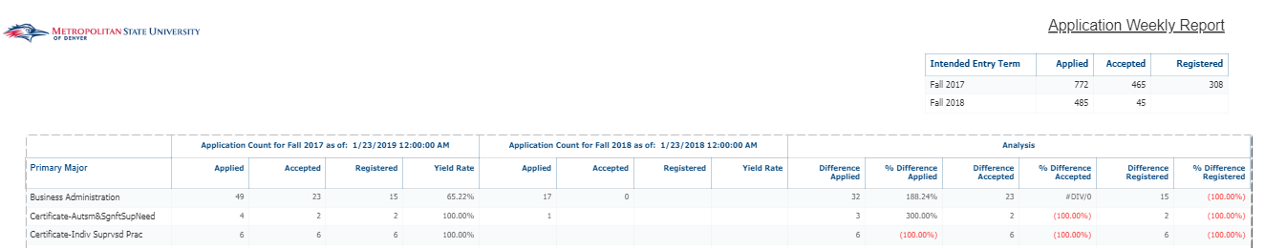
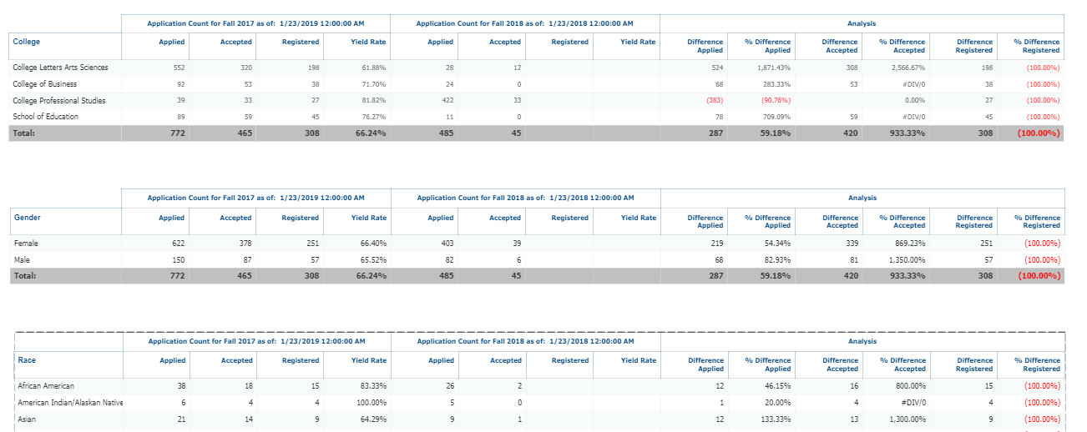
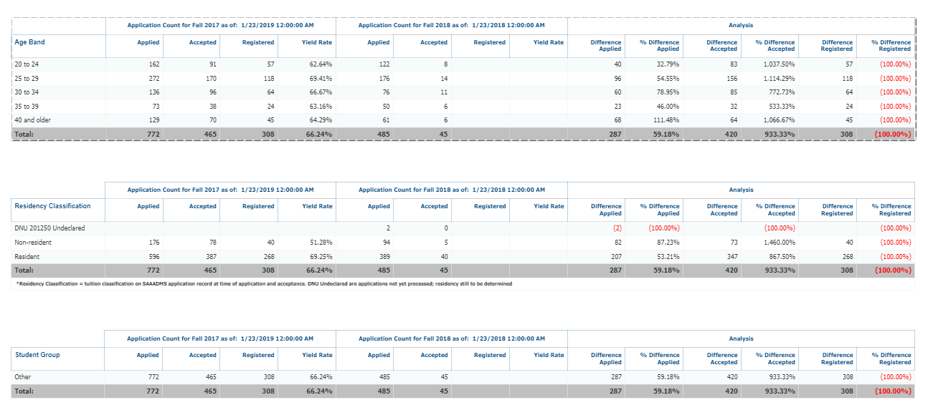
Tab 2: College
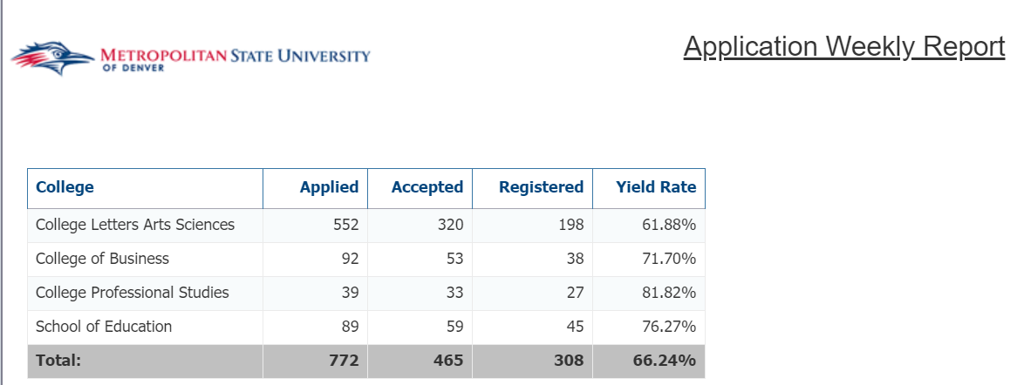
Tab 3: Department
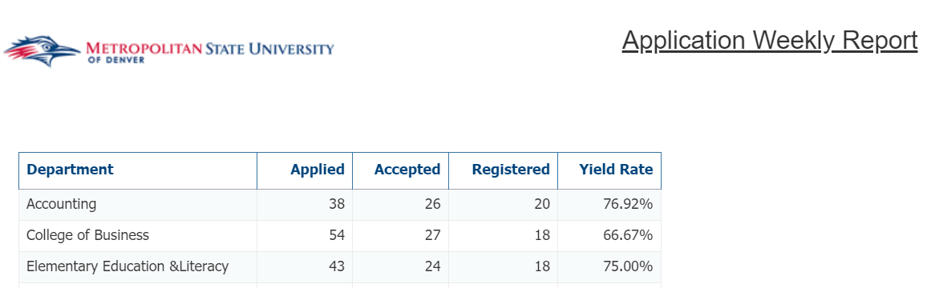
Tab 4: Major
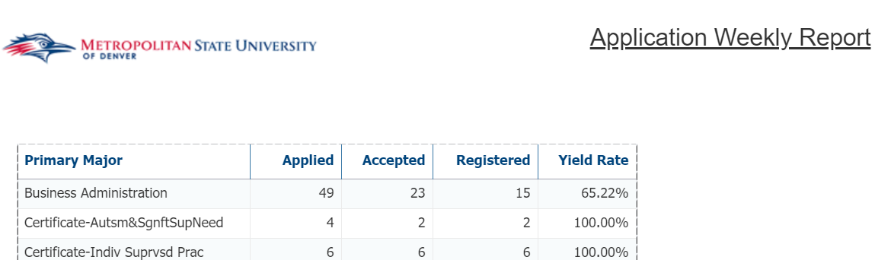
Tab 5: Student List Term 1
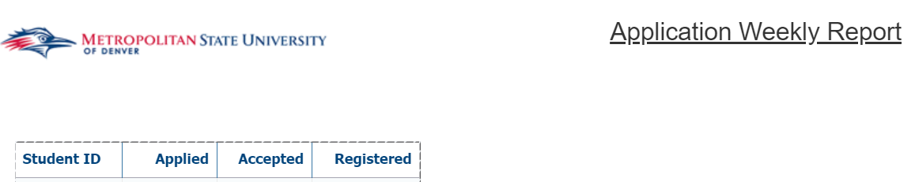
Tab 6: Student List Term 2
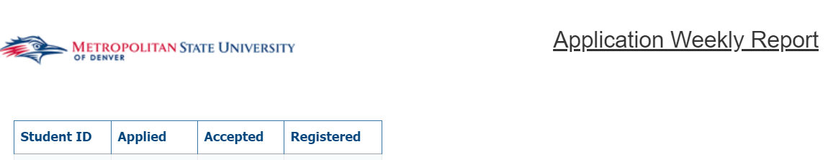

CBUS Graduate Program Admits
Description: This report lists Graduate students that were admitted to the College of Business Graduate Programs for a user selected term. The report has 5 tabs: Summary, Demographics, Residency, Holds, and Previous Degrees. Each tab provides a different view of the student list.
Data Elements:
- Summary: Intended Entry Term Code, Student ID, Student Name, MSU Email Address, Non-MSU Email Address, First Term Registered, Student Attribute Cd, Primary Major Code, Primary Major, Last Decision, Registered Indicator, GR – Cumm Hours Earned, GPA Cumulative, Student Status
- Demographics: Intended Entry Term Code, Student ID, Student Name, Primary Major Code, Primary Major, Student Attribute Cd, Student Status, Gender, Race, Race (without Ethnicity), Visa Description, Veteran Status, Age at time of Admission, Age at Census, Current Age, Date of Birth, Last Decision, Registered Indicator
- Residency: Intended Entry Term Code, Student ID, Student ID, Student Name, Primary Major Code, Primary Major, Student Attribute Cd, Student Status, Residency Classification, Last Decision, Registered Indicator
- Holds: Intended Entry Term Code, Student ID, Student Name, Primary Major Code, Primary Major, Hold Code – Description, Hold Type, Hold Reason, Hold Start Date, Hold End Date, Hold Released Ind
- Previous Degree: Intended Entry Term Code, Student ID, Student Name, Primary Major Code, Last Decision, Registered Indicator, School Name, School Location, Degree Code, Degree Description, Graduation GPA
Source: Student Admissions and Enrollment Universe
Location: Public Folders Admissions CBUS Graduate Program Admits
Prompts: Intended Entry Term Code (Required)
Input Controls: Primary Major Code, Student Attribute Code
Report Pages:
Tab 1: Summary
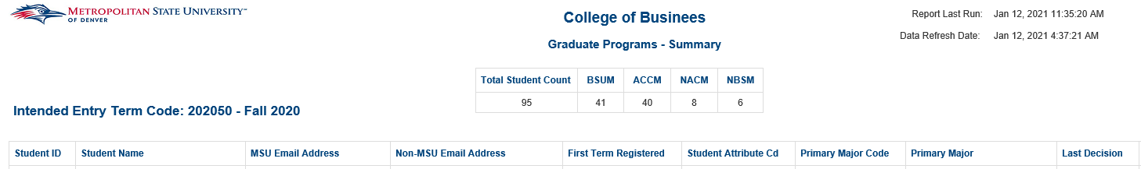
Tab 1: Summary (Cont.)

Tab 2: Demographics
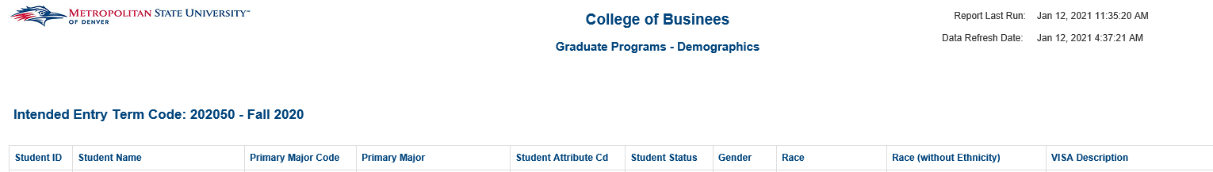
Tab 3: Residency
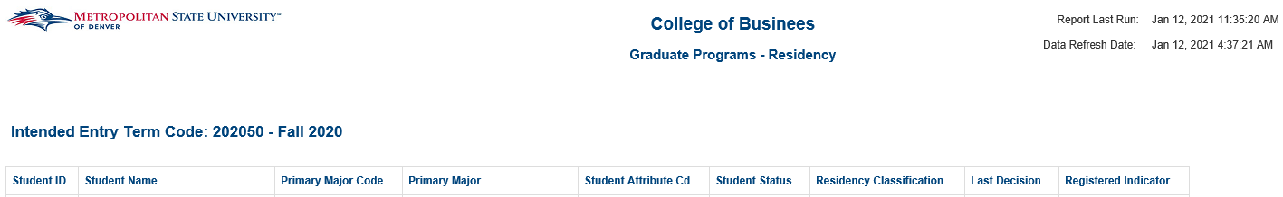
Tab 4: Holds
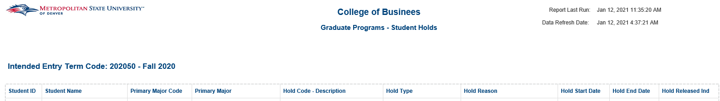
Tab 5: Previous Degrees
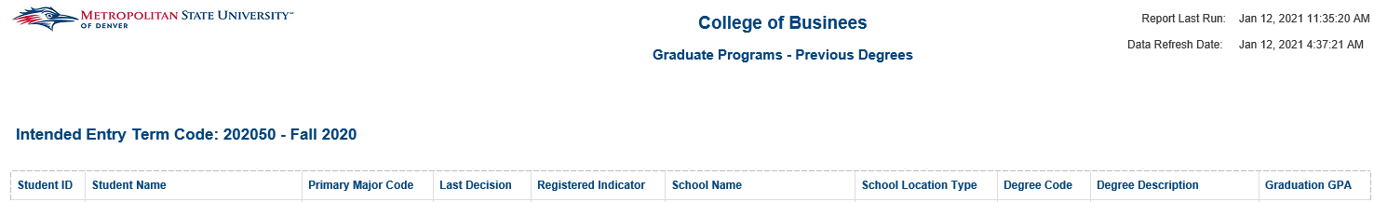

EAB Final Check – Inactive Students
Description: Displays a list of ‘Inactive’ students that were registered at one point in the past 9 terms from their Inactive Term. The list includes contact information for the students so they can be sent communications from the Admissions department to re-apply to MSU Denver.
Data Elements: Student ID, First Name, Last Name, Date of Birth (DOB), Gender (Sex), Citizenship, High School Graduation Date (HS GRAD), Overall Undergraduate Credit Hours (Earned + Transfer), First Term Registered, Last Term Registered, Street 1, Street 2, City, State, Zip, Primary Phone, Primary Email
Source: Student Admission and Enrollment Universe
Location: Public Folders Admissions EAB Final Check – Inactive Students
Prompts: Inactive Term Code
Input Controls: None
Report Page:
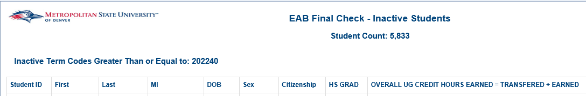
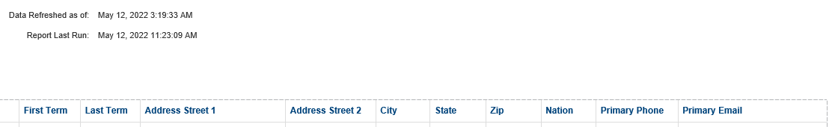

Eligible to Enroll but Not Enrolled
Description: Displays Students that are eligible to be enrolled but have not enrolled yet for a specific term. The report is sorted by Student ID.
Data Elements: Student ID, Student Name, College, Department, Major, Email, Phone
Source: Student Admission and Enrollment Universe
Location: Public Folders Admissions Eligible to Enroll but Not Enrolled
Prompts: Term
Input Controls: None
Report Page:
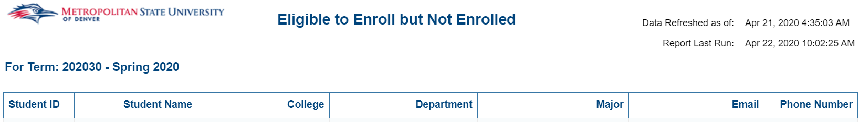

New Students Admitted in Last 7 Days Reports
Description: Displays a list of students that were admitted to the College/School specified in the title or are international students or have an undeclared Social Work Major. The report lists the student’s major, demographical information, acceptance data and whether the student is enrolled or not.
Data Elements: Major Code, Major, Program, Term, Student Type, Student ID, Last Name, First Name, Phone Number, MSU Email, APW Email, APP Email, Address Line 1, Address Line 2, City, State, Zip Code, Acceptance Data, Date of Birth, Enrolled
Source: Student Admission and Enrollment Universe
Location: Public Folders Admissions
Prompts: None
Input Controls: Program, Major, Student Type, International Student
Report Page:

New to MSU Denver
Description: Displays Students for a given year that are completely new to MSU Denver. The report is broken down by College and sorted by Student ID.
Data Elements: Student ID, Name, Student Type, Department, Major, Race, Gender, High School, County, Residency
Source: Student Admission and Enrollment Universe
Location: Public Folders Admissions New to MSU
Prompts: Academic Year
Input Controls: None
Report Page:
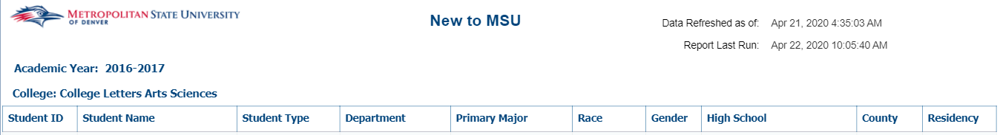

Orientation Report
Description: Displays Students who have not completed Orientation. The report is broken down by College and sorted by Student’s Last Name.
Data Elements: Department, Student ID, First Name, Last Name, Major, Student Type, Last Decision, Hold Code, Hold Description, Registration Status, Hold Released, Hold End Date, Email Address, Phone Number, Phone Number Type
Source: Student Admission and Enrollment Universe
Location: Public Folders Admissions Orientation Report
Prompts: Term
Input Controls: Registered, Hold Released
Report Page:
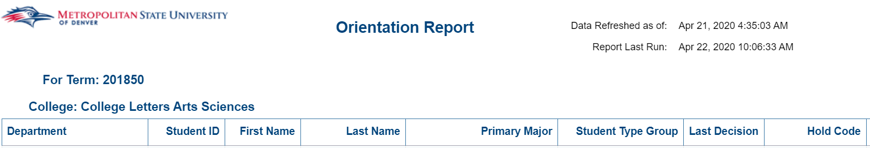

Advancements

CAMP (College Assistance Migrant Program) Report
Description: This report is used to find students that are eligible for the College Assistance Migrant Program (CAMP). The report displays a list of students that have a specific citizenship status (U.S. Citizen, Permanent Resident, or U.S. Eligible Non-Citizens) are FAFSA eligible and have less than 24 cumulative credit hours as of the term selected.
Data Elements: Student Name, Student ID, Gender, Primary Major, Intended Entry Term Code, First Term Registered Term Code, Student Phone Number CE/AA, Street Line 1, Street Line 2, City, State Code, Zip Code, High School Desc, CDE District Number, CDE District Name, Date of Birth, U.S. Citizenship Status, Enrolled Credit Hours, Cumulative Earned Hours, Cumulative Transfer Hours, Race, First Generation Desc
Source: Student Admission and Enrollment Universe
Location: Public Folders Advancements CAMP Report
Prompts: Term Code
Input Controls: None
Report Page:

HI Prospecting: Medical Professional Prereq Non-Degree Students_SplitTab
Description: This report displays a list of students who attended MSU Denver but either did not graduate took specific courses in CHE, BIO, and PHY before Spring of 2015 or received a Health Certificate from MSU Denver. The report contains 4 tabs: HI Prospecting – Non-Grad – Contact, HI Prospecting – Non-Grad - Student Details, HI Prospecting – Health Certs – Contact, and HI Prospecting – Health Certs – Student Details.
Data Elements: Contact Tabs: Student ID, Student Name, Street Line 1, Street Line 2, City, State Cd, Zip Code Student Phone Number CE/AA, MSU Email Address, Non-MSU Email Address
Student Details Tabs: Student ID, Student Name, Primary Major Code, Primary Major, Cumulative GPA, Term Start Date, Term End Date
Source: Student Admission and Enrollment Universe
Location: Public Folders Advancements HI Prospecting: Medical Professionals Prereq Non-Degree Students
Prompts: None
Input Controls: Primary Major, Current Age, Student ID
Report Page:
HI Prospecting – Non-Grad – Contact:
HI Prospecting – Non-Grad – Student Details:
HI Prospecting – Health Certs – Contact:
HI Prospecting – Health Certs – Student Details:

Student Prospecting List by Course and Faculty
Description: This report provides a list of all students that were registered for a particular course taught by a particular faculty member regardless of the term the course was taken. This report provides the contact details of the students that were registered for the course to be used by University Advancement for prospecting.
Data Elements: Term Code, Student ID, Student Name, Full Street Address, City, State Code, State Desc, Zip Code, Non-MSU Email Address, Student Phone Number CE/AA, Primary Major Code, Primary Major, GPA Cumulative, Graduation Date, Degree, Course Subject/ID, Faculty ID, Primary Instructor
Source: Student Admission and Enrollment Universe
Location: Public Folders Advancements Student Prospecting List by Course and Faculty
Prompts: Subject Code (Required), Course Number (Required), Primary Instructor (Optional)
Input Controls: None
Report Page:
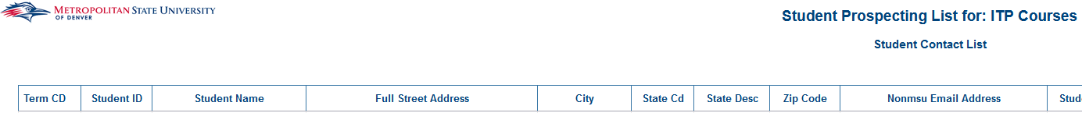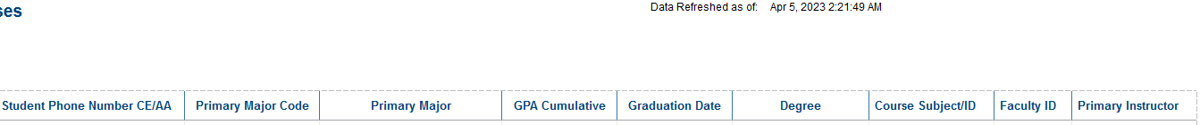

Advising

College Transfer Success Tracking
Description: This report displays Transfer Students for a given selection of terms. There are two tabs. The first tab displays each student and their Major, Minor, Status, Academic Standing, Graduation Indicator, Cumulative GPA and Hours earned. The second tab shows Transfer Students by Course and their grade received for that course.
Data Elements:
- College Transfer Success Tracking Report: Id, Name, Email, College, Department, Major, Minor, Student Status, Term Credits Transferred, Start Term, Transfer Institution, Graduation Status, Graduation Term Code, GPA Cumulative, Student Type, Academic Standing, Term Code, Credit Hours Earned – MSU, Cumulative Hours Attempted, Completion Percentage
- Transfer Success Course: Id, Name, College, Department, Term Code, CRN, Subject Code, Course #, Final Grade.
Source: Student Admission and Enrollment Universe
Location: Public Folders Advising College Transfer Success Tracking
Prompts: Start Term – Start (Required), Start Term – End (Required), Transfer Institution
Input Controls: School Name, Grades, College, Department
Report Page:
College Transfer Success Tracking Report
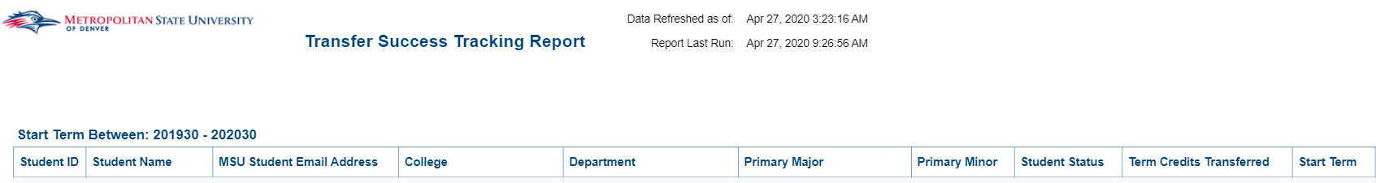
College Transfer Success Tracking Courses
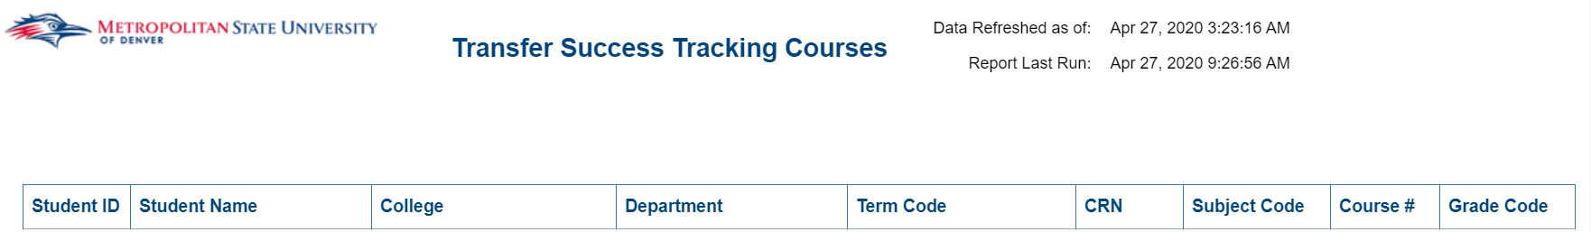

Course and Prerequisites
Description: This report allows you to enter a course and compare it to a follow up course that is taken not necessarily a prerequisite.
Data Elements: Id, Name, Race, Gender, Major, Minor, Concentration, High School, High School GPA, Prerequisite Course, Prerequisite Course Grade, Course, Course Grade, Term Course Taken, Email
Source: Student Admission and Enrollment Universe
Location: Public Folders Advising Course and Prerequisites
Prompts: Term, First Subject Code, First Course Number, Second Course Subject Code, Second Course Number (All are Required).
Input Controls: None
Report Page:
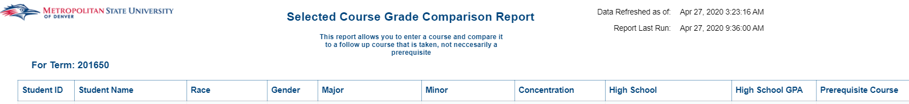
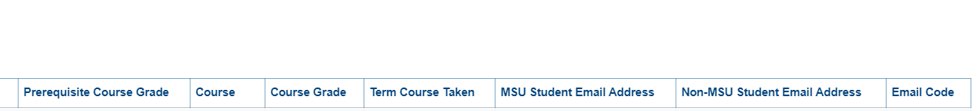

English Major Minor Concentration Count
Description: This report displays ENG Majors and Minors and what their concentrations are. There are 4 tabs. The first tab is ENG Majors and their concentrations broken down by Gender, Race and Age. The second tab is a detailed list of the first tab by student. The third tab is ENG Minors and their concentrations broken down by Gender, Race and Age. The fourth tab is a detailed list of the third tab by student.
Data Elements: Majors by Concentration Summary: Major, Concentration, Concentration Description, Gender, Race, Age
Majors by Concentration Detailed: Major, Concentration, ID, Name, Email, Age at Census, Gender, Race, Major Code, Minor Code, Minor, Concentration Code, Concentration, GPA, Class
Minors by Concentration Summary: Minor, Minor Description, Concentration, Concentration Description, Gender, Race, Age
Minors by Concentration Detailed: Minor, Minor Description, Concentration, Concentration Description, ID, Name, Email, Age at Census, Gender, Race, Term, Major, Class, Cumulative GPA
Source: Student Admission and Enrollment Universe
Location: Public Folders Advising English Major Minor Concentration Count
Prompts: Term Code (Required)
Input Controls: Primary Concentration Area
Report Page:
Major by Concentration – Summary
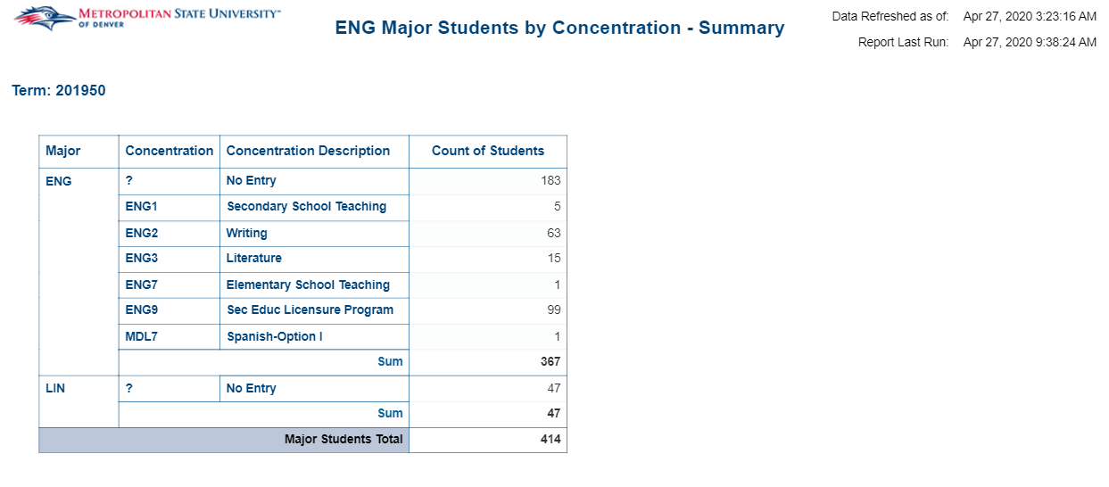

Majors by Concentration – Detailed
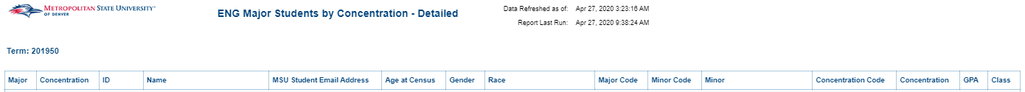

Minors by Concentration – Summary
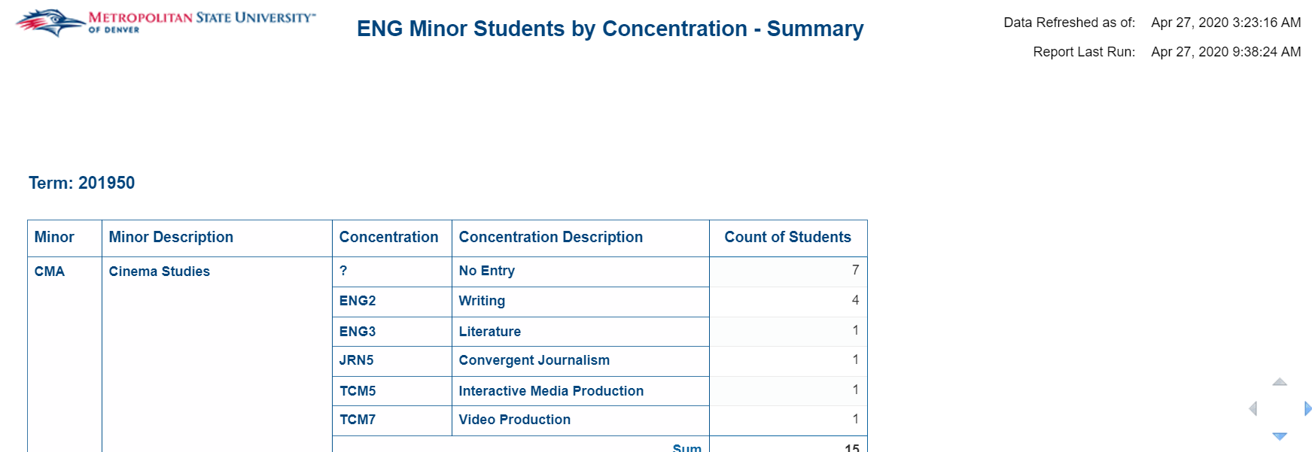

Minors by Concentration – Detailed
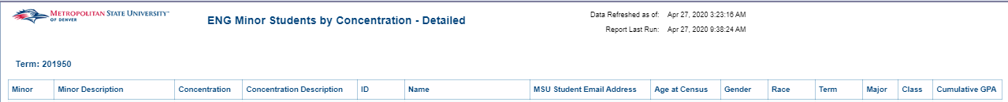

English Registered Students Report (1001, 1008, 1009, 1010, 1020, and 1021)
Description: This report displays enrolled students in ENG 1001, 1008, 1009, 1010, 1020 and 1021 for a given term. There are 2 tabs. The first tab displays a summary by Gender, Race and shows a 7 Year Trend. The second tab shows a detailed list of students for the data from the first tab.
Data Elements:
- Summary & 7 Year Trend: Course #, Gender, Age, and enrollment count for the previous 7 years.
- Detailed: Course Subject/ID, CRN, Student ID, Name, Email, Major, Minor, Gender and Race.
Source: Student Admission and Enrollment Universe
Location: Public Folders Advising English Registered Students Report (1001, 1008, 1009, 1010, 1020 and 1021)
Prompts: Term (Required)
Input Controls: Subject Code ID
Report Page:
Summary & 7 Year Trend
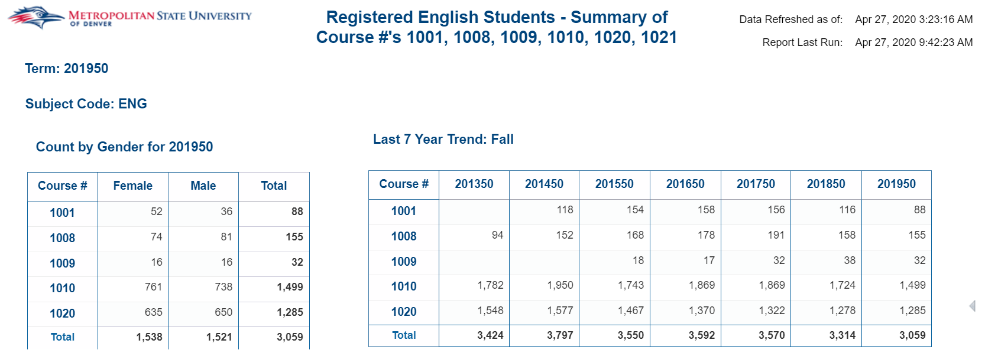
Detailed
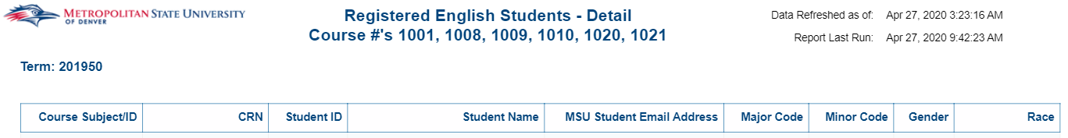

First Term GPA vs HS GPA
Description: This report compares first term GPA to High School GPA for students in a given Major for a given first term
Data Elements: ID, Name, Race, Gender, Major Code, Major, Minor Code, Minor, Concentration Code, Concentration, Credit Hours Earned, First Term GPA, High School GPA, High School, Test Code, Test Description, Test Score Numeric, email.
Source: Student Admission and Enrollment Universe
Location: Public Folders Advising First Term GPA vs HS GPA
Prompts: Term (Required), College, Department, Major
Input Controls: None
Report Page:
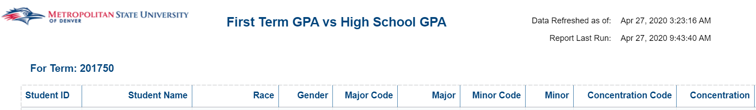

Student Academic Standing by Term – Last 5 Years
Description: This report displays the academic standing of students at the end of term. The first table is a total by academic standing categories for the last 5 years. The second table displays the academic standing for students over the last 5 years.
Data Elements: Academic Standing, Term, ID.
Source: Student Admission and Enrollment Universe
Location: Public Folders Advising Student Academic Standing by Term – Last 5 Years
Prompts: None
Input Controls: Active vs Inactive, Term, Registered, Enrolled, Age, High School GPA Band, Gender, Race, College, Department, Major
Report Page:
Table 1: By Academic Standing
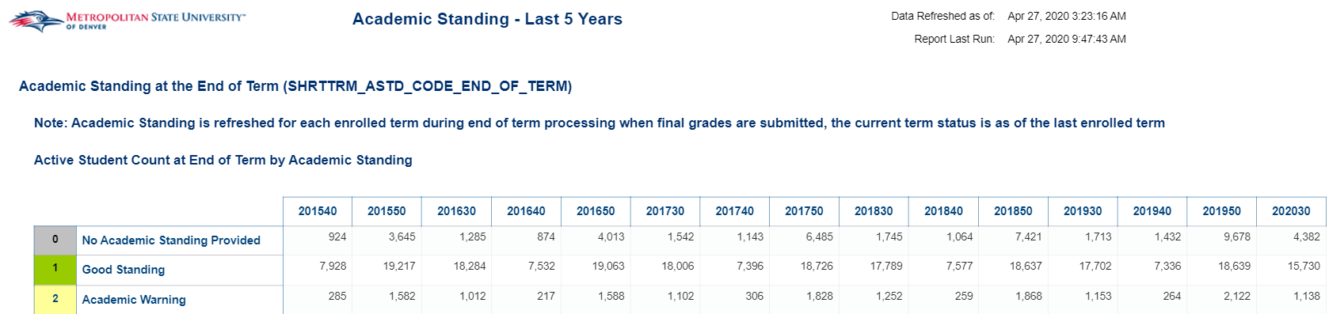
Table 2: By Student ID
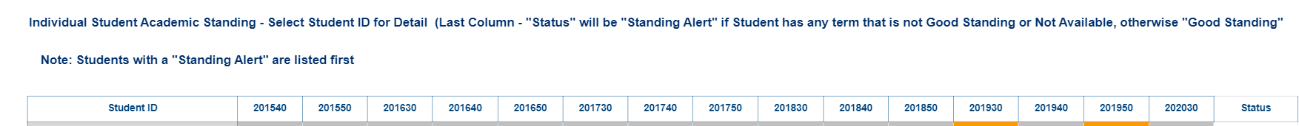

Student Honor Potential
Description: This report lists students who are eligible for Honors by term.
Data Elements: Student ID, Name, Email, Course, High School GPA, Cumulative GPA, Credit Hours Earned, Class, Major, Minor, Concentration.
Source: Student Admission and Enrollment Universe
Location: Public Folders Advising Student Honor Potential
Prompts: Term, Course Subject Cd
Input Controls: Course Subject Cd: Course #, High School GPA minimum, GPA Cumulative minimum
Report Page:
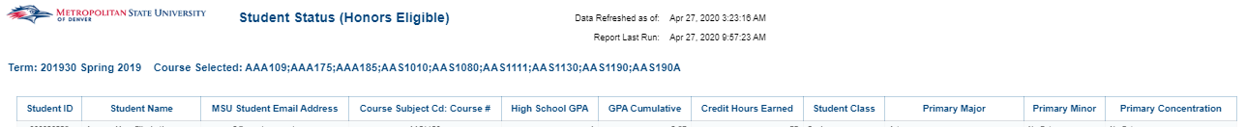

Transfer Repeated Courses
Description: This report lists students who are repeating a course that they’ve taken at a previous institution. It also lists how many times if any that they have repeated this course at MSU Denver.
Data Elements: ID, Name, MSU Email Address, Non-MSU Email Address, Phone Number, College, Department, Major, Minor, Subject, Course #, Course Title, Grade, Part of Term, Registered for Course, Transferred in Course, Times Repeated at MSU Denver, Academic Advisor, Advisor Email Address
Source: Student Admission and Enrollment Universe
Location: Public Folders Advising Transfer Repeated Courses
Prompts: None (Automatically runs for the current term and the next term – ex: Summer 2023 and Fall 2023)
Input Controls: Student ID, College, Department, Primary Major, Subject Code, Grade
Report Page:
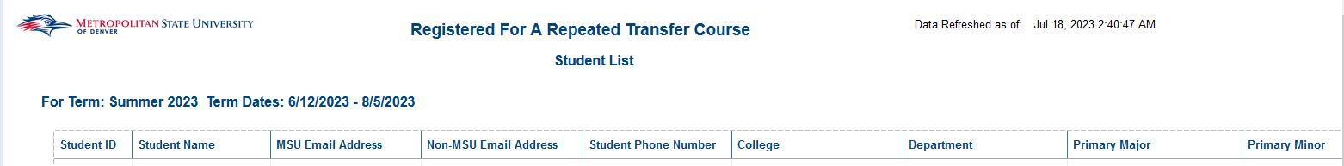

Aggregated Data with no Detail

Demographics by Degree Program and Low Income
Description: This report displays aggregated counts for the College of Business degree program and demographic information. The report contains five tabs Applications, Accepted, Newly Registered, Census Headcount, and Degrees Awarded. The report includes aggregated data from financial aid in the form of a low-income designation (no student data is available in this report).
Data Elements: Applications: Intended Entry Term Code, College, Primary Major Code, Primary Major, Race/Ethnicity, Gender, Low Income Ind, Admission Application Ind, Department, Veteran Ind, First Generation, Low Income Count, Applied Count
Accepted: Intended Entry Term Code, College, Primary Major Code, Primary Major, Race/Ethnicity, Gender, Low Income Ind, Admission Appl Accepted Ind, Department, Veteran Ind, First Generation, Low Income Count, Accepted Count
Newly Registered: Intended Entry Term Code, College, Primary Major Code, Primary Major, Race/Ethnicity, Gender, Low Income Ind, Registered Ind, Department, Veteran Ind, First Generation, Low Income Count, Registered Count
Census Headcount: Term Code, College, Primary Major Code, Primary Major, Race/Ethnicity, Gender, Low Income Ind, Registered Ind, Department, Veteran Ind, First Generation, Low Income Count, Registered Count
Degrees Awarded: Graduation Term Code, College, Primary Major Code, Primary Major, Race/Ethnicity, Gender, Low Income Ind, Department, Veteran Ind, First Generation, Low Income Count, Student Count
Source: Financial Aid Universe
Location: Public Folders Aggregated Data with no Detail Demographics by Degree Program and Low Income
Prompts: Term Code (Same for all Tabs), College Code (Same for all Tabs)
Input Controls: None
Report Page:
Applications:
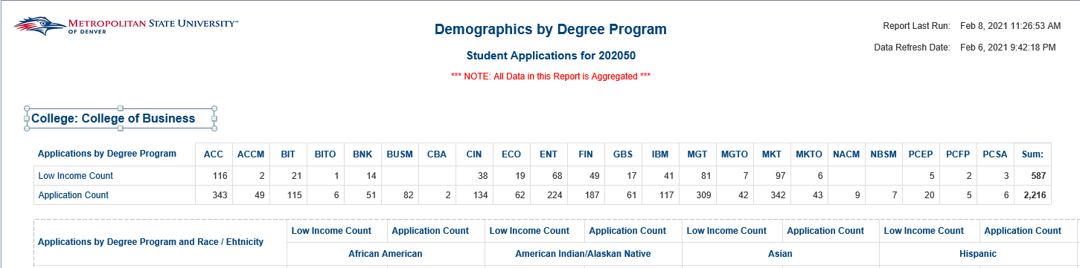
Accepted:
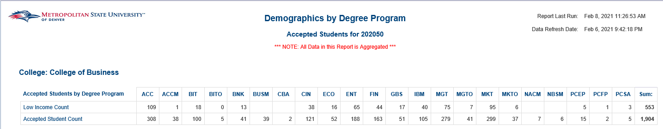
Newly Registered:
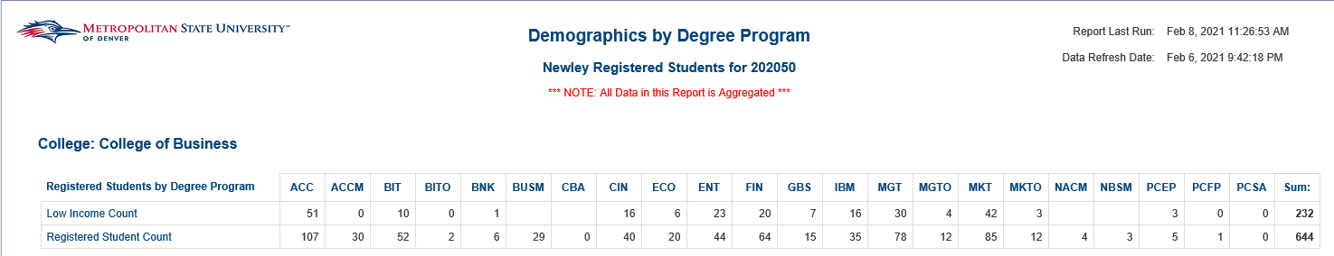
Census Headcount:
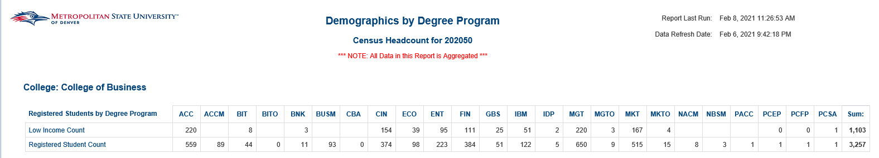
Degrees Awarded:
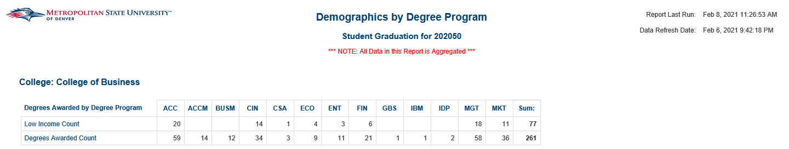

Annual Reports

CHAS Grant
Description: The report is intended to provide information for the CHAS Grant by identifying the number of Pell Eligible students for each major and race/ethnicity.
Data Element: Race/Ethnicity, Nursing Programs, Student Count, Percent Change, Total %
Source: Student Admission and Enrollment, Financial Aid
Location: Public Folders Annual Reports CHAS Grant
Prompts: None
Input Controls: None
Report Page:

Departmental Data – Credit Hour Production
Description: This report gives credit hour production by courses. You can choose by a single year of over multiple years. There are two reports. One is an undergraduate report and the other is a graduate report.
Data Elements: Credit Hour Production, Course Prefix, % Change
Source: Student Admission and Enrollment Universe
Location: Public Folders Annual Reports Department Data – Credit Hour Production
Prompts: Starting Academic Year, Ending Academic Year
Input Controls: Course Prefix
Report Page:
Credit Hr Production - Undergraduate
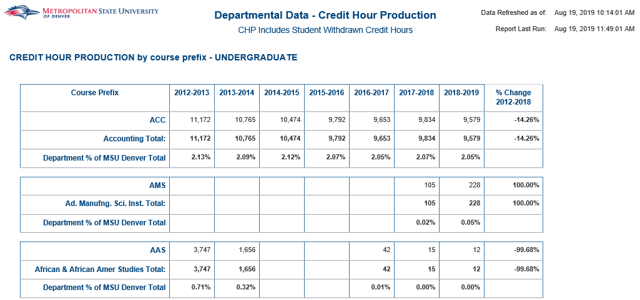
Credit Hr Production - Graduate
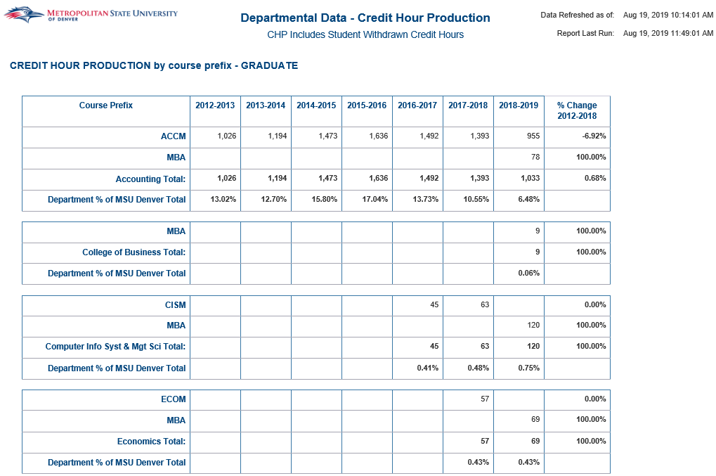

Program Data – Major Code
Description: This report is for the current year and going back 7 years. It gives full-year major totals and percentages by level, gender, age, race/ethnicity and concentration. You can drill down on the totals to get the actual students in each major. It also shows 1 year (fall to fall) retention totals and percentages. Finally, it gives the full-year graduate total and percentages for each major. This report also includes the ability to select multiple Primary Major Codes to aggregate counts, this is provided so that users can see totals for both Classroom and On-line Majors of the same type.
Data Elements: Major, Year, Level, Gender, Age Band, Race/Ethnicity, Concentration
Source: Student Admission and Enrollment Universe
Location: Public Folders Annual Reports Program Data – Major Code
Prompts: None (report automatically lists current year and goes back 7 years)
Input Controls: Primary Major Code (Multiple Major Codes can be selected after report loads. The main purpose is to allow the aggregation of Primary Major codes for both Classroom and On-line Majors of the same type, but are represented by two separate Primary Major Codes, i.e. Codes ending in “O” are typically for On-Line Majors), and Program Code.
Report Page:
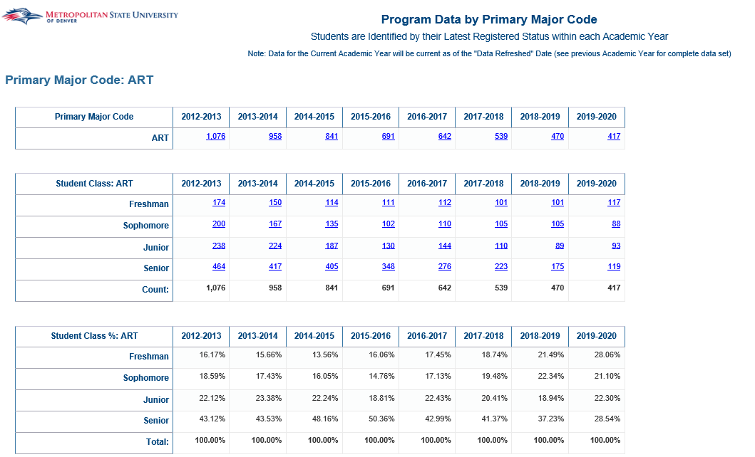
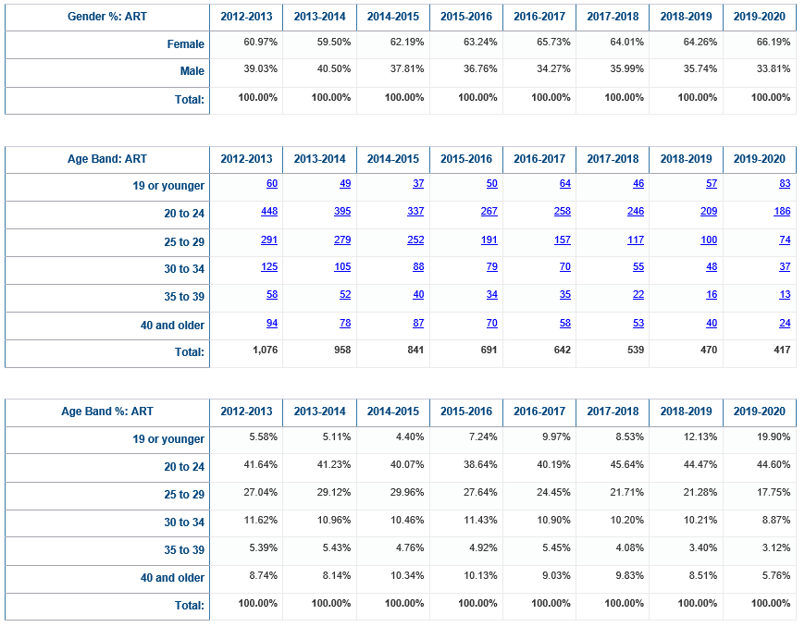
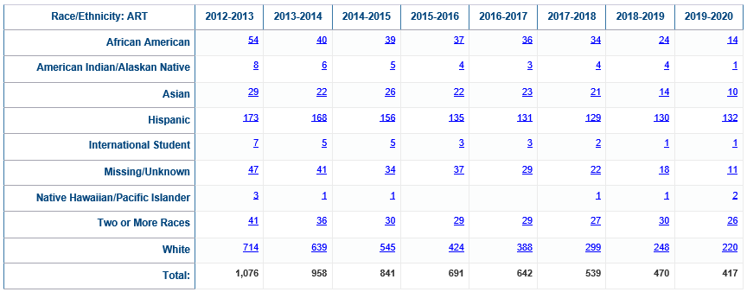
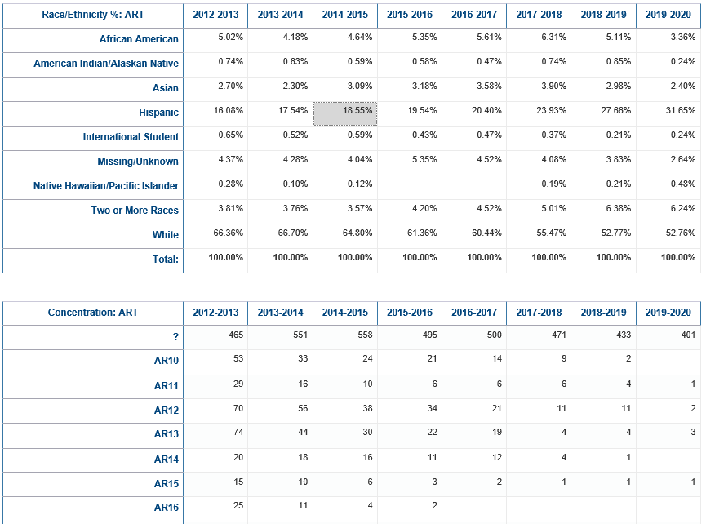
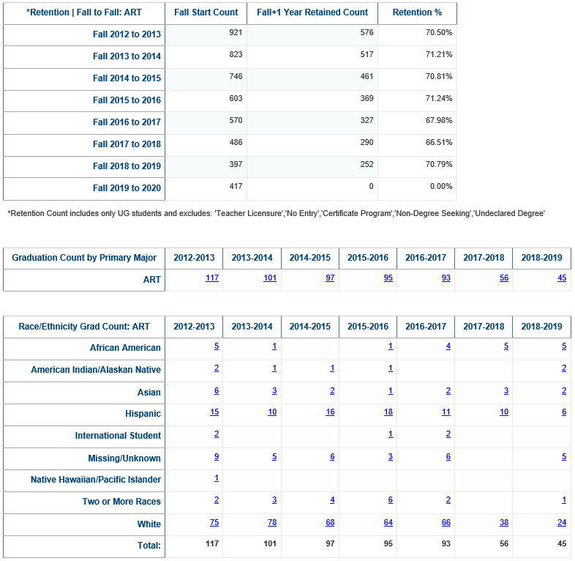
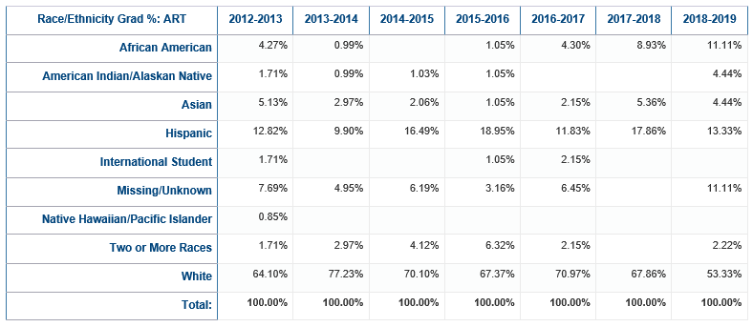
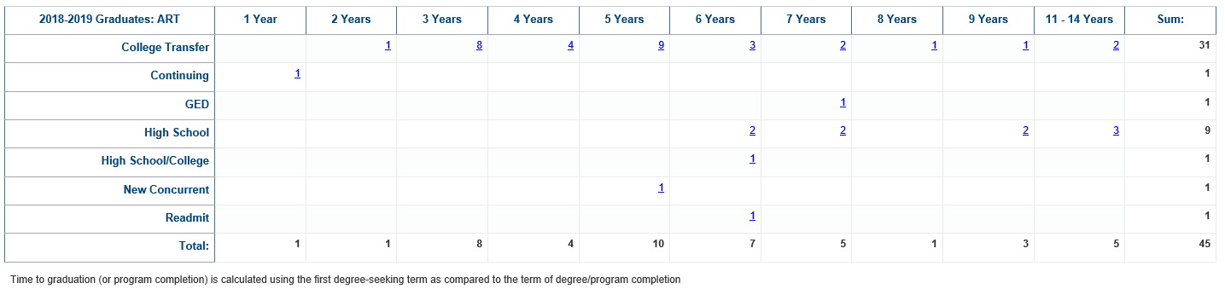

Student Detail List
Description: Displays a list of registered students that meet the conditions of the prompts and provides demographic and field of study information about those students. There are three reports. One is for Undergraduate, one is for Graduate, and one lists filters and input controls.
Data Elements:
- Student List: Last Registered Term for Academic Year, Student ID, Name, Email, Gender, Race, Age Band at Census, Student Class, College, Department, Primary Major Code, Program Code, Primary Concentration Code
- Student List_Graduates: Student ID, Student Name, Race, Student Type – First Reg Term, Graduation Term Code, Elap Reg Yrs to Grad Degseek, Elap Reg Yrs to Grad Degseek_Roll Up, Email, College, Department, Primary Major Code, Primary Program Code, Primary Concentration Code
- Applied Filters and Input Controls: Queries, Input Controls, Filters
Source: Student Admission and Enrollment Universe
Location: Public Folders Annual Reports Student Detail List
Prompts: Academic Year, Major Code, Program Code, Concentration Code, Student Class, Race, Gender, Age Band at Census, Elapsed Registered Years to Graduation, Graduation Academic Years Before Curr Amt, First Reg Term
Input Controls: College, Department, Major, Program, Concentration, Gender, Race, Age Band at Census
Report Page:
Student List
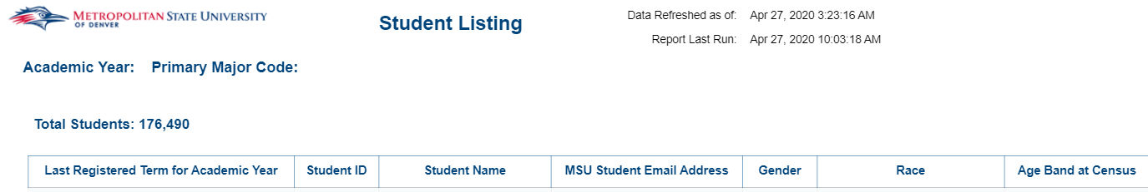
Student List_Graduates
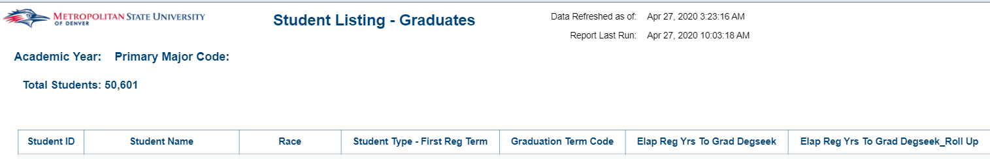
Applied Filters and Input Controls
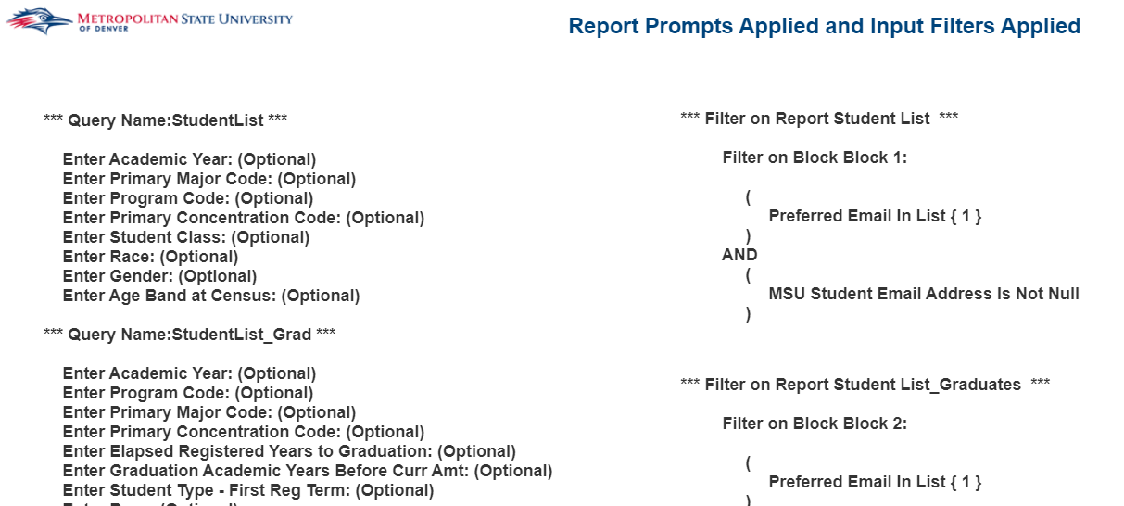

Athletics

Graduation Status Description – All Sports
Description: This report displays the graduation status for Student Athletes during a given term.
Data Elements: Graduation Term, Activity, ID, Name, Degree Code, Degree, Degree Status Code, Degree Status
Source: Student and Enrollment Universe
Location: Public Folders Athletics Graduation Status Description – All Sports
Prompts: Graduation Term (greater than or equal to term) (Required)
Input Controls: Activity, Degree Status
Report Page:

Student Athlete Courses and Grades
Description: This report lists the courses, meeting times and grades for Student Athletes during a given term.
Data Elements: Name, ID, Term, Reg Status, CRN, Subject, Course #, Course Title, Start Time, End Time, Meeting days, Building, Building Desc, Room, Credits, Final Grade, GPA by Term, Cumulative GPA
Source: Student and Enrollment Universe
Location: Public Folders Athletics Student Athlete Courses and Grades
Prompts: Term (Required)
Input Controls: Sport Cd
Report Page:
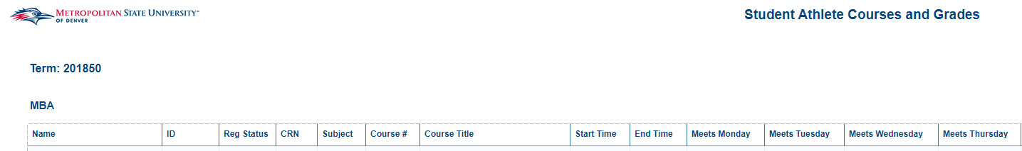

Student Athlete Eligibility Report
Description: This report lists the courses, credit hours and total credit hours for Student Athletes during the current term.
Data Elements: Name, ID, Subject, Course #, Section #, CRN, Registered Ind, Registration Status, Credit Hours
Source: Student and Enrollment Universe
Location: Public Folders Athletics Student Athlete Eligibility Report
Input Controls: None
Report Page:

Student Athlete Majors and Cipcodes
Description: This report lists student athletes and provides their field of study information for their majors and minors.
Data Elements: Student ID, Last Name, First Name, College, Primary Major, Secondary Major, Primary Minor, Class, Sport
Source: Student Admission and Enrollment Universe
Location: Public Folders Athletics Student Athlete Majors and Cipcodes
Prompts: Term
Input Controls: College, Term, Primary Major, Primary Minor, Sport, Class
Report Page:
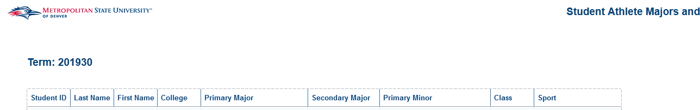

Student-Athlete Average Credit Hours
Description: This report displays the average credit hours for Student Athletes. The first tab displays graphs showing the trend of student athlete credit hours for the past 8 terms. It is broken down by each different sport. The second tab is a summary of the first tab and shows the actual data. The third tab displays each student athlete for the current term and their total enrolled credit hours. The fourth tab shows each student athlete for the current term and their total enrolled credit hours but broken out by Sport.
Data Elements: ID, Name, Total Enrolled Credit Hours, Sport
Source: Student and Enrollment Universe
Location: Public Folders Athletics Student – Athlete Average Credit Hours
Prompts: None
Input Controls: Term, Student Type, Financial Aid Accepted (Y/N), Residency Status
Report Page:
Average Credit Hour Trend
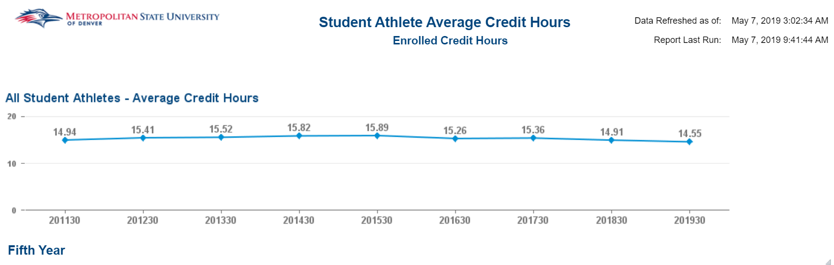
Summary
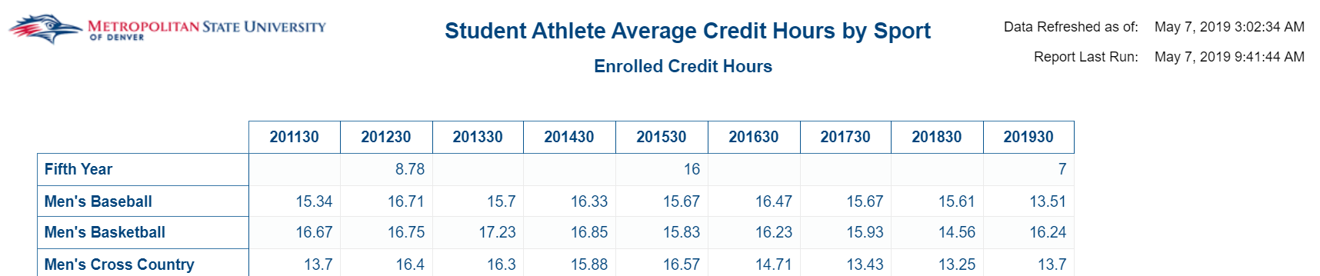

Student List by Term
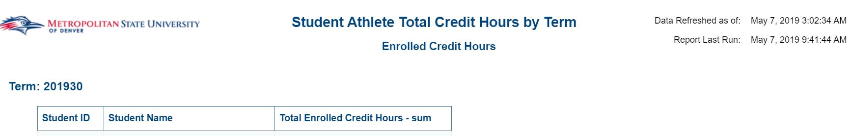
Student List by Sport
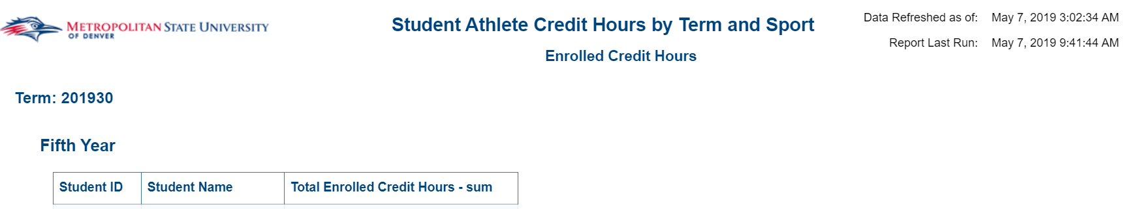

Chair Reports and Dashboards

Chair Dashboard – Enrollment – 5 Year Trend
Description: The Chair Dashboard - Enrollment - 5 Year Trend is an academic year-based dashboard. It captures the Credit Hour Production, Full-Time Equivalencies (FTES), Count of Enrolled Students by College, Department and Course Subject, as well as CHP by Instructional Method. The dashboard contains five tabs: Credit Hour Production, Full-Time Equivalents – UG, Full-Time Equivalents – GR, Enrollment, College and Department CHP by Instruction Method, and Course CHP by Instructional Method.
Data Elements:
- Credit Hour Production: Department, Term Description, Credit Hour Production (CHP) Trend (Charts), Academic Year, Department CHP Total, College CHP Total, Course Subject, Course Subject CHP Total
- Full-Time Equivalents - UG: Department, Term Description, Full-Time Equivalents (FTEs) Trend (Charts), Academic Year, College FTEs Total, Department FTEs Total, Course Subject, Course Subject FTEs Total
- Full-Time Equivalents - GR: Department, Term Description, Full-Time Equivalents (FTEs) Trend (Charts), Academic Year, College FTEs Total, Department FTEs Total, Course Subject, Course Subject FTEs Total
- Enrollment: Department, Term Description, Current Enrollment Amount Trend (Charts), Academic Year, College Enrollment Total, Department Enrollment Total, Course Subject, Course Subject Enrollment Total
- College & Department CHP by Instructional Method: Department, Term Description, College CHP Total (Chart), Academic Year, College CHP Total, Department CHP Total (Chart), Department CHP Total, Instructional Method, Instructional Method CHP Percentages
- Course CHP by Instructional Method: Department, Term Description, Course Subject, Course Subject CHP Total (Chart), Academic Year, Course Subject CHP Total, Instructional Method, Instructional Method CHP Percentages
Source: Student Admission and Enrollment Universe
Location: Public Folders Chair Reports and Dashboards Chair Dashboard – Enrollment – 5 Year Trend
Prompts: Department (Required)
Input Controls: Term Type, Course Funding, Course Subject Trend Chart
Report Page:

Credit Hour Production:
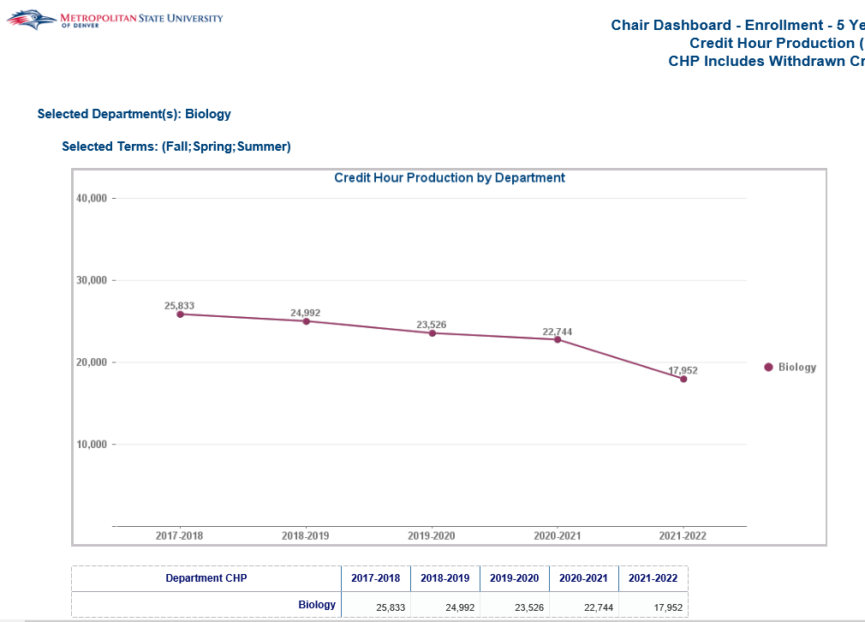
Full-Time Equivalents – UG:
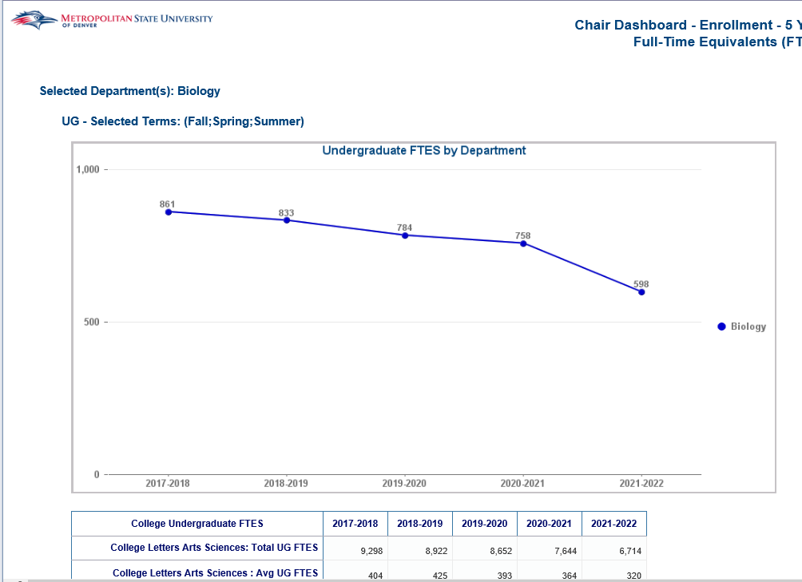

Full-Time Equivalents – GR:
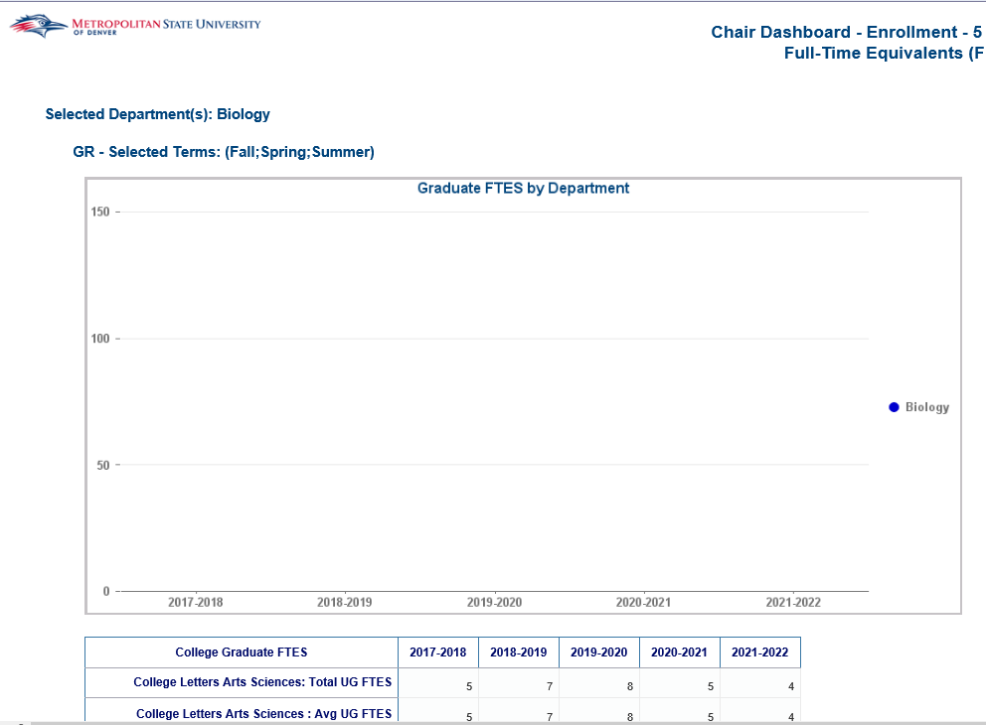
Enrollment:
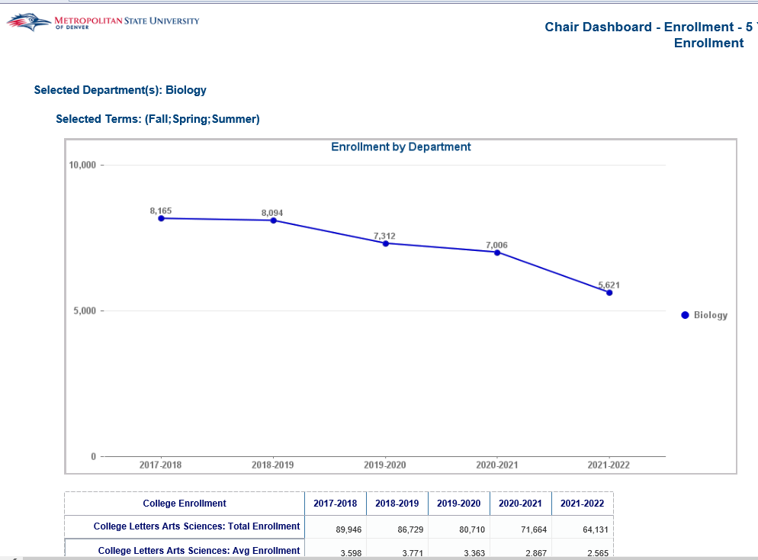

College & Department CHP by Instructional Method:
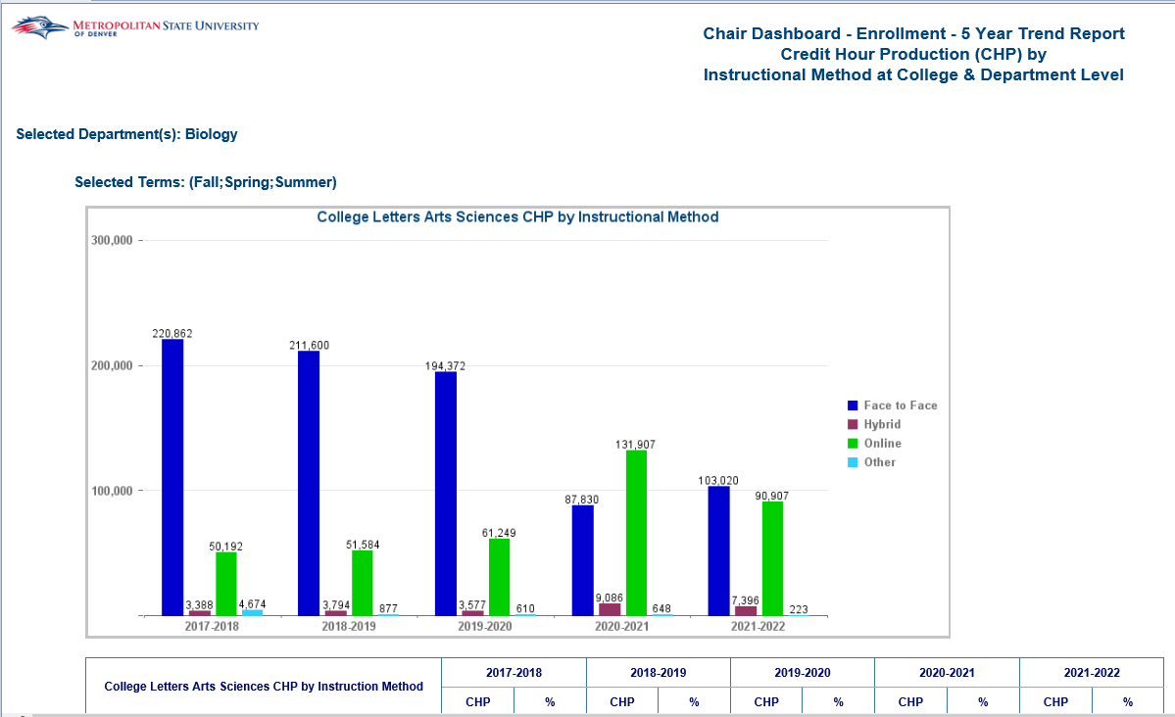
Course CHP by Instructional Method:
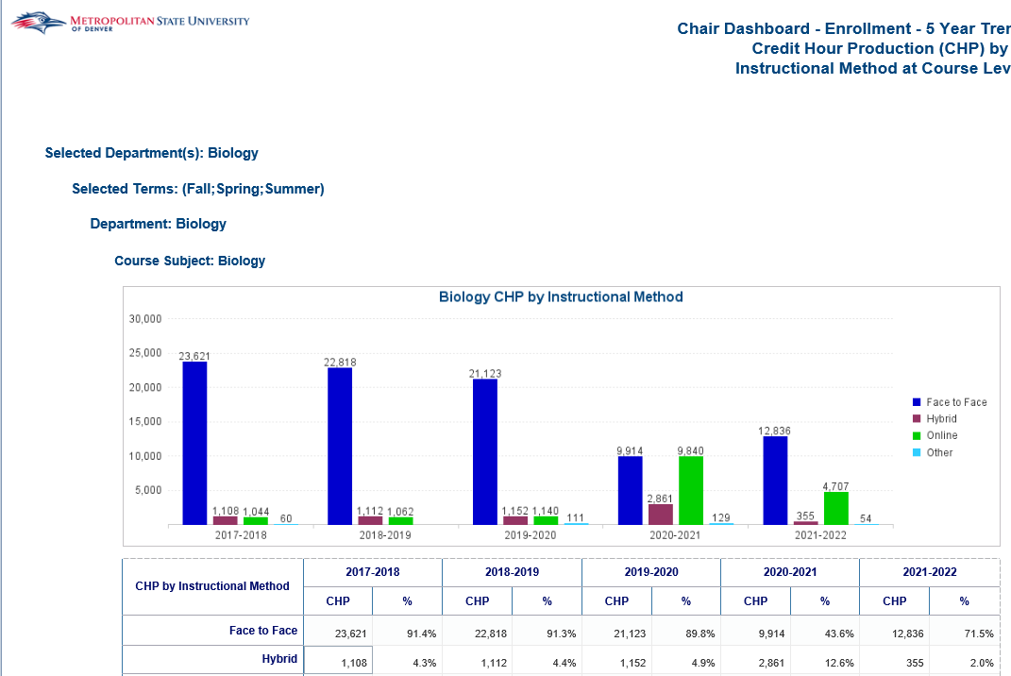

Chair Dashboard – Program – 5 Year Trend
Description: The Chair Dashboard - Program - 5 Year Trend is an academic year-based dashboard. It captures the number of students that have declared a certain Major and Minor, and the number of students that have graduated by College and Department. This report includes 4 tabs: Number of Majors, Number of Graduates, Number of Graduates – Demographics, and Number of Minors.
Data Elements:
- Number of Majors: Department, Term Description, Department Count of Majors (Charts), Count of Majors in Department (Charts), Academic Year, Department Count of Majors Total, College Count of Majors Total, College Average Number of Majors, Count of Majors in Department
- Number of Graduates: Department, Term Description, Department Count of Gradates (Charts), Count of Graduates in Department (Charts), Academic Year, Department Count of Graduates Total, College Count of Graduates Total, College Average Number of Graduates, Count of Graduates in Department by Major
- Number of Graduates – Demographics: Department, Term Description, Academic Year, College Count of Graduates Total, College Average Number of Graduates, Gender, Race/Ethnicity, First Generation Status, Average GPA
- Number of Minors: Department, Term Description, Count of Minors (Charts), Academic Year, Count of Minors
Source: Student Admission and Enrollment Universe
Location: Public Folders Chair Reports and Dashboards Chair Dashboard – Program – 5 Year Trend
Prompts: Department (Required), Primary Minor (Required)
Input Controls: Term Short Description, Student Level, College (Number of Majors), Department (Number of Majors), Primary Major Code (Number of Majors)
Report Page:

Number of Majors:
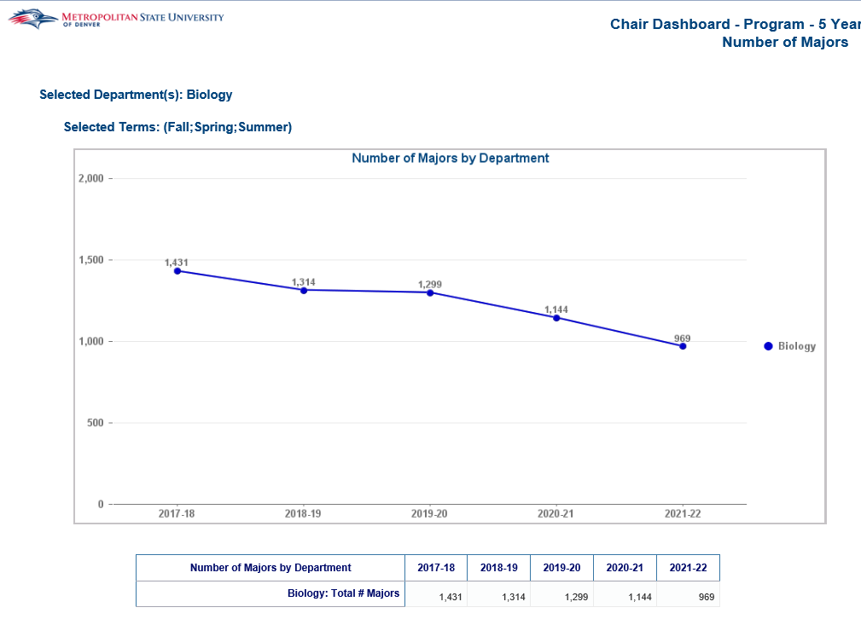
Number of Graduates:
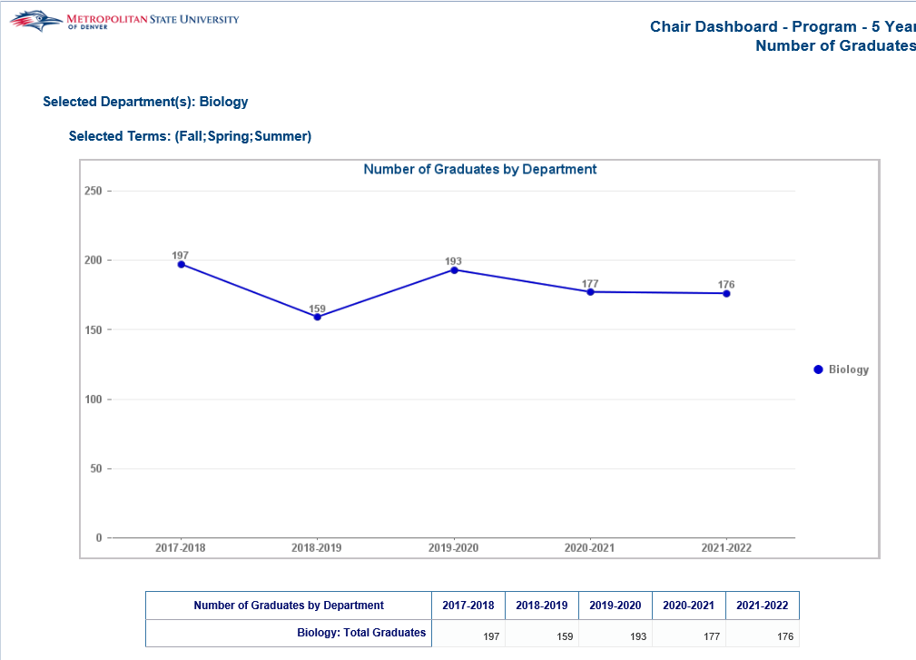

Number of Graduates – Demographics:
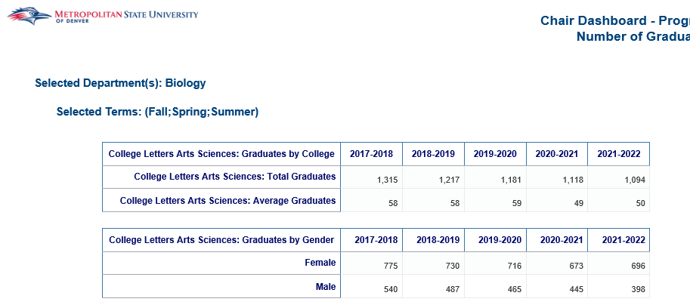
Number of Minors:
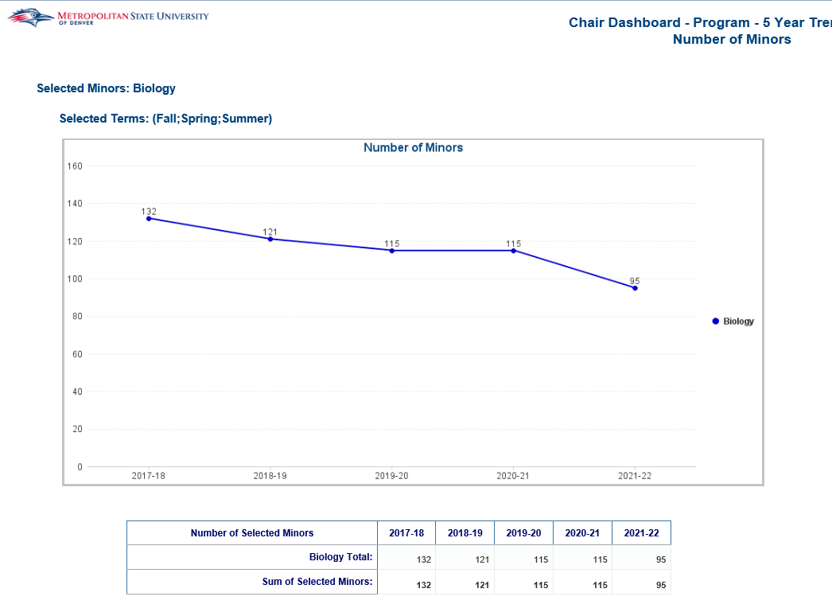

Chair Dashboard – Retention – 5 Year Trend
Description: The Chair Dashboard - Retention - 5 Year Trend is an academic year-based dashboard. It captures the number and percentage of students that have been retained from Fall to Spring and Fall to Fall by College and Department. The dashboard also captures DFWI rates by College and Department. This report includes 3 tabs: Fall to Spring Retention, Fall to Fall Retention, and DFWI Rates.
Data Elements:
- Fall to Spring Retention: Department, Retained Fall to Spring Percentage (Chart), Academic Year, Department Count of Retained Students, College Count of Retained Students, College Average Number of Retained Students
- Fall to Fall Retention: Department, Retained Fall to Fall Percentage (Chart), Academic Year, Department Count of Retained Students, College Count of Retained Students, College Average Number of Retained Students
- DFWI Rates: Department, Term Description, Department Percentage of DFWI Grades (Charts), Academic Year, Department Count of DFWI Grades Total, College Count of DFWI Grades Total, College Average Number of DFWI Grades
Source: Student Admission and Enrollment Universe
Location: Public Folders Chair Reports and Dashboards Chair Dashboard – Retention – 5 Year Trend
Prompts: Department (Required)
Input Controls: None
Report Page:
Fall to Spring Retention:
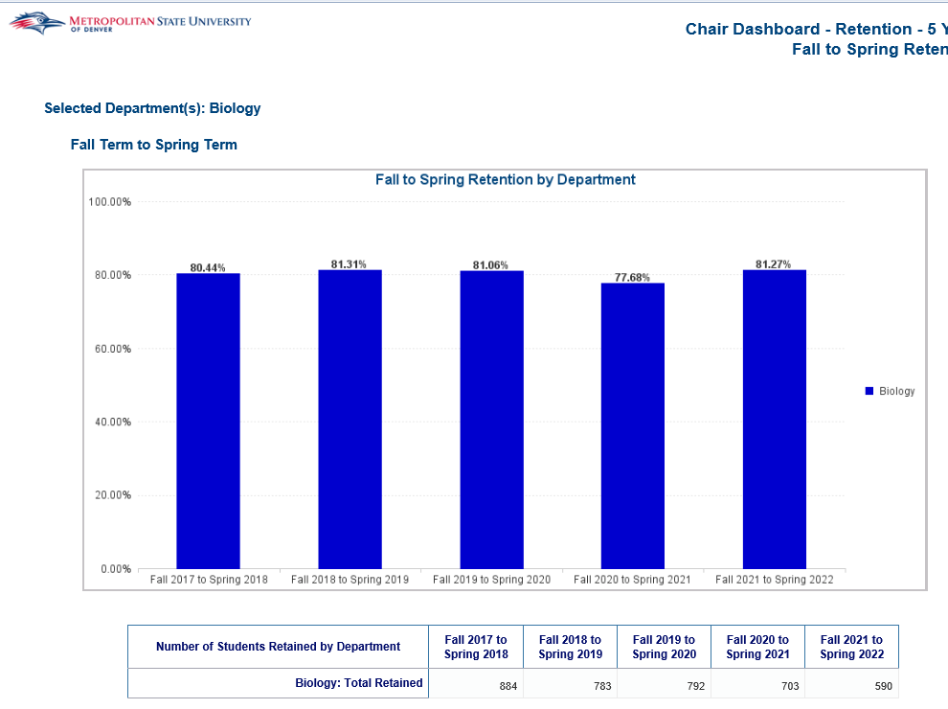
Fall to Fall Retention:
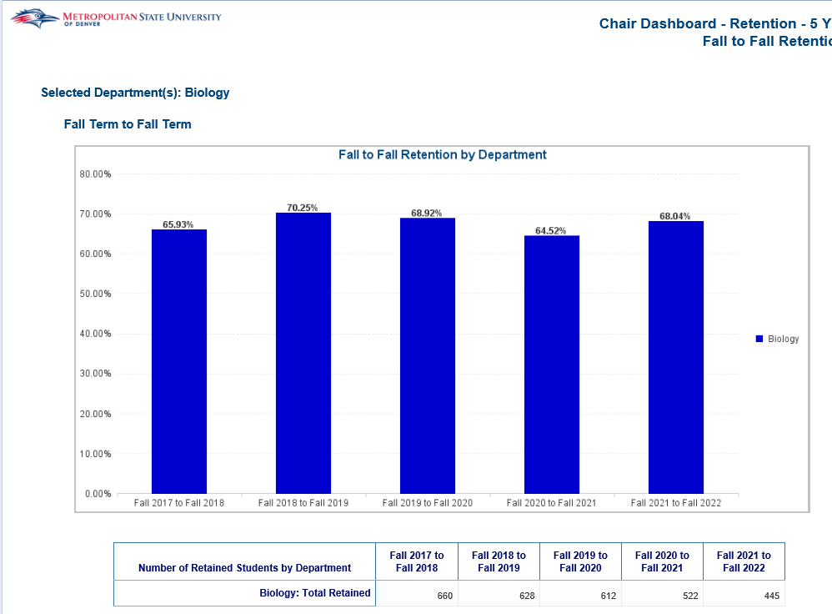
DFWI Rates:
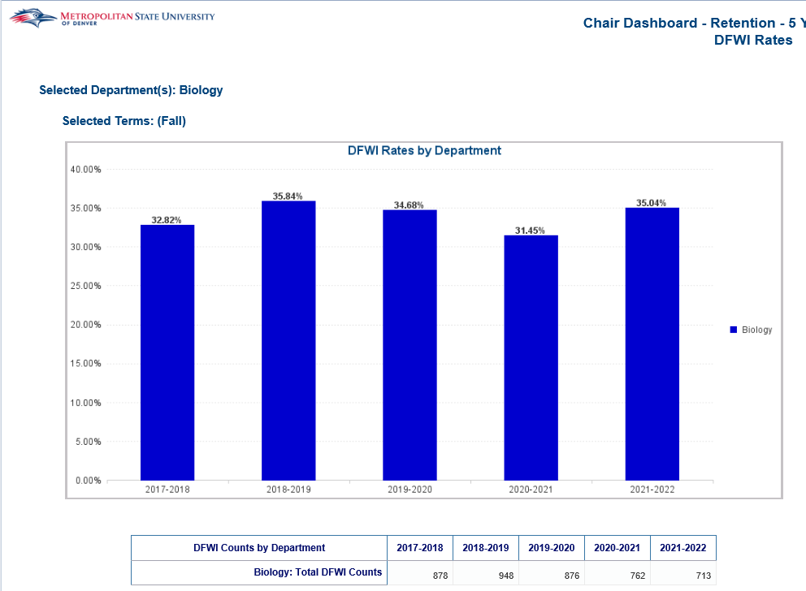

Chair Dashboard – Scheduling – 5 Year Trend
Description: The Chair Dashboard - Scheduling - 5 Year Trend is an academic year-based dashboard. It captures the CHP taught by Faculty Category, the count of Course Sections offered, the Section Fill Rate by College, Department and Course Subject. This report includes 4 tabs: College & Department CHP by Faculty Type, Course CHP by Faculty Type, Count of Sections, and Section Fill Rate
Data Elements:
- College & Department CHP by Faculty Type: College, Department, Term Description, College CHP Total (Chart), Faculty Type (Chart), College CHP Total, Academic Year, Percentage of College CHP by Faculty Type, Department CHP Total (Chart), Faculty Type (Chart), Department CHP Total, Percentage of Department CHP by Faculty Type
- Course CHP by Faculty Type: Department, Term Description, Course Subject, Course CHP Total (Chart), Faculty Type (Chart), Course CHP Total, Academic Year, Percentage of Course CHP by Faculty Type
- Count of Sections: Department, Term Description, Department Count of Sections (Charts), Academic Year, Department Count of Sections Total, College Count of Sections Total, College Average Number of Sections, Course Subject Count of Sections (Charts), Academic Year, Course Subject Count of Sections Total
- Section Fill Rate: Department, Term Description, Department Section Fill Rate (Chart) Academic Year, Department Section Seats Filled Count, Department Section Seat Fill Rate, College Seats Filled Count, College Average Seats Filled Count, Course Subject Section Fill Rate (Chart), Course Subject Seats Filled Count, Course Subject Seat Fill Rate
Source: Student Admission and Enrollment Universe
Location: Public Folders Chair Reports and Dashboards Chair Dashboard – Scheduling – 5 Year Trend
Prompts: Department (Required)
Input Controls: Term Type, Course Funding, Instructional Method, Course Subject Trend Chart (Count of Sections, Section Fill Rate)
Report Page:

College & Department CHP by Faculty CHP:
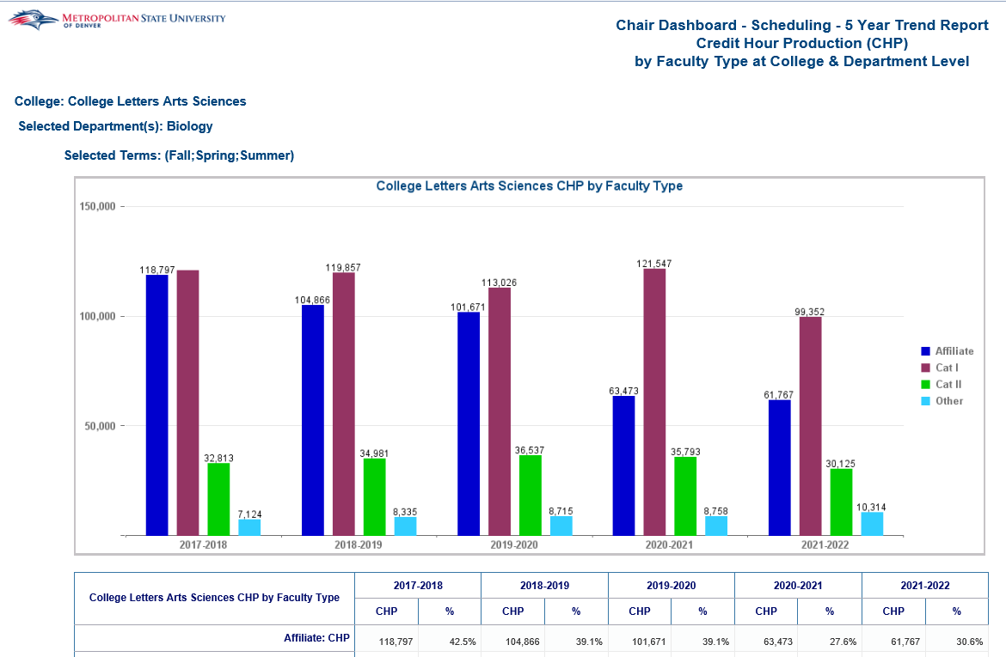
Course CHP by Faculty CHP:
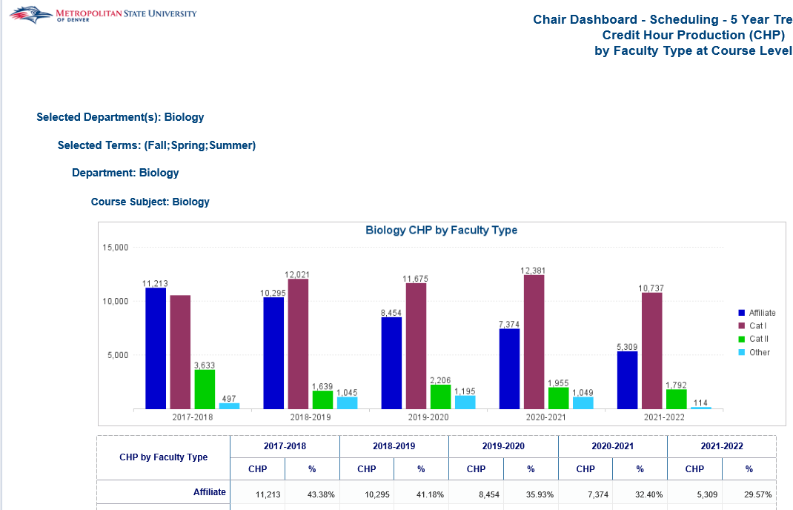

Count of Sections:
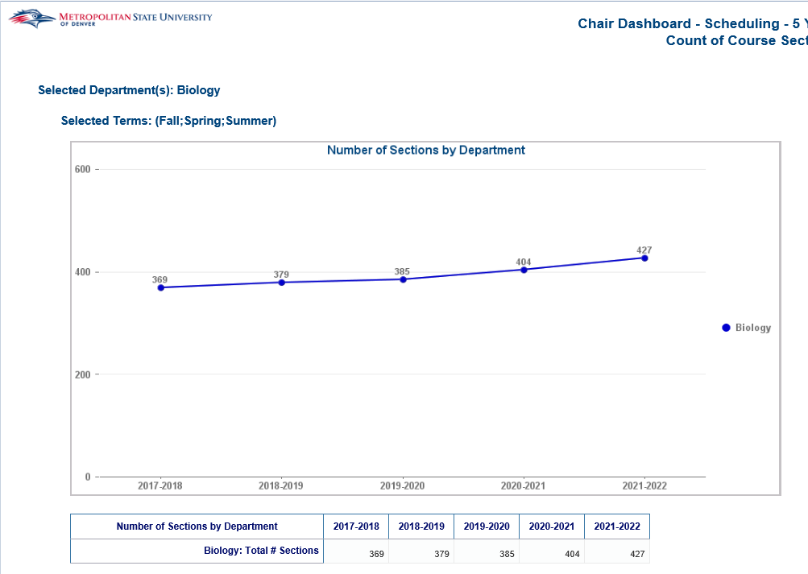
Section Fill Rate:
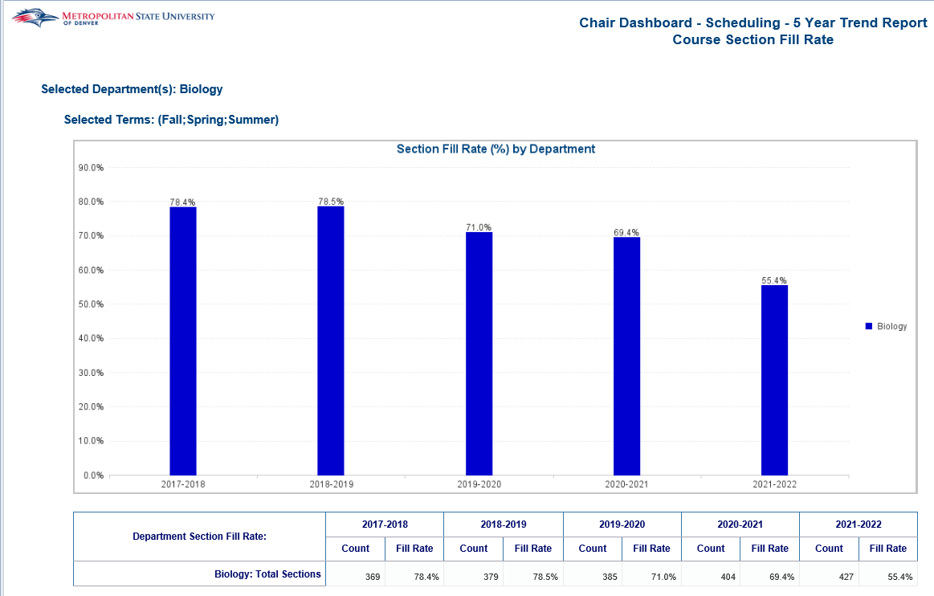

CHP-FTES-Headcount

7 Year Operational Report - FTES and CHP
Description: The report displays CHP (Credit Hour Production) and FTES (Full Time Equivalent Student) trends for the last 7 years. This is four reports: CHP and FTE overall 7 Year Trend, CHP and FTE Undergraduate 7 year trend by Race and Gender, FTES by College, Department and Subject Course, and CHP by College, Department and Subject Course.
Data Elements:
- CHP and FTE Overall Trend: CHP and FTE overall 7 year trend by Undergraduates and Graduates.
- CHP and FTE Undergraduate Trend Race and Gender: Undergraduate CHP and FTE 7 year trend by Race, Undergraduate FTE 7 year trend by Gender
- FTE College, Department, Subject and Course: Undergraduate and Graduate FTE 7 year trend by College, Department, Subject and Course
- CHP College, Department, Subject and Course: Undergraduate and Graduate CHP 7 year trend by College, Department, Subject and Course
Source: Student Admission and Enrollment Universe
Location: Public Folders CHP-FTES-Headcount 7 Year Operational Report – FTES and CHP
Prompts: None
Input Controls: Course Funding, Term Description, Couse Level Cd, College, Department, Course Subject, Gender, Race
Report Page:
CHP & FTP Overall Trend
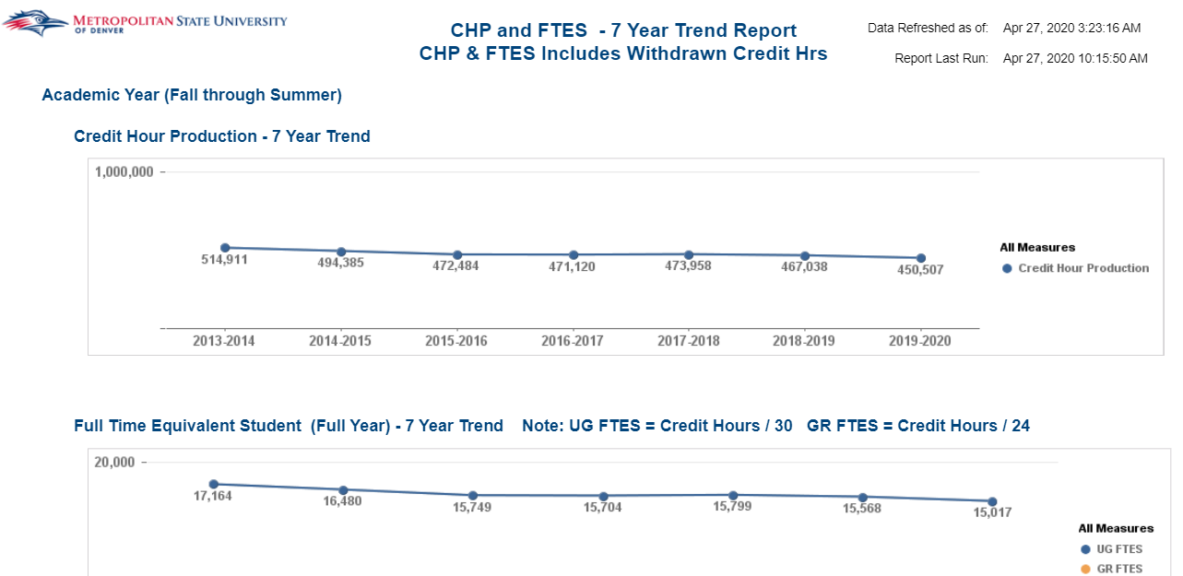
CHP and FTE Undergraduate Trend Race and Gender
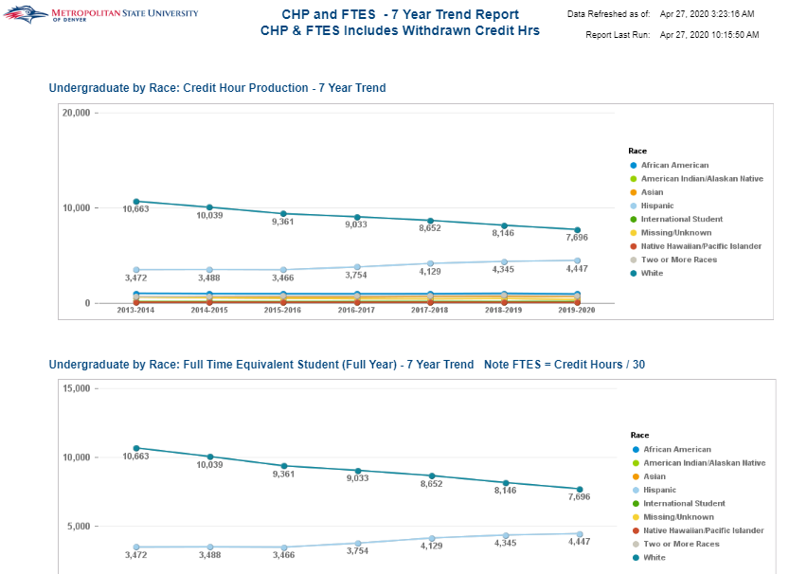
FTES College, Department, Subject and Course
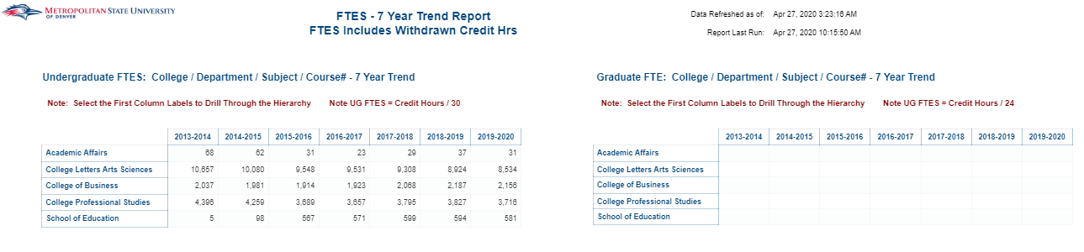

CHP College, Department, Subject and Course
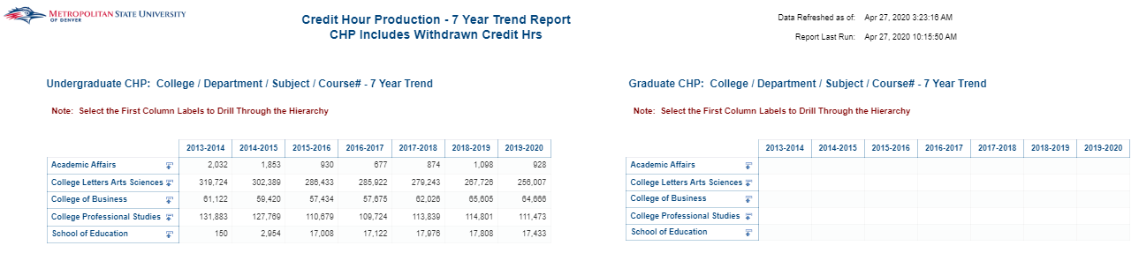

7 Year Operational Report – Student Headcount
Description: The report displays Headcount trends for the last 7 years. Headcount overall 7 Year Trend by Race, Gender,
Student Class and Student Level. Headcount 7 year trend by College, Department, Major and Concentration
(Table Format). Headcount 7 year trend by College, Department, Major and Concentration (Chart Format).
Data Elements:
- Headcount Overall Trend: Headcount overall 7 year trend by Race, Gender, Student Class and Student
Level.
- Headcount College, Department, Major and Concentration Table: Headcount 7 year trend by College, Department, Major and Concentration (Table Format). Select the first column labels to drill through the hierarchy.
- Headcount College, Department, Major and Concentration Chart: Headcount 7 year trend by College, Department, Major and Concentration (Table Format). Select the first column labels to drill through the hierarchy.
Source: Student Admission and Enrollment Universe
Location: Public Folders CHP-FTES-Headcount 7 Year Operational Report - Headcount
Prompts: None
Input Controls: Term, Student Level, College, Department, Major, Concentration, Race, Gender, Age Band, Student Class
Report Page: Headcount Overall Trend; Headcount College, Department, Major and Concentration Table (Drilldown
Report); Headcount College, Department, Major and Concentration Chart (Drilldown Report)
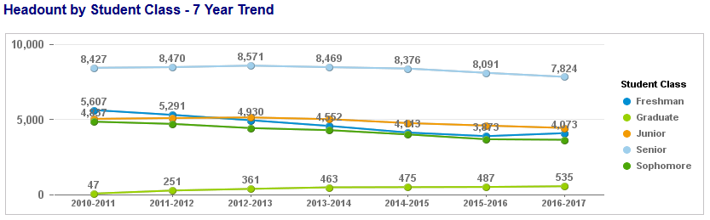
Headcount Overall Trend
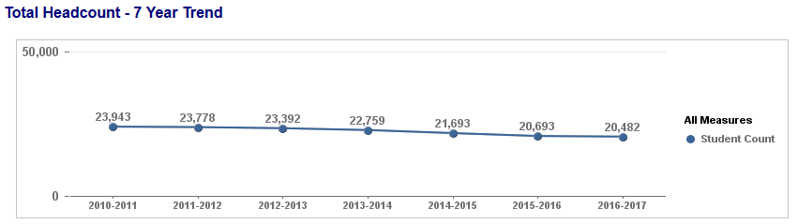
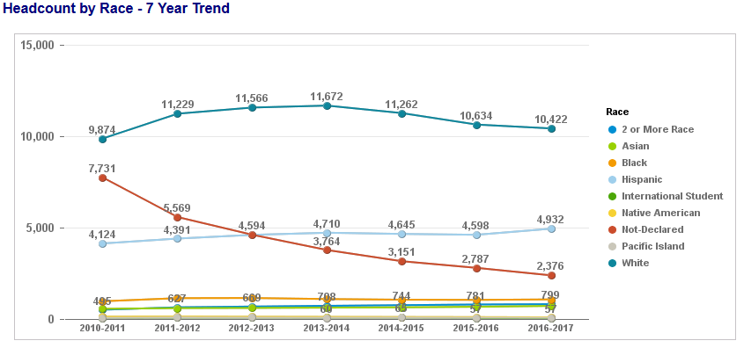
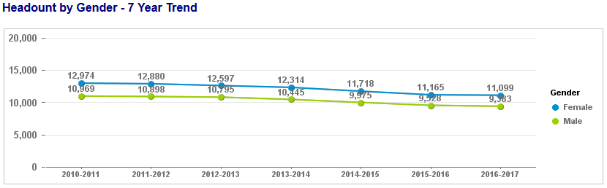

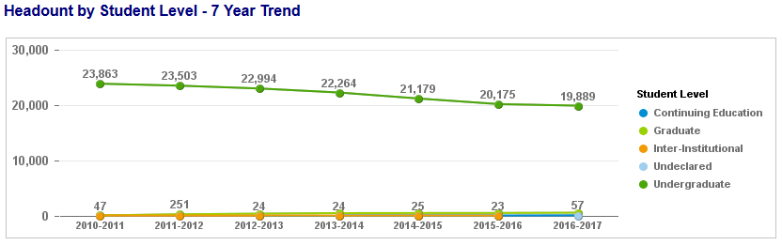
Headcount College, Department, Major and Concentration Table (Drilldown Report)
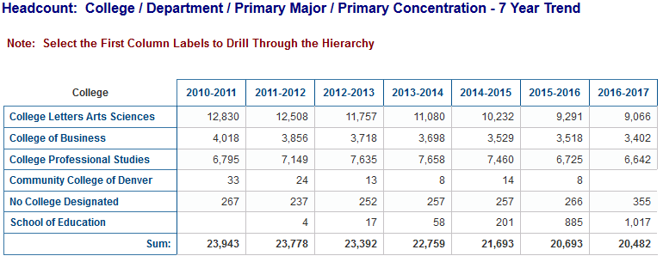
Headcount College, Department, Major and Concentration Chart (Drilldown Report)
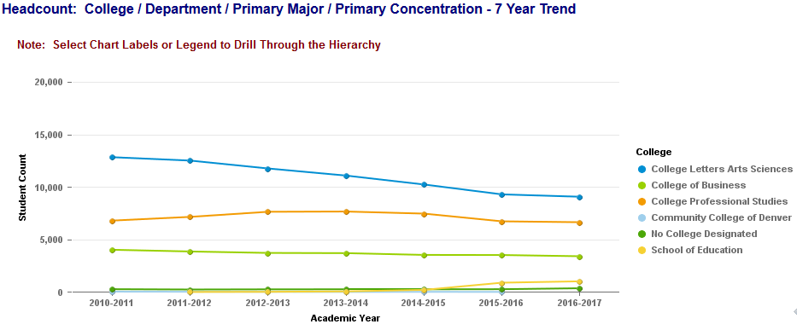

Billing Hour Production at Census Date
Description: This report displays Billing Hour Production (BHP) for each Course Section. The BHP is broken out by Department, Subject, Course Number and Section Number. There are two tabs in this report. One tab is for State Funded Courses while the other is for Cash Funded Courses.
When running this report before the Term Census Date the data will be as of the refresh date; after the Term Census Date the data will be a snapshot of the Census Date.
Billing Hour Production (BHP) is calculated by summing the billing hours for the students in the course.
Data Elements: Term Code, College, Department, Subject Code, Course #, Section #, CRN, Faculty Name, Faculty Type, Campus Code, Course Delivery, Credit Type, Billing Hours, Registered Count, BHP
Source: Student Admission and Enrollment Universe
Location: Public Folders CHP-FTES-Headcount Billing Hour Production at Census Date
Prompts: Term
Input Controls: College, Department, Subject
Report Page:
State Funded
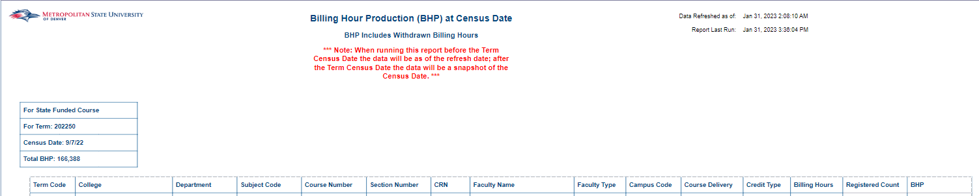
Cash Funded
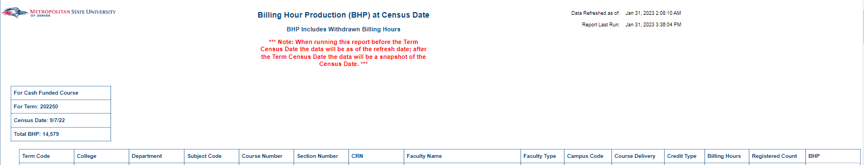

Credit Hour Production at Census Date
Description: This report displays Credit Hour Production (CHP) for each Course Section. The CHP is broken out by Department, Subject, Course Number and Section Number. There are two tabs in this report. One tab is for State Funded Courses while the other is for Cash Funded Courses.
When running this report before the Term Census Date the data will be as of the refresh date; after the Term Census Date the data will be a snapshot of the Census Date.
Credit Hour Production (CHP) is calculated by multiplying the Registered Count of students in a course by the average credit hours for the course.
Data Elements: Term Code, College, Department, Subject Code, Course #, Section #, CRN, Faculty Name, Faculty Type, Campus Code, Course Delivery, Credit Type, Avg Credit Hrs, Registered Count, CHP
Source: Student Admission and Enrollment Universe
Location: Public Folders CHP-FTES-Headcount Credit Hour Production at Census
Prompts: Term
Input Controls: College, Department, Subject
Report Page:
State Funded
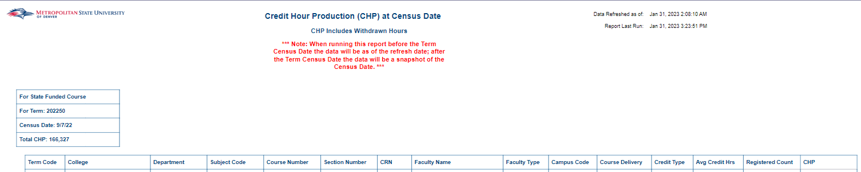
Cash Funded
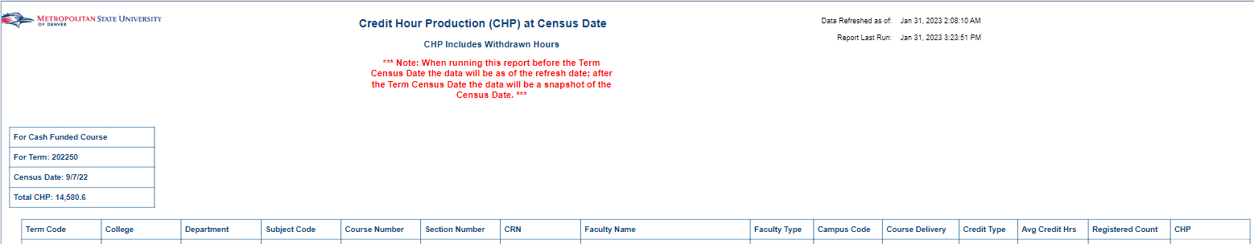

Credit Hour Production at End of Term
Description: The report displays Credit Hour Production (CHP) by faculty at the end of the term. The first tab lists the CHP for faculty by each course prefix. The second tab lists CHP for faculty by CRN and is broken out by College and Subject. Using the Input Controls (listed below) you can select single or multiple Colleges, Departments and Faculty Types.
Data Elements:
- CHP by Faculty: Department, Subject, Primary Instructor, Faculty Type, CHP, Instructional Method
- CHP by Faculty – Part 2: Subject Code, CRN, Course Section #, Course #, Faculty Type, Faculty ID, Primary Instructor, Instructional Method, CHP
Source: Student Admission and Enrollment Universe
Location: Public Folders CHP-FTES-Headcount Credit Hour Production at End of Term
Prompts: Term
Input Controls: College, Department, Faculty Type
Report Page:
CHP by Faculty
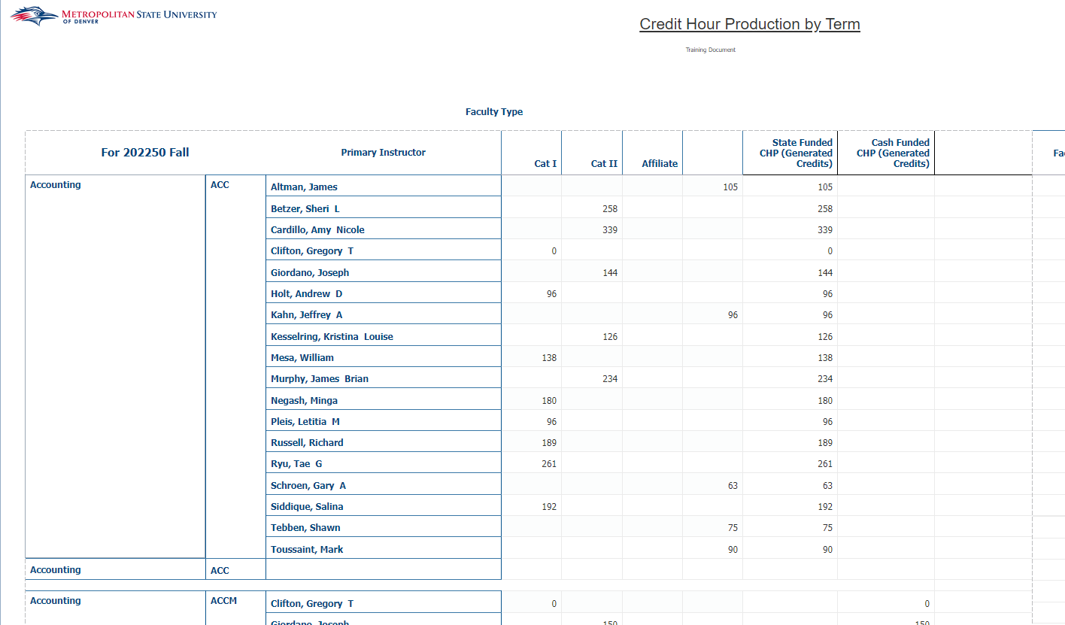
CHP by Faculty – Part 2
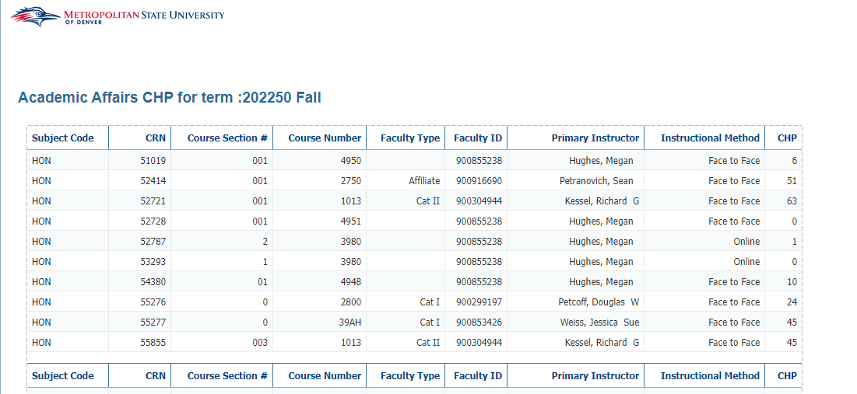

I&LL CHP by Term
Description: The report displays Credit Hour Production (CHP) for the Innovative and Life-Long Learning (I&LL) Department by Term. The report provides a summary of all I&LL CHP by College, Student Attribute, Course Detail Codes and Course Attributes. The report also provides detail data on Student Attributes, Course Detail Codes and Course Attributes over five tabs.
Data Elements:
- I&LL CHP - Summary: Term Code, College Code Long, Student Attribute Code, Student Attribute Desc, Detail Code, Detail Desc, Course Attribute Code, Course Attribute Desc, CHP
- I&LL CHP – Student Attr: Term Code, College Code Long, Student Attribute Code, Student Attribute Desc, College, Department, Course Subject, CHP
- I&LL CHP – Student Detail: Term Code, College Code Long, Student Attribute Code, Student Attribute Desc, College, Department, Course Subject, Course Number, Course Section Number, Student ID, CHP
- I&LL CHP – Detail Codes: Term Code, College Code Long, Detail Code, Detail Description, College, Subject Code, Course Number, Course Section Number, Tuition Fee Waiver Ind, Course Delivery Method, CHP
- I&LL CHP – EXTN: Term Code, College Code Long, Course Attribute Code, Course Attribute Desc, College, Department, Subject Code, Course Delivery Method, Tuition Fee Waiver Ind, CHP
Source: Student Admission and Enrollment Universe
Location: Public Folders CHP-FTES-Headcount I&LL CHP by Term
Prompts: Term Code (Required)
Input Controls: None
Report Page:
I&LL CHP – Summary:
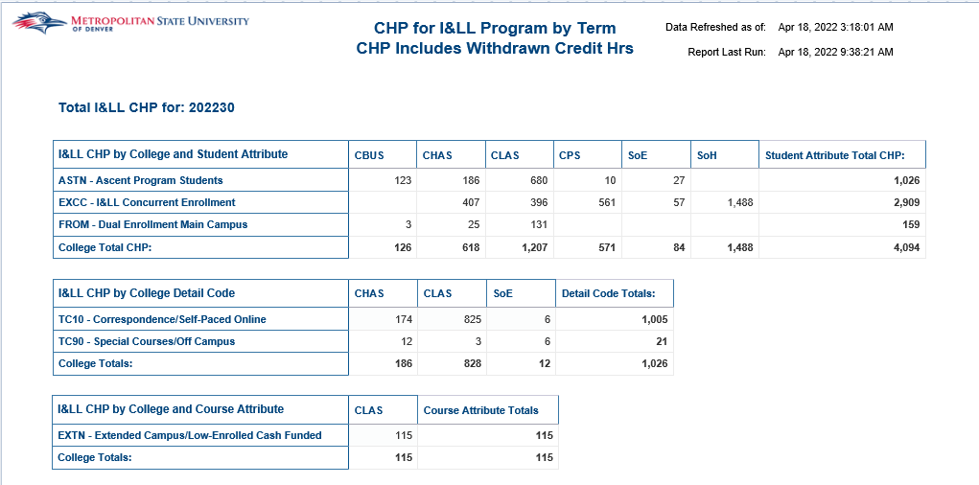
Report Page (Cont.):
I&LL CHP – Student Attr:
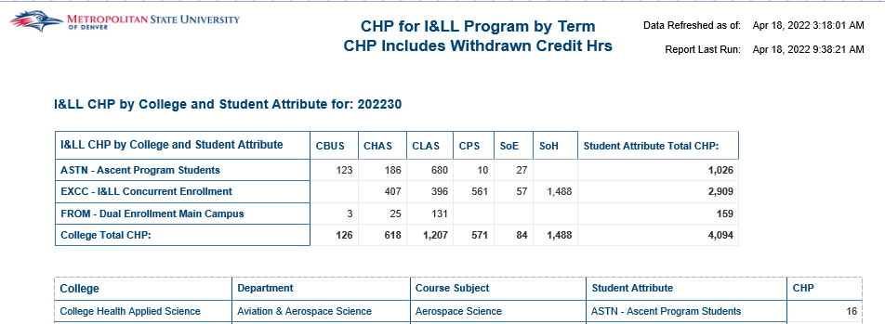
I&LL CHP – Student Detail:
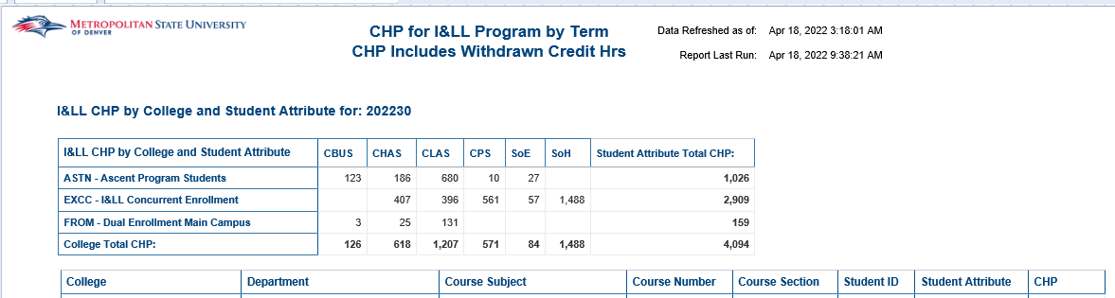
I&LL CHP – Detail Codes:
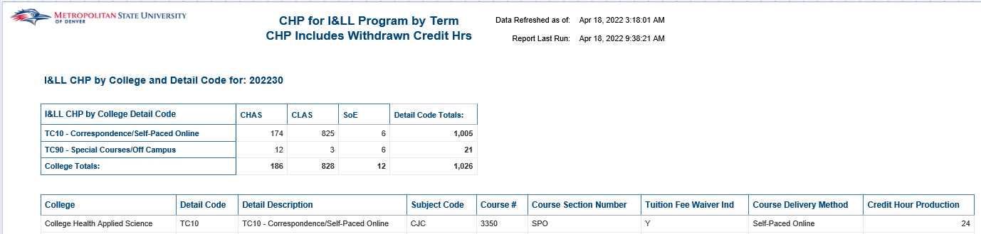

Report Page (Cont.):
I&LL CHP – EXTN:
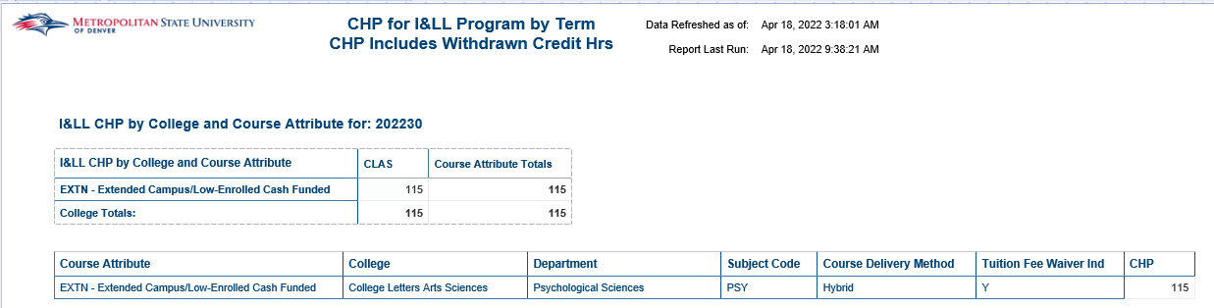

Student Enrollment Count - Census
Description: This report shows all registered students as of Census Date. Prior to census date, data is current as of refresh date. Students that drop all courses prior to registration are not included. Students with withdrawal after Census are included. Individual students are listed, and also aggregated by major and by minor.
Data Elements:
- Headcount Summary: Academic Year, Term Code, College, Department, Student ID, Student Name, Student Type, Student Level, Primary Major Code, Primary Minor Code, Primary Concentration Code
- Headcount by Major: Academic Year, Term Code, Primary Major Code, Student Count
- Headcount by Minor: Academic Year, Term Code, Primary Minor Code, Student Count
Source: Student Admission and Enrollment Universe
Location: Public Folders CHP-FTES-Headcount Student Enrollment Count - Census
Prompts: Term
Input Controls: Term Code, Student Level, Student Type, College, Department, Primary Major Code, Primary Minor Code, Primary Concentration Code
Report Page: Headcount by Summary
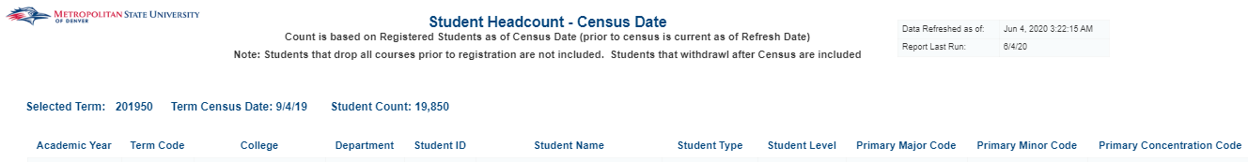
Headcount by Major
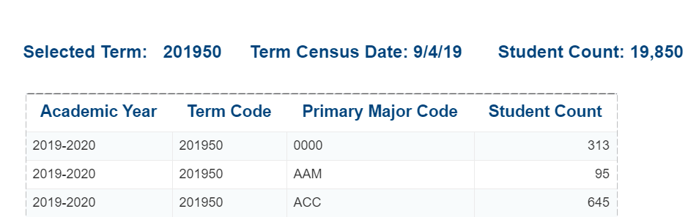

Headcount by Minor
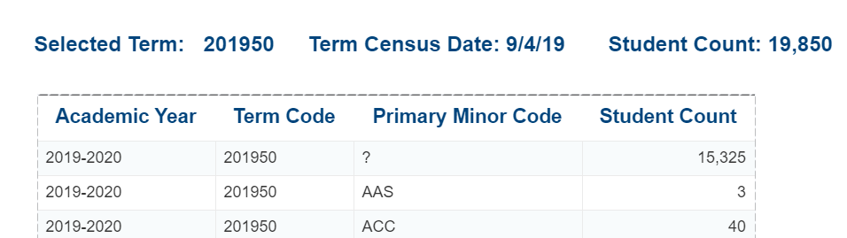

Student Headcount by Major – Date to Date Comparison
Description: This report displays tables detailing the headcount and percentage changes of student enrollment by major for one semester, between two user selected days before and after census.
Data Elements: Major, Enrollment Count, Percentage Change, Term, Day 1 – before or after census, Day 2 – before or after census
Source: Student and Enrollment Universe
Location: Public Folders CHP-FTES-Headcount Student Headcount by Major – Date to Date Comparison
Prompts: Term 1 Code, Day 1 Number of days before or After Census, Day 2 Number of days before or After Census
Input Controls: College, Department, Major, and Concentration
Report Page:

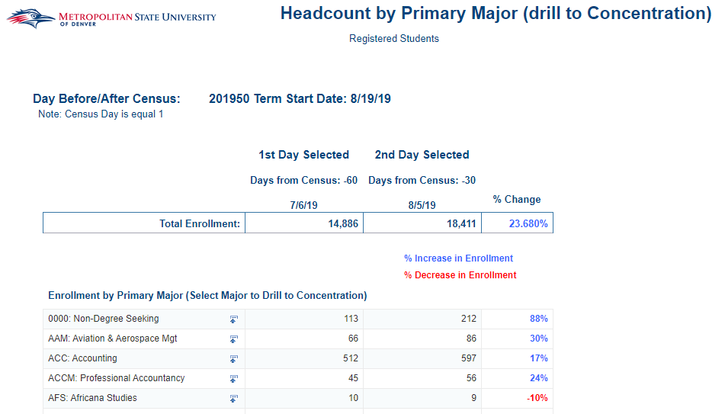

Student Headcount by Major (Drill to Concentration)
Description: This report displays tables and charts detailing the headcount and percentage changes of student enrollment by major between two user selected terms and number of days after the census. You can drill down to the concentrations for each major. There is a second tab that shows the current headcount for each major by 1st major, 2nd major and Tertiary Major.
Data Elements: Major, Enrollment Count, Percentage Change, Term 1, and Term 2
Source: Student and Enrollment Universe
Location: Public Folders CHP-FTES-Headcount Student Headcount by Major (Drill to Concentration)
Prompts: Day Number Before or After Census, Term 1 Code, Term 2 Code (All Required)
Input Controls: College, Department, Major, and Concentration
Report Page:
Headcount by Primary Major
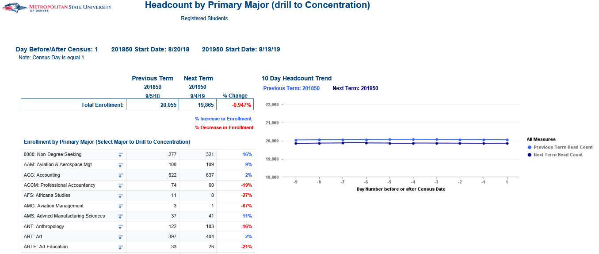

Headcount by Primary, Secondary, Tertiary
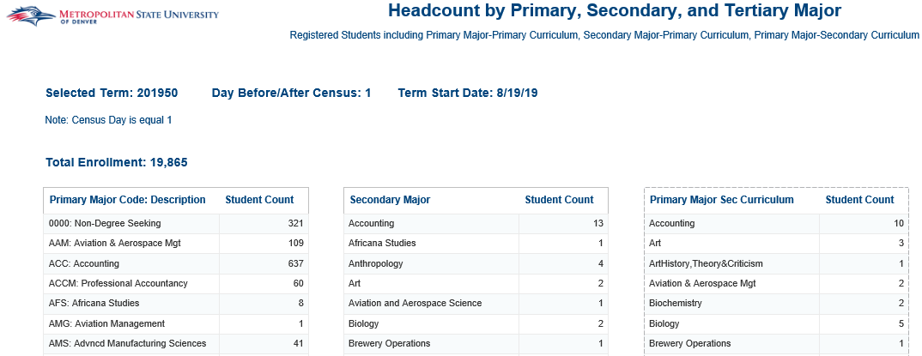

Student Headcount by Minor
Description: This report displays tables and charts detailing the headcount and percentage changes of student enrollment by minor between two user selected terms and number of days after the census.
Data Elements: Minor, Enrollment Count, Percentage Change, Term 1, and Term 2
Source: Student and Enrollment Universe
Location: Public Folders CHP-FTES-Headcount Student Headcount by Minor
Prompts: Day Number Before or After Census, Term 1 Code, and Term 2 Code (All Required)
Input Controls: Minor
Report Page:
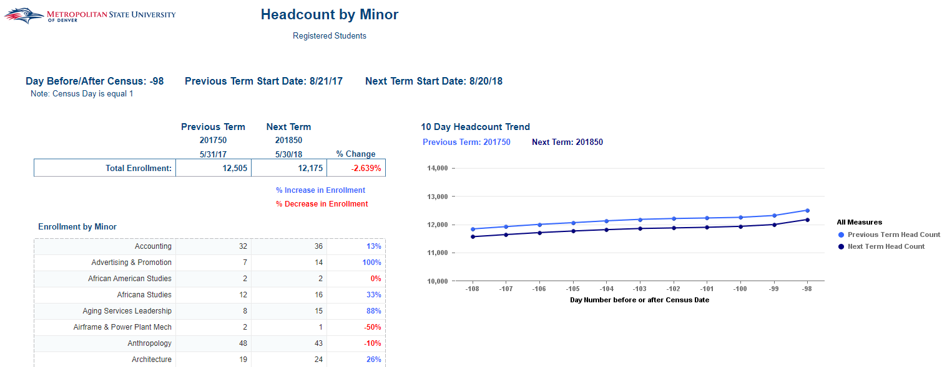

Course Subject and Class

Back to Back Classes
Description: Lists students for that are registered for an online course and an in-person course that occur within 160 minutes of each other. The report provides information on both courses including the location of the courses, meeting days and times.
Data Elements: Student Id, Student Name, Msu Email Address, Primary Major Code, Course Number A, Course Reference Number A, Course Section Number A, Course Subject Cd A, Billing Hrs Amt A, Building Cd A, Building Desc A, Course Meeting Begin Time A, Course Meeting End Time A, Instructional Method A, Meets Monday A, Meets Tuesday A, Meets Wednesday A, Meets Thursday A, Meets Friday A, Meets Sunday A, Part of Term Cd A, Part of Term Desc A, Registration Status Cd A, Registration Status Desc A, Room Number Cd A, Room Number Desc A, Schedule Type Cd A, Schedule Type Desc A, Section Status Cd A, Section Status Desc A, Course Section Number B, Course Subject Cd B, Billing Hrs Amt B, Building Cd B, Building Desc B, Course Meeting Begin Time B, Course Meeting End Time B, Instructional Method B, Meets Monday B, Meets Tuesday B, Meets Wednesday B, Meets Thursday B, Meets Friday B, Meets Sunday B, Part of Term Cd B, Part of Term Desc B, Registration Status Cd B, Registration Status Desc B, Room Number Cd B, Room Number Desc B, Schedule Type Cd B, Schedule Type Desc B, Section Status Cd B, Section Status Desc B, Time Between Classes
Source: Student Admission and Enrollment Universe
Location: Public Folders Course Subject and Class Back to Back Classes
Prompts: Term Code
Input Controls: None
Report Page:
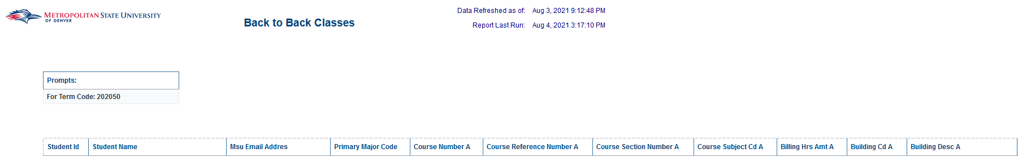

CBUS Course List by Term
Description: This report displays a list of students, courses and the faculty assigned to those courses for the College of Business for a user selected term. The report includes a course count, undergraduate and graduate student count, and the faculty count for the selected term.
Data Elements: Course Reference Number, Subject Code, Couse Number, Course Title, Course Section Number, Student ID, Student First Name, Student Last Name, Primary Major Code, MSU Email Address, Primary Instructor, Faculty ID, Faculty Email
Source: Student Admission and Enrollment Universe
Location: Public FoldersCourse Subject and Class CBUS Course List by Term
Prompts: Term Code, Primary Major Code
Input Controls: Student Level, Primary Major Code
Report Page:
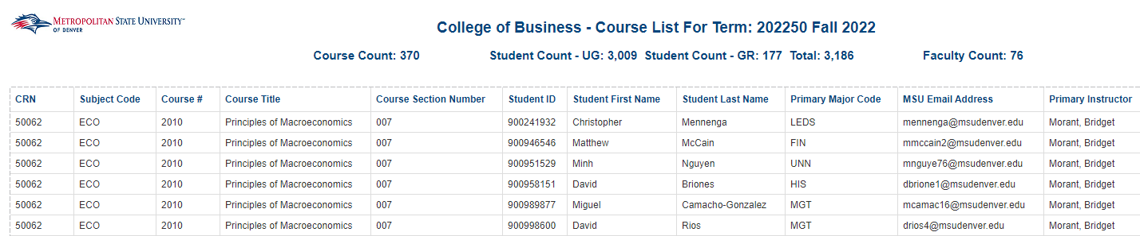
Report Page (Cont.):

Course Coding Audit
Description: This report displays details on courses for MSU Colleges ONLY or for courses without an assigned college. College codes being accounted for are 'AA','BU','ED','HS','LA','PS','SH' and '00'. This report is utilized to review coding for the courses.
Data Elements: Campus Code, College Code, Department Code, Course Title, CRN, Course Subject Cd: Course#, Course Section Number, Section Status Code, Instructional Method Code, Grading Mode Code, Special Approval Code, Part of Term Code, Meeting Type Code, Course Meeting Begin Time, Course Meeting End Time, Building Code, Room Code.
Source: Student Admission and Enrollment Universe
Location: Public FoldersCourse Subject and Class Course Coding Audit
Prompts: Term Code, MSU College Code, Department Code
Input Controls: Term Code, MSU College Code, Department Code
Report Page:
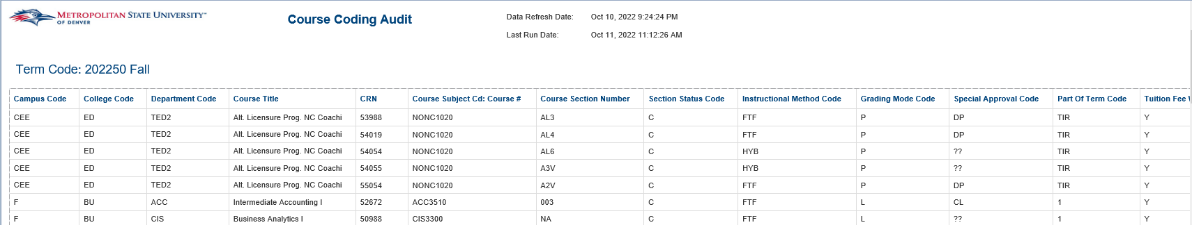
Report Page (Cont.):
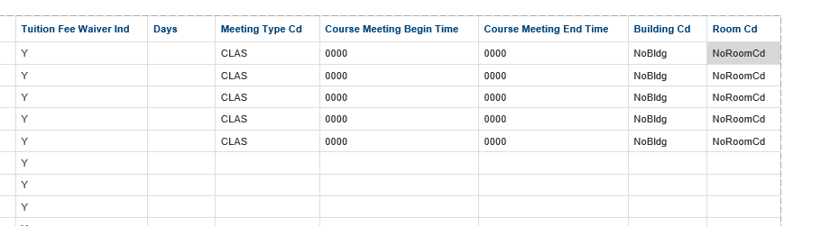

Course Delivery Method Summary
Description: This report compares courses and course enrollment by course delivery method across several terms. The report has 5 tabs: Summary, Registered Students, FTES, Courses by Delivery Method, Students by Course Delivery Method.
Data Elements:
Summary: Term, Student Count, FTE – UG (Academic Year), FTE – GR (Academic Year), Course Delivery Method, Term Instructional Method
Registered Students: College, Department, Primary Major Code: Description, Term, Student Count
FTES: College, Department, Primary Major Code: Description, Term, FTE – UG (Academic Year), FTE – GR (Academic Year)
Courses by Delivery Method: College, Department, Subject CD, Term, Course Delivery Method
Students by Course Delivery Method: College, Department, Primary Major Code: Description, Term, Term Instructional Method, Student Count
Source: Student Admission and Enrollment
Location: Public Folders Course Subject and Class Course Delivery Method Summary
Prompts: Term Code
Input Controls: None
Report Page:
Summary:
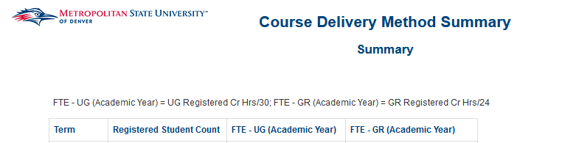
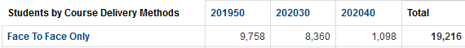

Registered Students
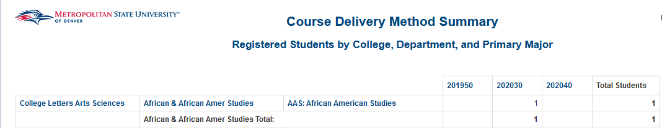
FTES
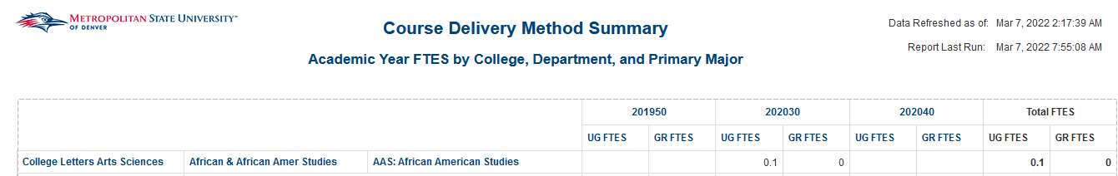
Courses by Delivery Method
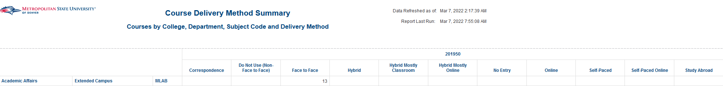
Students by Course Delivery Method
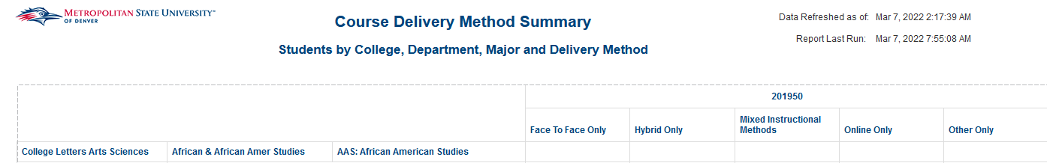

Course Enrollment by Subject
Description: This report displays Enrollment by Subject and Course. It allows you to compare the current term to the previous year’s term. The first tab shows enrollment by subject and course as well as the % change between the current term and the previous year’s term. The second tab is a graph that displays the FTES trend for 10 days prior to Census date.
Data Elements: Course, Term 1, Term 2, % Change
Source: Student and Enrollment Universe
Location: Public Folders Course Subject and Class Course Enrollment by Subject
Prompts: Term 1, Days before/after Census, Term 2 (All Required)
Input Controls: Course Funding, Course Level, College, Department, Course Subject
Report Page:
Enrollment by Subject
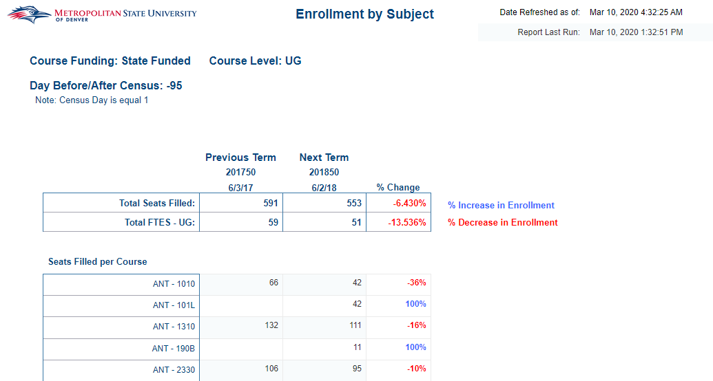

10 Day FTES Trend
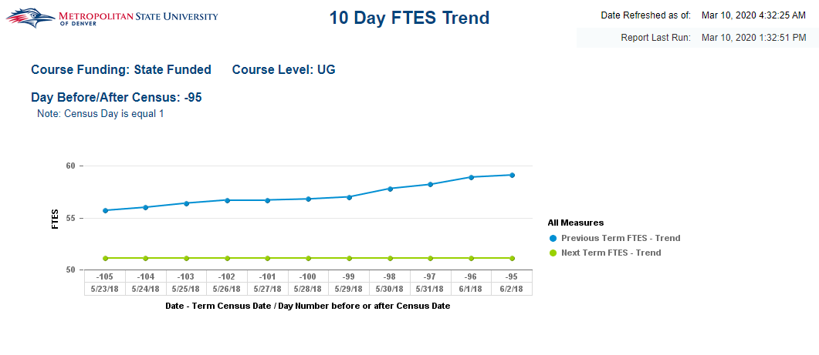

Course Info by Class Location
Description: The Student list report displays a list of students and how many classes and credit hours they’re registered for in a given term. The report is sorted by student ID. The Trend by Credit Hours Report shows the Credit Hour Trend and Class Count Trend for the past 7 years. It is displayed in both a table and a chart.
Data Elements:
- Student List: Student ID, Name, College, Department, Major, Minor, Concentration, Certificate, Class Count, Credit Hours Amount, Cumulative GPA
- Trend by Credit Hours: Credit Hour Trend, Class Count Trend (All for last 7 years, including a Table & Chart)
Source: Student Admission and Enrollment Universe
Location: Public Folders Course Subject and Class Course Info by Class Location
Prompts: Term (required)
Input Controls: Campus, College, Department, Major, Minor, Concentration
Report Page: Student List, Trend by Credit Hours
Student List
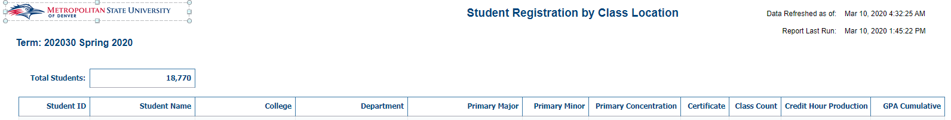
Trend by Credit Hours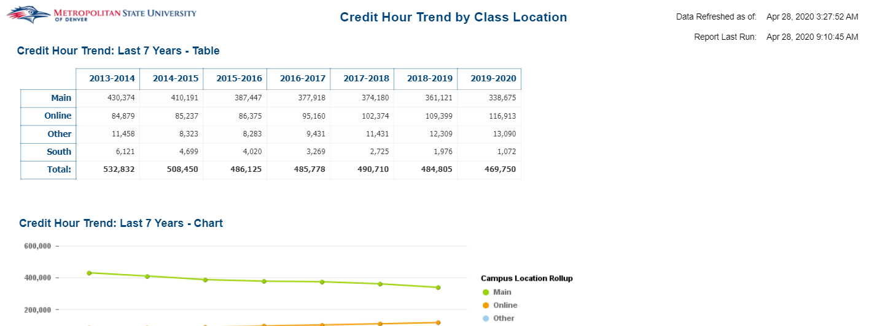

Course Overrides by Date
Description: This report provides a list of course overrides that were entered by authorized users for a selected date range. The report is show all overrides entered by the CRN, Course Subject, Course Number and Course Section Number of the course. The report includes three tabs: Overview (provides details on the report description and function), Summary (provides high level aggregated data for overrides based on User ID, Course Subject and Number, and by Term Cd), Student Detail (provides individual student details on the overrides that were entered for the Student).
Data Elements: Overview Tab: Term Code, Override Codes, Authorized Users
Summary Tab: Total Count of Overriedes Issued, Total Count of Overrides Used, Total Count of Section, Specific Overrides, Count of Students with Overrides, Count of Students Using Overrides, Count of Students Not Using Override, Count of Users, Override Code, User ID, Course Subeject, Course Number
Student Detail Tab: Student ID, Student Name, CRN, Subject Code, Course #, Course Section Number, Term Code, Override Code, Override Desc, User ID, Override Activity Date, Section Sepcific Indicator, Override Used Indicator
Souce: Student Admission and Enrollment Universe
Location: Public Folders Course Subject and Class Course Overrides by Date
Prompts: Override Activity Date (Start), Override Activity Date (End), Subject Code, Course Number, User ID
Input Controls: Student ID, Course Subject, Course Number, Course Section Number, Override Code, User ID, Section Specific Override Indicator, Override Used Indicator
Report Page: Overview
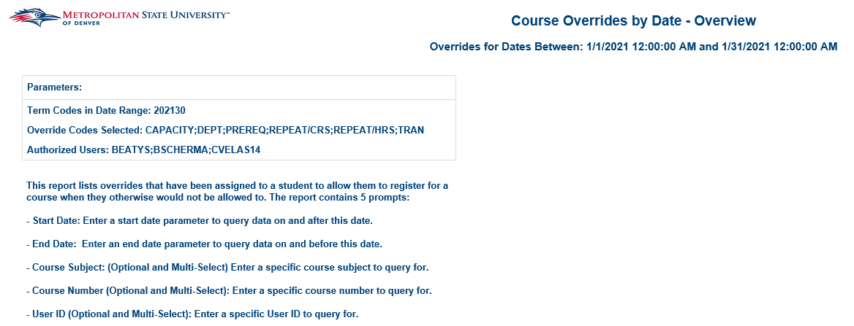

Report Page: Summary
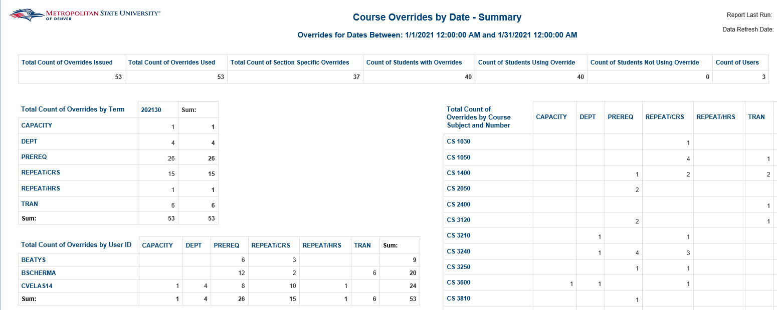
Report Page: Student Detail
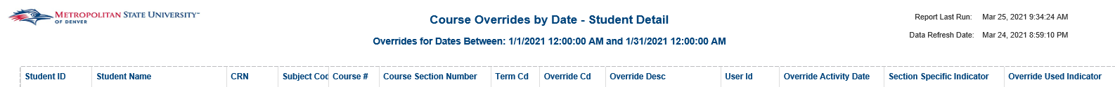

Detail Code by Semester
Description: Provides a list of courses with their associated detail code for a given term. The report is sorted by the CRN (Course Reference Number) then by Course Subject, Course Number and Course Section Number.
Data Elements: Term Code, CRN, Course Subject, Course Number, Course Section Number, Course Title, Section Status, Detail Code, Detail Code Description, Fee Amount, Fee Type
Souce: Student Admission and Enrollment Universe
Location: Public Folders Course Subject and Class Detail Code by Semester
Prompts: Term (Required), Detail Code (Optional)
Input Controls: Term Code (if multiple are selected), Course Subject Code: Course Number, Detail Code
Report Page:

Enrollment Details by Course Attribute with Waitlist
Description: The report displays the enrollment data for courses with a given course attribute for a given course. You can drilldown to get a report giving detailing information on enrolled students.
Data Elements:
- Enrollment Waitlist: Department, Course Subject, Course #, Section, CRN, Instructional Method, Primary Instructor, Seats Available, Max Seats, Seats Filled, Wait List, % Filled, Student List, Credits Low, Credits High, Begin Date, End Date, Days, Begin Time, End Time, Campus, Building, Room
- Registered MSU Denver Students by Course (Drill down Report): Course Subject & ID, Section, CRN, Waitlisted Y/N, Waitlisted Date, Waitlist Priority Amt, Student Id, Name, Email, Student Class, UG – Cumm Hours Earned, GR – Cumm Hours Earned, Primary Major, Primary Minor, Primary Concentration
Source: Student Admission and Enrollment Universe
Location: Public Folders Course Subject and Class Enrollment Details by Course with Waitlist
Prompts: Term (required), Course Attribute (required)
Input Controls: Course Funding, Instructional Method, College, Department, Subject, % Filled, Current Enrollment, Wait List Count
Report Page:
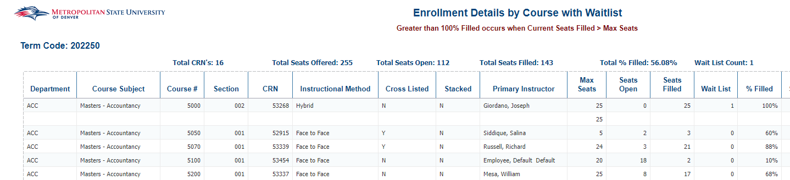
Enrollment Waitlist, Registered Students by Course (Drilldown Report) Enrollment Waitlist
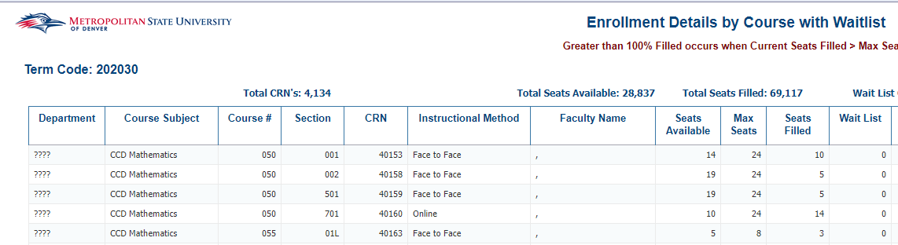 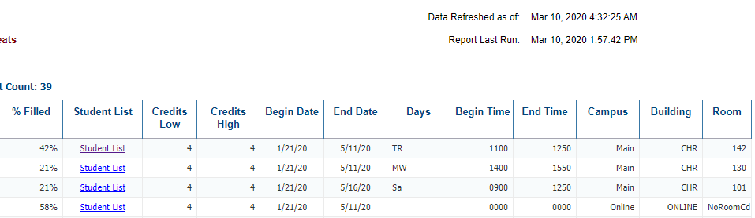
Registered Students by Course (Drilldown Report)
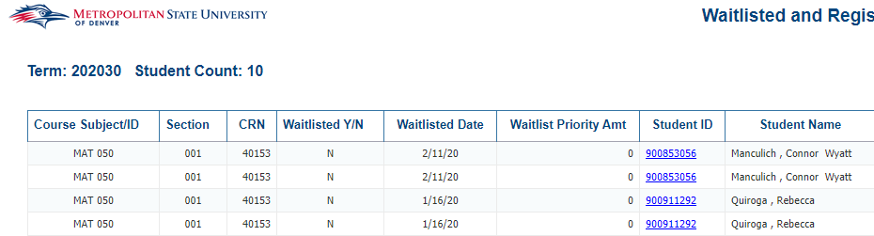 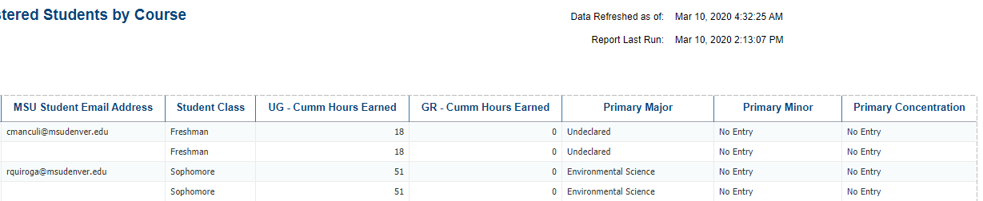

Enrollment Details by Course with Waitlist
Description: The report displays course information and enrollment counts for courses in a given term. You can drilldown to get a report giving enrolled student detail information.
Data Elements:
- Enrollment Waitlist: Department, Course Subject, Course #, Section, CRN, Instructional Method, Primary Instructor, Seats Available, Max Seats, Seats Filled, Wait List, % Filled, Student List, Credits Low, Credits High, Begin Date, End Date, Days, Begin Time, End Time, Campus, Building, Room
- Registered MSU Denver Students by Course (Drill down Report): Course Subject & ID, Section, CRN, Waitlisted Y/N, Waitlisted Date, Waitlist Priority Amt, Student Id, Name, Email, Student Class, UG – Cumm Hours Earned, GR – Cumm Hours Earned, Primary Major, Primary Minor, Primary Concentration
Source: Student Admission and Enrollment Universe
Location: Public Folders Course Subject and Class Enrollment Details by Course with Waitlist
Prompts: Term (required)
Input Controls: Course Funding, Instructional Method, College, Department, Subject, % Filled, Current Enrollment, Wait List Count
Report Page:
Enrollment Waitlist, Registered Students by Course (Drilldown Report) Enrollment Waitlist
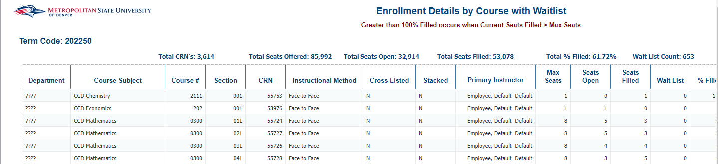
Registered Students by Course (Drilldown Report)

Potential Course Demand
Description: Displays a list of students that are eligible for the given target course in the given target term, but are not currently registered for the course. The report allows the selection of students that have completed up to two perquisite courses using the optional prompts.
Data Elements: Student ID, Student Name, Meets Required Count, Cell Phone #, General Phone #, Email, Level, Student Class, Degree Status, Catalog Term, Major, Minor, Concentration
Source: Student Admission and Enrollment Universe
Location: Public Folders Course Subject and Class Potential Course Demand
Prompts: Course 1 that must be completed (required), Alternate Course 2 that must be completed, Alternate Course 3 that must be completed, Course 2 that must be completed, Course 3 that must be completed, Target Course (required), Target Term (required), Summer Term, Current Term
Input Controls: Student Class, Degree Status, Major, Minor, Concentration
Report Page:
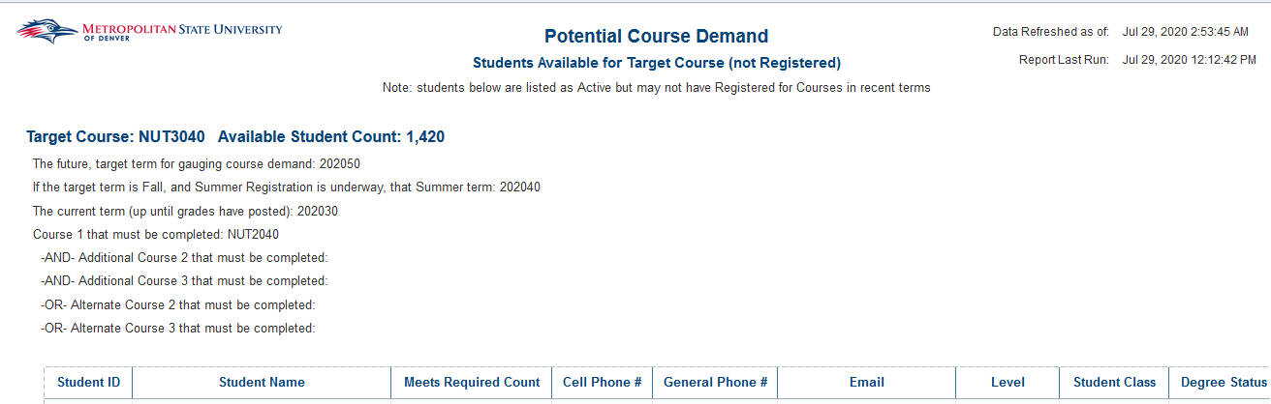

Seat Availability Report
Description: Displays current seats available and % of seats filled for a specific term. The report is sorted by CRN.
Data Elements:
- Seat Availability Count: CRN, Subject, Course #, Seats Available, Begin Date, End Date, Meeting Days, Begin Time, End Time, Campus, Building, Room
- Seat Availability %: CRN, Subject, Course #, Seats Available, Max Seats, Current Seats Filled, Seats Filled %, Begin Date, End Date, Meeting Days, Begin Time, End Time, Campus, Building, Room
Source: Student Admission and Enrollment Universe
Location: Public Folders Course Subject and Class Seat Availability Report
Prompts: Term (Required), Term Start Date
Input Controls: College, Department, Campus
Report Page: Seat Availability Count, Seat Availability Count
Seat Availability Count
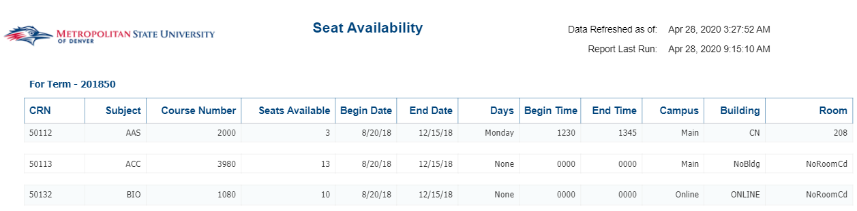
Seat Availability %
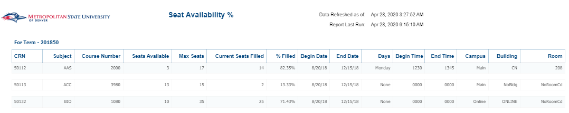

Student Class Lists by Term and Subject
Description: Provides a list of a list of students in a given class in a given term. The report includes field of study data for each student and the last registration status for the students.
Data Elements: Term CD, Course Subject/ID, Section, CRN, Calculated Credit Hrs Amt, Student ID, Student Name, Student Class, Primary Major, Primary Minor, Primary Concentration, Registration Status Cd
Source: Student Admission and Enrollment Universe
Location: Public Folders Course Subject and Class Student Class Lists by Term and Subject
Prompts: Term (required), Course Subject (required), Course Number
Input Controls: Course Subject, Course Number, Course Section Number
Report Page:
Student Listing by Class (Drill to Report)
Description: The report displays Waitlisted and Registered Students by Course.
Data Elements: Course Subject/ID, Section, CRN, Waitlisted Y/N, Waitlisted Date, Waitlist Priority Amt, ID, Name, Email, Class, UG – Cumm Hours Earned, GR – Cumm Hours Earned, Major, Minor, Concentration
Source: Student Admission and Enrollment Universe
Location: Public Folders Course Subject and Class Student Listing by Class (Drill to Report)
Prompts: Term (required), CRN
Input Controls: Waitlist Y/N
Report Page:
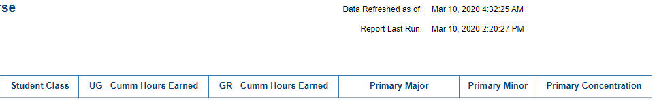

Student Listing by Class (Drill to Report)
Description: The report lists waitlisted and registered students by Course Subject/ID and Section.
Data Elements: Course Subject/ID, Section, CRN, Waitlisted Y/N, Waitlisted Date, Waitlisted Priority Amt, Student ID, Student Name, Current Age, MSU Email Address, Student Class, UG – Cumm Hours Earned, GR – Cumm Hours Earned, Primary Major, Primary Minor, Primary Concentration
Source: Student Admission and Enrollment Universe
Location: Public Folder Course Subject and Class Student Listing by Class (Drill to Report)
Prompts: Term CD, CRN (Optional)
Input Controls: Waitlist Y/N
Report Page:
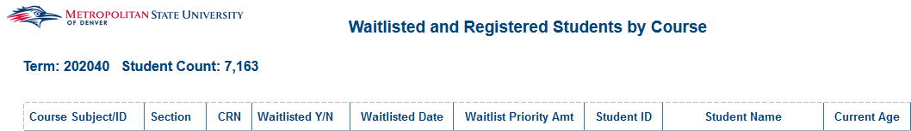
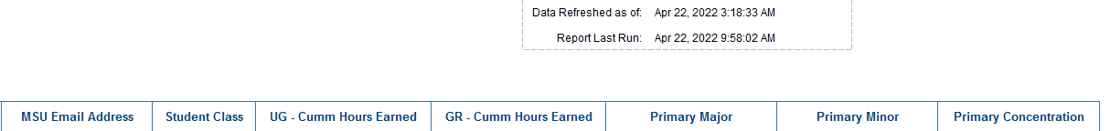

Student Listings by CRN (Drill to Report)
Description: The report displays Waitlisted and Registered Students by CRN.
Data Elements: Course Subject/ID, Section, CRN, Waitlisted Y/N, Waitlisted Date, Waitlist Priority Amt, Student ID, Student Name, MSU Email, Class, UG – Cumm Hours Earned, GR – Cumm Hours Earned, Major Code, Major, Minor Code, Minor, Concentration Code, Concentration
Source: Student Admission and Enrollment Universe
Location: Public Folders Course Subject and Class Student Listing by CRN (Drill to Report)
Prompts: Term (required), CRN
Input Controls: Waitlist Y/N
Report Page:
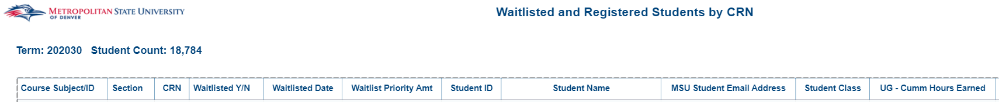
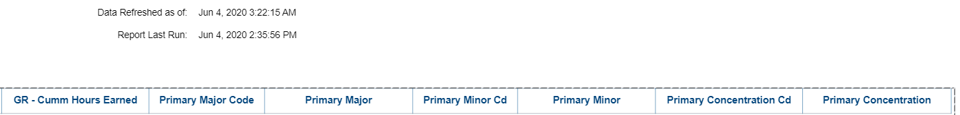

Student Withdrawals by Course After Census
Description: Shows each student that withdrew from each course after the census date
Data Elements: College, Department, Primary Major Code, Primary Advisor, Student ID, Student Name, Student Class, MSU Email, Phone #, Phone # (alt), Withdrew All Classes, Course Subject Cd: Course #, Course Section Number, CRN, Instructor (Primary), Registration Status, Withdrawal Date
Source: Student Admission and Enrollment Universe
Location: Public Folders Course Subject and Class Student Withdrawals by Course After Census
Prompts: Term Code, College (optional), Department (optional), Primary Major Code (optional)
Input Controls: Withdrew All Classes, Student Class, Primary Advisor, College, Department, Primary Major Code
Report Page:
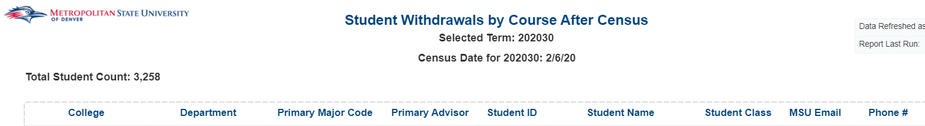
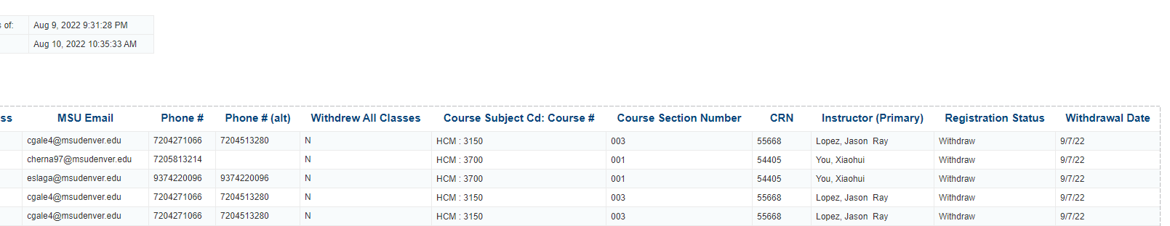

Student Withdrawals by Course After Census_All Students
Description: Shows each student for a term and whether or not they withdrew from a course after the census date
Data Elements: Student ID, Student Name, MSU Email Address, Phone #, Phone # (alt), Withdrew All Classes, Registered Credit Hours, Withdrawn Credit Hours, Student Class, Primary Advisor, College, Department, Primary Major Code
Source: Student Admission and Enrollment Universe
Location: Public Folders Course Subject and Class Student Withdrawals by Course After Census_All Students
Prompts: Term, College (optional), Department (optional), Primary Major Code (optional)
Input Controls: Withdrew All Classes, Student Class, Primary Advisor, College, Department, Primary Major Code
Report Page:
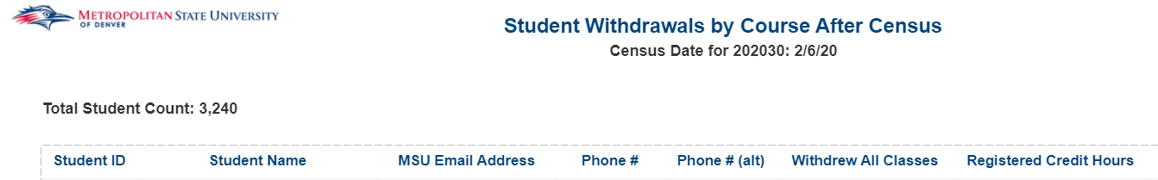
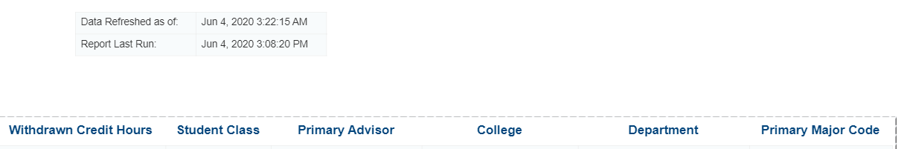

Student Withdrawals by Course After Census_Student Detail
Description: Provides detailed information about an individual student that withdrew from at least one course after the census date.
Data Elements: Student ID, Student Name, Student Class, MSU Email, Phone #, Phone # (alt), Withdrew All Classes, College, Department, Primary Major Code, Primary Advisor, Course Subject Cd: Course #, Course Section Number, CRN, Instructor (Primary), Registration Status, Registration Status Date, Credit Hours
Source: Student Admission and Enrollment Universe
Location: Public Folders Course Subject and Class Student Withdrawals by Course After Census_Student Detail
Prompts: Student ID, Term Code, College (optional), Department (optional), Primary Major Code (optional)
Input Controls: Withdrew All Classes, Student Class, Primary Advisor, College, Department, Primary Major Code
Report Page:

Students That Have Not Taken Course
Description: This report lists all students that have not taken previously completed and are not registered for a given course.
Data Elements: Student ID, Student Name, MSU Email Address, Catalog Term Code, Major, Minor, Concentration
Source: Student Admission and Enrollment Universe
Location: Public Folders Course Subject and Class Students That Have Not Taken Course
Prompts: Target Course, Current Term Cd, Check Course Registration Through, Students in Major (optional), Students in Minor (optional)
Input Controls: Major, Minor, Concentration
Report Page:
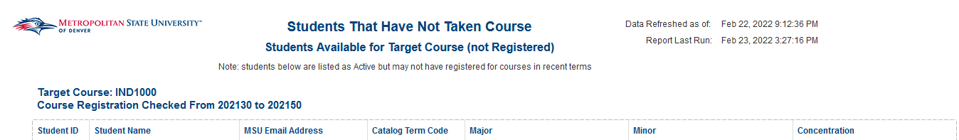

Tuition and Fee Waiver Courses
Description: This report lists all courses for a given term that have a tuition and fee waiver.
Data Elements: Term, CRN, Subject, Course #, Section #, Section Status, Campus Code, Instructional Method, Tuition Fee Waiver
Source: Student Admission and Enrollment
Location: Public Folders Course Subject and Class Tuition and Fee Waiver Courses
Prompts: Term Code
Input Controls: Subject, Section Status, Campus Code, Instructional Method
Report Page:
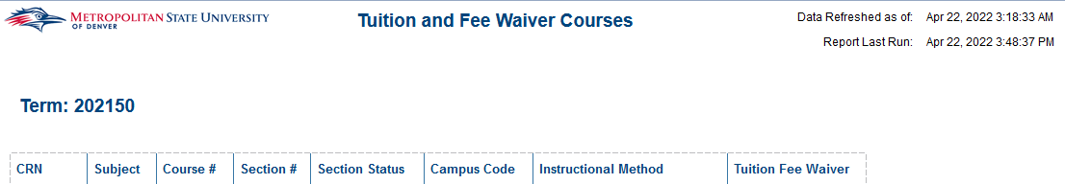

Waitlist Priority Report
Description: Displays Students on the wait list for a given term. The report is sorted by student ID.
Data Elements: Student ID, Name, Phone #
Source: Student Admission and Enrollment Universe
Location: Public Folders Course Subject and Class Wait List Priority Report
Prompts: Term (required)
Input Controls: None
Report Page:
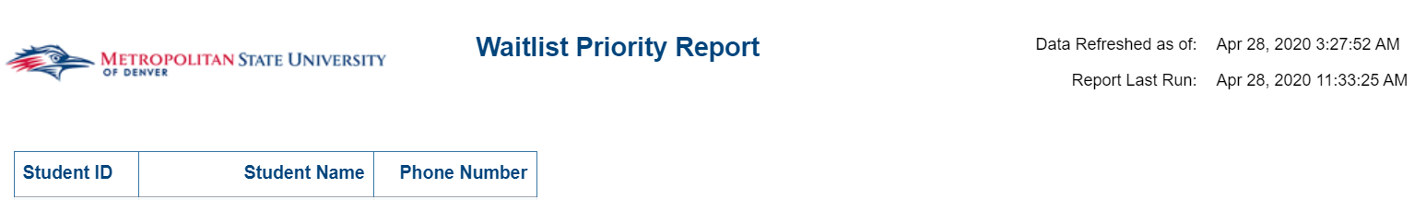

Denver Scholarship Foundation

Campus Advising – Scholarship Foundation
Description: This report deals with CDSF (Scholarship Intervention) students. The first tab displays Student Profile information for CDSF students. The second tab displays Financial Aid information for CDSF students. The third tab displays Financial Aid Holds for CDSF students.
Data Elements:
- Student Profile: Student ID, Name, Registered, Phone #, DOB, Address, Gender, Race, US Citizenship, Student Type, High School, HS GPA, MSU Email, Alternate Email, First Term Enrolled, Primary Major, Degree, Program, Graduation Status, Expected Grad Date, First Generation, Credit Hours Earned, Cumulative GPA, Term GPA, Enrolled Credit Hours, SAP Status
- Financial Aid Summary: Student ID, Student Name, Requirement Cd, Requirement, Requirement Status, Requirements Status Date, Fund Cd, Fund Title, Award Status, Award Status Desc, EFC, Pell Paid Efc Amt, Aid Period Cd, Verification Complete Ind, Package Complete, Package Reqs Complete
- Financial Aid Holds: Student ID, Name, Hold Cd, Hold Desc, Hold from Date, Hold to Date, Hold Explanation
Source: Student and Enrollment Universe, Financial Aid Universe
Location: Public Folders Denver Scholarship Foundation Campus Advising – Scholarship Foundation
Prompts: Term, Aid Year
Input Controls: Registered, Graduation Status, Program, Degree, Requirements Status Date, Verification Complete Ind, Aid Period, Award Status, Fund
Report Page:
Student Profile
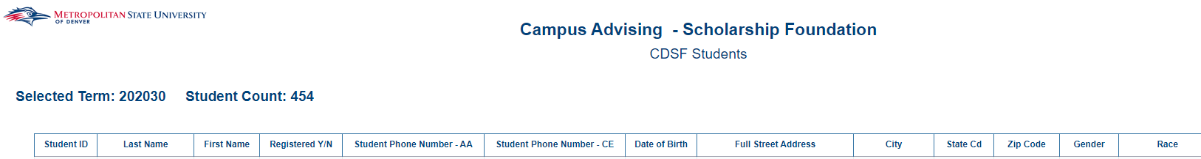
Financial Aid Summary
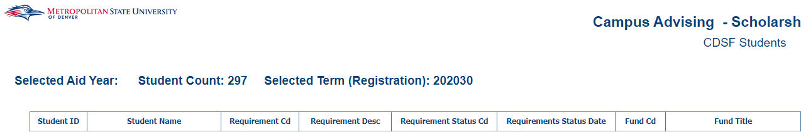 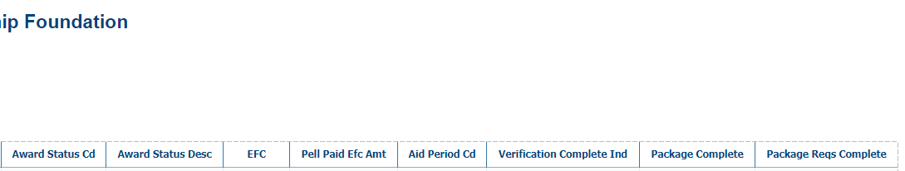
Financial Aid Holds
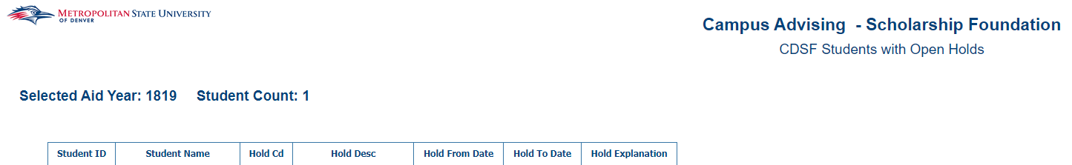

Exception Reporting

Fall 2017 PS Courses
Description: Displays Non-COF eligible courses for a specific term. The report is sorted alphabetically by course.
Data Elements: Subject Code, Course ID, CRN, Course Attribute Cd, Course Attribute Description, Couse Funding Code
Source: Student Admission and Enrollment Universe
Location: Public Folders Exception Reporting Fall 2017 PS Courses
Prompts: Term (required)
Input Controls: None
Report Page:
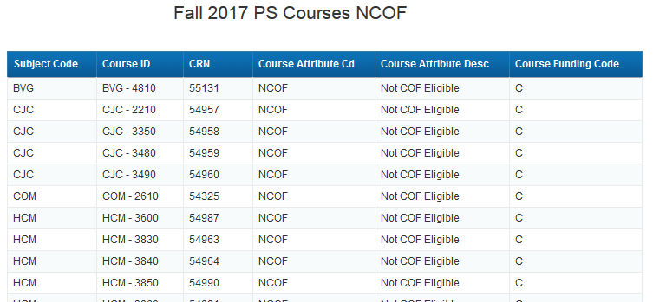

Total Student Counts Exception
Description: Displays Total students for a specific term. There are 3 tabs, 1) overall 2) by race 3) total student veterans
Data Elements:
- Total Student Count Fall 2017: Level Code, Student Count, Avg Undergrad Age
- Total Student Count by Race: Race, Student Count
- Total Count of Student Veterans: Level Code, Veteran Status, Student Count
Source: Student Admission and Enrollment Universe
Location: Public Folders Exception Reporting Total Student Counts
Prompts: Term (Required)
Input Controls: None
Report Page:
1)
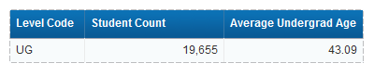
2)
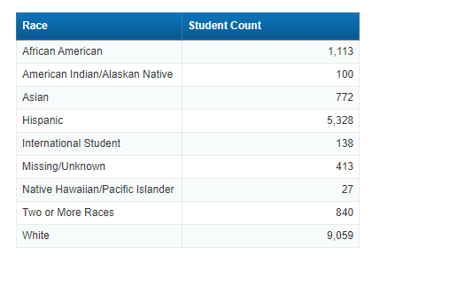
3)
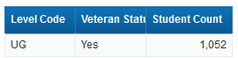

College: Courses without a Primary Instructor Assigned
Description: The report displays courses that do not have a Primary Instructor assigned to them during a given term. You can click on students to drill down and get a list of the enrolled students.
Data Elements: Subject, Course #, Section, CRN, Instructional Method, Primary Instructor, Seats Available, Max Seats, Seats Filled, Wait List, % Filled, Student List (drill down), Credits Low, Credits High, Begin Date, End Date, Days, Begin Time, End Time, Campus, Building, Room
Source: Student Admission and Enrollment Universe
Location: Public Folders Exception Reporting College Courses without a Primary Instructor Assigned
Prompts: Term (required)
Input Controls: Course Funding, Instructional Method, College, Department, Course Subject, % Filled, Wait List
Report Page:
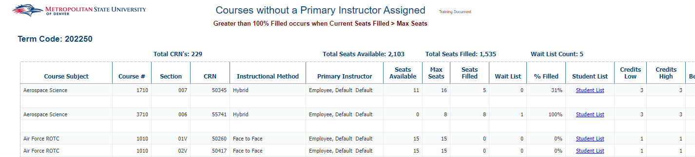
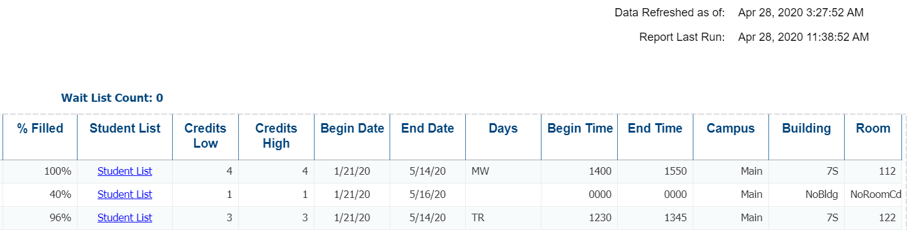

College: Major Change Report
Description: The report displays the number of times a student has changed their major. It is sorted by student ID. Using the Input Controls (listed below) you can select single or multiple Colleges, Departments, Majors, Concentrations, Term.
Data Elements: Term, Student ID, Name, College, Department, Major, Concentration, Term GPA, Cumulative GPA, Major Change Indicator, Major Count
Source: Student Admission and Enrollment Universe
Location: Public Folders Exception Reporting College Major Change Report
Prompts: Term (required)
Input Controls: College, Department, Major, Concentration, Term
Report Page:
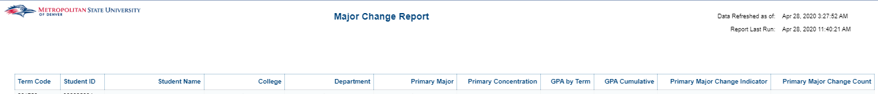

Ellen’s Exceptions: GED & High School with Transfer Information
Description: Displays GED and High School students with Transfer Information for a specific term.
Data Elements: Student ID, Name, Type Code (high school or GED), High School Code, School Name, Total Transferred Credit Hours
Source: Student Admission and Enrollment Universe
Location: Public Folders Exception Reporting Ellen’s Exceptions GED & High School with Transfer Information
Prompts: Term (Required)
Input Controls: None
Report Page:
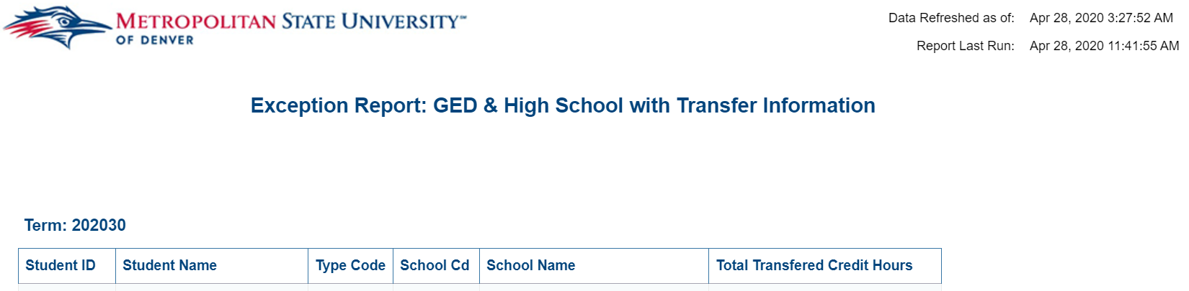

Ellen’s Exceptions: GED with High School Information
Description: Displays High School information for GED Students for a specific term.
Data Elements: Student ID, Last Name, First Name, Type Code, Test Code, Test Score, High School Code, High School Desc, High School GPA
Source: Student Admission and Enrollment Universe
Location: Public Folders Exception Reporting Ellen’s Exceptions GED with High School Information
Prompts: Term (Required)
Input Controls: None
Report Page:
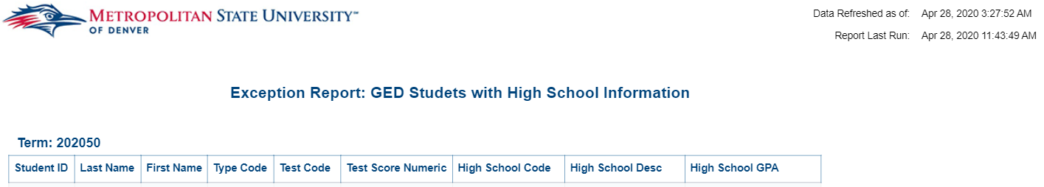

Ellen’s Exceptions: Grad Courses missing NCOF
Description: Displays Graduate Courses missing NCOF for a specific term.
Data Elements: Subject Code, Course #, Course Level Cd, CRN, Course Funding Code, Course Funding
Source: Student Admission and Enrollment Universe
Location: Public Folders Exception Reporting Ellen’s Exceptions Grad Courses Missing NCOF
Prompts: Term (Required)
Input Controls: None
Report Page:
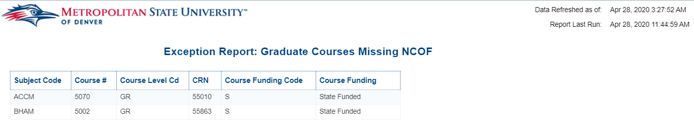

Ellen’s Exceptions: Major Cd with Incorrect Program Exception
Description: Displays Primary Majors with the incorrect Program attached to them.
Data Elements: Student Id, Last Name, First Name, Level Code, Primary Program, Primary Major, Department, Primary Concentration, Incorrect Program
Source: Student Admission and Enrollment Universe
Location: Public Folders Exception Reporting Ellen’s Exceptions Major Cd with Incorrect Program Exception
Prompts: Term (Required)
Input Controls: Incorrect Program Flag
Report Page:
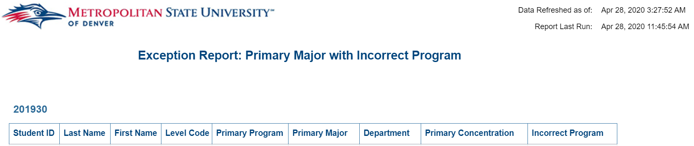

Ellen’s Exceptions: Major with Incorrect Degree Type
Description: Displays Primary Majors with the incorrect Degree’s attached to them.
Data Elements: Student Id, Last Name, First Name, Level Code, Catalog Term, Primary Program, Primary Major, Primary Concentration, College, Degree, Primary Major of Secondary, Incorrect Degree
Source: Student Admission and Enrollment Universe
Location: Public Folders Exception Reporting Ellen’s Exceptions Major with Incorrect Degree Type
Prompts: Term (Required)
Input Controls: Incorrect Degree Flag
Report Page:
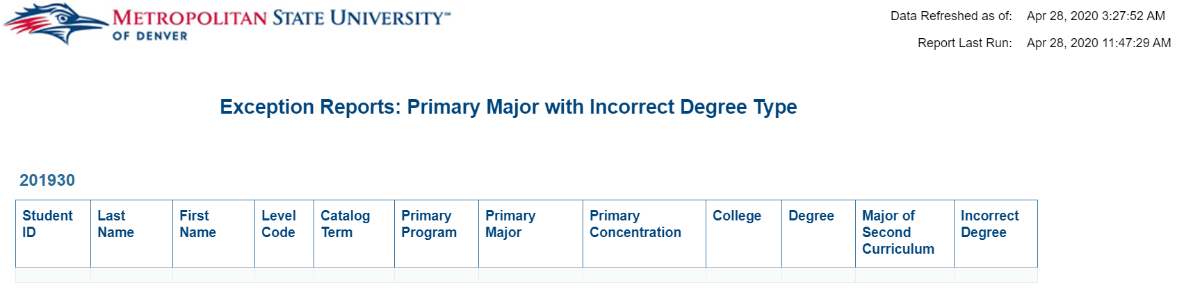

Ellen’s Exceptions: Primary Major with Incorrect College
Description: Displays Primary Majors with the incorrect Colleges attached to them.
Data Elements: Student Id, Last Name, First Name, Catalog Term, Primary Program, Primary Major, Primary Concentration, Degree, College, Department, Incorrect College, Incorrect Degree
Source: Student Admission and Enrollment Universe
Location: Public Folders Exception Reporting Ellen’s Exceptions Primary Major with Incorrect College
Prompts: Term (Required)
Input Controls: Incorrect College Flag, Incorrect Dept Flag
Report Page:
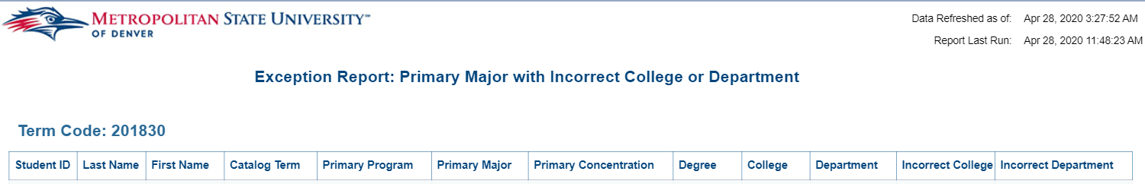

Ellen’s Exceptions: Secondary Curriculum Exception
Description: Displays Primary Majors with the incorrect College’s attached to them.
Data Elements: Student Id, Last Name, First Name, Catalog Term, 2nd Curriculum Program, 2nd Curriculum College, 2nd Curriculum Department, 2nd Curriculum Major, 2nd Curriculum Concentration, Incorrect College, Incorrect Degree
Source: Student Admission and Enrollment Universe
Location: Public Folders Exception Reporting Ellen’s Exceptions Secondary Curriculum Exception
Prompts: Term (Required)
Input Controls: Incorrect College Flag, Incorrect Degree Flag
Report Page:
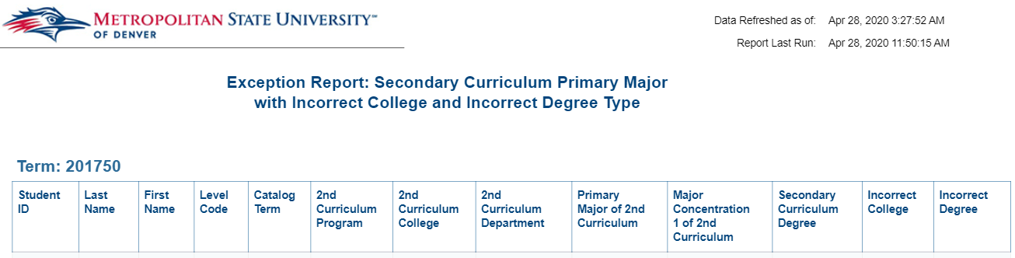

Registrar’s Office: Prerequisites Error and Description Report
Description: Displays courses with prerequisites and what the prerequisites are for a given year. There are two reports. The prerequisite error report and the prerequisite report.
Data Elements:
- Prerequisite Error Report: College Code, Department, Course Subject Code, Course Subject, Course Number, Effective Term, Problem Start Line Num
- Prerequisite Report: College, Dept Cd, Department, Course Subject, Course Number, Prerequisites
Prompts: Term
Source: Student Admission and Enrollment Universe
Location: Public Folders Exception Reporting Registrar’s Office Prerequisites Error and Description Report
Prompts: Term (Required)
Input Controls: Term
Report Page:
Prerequisite Error Report:
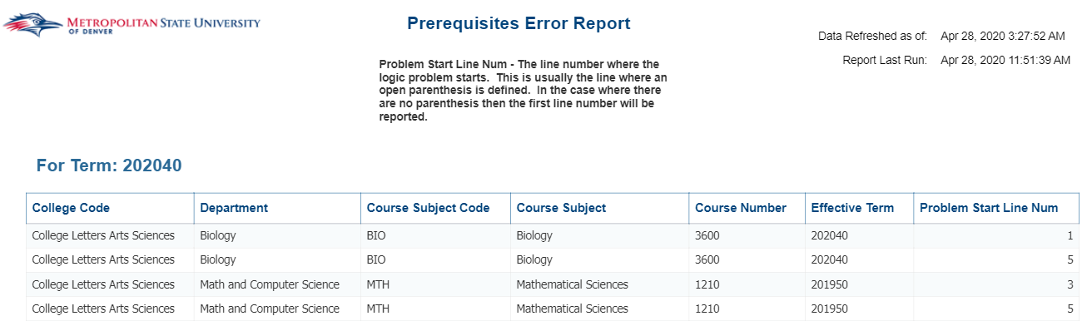
Prerequisite Report:
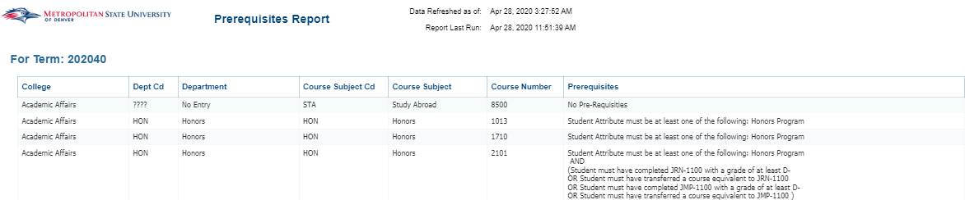

Grade / Ranking Reports

Grade Report with Faculty Tab
Description: This report shows the grades given out by faculty for a given term. The first tab is Summary by Subject. This information is broken down by Subject, Course and Section #. The second tab is the Summary by Faculty report. This report has a list of Faculty and the grades they gave out for each of the courses they taught. The third tab is the Student Detail Report. This reports the grade that each student received for a given course.
Data Elements:
- Summary by Subject: Subject Code, Course #, Section, Primary Instructor, Student Count, Count of DFWI and % of DFWI, Letter Grade Count, Letter Grade Percentage
- Summary by Faculty: Primary Instructor, Faculty Status, Subject Code, Subject Description, Course #, Course Title, Section, Student Count, Count of DFWI, % of DFWI, Letter Grade Count, Letter Grade Percentage
- Student Detail: Subject Code, Course #, Course Section Number, CRN, Primary Instructor, Student ID, Student Name, Grade
Source: Student and Enrollment Universe
Location: Public Folder Grades/Rankings Report Grade Report with Faculty Tab
Prompts: Term Code (Required), Course
Input Controls: Term Code and Description, College, Department, Subject Code, and Grade Code
Report Page:
Tab 1: Summary by Subject
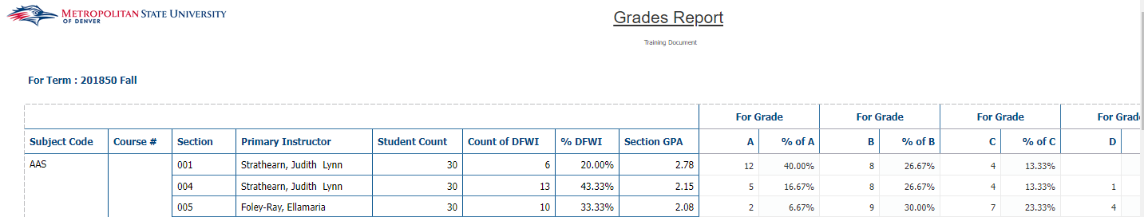

Tab 1: Summary by Faculty

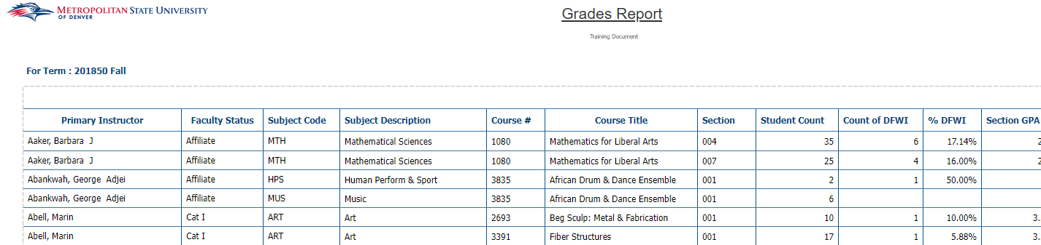
Tab 1: Student Detail
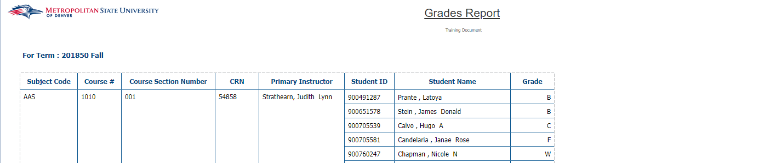

Grades Report
Description: This report has two tabs, Summary and Student Detail. The Summary tab displays a list of courses detailing the count of each letter grade and the percentage for each grade out of the class for a given semester. The Student Detail tab displays a list of courses and the grade for each student that took that course. The report is grouped by Subject Code, Course Number, Course Section Number and Faculty Name.
Data Elements:
- Summary: Subject Code, Course #, Section, Delivery Method, Primary Instructor, Student Count, Count of DFWI, % DFWI, Grade Counts, Grade Percentages, and Sum
- Student Detail: Subject Code, Course #, Section, CRN, Delivery Method, Primary Instructor, Student ID, Name, Grade
Source: Student and Enrollment Universe
Location: Public Folder Grades/Rankings Report Grades Report
Prompts: Term Code (Required), Course
Input Controls: Term Code and Description, College, Department, Subject Code, and Grade Code
Report Page: This report has two tabs, Summary and Student Detail
Tab 1: Summary
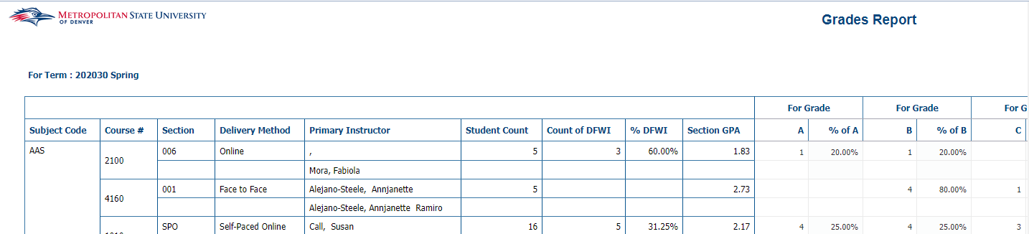
Tab 2: Student Detail
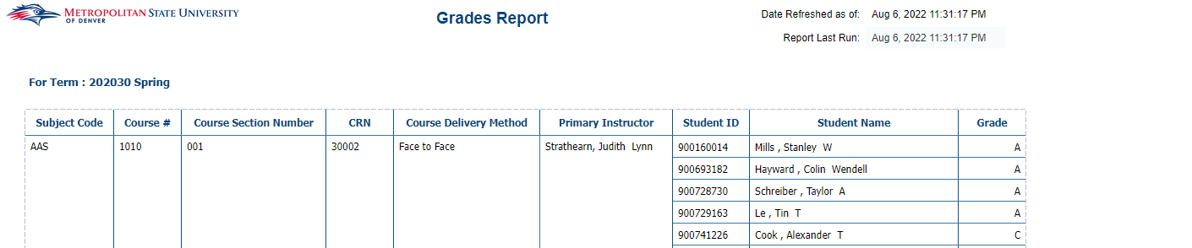

Grades Report – with Course Summary + Unmerged Tabs
Description: This report displays the grades and the % of grades given for a specific term. It is broken down by College, Course and Student. This report has 6 tabs; MSU Summary, Course Summary, Course Summary Across Sections, Student Detail, Course Summary Unmerged, Student Detail Unmerged.
Data Elements:
- MSU Summary: College, Student Count, Count of DFWI, % DFWI, Grades and % of Grades Given
- Course Summary: Subject, Course #, Section, Primary Instructor, Course Delivery Method, Student Count, Count of DFWI, % DFWI, Grades and % of Grades Given
- Course Summary Across Sections: Subject, Course #, Student Count, Count of DFWI, % DFWI, Course GPA, Grades and % of Grades Given
- Student Detail: Subject, Course #, Section, CRN, Primary Instructor, Instructional Method, ID, Name, Grade
- Course Summary Unmerged: Term, Subject, Course #, Section, Primary Instructor, Course Delivery Method, Student Count, Count of DFWI, % DFWI, Grades and % of Grades Given
- Student Detail Unmerged: Term, Subject, Course #, Section, CRN, Primary Instructor, Instructional Method, ID, Name, Major, Grade
Source: Student and Enrollment Universe
Location: Public Folder Grades/Rankings Report Grades Report – with Course Summary + Unmerged Tabs
Prompts: Term Code (Required), Subject Code, Course #
Input Controls: Term Code, College, Department, Subject Code
Report Page:
Tab 1: MSU Summary (can drill down by College)
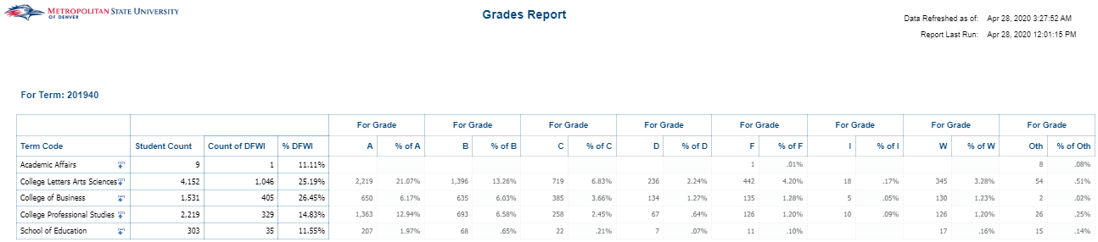
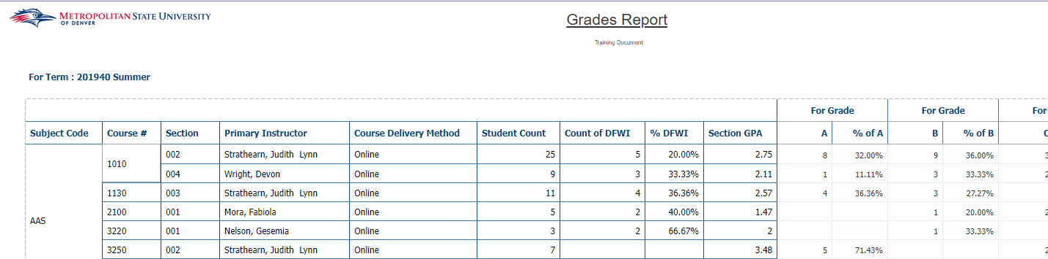
Tab 2: Course Summary

Tab 3: Course Summary Across Sections
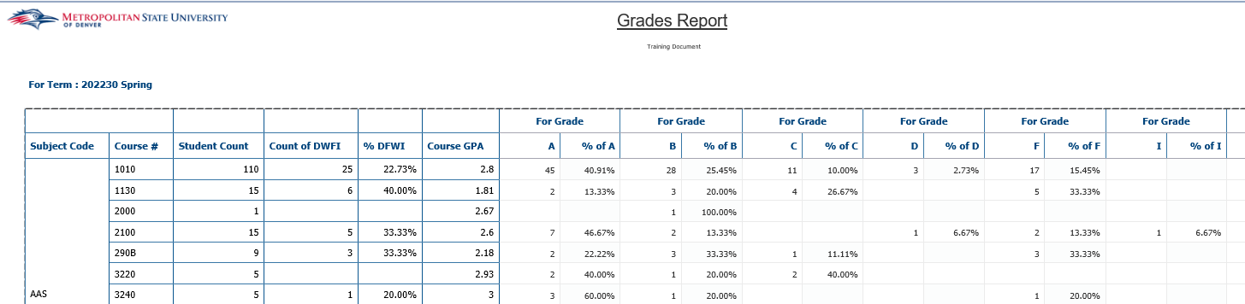

Tab 4: Student Detail
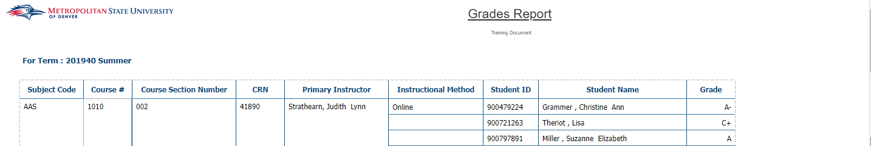
Tab 5: Course Summary Unmerged
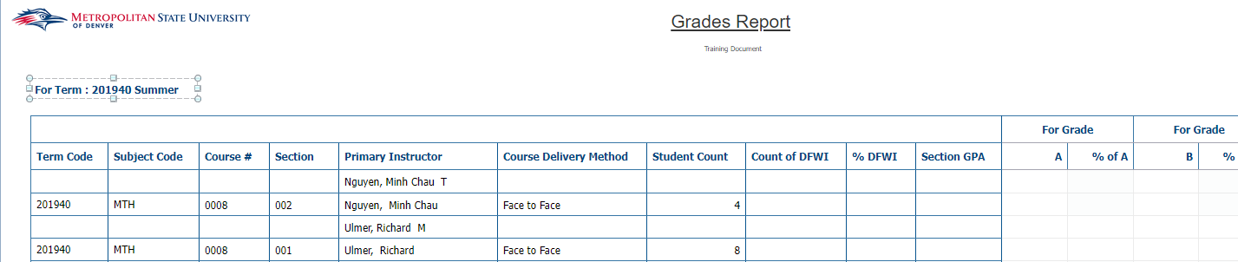
Tab 6: Student Detail Unmerged

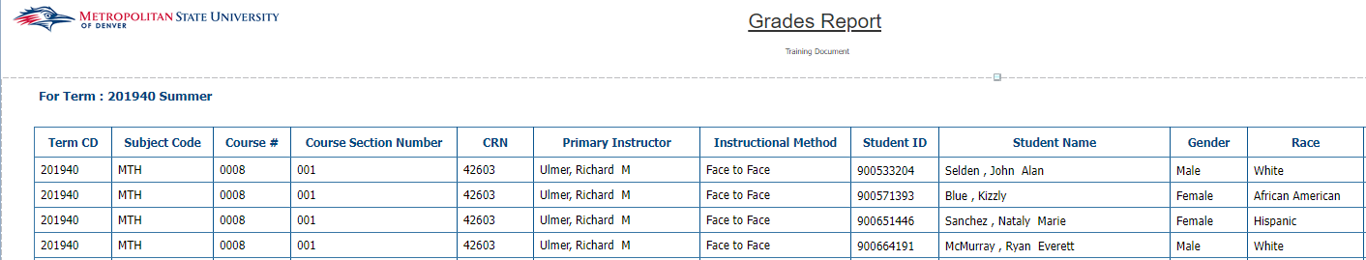

Grades Report by Delivery Method
Description: This report has two tabs, Summary and Student Detail. The Summary tab displays a list of courses detailing the count of each letter grade and the percentage for each grade out of the class for a given semester. The Student Detail tab displays a list of courses and the grade for each student that took that course. The report is grouped by Subject Code, Course Number, Course Section Number and Faculty Name.
Data Elements:
- Summary: Subject Code, Course #, Section, Delivery Method, Primary Instructor, Student Count, Count of DFWI, % DFWI, Grade Counts, Grade Percentages, and Sum
- Student Detail: Subject Code, Course #, Section, CRN, Delivery Method, Primary Instructor, Student ID, Name, Grade
Source: Student and Enrollment Universe
Location: Public Folder Grades/Rankings Report Grades Report by Delivery Method
Prompts: Term Code (Required), Course
Input Controls: Term Code and Description, College, Department, Subject Code, Grade Code, Course Delivery Method
Report Page: This report has two tabs, Summary and Student Detail
Tab 1: Sum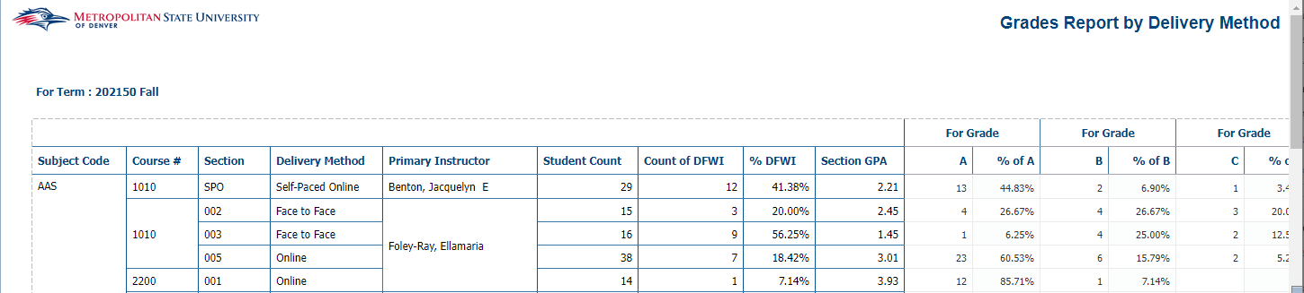 mary

Tab 2: Student Detail
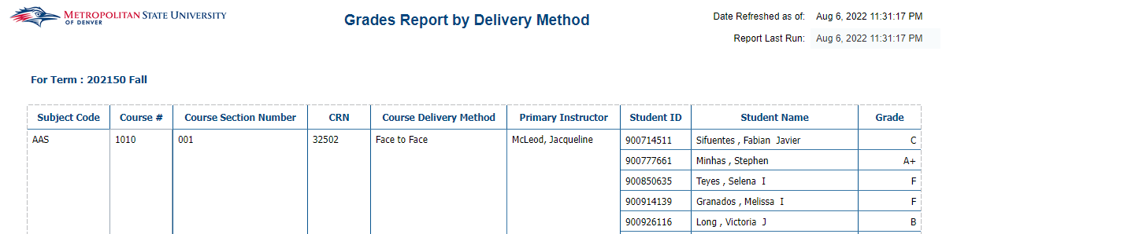

Grades Report with Course Attributes
Description: This report has two tabs, Summary and Student Detail. The Summary tab displays a list of courses detailing the count of each letter grade and the percentage for each grade out of the class for a given semester. The Student Detail tab displays a list of courses and the grade for each student that took that course. The report is grouped by Subject Code, Course Number, Course Section Number and Faculty Name.
Data Elements:
- Summary: Subject Code, Course #, Section, Delivery Method, Primary Instructor, Student Count, Count of DFWI, % DFWI, Grade Counts, Grade Percentages, and Sum
- Student Detail: Subject Code, Course #, Section, CRN, Delivery Method, Primary Instructor, Student ID, Name, Grade
Source: Student and Enrollment Universe
Location: Public Folder Grades/Rankings Report Grades Report with Course Attribute
Prompts: Term Code (Required), Course
Input Controls: Term Code and Description, College, Department, Subject Code, and Grade Code
Report Page: This report has two tabs, Summary and Student Detail
Summary:
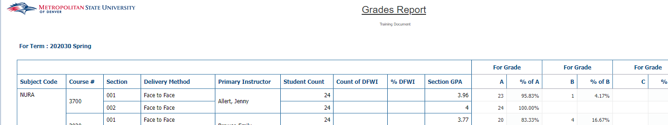
Student Detail:
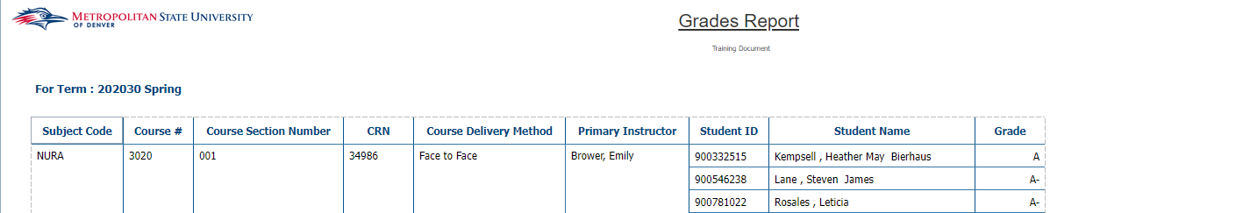

PLACE / PRAXIS Scores
Description: The report displays PLACE and PRAXIS test scores for students.
Data Elements: Test Code, Test Description, Test Date, Student ID, Name, Test Score
Source: Student Admission and Enrollment Universe
Location: Public Folders Grade / Ranking Reports PLACE / PRAXIS Scores
Prompts: Test Start Date (Required), Test End Date (Required), Test
Input Controls: None
Report Page:
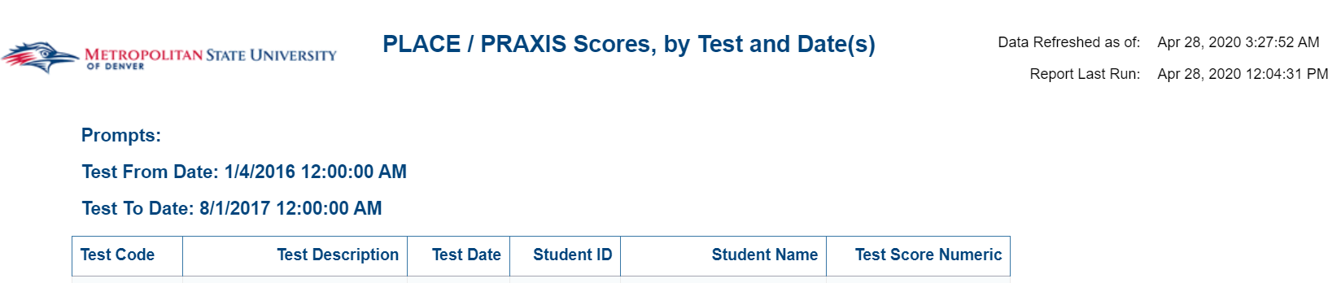

PRAXIS Licensure Test Scores
Description: This report lists all PRAXIS test scores for a given list of students, the Colorado ETS Passing Score, and the student’s pass/fail status for test. The Overview tab provides a list of PRAXIS tests included in the report and the current Colorado ETS Passing Score for each test. The Most Recent P/F Status tab provides the most recent score for each test that a student has taken and the student’s field of study information. The Test History tab provides all of the test scores for the PRAXIS tests a student has taken and the student’s field of study information. The No PRAXIS Test Record tab lists any student that was entered and does not have any PRAXIS test scores in Banner.
Data Elements:
Overview: Test Code – Description, ETS Passing Score
Most Recent P/F Status: Student ID, Student Name, Current Major, Current Concentration, Current Minor, Major at Time of Test, Concentration at Time of Test, Minor at Time of Test, Test Date, Test Code, Test Description, Test Score, ETS Passing Score, P/F Status, Date Checked
Test History: Student ID, Student Name, Current Major, Current Concentration, Current Minor, Major at Time of Test, Concentration at Time of Test, Minor at Time of Test, Test Date, Test Code, Test Description, Test Score, ETS Passing Score, P/F Status, Date Checked
No PRAXIS Test Record: Student ID, Student Name, Gender, Race, First Generation Desc, Current Major, Current Concentration, Current Minor, Date Checked
Source: Student Admission and Enrollment universe
Location: Public Folders Grades / Ranking Reports PRAXIS Licensure Test Scores
Prompts: Student ID (required)
Input Controls: Test Code, Test On or After
Report Page:
Overview:
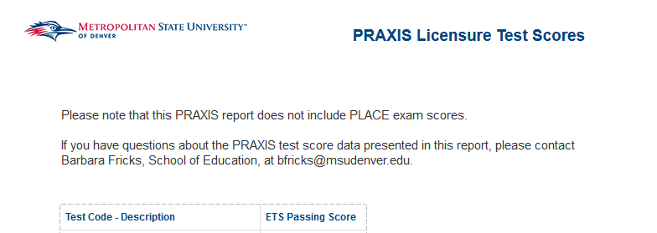

Most Recent P/F Status and Test History:
No PRAXIS Test Record:

Student Class Listing with Final Grade
Description: This report gives a detailed list of each course and the students individual grades in that course for a given term.
Data Elements: Subject Code/Course ID, CRN, ID, Name, Age at Census, Final Grade, Gender, Race, Major, Minor, Concentration, Certificate, Student Type, Transfer School, Accepted Credit Hours, Transfer Cumulative Hours, UG-Cumulative Hours Earned, GR-Cumulative Hours Earned.
Source: Student Admission and Enrollment Universe
Location: Public Folder Grade / Ranking Reports Student Class Listing with Final Grade
Prompts: Term Code (Required)
Input Controls: Campus, Student Type, College, Department, Subject, Course #, Major, Minor, Concentration, Certificate
Report Page:

Report Page Cont.:
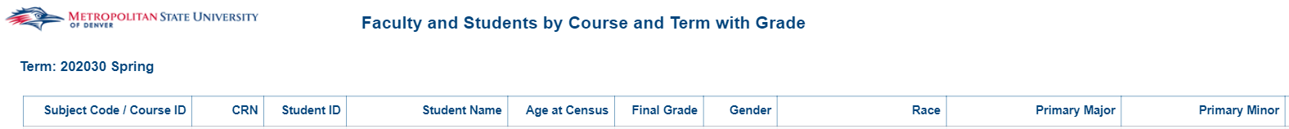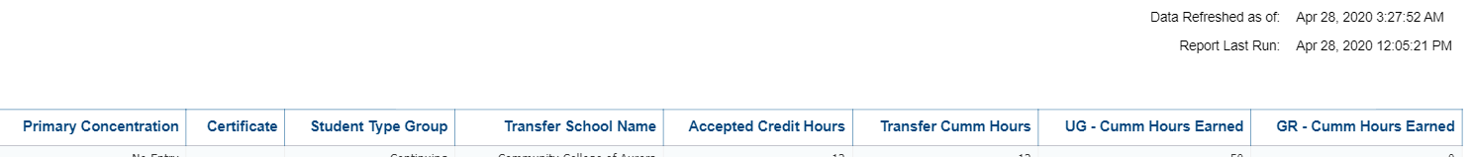

Student Class Ranking
Description: This report displays a detailed list of students that are ranked by cumulative GPA first then on GPA by Term in descending order. The report also includes scholastic information on each student as well as demographic information. The report is broken into sections based on the class of the student (i.e. Freshman, Sophomore, etc.).
Data Elements: Student ID, Student Name, GPA Cumulative, GPA by Term, Credit Hours Amount, Gender, Student Email Address, Street Line 1, Street Line 2, City, State Cd, Zip Code, College, Department, Primary Major, Primary Minor, Primary Concentration, and Certificate.
Source: Student Admission and Enrollment Universe
Location: Public Folder Grade / Ranking Reports Student Class Ranking
Prompts: Term Code (Required)
Input Controls: Minimum GPA Cumulative, Minimum GPA by Term, Minimum Credit Hours Amount, Student Class, College, Department, and Primary Major
Report Page:
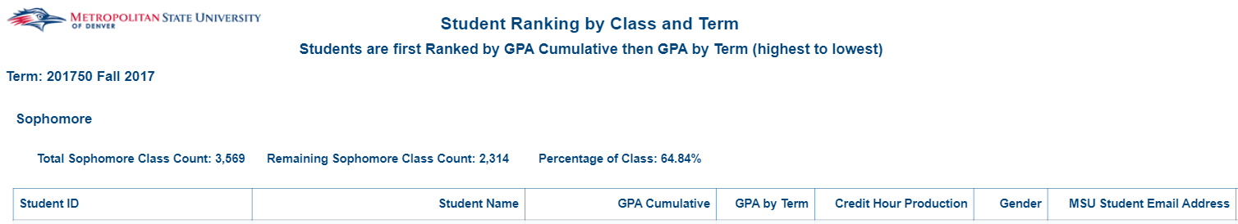
Cont.:
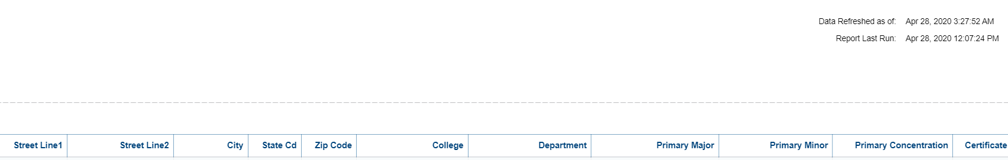

Graduate Programs

7 Year Operational Report – FTES and CHP_GR
Description: The report displays CHP (Credit Hour Production) and FTES (Full Time Equivalent Student) trends for the last 7 years. This is four reports: CHP and FTE overall 7 Year Trend, CHP and FTE Graduate 7 year trend by Race and Gender, FTES by College, Department and Subject Course, and CHP by College, Department and Subject Course.
Data Elements:
- CHP and FTE Overall Trend: CHP and FTE overall 7-year trend by Graduates.
- CHP and FTE Undergraduate Trend Race and Gender: Graduate CHP and FTE 7-year trend by Race, Graduate FTE 7-year trend by Gender
- FTE College, Department, Subject and Course: Graduate FTE 7-year trend by College, Department, Subject and Course
- CHP College, Department, Subject and Course: Graduate CHP 7-year trend by College, Department, Subject and Course
Source: Student Admission and Enrollment Universe
Location: Public Folders Graduate Programs 7 Year Operational Report – FTES and CHP_GR
Prompts: None
Input Controls: Course Funding, Term Description, Couse Level Cd, College, Department, Course Subject, Gender, Race
Report Page:
CHP & FTES Overall Trend:
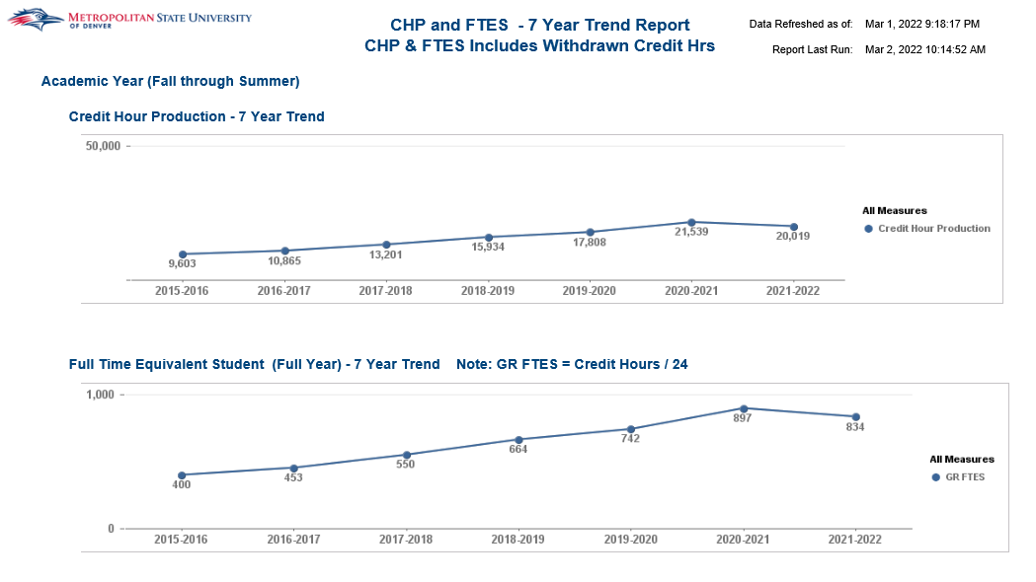
CHP & FTES Trend Graduate Race and Gender:
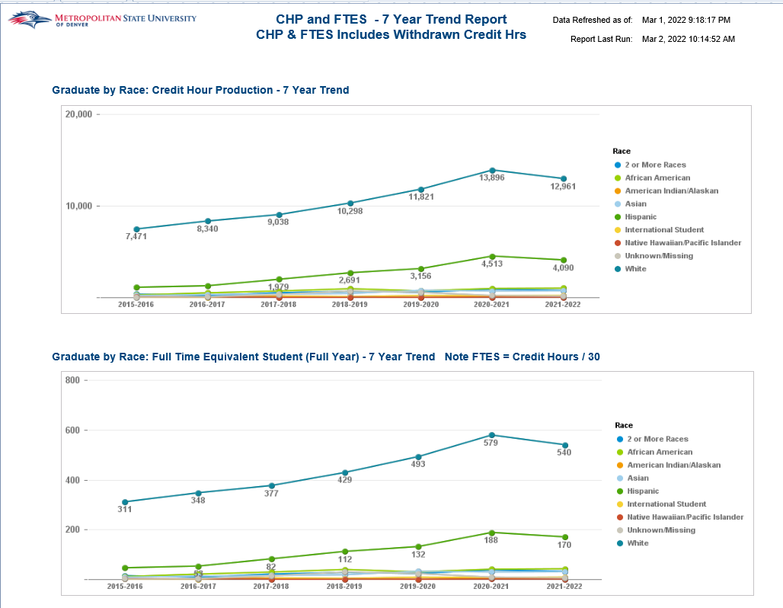
FTES College Department Subject Course:
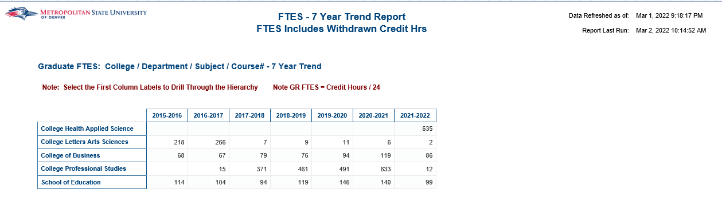

CHP College Department Subject Course:
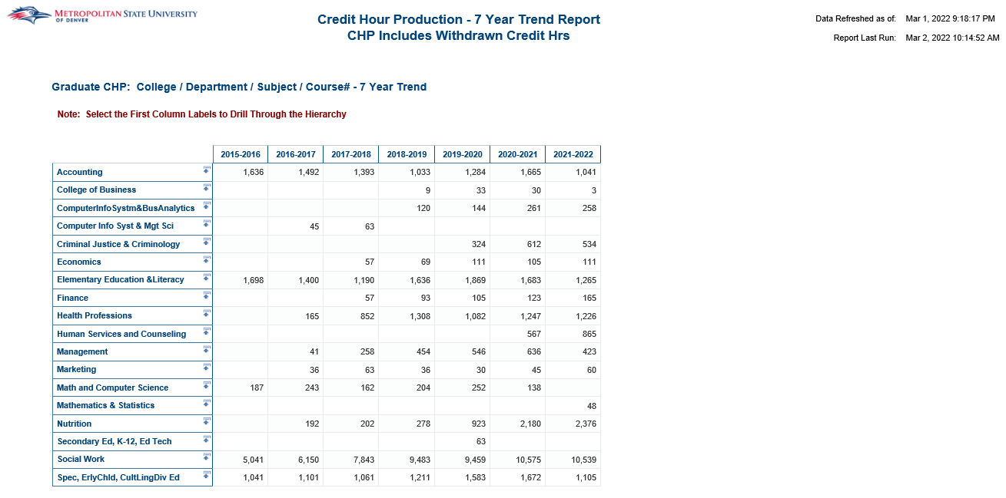

7 Year Operational Report – Student Headcount_GR
Description: The report displays Headcount trends for the last 7 years. Headcount overall 7 Year Trend by Race, Gender,
Student Class and Student Level. Headcount 7 year trend by College, Department, Major and Concentration
(Table Format). Headcount 7 year trend by College, Department, Major and Concentration (Chart Format).
Data Elements:
- Headcount Overall Trend: Headcount overall 7 year trend by Race, Gender, Student Class and Student
Level.
- Headcount College, Department, Major and Concentration Table: Headcount 7 year trend by College, Department, Major and Concentration (Table Format). Select the first column labels to drill through the hierarchy.
- Headcount College, Department, Major and Concentration Chart: Headcount 7 year trend by College, Department, Major and Concentration (Table Format). Select the first column labels to drill through the hierarchy.
Source: Student Admission and Enrollment Universe
Location: Public Folders Graduate Programs 7 Year Operational Report – Headcount_GR
Prompts: None
Input Controls: Term, Student Level, College, Department, Major, Concentration, Race, Gender, Age Band, Student Class
Report Page:
Headcount Overall Trends:
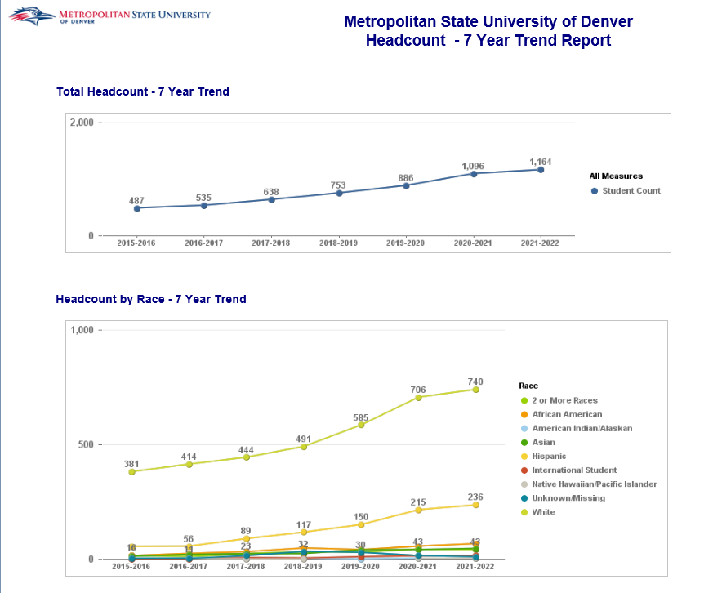
Headcount College Department Major Concentration_Table:
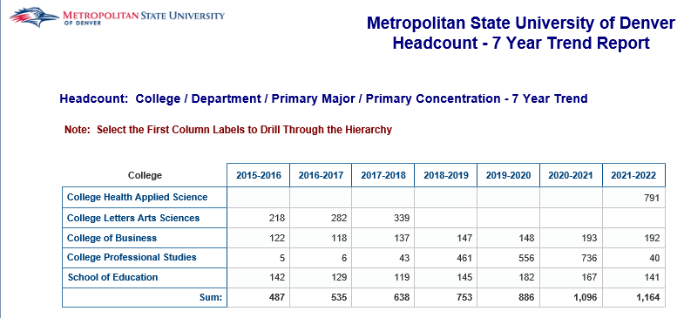
Headcount College Department Major Concentration_Chart:
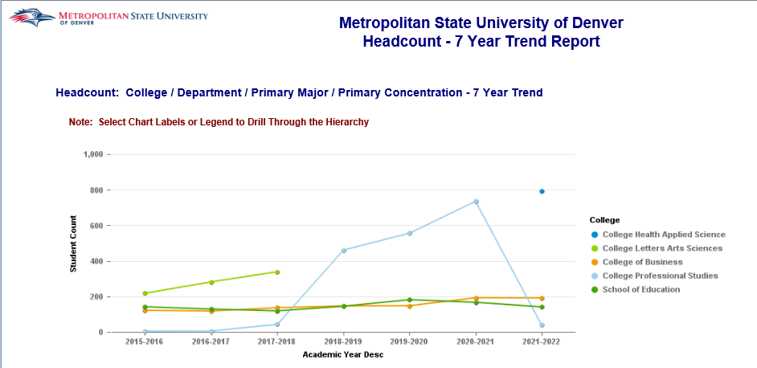

Admissions Dashboard
Description: The dashboard covers Applied, Accepted and Registered Students for a given term. Filter to Graduate students only.
Data Elements: Applied, Accepted, Registered by College, Department, Major, Admission Type, Student Level, Gender, Race, Age, Residency Status, Financial Aid, High School, High School GPA, ACT & SAT Scores, Transfers from 2 or 4 Year Institutions.
Source: Student Admission and Enrollment Universe
Location: Public Folders Graduate Programs Admission Dashboard
Prompts: None
Input Controls: None
Report Page:
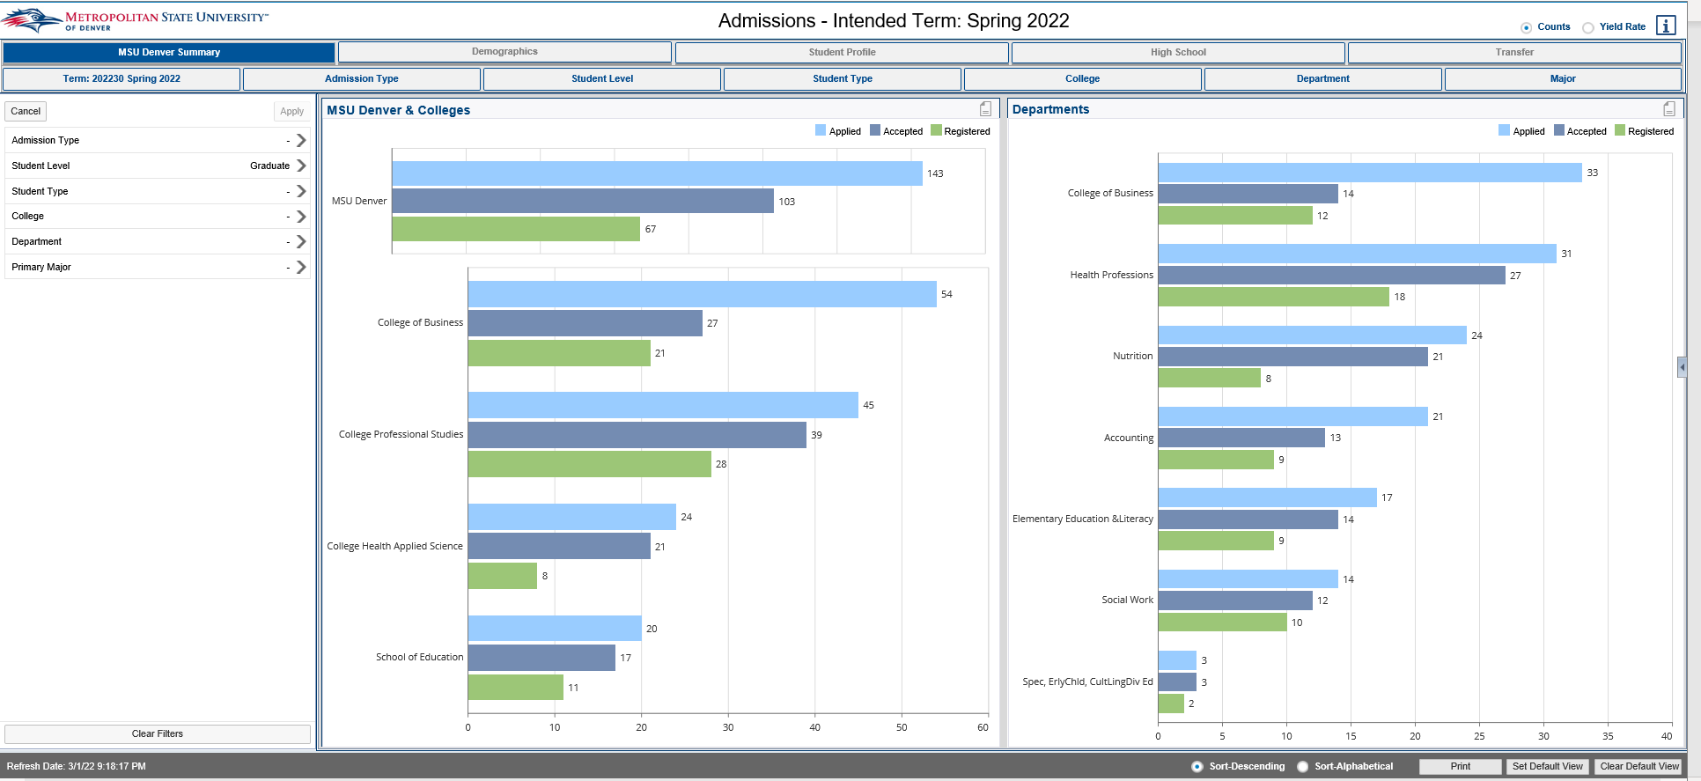

Admitted (Registered) Students Profile_GR
Description: Displays Admitted (Registered) Graduate Students for a specific term. The report is grouped by College and Department and is sorted by Student ID. Using the Input Controls (listed below) you can select single or multiple Terms, Colleges, Departments, Majors, or Degrees.
Data Elements: Student ID, Name, Gender, Race, Degree, Major, Minor, Primary Concentration, Program, Student Type, Student Level
Source: Student Admission and Enrollment Universe
Location: Public Folders Graduate Programs Admitted (Registered) Student Profile_GR
Prompts: Term (required)
Input Controls: Term, College, Department, Major, Degree, Minor, Concentration
Report Page:
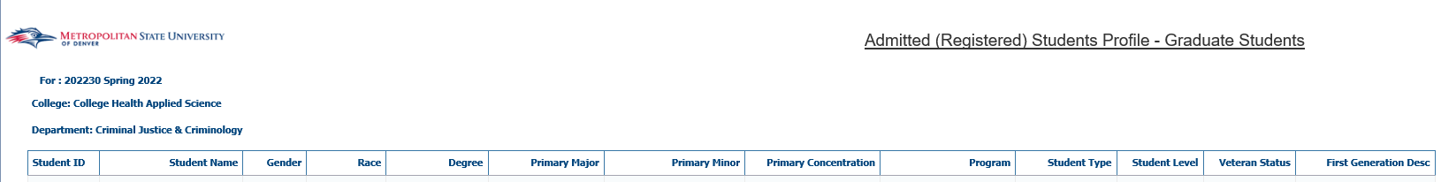

Credit Hour Production at Census Date
Description: The report displays Credit Hour Production (CHP) for each Course Section. It is broken out by Department, Subject, Course Number and Section Number. There are two tabs in this report. One tab is for State Funded Courses while the other is for Cash Funded Courses. Using the Input Controls (listed below) you can select single or multiple Colleges, Departments and Subjects.
Data Elements: College, Department, Subject Code, Course #, Section #, CRN, Primary Instructor, Faculty Type, Campus Code, Course Delivery, Credit Type, Avg Credit Hrs, Enrollment Count, CHP
Source: Student Admission and Enrollment Universe
Location: Public Folders Graduate Programs Credit Hour Production at Census Date
Prompts: Term
Input Controls: College, Department, Subject
Report Page:
State Funded:
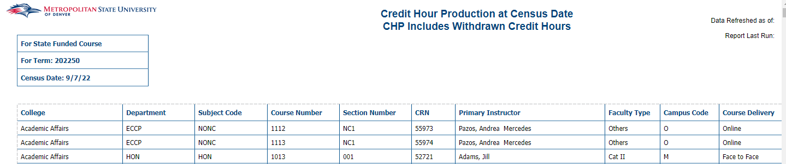
Cash Funded:
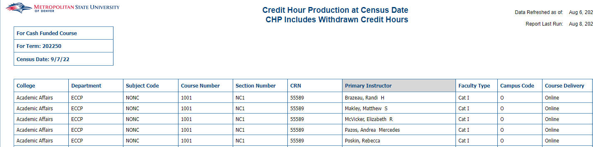

Graduation Report by Term_GR
Description: This report displays Graduate students who graduated during a specific term. The report is grouped by College and is sorted by student ID.
Data Elements: Student ID, Student Name, Elapsed Registered Years to Graduation, Elapsed Registered Terms to Graduation, Gender, Race, First Gen Code, First Gen Description, Major, Minor, Concentration, Program, Degree, Graduation GPA, Honors, Graduation Status, UG – Cumulative Hours Earned, GR Cumulative Hours Earned, Email, Graduation Term
Source: Student Admission and Enrollment Universe
Location: Public Folder Graduate Programs Graduation Report by Term_GR
Prompts: Term(s) (Required)
Input Controls: Term, Graduation Status, College, Major, Program, Degree, Concentration
Report Page:
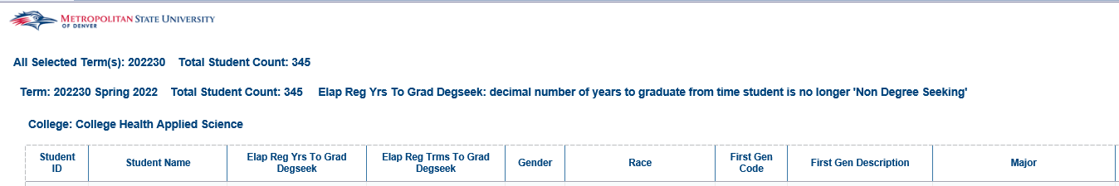
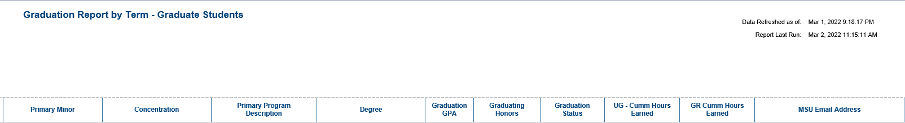

Registration Dashboard
Description: Displays headcounts of all registered students for a given term. Headcounts are displayed by College, Department, Student Type, Age Band at Census, Gender, Race/Ethnicity, Student Class, GPA bands, Financial Aid groups, Full Time/Part Time status, and an overall trend analysis. The dashboard can be filtered by College, Department, Major, Student Level and Student Class. The data displayed is end of term data for all past terms and is current as of today for the current term.
Data Elements: Term, Summary, Demographics, Student Profile, Trend Analysis, College, Department, Major, Student Level, Student Class
Source: Student Admission and Enrollment Universe
Location: Public Folders Graduate Programs Registration Dashboard
Prompts: None
Input Controls:
Report Page:
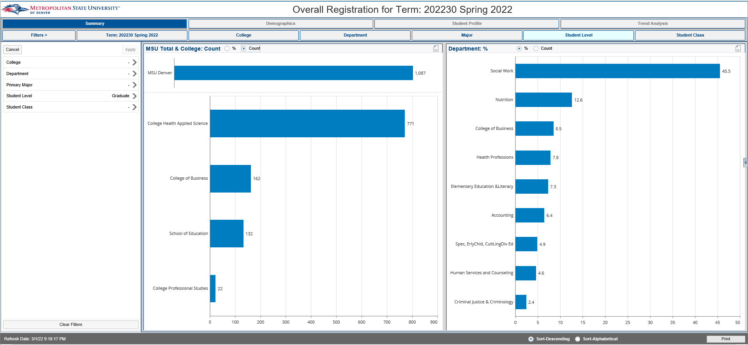

Retention Dashboard
Description: Displays term to term retention totals. There is an overall Summary section as well as Department, Major, Demographic and Student Profile sections. Each can be broken down by College, Department and Major.
Data Elements: Summary, Department, Major, Demographics, Student Profile, Beginning Term, Ending Term, College, Department
Source: Student Admission and Enrollment Universe
Location: Public Folders Graduate Programs Retention Dashboard
Prompts: None
Input Controls:
Report Page:
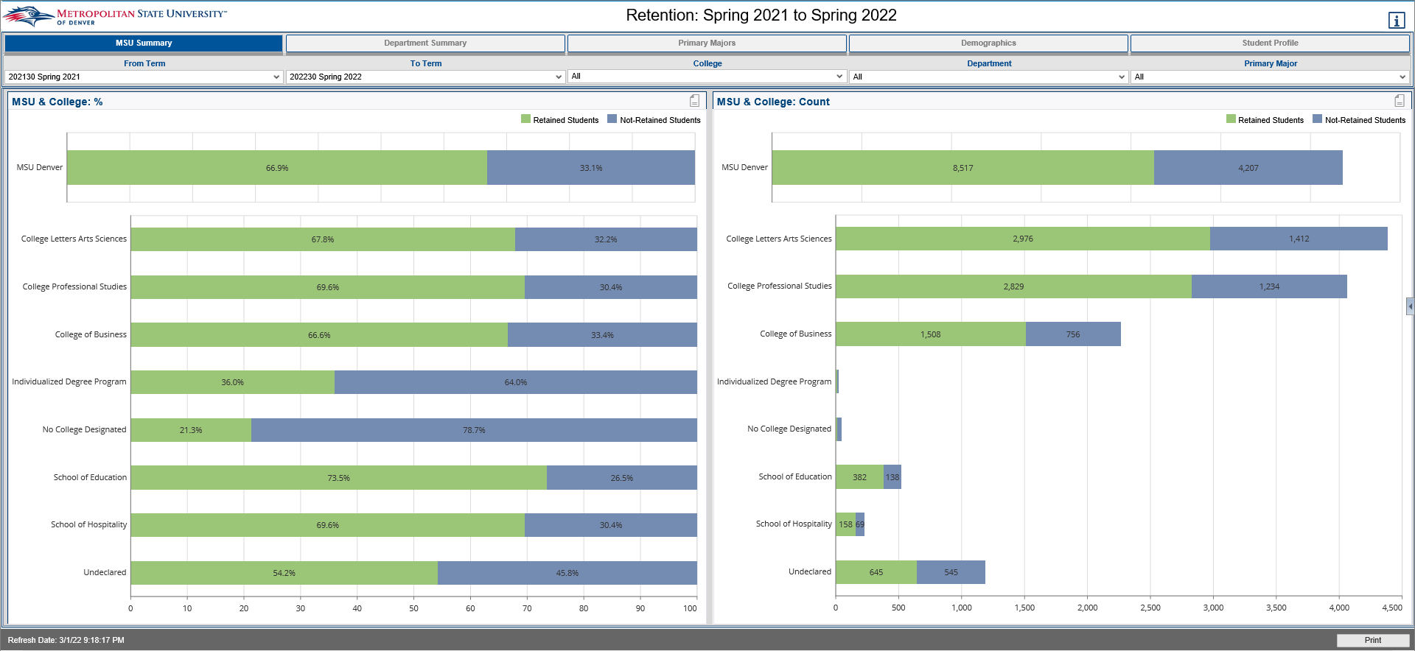

Retention Report_GR
Description: This report displays Retention data for Graduate students that have been retained and have not been retained for 1 to 3 years. The Retention count tab gives a summary of Graduate students retained and not retained from 1 to 3 years. The data is broken down by College, Age, Gender, Race and Degree. The other tabs provide a detailed list of students that have been retained and not retained for 1 to 3 years. (This report is specific to Graduate students and programs which have a different College definition then Undergraduate students.)
Data Elements:
- Retention Count: College, Age Band, Gender, Race, Degree, GPA Cumulative, Count of Retained Students for 1-3 Years, Count of not Retained Students for 1-3 Years, Retained Percentage, Not Retained Percentage
- Retention by Year Tabs (Not Retained/Retained (+1, +2, +3): ID, Name, Department, Major, Degree, Student Class, GPA Cumulative, Email
Source: Student Admission and Enrollment Universe
Location: Public Folders Graduation Programs Retention Report_GR
Prompts: Term (Required), College, Department, Major
Input Controls: College, Department, Major, Retention College
Report Page:
Retention Count:
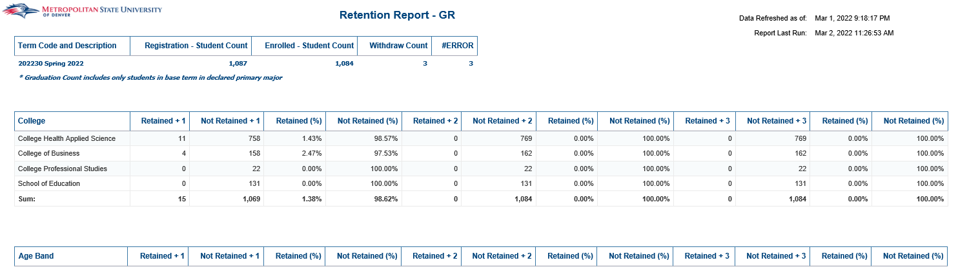
Retention by Year Tabs (Not Retained/Retained (+1, +2, +3):
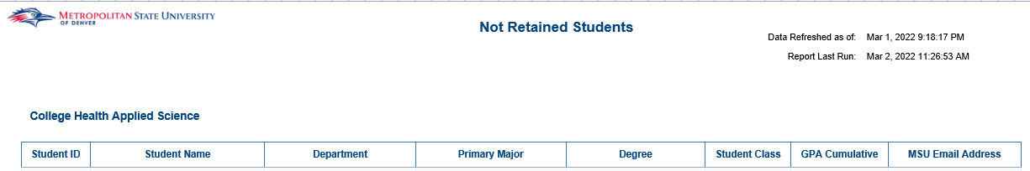

Graduation

Graduation Report by Term
Description: This report displays students who graduated during a specific term. The report is grouped by College and is sorted by student ID.
Data Elements: Student ID, Student Name, Elapsed Registered Years to Graduation, Elapsed Registered Terms to Graduation, Gender, Race, First Gen Code, First Gen Description, Major, Minor, Concentration, Program, Degree, Graduation GPA, Honors, Graduation Status, UG – Cumulative Hours Earned, GR Cumulative Hours Earned, Email, Graduation Term
Source: Student Admission and Enrollment Universe
Location: Public Folder Graduation Graduation Report by Term
Prompts: Term(s) (Required)
Input Controls: Term, Graduation Status, College, Major, Program, Degree, Concentration
Report Page:
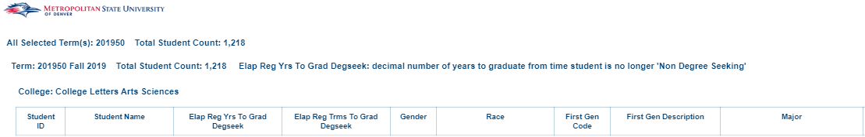
Cont.:
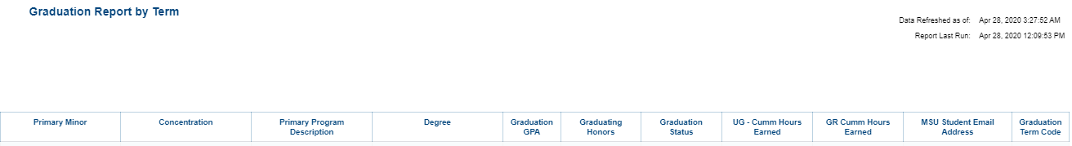

Graduation Report by Term for Transfer Students
Description: This report displays Transfer students who graduated during a specific term. The report is grouped by College and is sorted by student ID.
Data Elements: Student ID, Student Name, Email, Address, Major, Minor, Concentration, Certificate, Graduation GPA, Graduating Honors, Graduation Rate – Actual Terms Registered, Count – Years to Completion, Transfer Institution, Accepted Credit Hours.
Source: Student Admission and Enrollment Universe
Location: Public Folder Graduation Graduation Report by Term for Transfer Students
Prompts: Term Code (Required)
Input Controls: College, Major, Concentration
Report Page:
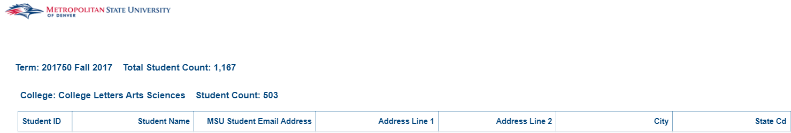
Report Page Cont.:
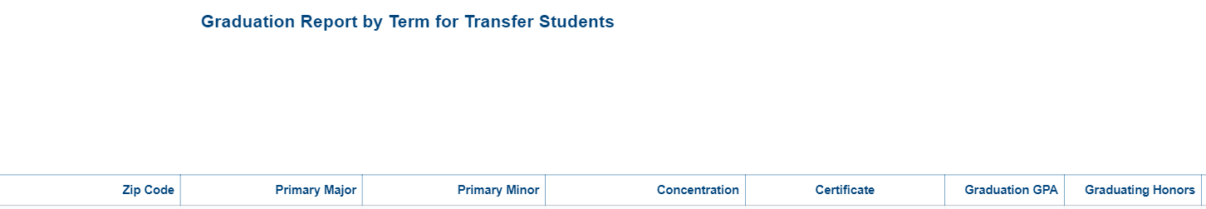
Report Page Cont.:
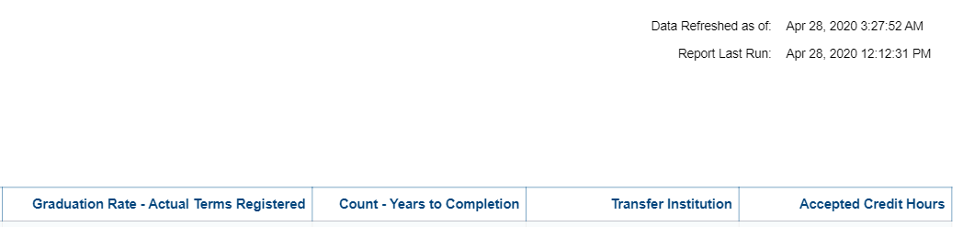

Graduation Report by Term with Student Address
Description: This Report displays students who graduated during a specific term along with their active and inactive addresses. The report is grouped by College and is sorted by student ID.
Data Elements: Student ID, Name, Graduation Term, Gender, Race, Major, Minor, Concentration, Primary Program Description, Degree, Degree Status, Diploma Name, Graduation GPA, Graduating Honors, Count-Terms Registered, Count-Years to Complete, Email, Address Status, Address Type, Address
Source: Student Admission and Enrollment Universe
Location: Public Folders Graduation Graduation Report by Term with Student Address
Prompts: Term (required)
Input Controls: Address Status, Address Type Desc., Graduation Term, Degree Status, College, Major, Degree, Concentration, Primary Program Desc.
Report Page:
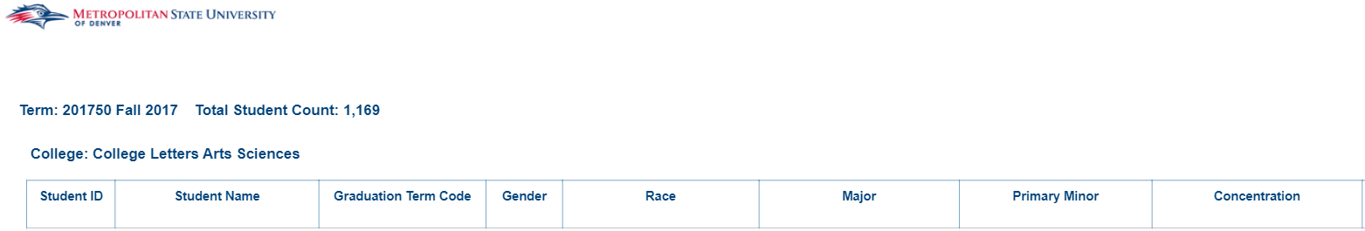
Report Page Cont.:
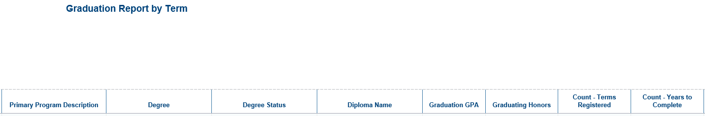
Report Page Cont.:
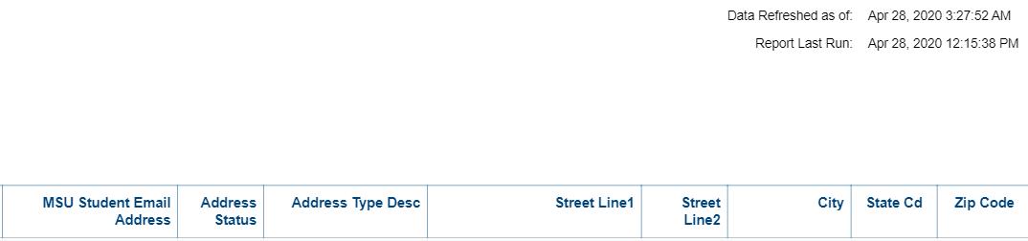

Graduation Report by Term with Student Address and Name Split
Description: This Report displays students who graduated during a specific term along with their active and inactive addresses. The report has two tabs: the Summary tab is grouped by College and is sorted by student ID and the Breakdown by College/School & Depart tab is broken down by College and Department and sorted by student ID.
Data Elements: Student ID, Last Name, First Name, Middle Name, Graduation Term, Gender, Race, Major, Minor, Concentration, Primary Program Description, Degree, Degree Status, Diploma Name, Graduation GPA, Graduating Honors, Count-Terms Registered, Count-Years to Complete, MSU Email Address , Cell Phone Number, Address Status, Address Type, Address
Source: Student Admission and Enrollment Universe
Location: Public Folders Graduation Graduation Report by Term with Student Address
Prompts: Term (required)
Input Controls: Address Status, Address Type Desc., Graduation Term, Degree Status, College, Major, Degree, Concentration, Primary Program Desc.
Report Page:
Summary:
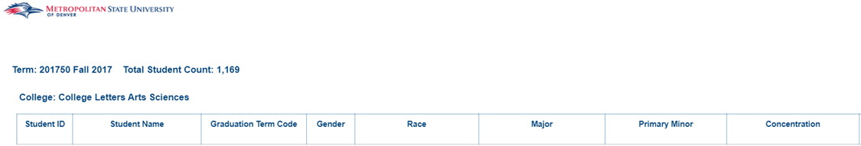
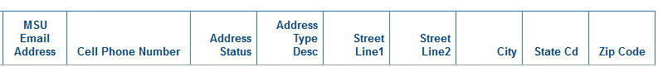

Breakdown by College/School & Depart:
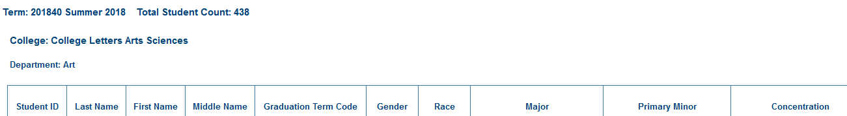

Pending Grads Repeat Courses
Description: This report lists all students that have applied for graduation in a give term and any courses they have repeated.
Data Elements: Student ID, Student Name, Term Registered/Repeated, Course Number, CRN, Course Subject Cd, Course Description, Course Title, Grade, Credit Hours, Max Credits Allowed, Max Repeats Allowed, Course Source
Source: Student Admission and Enrollment
Location: Public Folders Graduation Pending Grads Repeat Courses
Prompts: Graduation Term Code, Graduation Status (optional)
Input Controls: Course Source Code, Grades
Report Page:
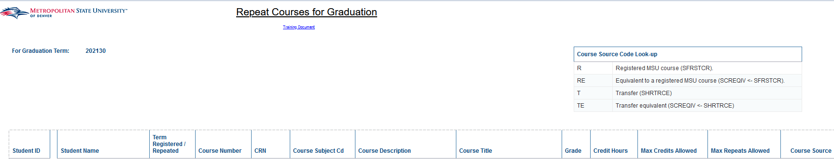

Honors Program

Honors Program – Recruiting (Active Students)
Description: Displays all active students who are eligible for the Honors Program for the given term.
Data Elements: Student ID, Last Name, First Name, Email, Race, Gender. College, Department, Major, MSU GPA Cumulative, GPA by Term, Credit Hours (Including Transfer), First Time Registered Y/N, Street, City, State, Zip
Source: Student Admission and Enrollment Universe
Location: Public Folders Honors Program Honors Program – Recruiting (Active Students)
Prompts: Term, Credit Hours Earned (Start), Credit Hours Earned (End), MSU Cumulative GPA
Input Controls: College, Department, Major
Report Page:
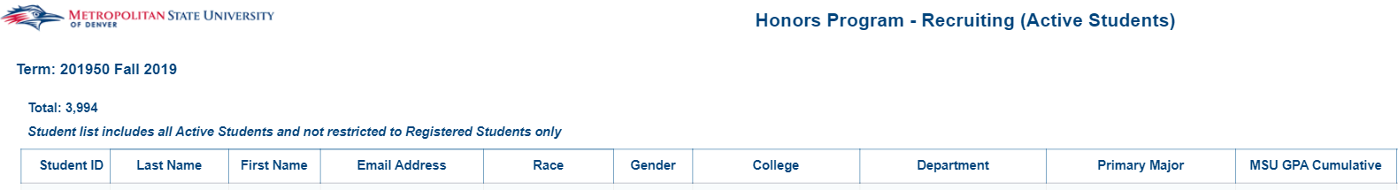
Cont.
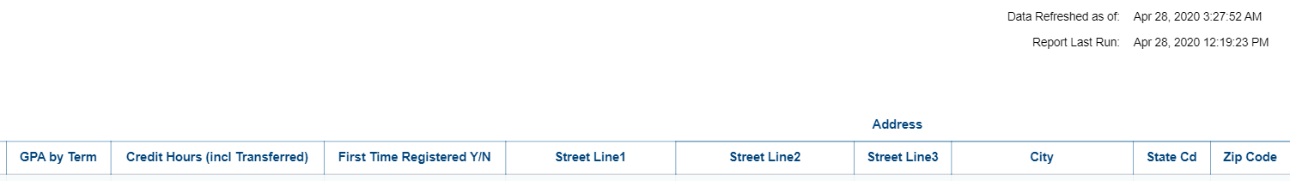

Honors Program – Recruiting (New Applications)
Description: Displays all newly accepted student for a given semester that are eligible for the honors program based on the prompt criteria. The All New Applicants tab lists all accepted students and demographic and scholastic information. The HighSchool tab lists all students that have high school information and provides demographic and the students’ high school scholastic information. The Transfer tab list all students with transfer data and provides demographic and the students’ transfer scholastic information.
Data Elements:
- All New Applicants: ID, Last Name, First Name, Email, Race, Gender, College, Department, Primary Major, GPA – High School, GPA – Transferred, ACT Composite, SAT Total, Accepted Credit Hours, Registered Indicator
- High School: ID, Last Name, First Name, Email, Race, Gender, College, Department, Primary Major, GPA – High School, ACT Composite, SAT Total, High School Name, Registered Indicator
- Transfer: ID, Last Name, First Name, Email, Race, Gender, College, Department, Major, GPA Transferred, Accepted Credit Hours, School Name, School Type, School Location Type, Registered Indicator
Source: Student Admission and Enrollment Universe
Location: Public Folders Honors Program Honors Program – Recruiting (New Applications)
Prompts: Term, GPA Transferred, Accepted Credit Hours, ACT Composite, SAT Total, High School GPA
Input Controls: Registered, College, Department, Major, ACT Score Min, SAT Score Min
Report Page:
Summary
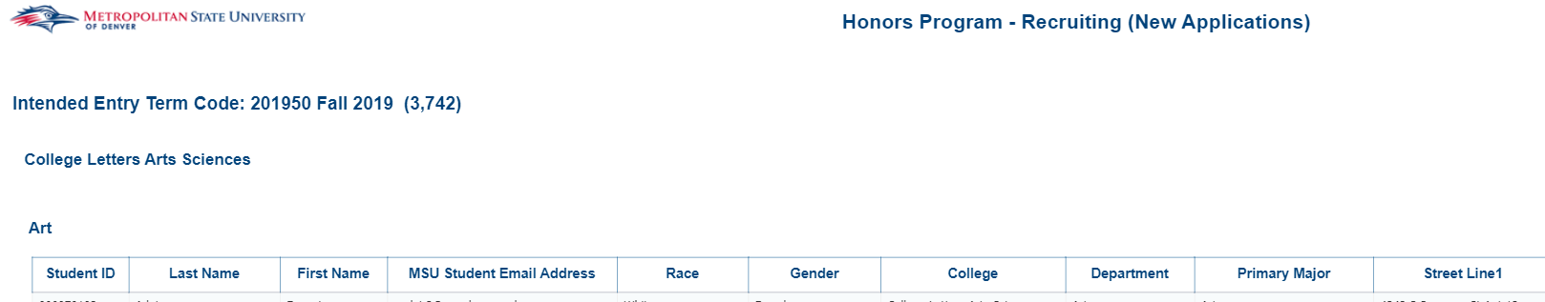
Summary Cont.
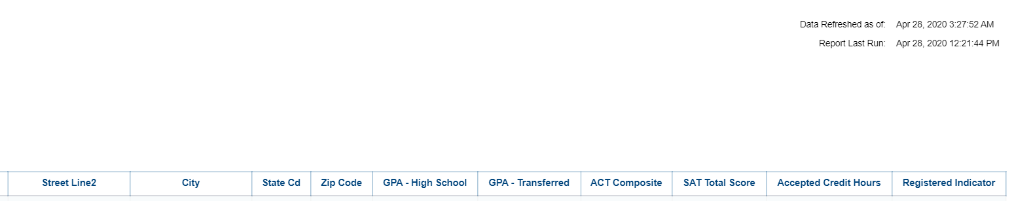
High School
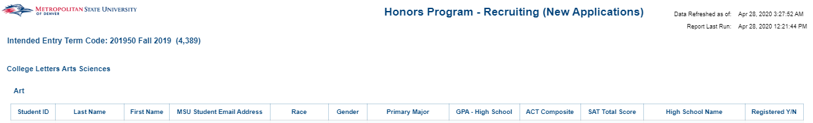
Transfer
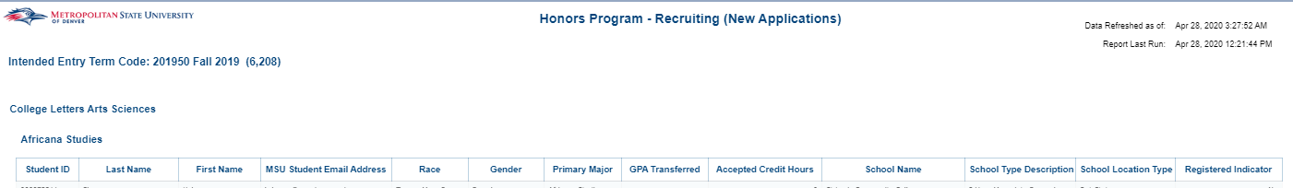

Honors Program List
Description: Displays Honors Students for a given term. There are three reports. The Summary Report lists Honors students by College, Gender and Race. The Student List with HHP gives a detailed list of all Honors Students. The Student List by Course lists Honors students by course
Data Elements:
- Summary: College, Student Count; Gender, Student Count; Race, Student Count
- Student List with HHP: Student ID, Name, Gender, Race, MSU Email, Graduation Status, Registered
- Student List by Course: Student ID, Name, College, Department, Course ID, CRN, Subject Code, Course Subject, Graduation Indicator
Source: Student Admission and Enrollment Universe
Location: Public Folders Honors Program Honors Program List
Prompts: Term (Required)
Input Controls: None
Report Page:
Summary
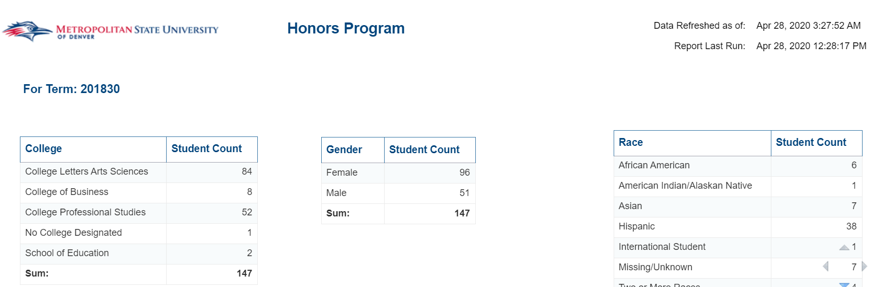
Student List with HHP
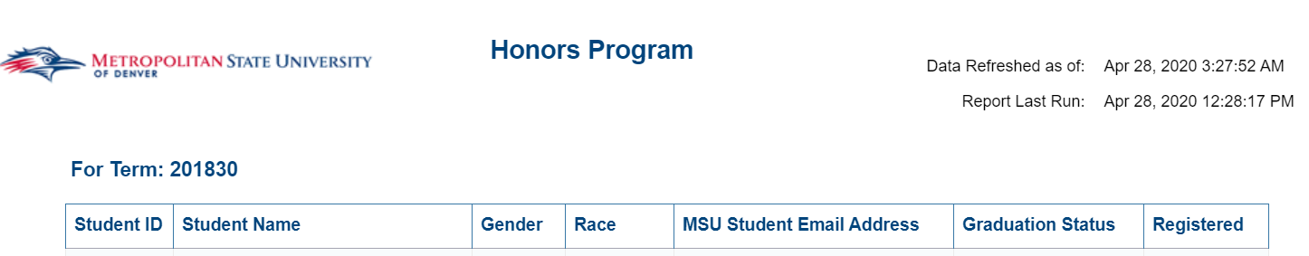
Student List by Course
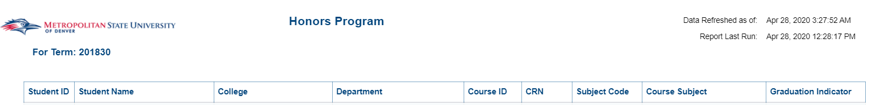

Master List- Honors Program
Description: Displays Honors Students who have completed an Honors Course and the grade they received in it. There are three reports. The HON Curriculum Completion Report list of students and the honors courses they’ve taken and the grade they received. The Demographics report gives certain demographics for the students from the HON Curriculum Report. The GPA report gives the Cumulative GPA for the same group of students.
Data Elements:
- HON Curriculum Completion: Last Name, First Name, Student ID, HON Courses, Credits
- Demographics: Name, Student ID, Gender, Race, College, Department, Concentration, Minor, MSU Email, Address, High School, Transfer College, Registration Status, First Term Entry to Honors Program, First Time Registered at MSU
- Student List by Course: Name, Student ID, Cumulative GPA for given terms.
Source: Student Admission and Enrollment Universe
Location: Public Folders Honors Program Master List – Honors Program
Prompts: Term (Required)
Input Controls:
- HON Curriculum Completion: Student ID, Course,
- Demographics: Student Status, Registration Status_1,
Report Page:
Hon Curriculum Completion
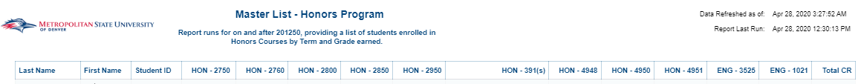
Demographics
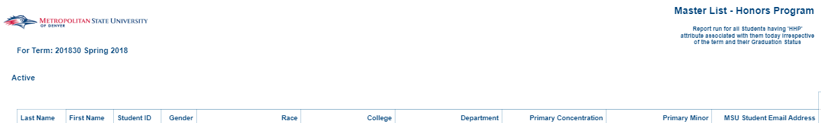
Demographics (Cont)
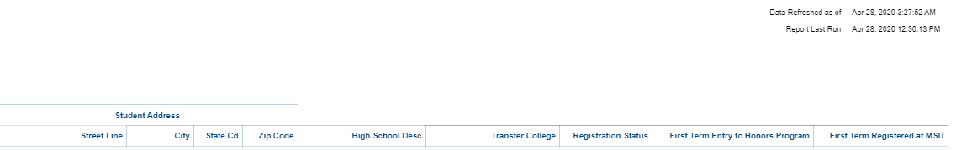
GPA
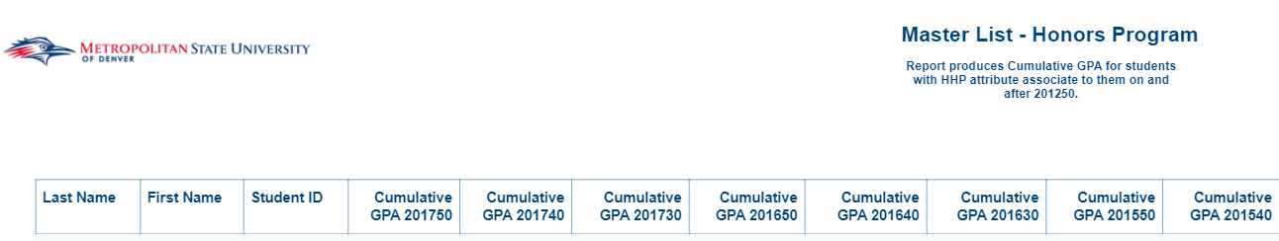
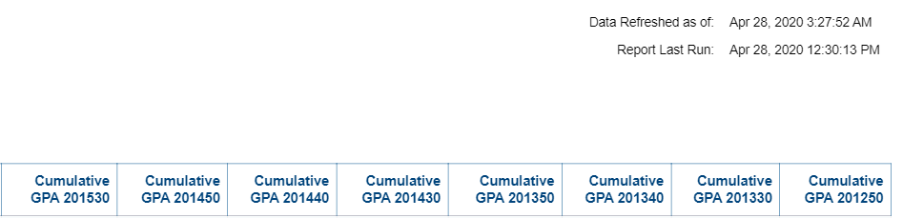

Registration Dashboard – Honors Program
Description: Displays all Active students and all Active Honors Students by College, Department, Major, Student Level and Student Class.
Data Elements: Term, Summary, Demographics, Student Profile, Trend Analysis, College, Department, Major, Student Level, Student Class
Source: Student Admission and Enrollment Universe
Location: Public Folders Honors Program Registration Dashboard – Honors Program
Prompts: None
Input Controls:
Report Page:
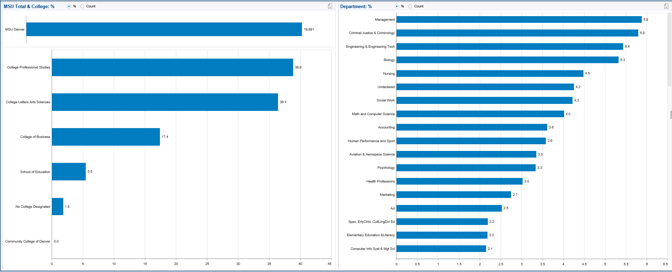

Retention Report - Optional Student Attribute
Description: Displays Retention information for Honors Students by College, Age, Gender, Race and Degree over 3 years. There are more tabs that list the students that were retained or not retained for 1,2 and 3 years.
Data Elements: College, Age, Gender, Race, Degree, Student ID, Name, Department, Major, Student Class, Email
Source: Student Admission and Enrollment Universe
Location: Public Folders Honors Program Retention Report – Optional Student Attribute
Prompts: Term, College, Department, Major, Student Attribute
Input Controls: College, Department, Major
Report Page:
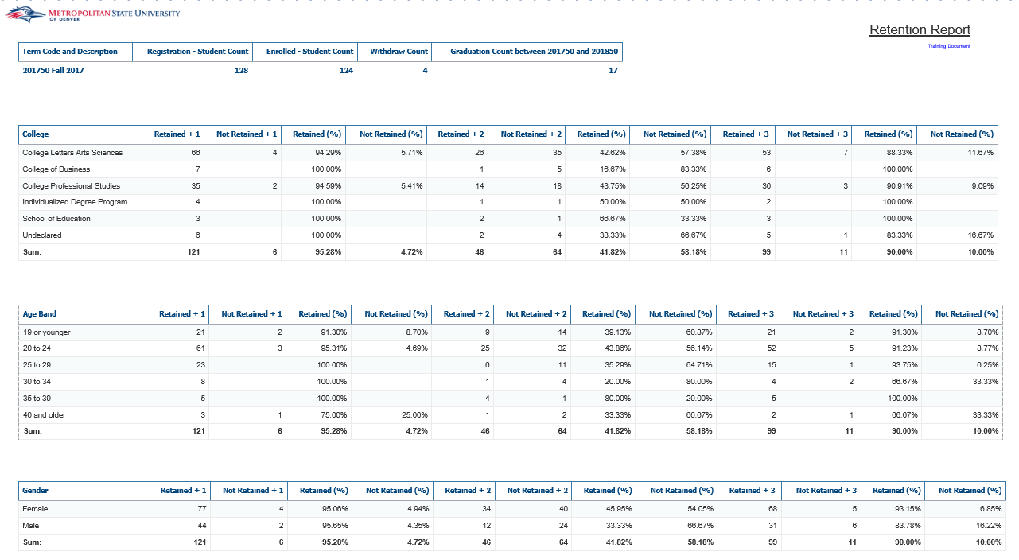
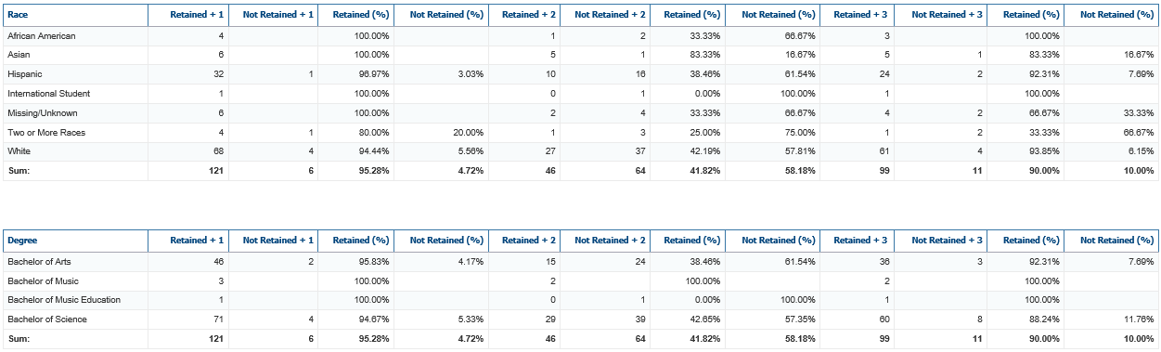

P2P Program

P2P Program Report
Description: This report pulls all students that have the 'P2P' student attribute effective for the term the user has selected. The report contains student details such as major, transferred credits hours, student charges, student holds, other student attributes, and financial aid detail including a student's invoice and check data for their financial aid awards. This report includes 5 tabs: P2P Roster, P2P Roster – Holds, P2P Roster - Other Programs, P2P Roster - Financial Aid (Please Note: This tab contains sensitive student data that is not to be shared outside of MSU Denver) and P2P Roster - Invoices
Data Elements:
- P2P Roster: P2P Student Count, P2P Registered Student Count, Student ID, Term, First Name, Last Name, Student Level, Primary Major Code: Description, Residency Status, ACT Composite, SAT Total Score, Transfer Credit Hours, Transaction Detail, Transaction Amount, Transaction Balance, Transaction Date
- P2P Roster - Holds: Student ID, Term, Student First Name, Student Last Name, Hold Code, Hold Description, Hold Type, Hold Start Date, Hold End Date
- P2P Roster – Other Programs: Student ID, Term, Student First Name, Student Last Name, Student Attribute Code, Student Attribute Description
- P2P Roster – Financial Aid:
- Financial Aid – Application Requirements: Student ID, Student First Name, Student Last Name, Requirement Code, Requirement, Requirements Established Date, Requirement Status Code, Requirement Status Date, Verification Required Ind
- Financial Aid – Packaging and Awards: Student ID, Student First Name, Student Last Name, Award Status Desc, Fund Type, Fund Title, Award Decline Amt, Award Memo Amt, Award Authorize Amt, Award Cancel Amt, Award Accepted – Sum, Award Paid Amt, EFC
- P2P Roster – Invoices: Invoice Vendor ID, Invoice Vendor Name, Invoice Vendor Invoice Code, Open/Paid Indicator, Cancel Indicator, Invoice Payment Due Date, Invoice Check Number, Invoice Check Date, Invoice Check Net Amount
Source: Student Admission and Enrollment Universe
Location: Public Folders P2P Program P2P Program Report
Prompts: Term (Required), Student ID, Aid Year Code (Required)
Input Controls: Student ID
Report Page:

P2P Roster:
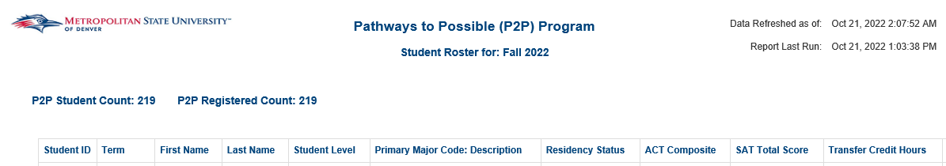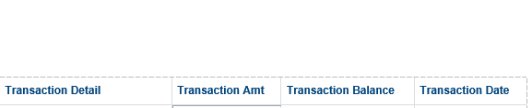
P2P Roster – Holds:
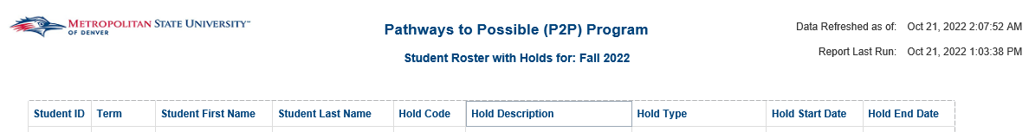
P2P Roster – Other Programs:
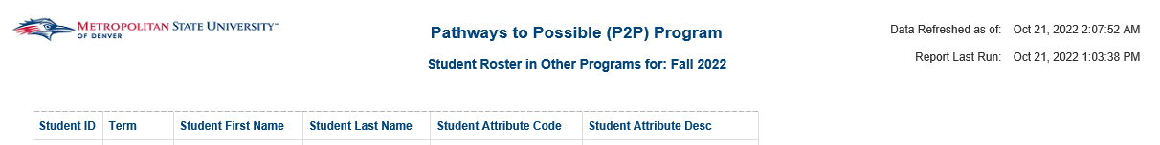
P2P Roster – Financial Aid:
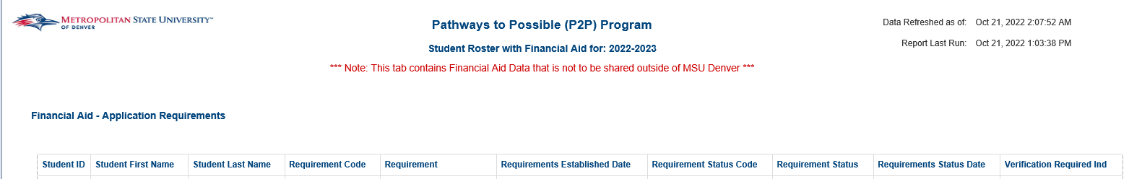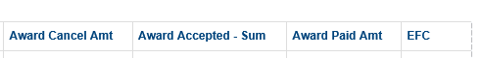

P2P Roster – Invoices:
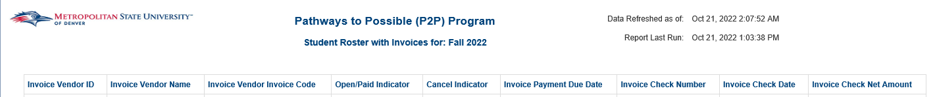

Registration

Active Students Not Registered by Term
Description: Lists all active students that are not registered in the given term.
Data Elements: Student ID, Student Name, Full Street Address, City, State Cd, Zip Code, Student Class, Student Level, Primary Major Code, Primary Major, Primary Minor Code, Primary Minor, Primary Concentration Code, Primary Concentration, Degree, MSU Email Address
Source: Student Admission and Enrollment Universe
Location: Public Folders Registration Active Students Not Registered by Term
Prompts: Term
Input Controls: None
Report Page:
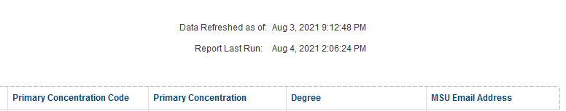

Course Registration Dashboard
Description: This dashboard displays Registration data. There is a Course Summary section, Wait List section, and Class Trends section. Each section can be filtered by Term, College and Department.
Data Elements: Course Summary: Subject Code, Course #, CRN, Course Title, Max Enrollment, Current Enrollment, Seats
Available, Wait Available #, Wait Count Max Ever
Wait List:
Class Trends: Applied, Accepted & Enrolled by Student Type, Gender, Race Age (All by % or
Count)
Source: Student Admission and Enrollment Universe
Location: Public Folders RegistrationCourse Registration Dashboard
Prompts: None
Input Controls: Term, College, Department
Report Page:
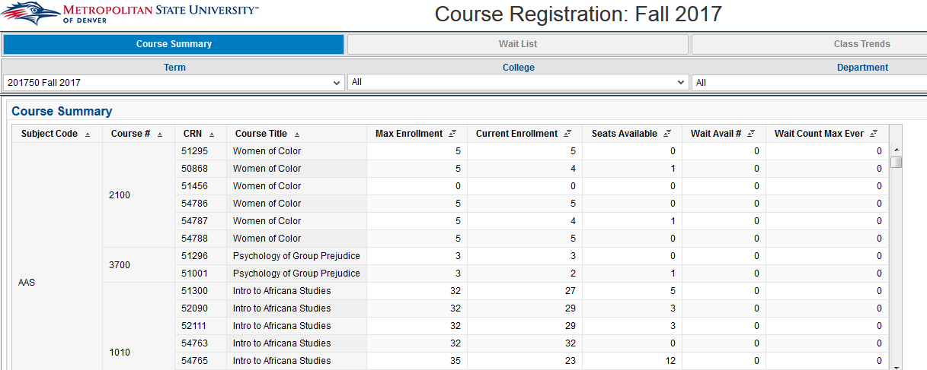

Drop All and Withdraw All
Description: This report shows the list of students that have either dropped all their courses prior to Cenus date or Withdrawn from all the courses after Census for a particular term.
Data Elements: Academic Year Desc, Term, Student ID, Student Name, Dropped All/Withdrawn All, Trigger Date, MSU Email, College, Department, Primary Major, Primary Minor, Primary Concentration, Student Type, Student Level, Student Class, Full Time/ Part Time, Race, Gender, Age Band at Census, Residency Status, Veteran Status, First Generation Status, GPA Cumulative, First Time Registration Y/N
Source: Student Admission and Enrollment Universe
Location: Public Folders Registration -> Drop All and Withdraw All
Prompts: None
Input Controls: Term, College, Department
Report Page:

Enrollment by Term w/ Expected Grad Date
Description: This report lists all students enrolled students, their contact information, major, and expected graduation date for a given term.
Data Elements: Student ID, Student Name, MSU Email Address, Non-MSU Email Address, Phone Number, Street Address 1, Street Address 2, State, Zip Code, Date of Birth, Gender, Primary Major, Expected Graduation Date
Source: Student Admission and Enrollment Universe
Location: Public Folders Registration Enrollment by Term w/ Expected Grad Date
Prompts: Term
Input Controls: Primary Major
Report Page:
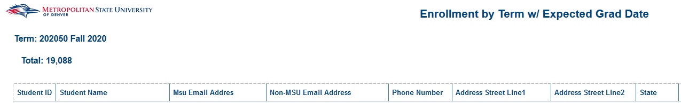
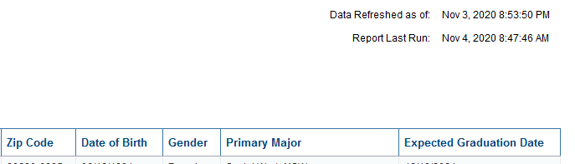

Registered Students by Credit Hours
Description: Displays Students registered for a specific term. The report is grouped by College and Department and is sorted by student ID. Using the Input Controls (listed below) you can select single or multiple Colleges, Departments and Majors
Data Elements: Student ID, Name, Gender, Race, Class, Type, Level, Major Code, Major, Minor Code, Minor, Program Code, Program, Concentration Code, Concentration, Degree, Email, GR – Registered Credit Hours, UG – Registered Credit Hours
Source: Student Admission and Enrollment Universe
Location: Public Folders Registration Registered Students by Credit Hours
Prompts: Term (required)
Input Controls: College, Department, Major
Report Page:
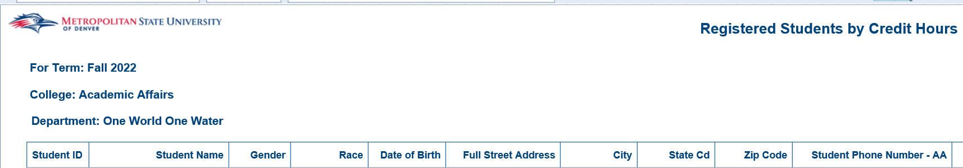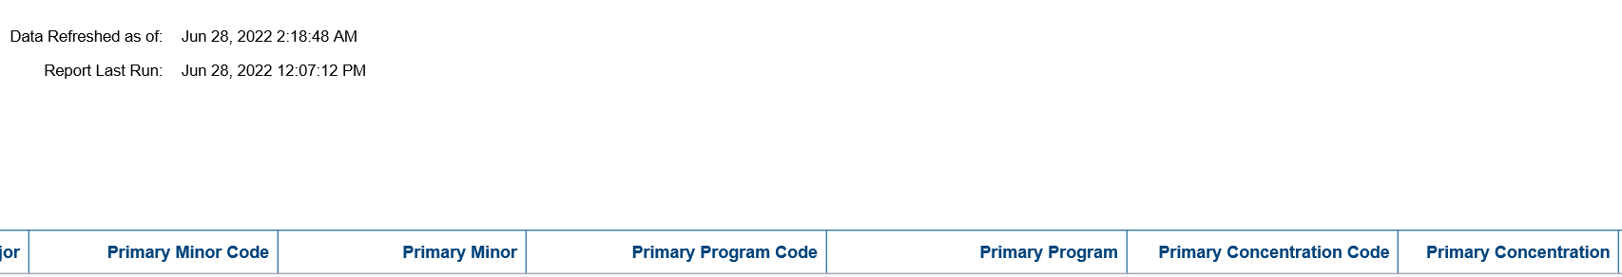

Registered Students by Credit Hours - UG
Description: Displays Students registered for a specific term. The report is grouped by College and Department and is sorted by student ID. Using the Input Controls (listed below) you can select single or multiple Colleges, Departments and Majors
Data Elements: Student ID, Name, Gender, Race, Class, Type, Level, Major Code, Major, Minor Code, Minor, Program Code, Program, Concentration Code, Concentration, Degree, Email, Registered Credit Hours
Source: Student Admission and Enrollment Universe
Location: Public Folders Registration Registered Students by Credit Hours - UG
Prompts: Term (required)
Input Controls: College, Department, Major
Report Page:

Registered Students by Credit Hours – UG_less than 12
Description: Displays Students registered for less than 12 hours for a specific term. The report is grouped by College and Department and is sorted by student ID. Using the Input Controls (listed below) you can select single or multiple Colleges, Departments and Majors
Data Elements: Student ID, Name, Gender, Race, Major, Minor, Program, Degree, Registered Credit Hours
Source: Student Admission and Enrollment Universe
Location: Public Folders Registration Registered Students by Credit Hours – UG_less than 12
Prompts: Term (required)
Input Controls: College, Department, Major
Report Page:

Registered Students by Credit Hours with Total Earned Hours
Description: Displays Students registered for a specific term. The report is grouped by College and Department and is sorted by student ID. Using the Input Controls (listed below) you can select single or multiple Colleges, Departments and Majors
Data Elements: Student ID, Name, Gender, Race, Class, Type, Level, Major Code, Major, Minor Code, Minor, Program Code, Program, Concentration Code, Concentration, Degree, Email, Registered Credit Hours, Cumulative Earned Hours, GPA Cumulative
Source: Student Admission and Enrollment Universe
Location: Public Folders Registration Registered Students by Credit Hours with Total Earned Hours
Prompts: Term (required)
Input Controls: College, Department, Major
Report Page:
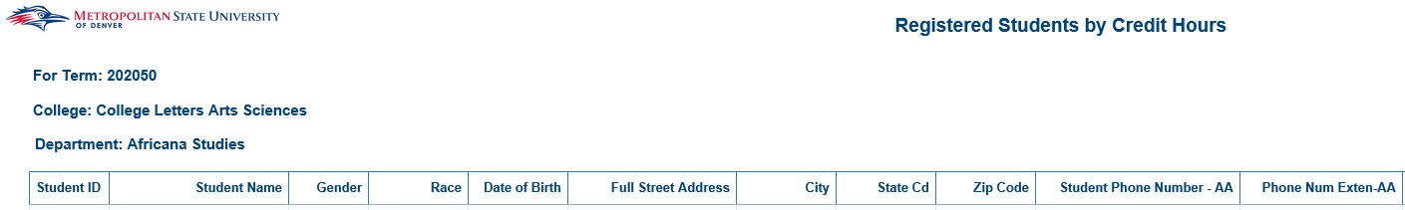

Registered Students by Field of Study
Description: Displays all registered students for a selected term with all possible fields of study (primary, secondary and tertiary curriculums).
Data Elements: Student Count, Student ID, Student Type, Term Cd, College Desc, Department Desc, FOS Code, FOS Desc, Degree Cd, Degree Desc, Curriculum Level Name, Level Type
Source: Student Admission and Enrollment Universe
Location: Public Folders Registration Registered Students by Field of Study
Prompts: Term (required)
Input Controls: None
Report Page:
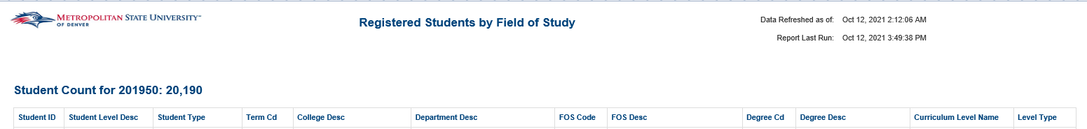

Registered Students by Location
Description: Displays all students for a term, and aggregates them by both city and zip code
Data Elements: City, Student Count, Zip Code, Student Count, Student ID, Student Name, State Cd, City, Zip Code, Email Address, College, Department, Major, Concentration, Student Type, Student Level, Student Class, Full Time / Part Time, Race, Gender, Age Band at Census, Residency Status, Veteran Status, GPA Cumulative, First Time Registered Y/N
Source: Student Admission and Enrollment Universe
Location: Public Folders Registration Registered Students by Location
Prompts: Term (required), College, Department, Primary Major, Student Level, Student Class, Student Attribute Cd
Input Controls: State, Campus, College, Department, Major, Concentration, Student Level, Student Class, Race, Full Time / Part Time
Report Page:

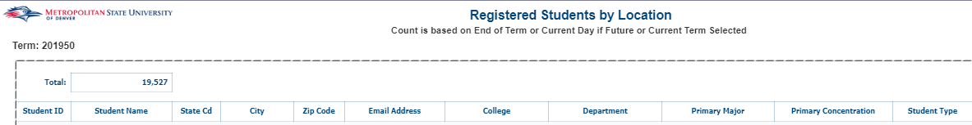

Registration Activity by Date
Description: This report pulls a list all registration activity for a user selected term and date range. The report shows all registration activity that occurs in Banner between the dates selected, including records that would've been deleted in Banner.
Data Elements:
- Registration Activity Summary: Academic Year, Term Code, College, Department, Student ID, Student Name, Primary Major Code, Course Subject Cd: Course #, Course Section Number, Date, Registration Status Codes, Registration Status Desc, Record Deleted Ind
Source: Student Admission and Enrollment Universe
Location: Public Folders Registration Registration Activity by Date
Prompts: Term Code, Begin Date, End Date, Registration Status Codes (optional), College (optional), Department (optional), Primary Major Code (optional)
Input Controls: Registration Status Codes, Primary Major Code, College, Department
Report Page:
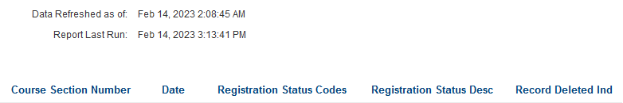

Registration Dashboard
Description: Displays headcounts of all registered students for a given term. Headcounts are displayed by College, Department, Student Type, Age Band at Census, Gender, Race/Ethnicity, Student Class, GPA bands, Financial Aid groups, Full Time/Part Time status, and an overall trend analysis. The dashboard can be filtered by College, Department, Major, Student Level and Student Class. The data displayed is end of term data for all past terms and is current as of today for the current term.
Data Elements: Term, Summary, Demographics, Student Profile, Trend Analysis, College, Department, Major, Student Level, Student Class
Source: Student Admission and Enrollment Universe
Location: Public Folders Registration Registration Dashboard
Prompts: None
Input Controls:
Report Page:

Registration Dashboard – 15 Year Trend
Description: Displays a 15 Year Trend analysis of all registered students by Age, Student Type, Race/Ethnicity, Gender, Student Class, Undergrad and Graduate students.
Data Elements: Age, Student Type, Race/Ethnicity, Gender, Student Class, Undergrad and Graduate students
Source: Student Admission and Enrollment Universe
Location: Public Folders Registration Registration Dashboard – 15 Year Trend
Prompts: None
Input Controls:
Report Page:
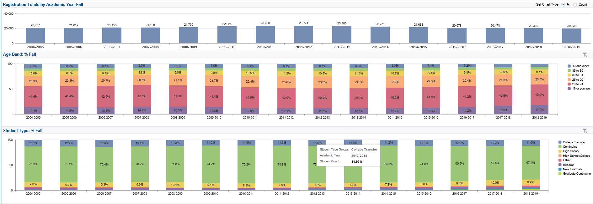
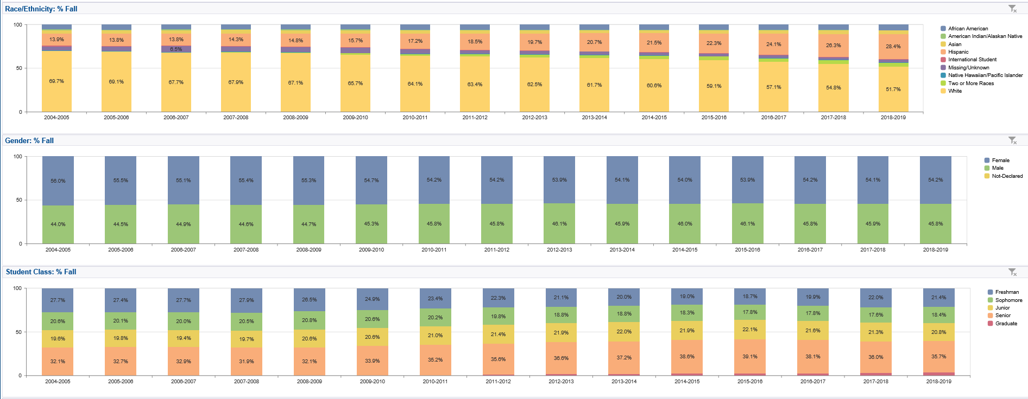
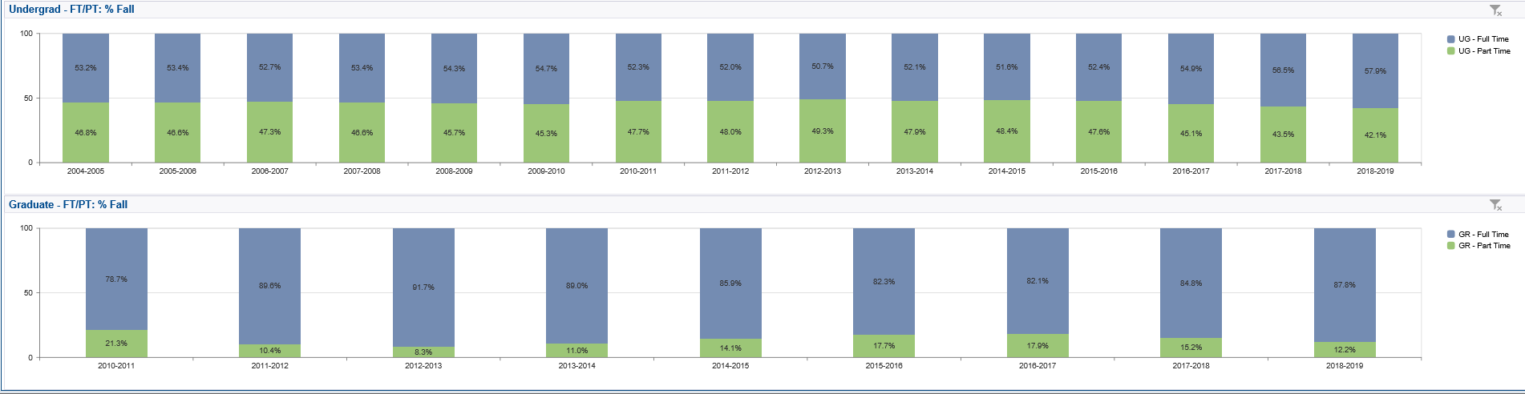

Registration Report – Multi-Select Term
Description: This report shows registered headcount for a given term. There are 4 tabs in this report. The first tab is an overall summary of registration. The second tab is registration totals by transfer students. The third tab is registration by majors. The fourth tab is registration by minors.
Data Elements:
- Summary: Academic Year, Term Code, Student ID, Student Name, Email Address, College, Department, Major, Minor, Concentration, Student Type, Student Level, Student Class, Full Time / Part Time, Race, Gender, Age Band at Census, Residency Status, Veteran Status, GPA Cumulative, First Time Registered Indicator, Total Registered Credit Hours, Total Enrolled Hours
- Transfer: Academic Year, Term Code, Student ID, Student Name, Email Address, School Name, Accepted Credit Hours, College, Department, Major, Concentration, Student Type, Student Level, Student Class, Full Time / Part Time, Race, Gender, Age Band at Census, Residency Status, Veteran Status, GPA Cumulative, First Time Registered Indicator
- Count by Major: Academic Year, Term, Major Code, Major, Student Count
- Count by Minor: Academic Year, Term, Minor Code, Minor, Student Count
Source: Student Admission and Enrollment Universe
Location: Public Folders Registration Registration Report – Multi-Select Term
Prompts: Term, College, Department, Major, Student Level, Minor, Student Class, Student Attribute
Input Controls: College, Department, Major, Minor, Concentration, Level, Class, Race, Full Time/Part Time
Report Page:
Summary
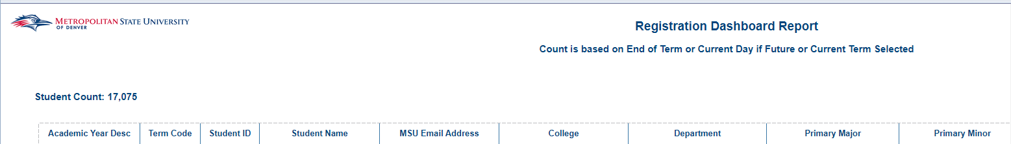
Summary Cont.
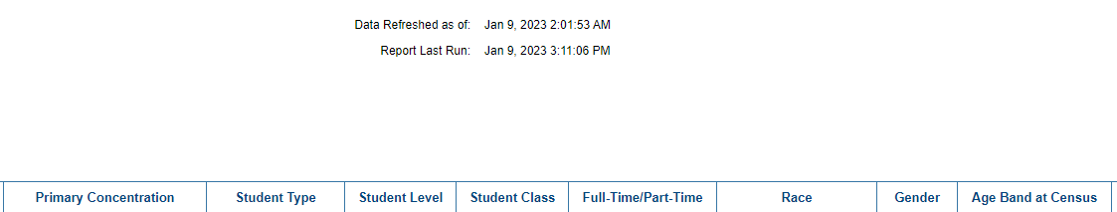
Transfer
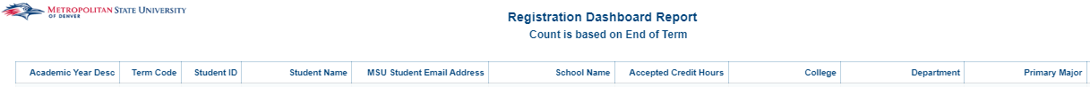
Transfer Cont.
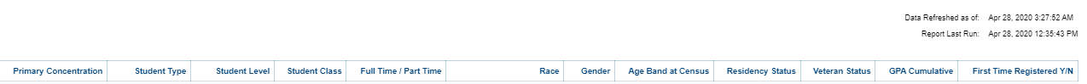
Count by Major
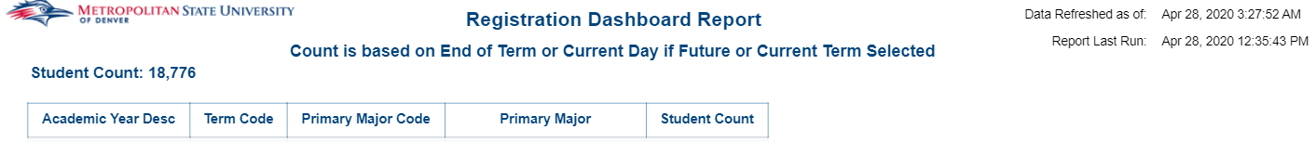
Count by Minor
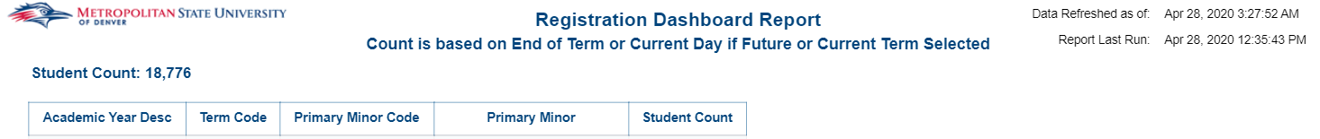

Registration Report (Dashboard Link)
Description: Displays a list of registered students for a given term and provides field of study, scholastic, and demographic information about the students. There are two tabs: Summary and Transfer. The first tab lists information about all registered students for the given term. The second tab lists information on registered transfer students for the given term.
Data Elements:
- Tab 1 Summary: Student ID, Student Name, Email Address, College, Department, Primary Major, Primary Minor, Primary Concentration, Student Type, Student Level, Student Class, Full Time / Part Time, Race, Gender, Age Band at Census, Residency Status, Veteran Status, GPA Cumulative, First Time Registered Y/N, First Generation Code, First Generation Desc, VISA Code, VISA Description
- Tab 2 Transfer: Student ID, Student Name, Email Address, School Name, Accepted Credit Hours, College, Department, Primary Major, Primary Minor, Primary Concentration, Student Type, Student Level, Student Class, Full Time / Part Time, Race, Gender, Age Band at Census, Residency Status, Veteran Status, GPA Cumulative, First Time Registered Y/N, First Generation Code, First Generation Desc
Source: Student Admission and Enrollment Universe
Location: Public Folders Registration Registration Report (Dashboard Link)
Prompts: Term Code and Description (required), Primary Major, College, Department, Student Level, Student Class, Student Attribute
Input Controls: College, Department, Primary Major, Primary Minor, Primary Concentration, Student Level, Student Class, Race, Full Time / Part Time, First Generation, VISA Code
Report Page:
Tab 1 Summary:

Tab 2 Transfer:

Registration Report with Citizenship_1st Student Type and 1st Term Reg
Description: This report shows registered headcount for a given term. There are 4 tabs in this report. The first tab is an overall summary of registration. The second tab is registration totals by transfer students. The third tab is registration by majors. The fourth tab is registration by minors.
Data Elements:
- Summary: Academic Year, Term Code, Student ID, Student Name, Email Address, College, Department, Major, Minor, Concentration, Original Student Type, Current Student Type, Student Level, Student Class, First Registered Term Code, Full Time / Part Time, Race, Gender, Age Band at Census, Residency Status, Citizenship Code, Citizenship Status, Veteran Status, First Generation Status, GPA Cumulative, First Time Registered Indicator
- Transfer: Academic Year, Term Code, Student ID, Student Name, Email Address, School Name, Accepted Credit Hours, College, Department, Major, Concentration, Student Type, Student Level, Student Class, Full Time / Part Time, Race, Gender, Age Band at Census, Residency Status, Veteran Status, GPA Cumulative, First Time Registered Indicator
- Count by Major: Academic Year, Term, Major Code, Major, Student Count
- Count by Minor: Academic Year, Term, Minor Code, Minor, Student Count
Source: Student Admission and Enrollment Universe
Location: Public Folders Registration Registration Report with Citizenship_1st Student Type and 1st Term Reg
Prompts: Term, College, Department, Major, Student Level, Minor, Student Class, Student Attribute
Input Controls: College, Department, Major, Minor, Concentration, Level, Class, Race, Full Time/Part Time
Report Page:
Summary:

Transfer:
Count by Major:
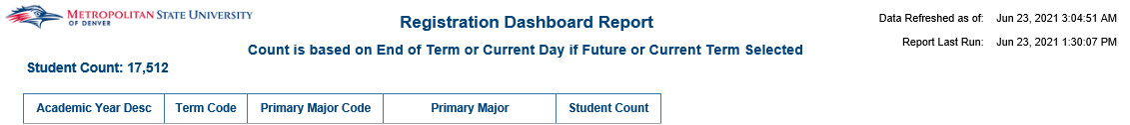
Count by Minor:
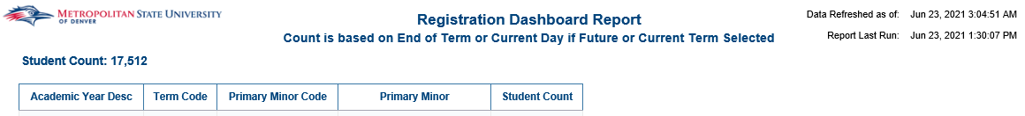

Registration Status by Date
Description: This report pulls a list all registration status codes for a user selected term and date range. The report shows all registration activity that occurs in Banner between the dates selected, excluding records that have been deleted in Banner.
Data Elements:
- Headcount Summary: Academic Year, Term Code, College, Department, Student ID, Student Name, Primary Major Code, Course Subject Cd: Course #, Course Section Number, Date, Catalog Term Code, Registration Status Codes, Registration Status Desc
Source: Student Admission and Enrollment Universe
Location: Public Folders Registration Registration Status by Date
Prompts: Term Code, Begin Date, End Date, Registration Status Codes (optional), College (optional), Department (optional), Primary Major Code (optional)
Input Controls: Registration Status Codes, Primary Major Code, College, Department
Report Page:
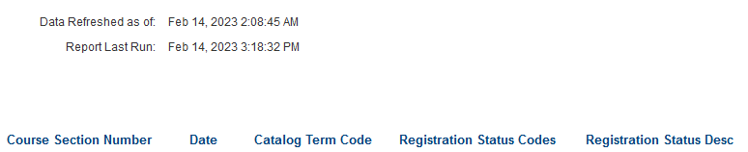

Registration Trends by Day (Registration Start, Term Start, Census)
Description: This report displays registration trends by semester (Fall, Spring, Summer) providing charts with trend lines. The report includes three tabs; Fall Term, Spring Term, and Summer Term.
Data Elements: Term Code, Term Start Date, Term Census Date, and Registration Start Date
Source: Student and Enrollment Universe
Location: Public Folder Registration Registration Trends by Day (Registration Start, Term Start, Census)
Prompts: Day Number Before or After Registration Start, Day Number Before or After Term Start, and Day Number Before or After Census (All Required)
Input Controls: Student Level, Class Description, Race, College, Department, and Major
Report Page: This report has three tabs; Fall Term, Spring Term, and Summer Term
Tab 1: Fall Term
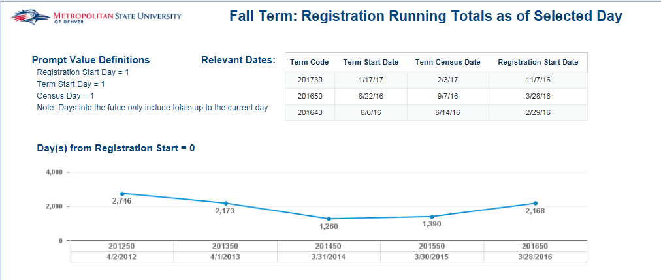
Tab 2: Spring Term
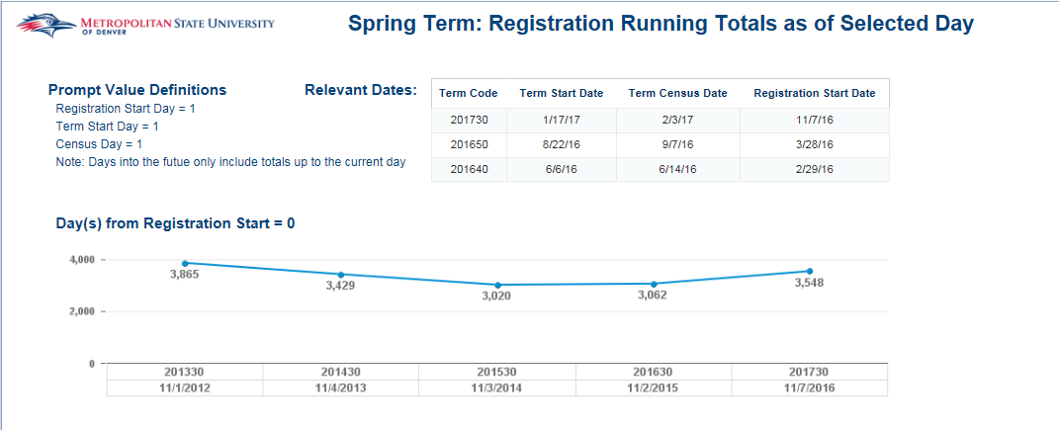
Tab 3: Summer Term
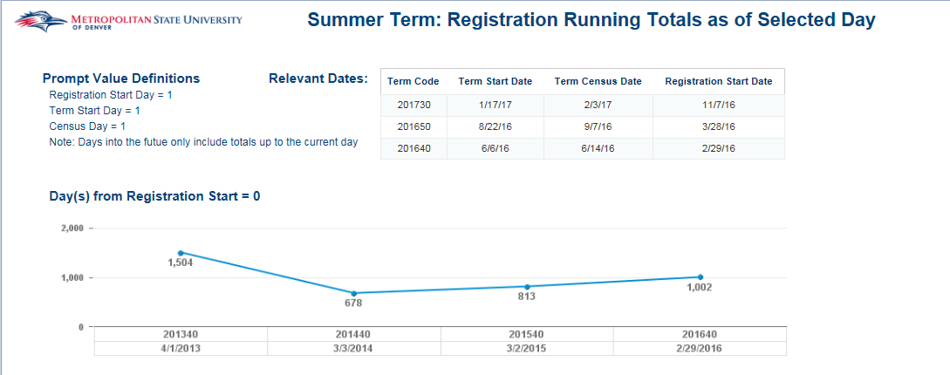

School District Student Totals Report
Description: This report displays Registered students, Registered Concurrent students and MSU Graduates from a given school district. The report includes three tabs; Registered Students, Registered Concurrent Students and Graduates.
Data Elements: Term, Graduation Term, High School, Student ID, Student Name, Gender, Race Student Type, County, Major
Source: Student and Enrollment Universe
Location: Public Folder Registration School District Student Totals Report
Prompts: Registration Term, Registered Concurrent Term, Graduation Term
Input Controls: High School, Major, County, Gender, Race
Report Page: This report has three tabs; Registered Students, Registered Concurrent Students and Graduates
Tab 1: Registered Students
Tab 2: Registered Concurrent Students
Tab 3: Graduates
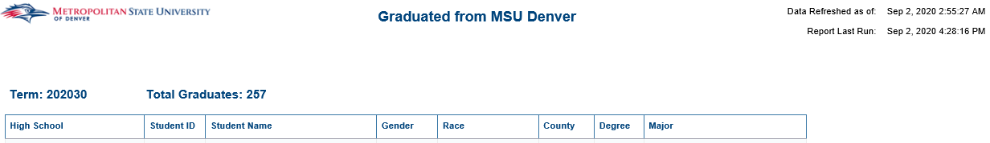

Student Hold Status for Registered Term
Description: This report identifies students who have any sort of a Student Hold on their account during a registered term. Users can use this report during a registered term to help students remove holds that may prevent them from registering for the next term.
Data Elements: Student ID (linked to student profile), Student Name, Advisor Full Name, Hold Start Date, Hold End Date, Hold Code – Description, Hold Reason, Registration Hold, AR Hold, Graduation Hold, Transcript Hold, Compliance Hold, Grade Report Hold, Enrollment Verify Hold, Non-MSU Email, MSU Email, Student Phone – AA, Student Phone – CE, Primary Major, Primary Minor, Primary Concentration, Student Class, Student Type, Academic Standing Desc
Source: Student and Enrollment Universe
Location: Public Folder Registration Student Hold Status for Registered Term
Prompts: Previous Term, Advisor Name, College, Department
Report Page: This report has one tab; Student Hold Status for Registered Term
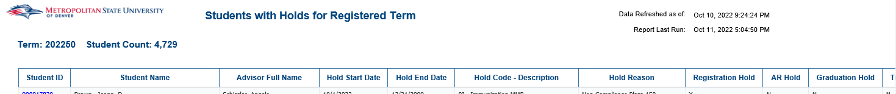

Student Registration Status by Advisor
Description: This report identifies students by advisor, who were registered for a term, but no longer registered for a target term. It provides a summary by advisor and also a student detail list with additional student level information.
Data Elements:
- Summary: Advisor Full Name, Registered Previous Term, Not Registered Target Term, Percent not Registered
- Student Registration Status by Course: Registered For: <Term>, Advisor Full Name, Student ID(linked to student profile), Student Name, Registration Hold (Y/N), Financial Hold (Y/N), MSU Email, Non-MSU Email, Student Phone -AA, Student Phone – CE, Student Class, Primary Major, Primary Minor, Primary Concentration, Student Type, UG – Cumm Hours, Academic Standing Desc, GR – Cumm Hours, GPA Cumulative, Graduation Status: <target term>
Source: Student and Enrollment Universe
Location: Public Folder Registration Student Registration Status by Advisor
Prompts: Previous Term, Advisor Name, Target Term
Report Page: This report has two tabs; Summary, Student Registration Status by Advisor
Tab 1: Summary
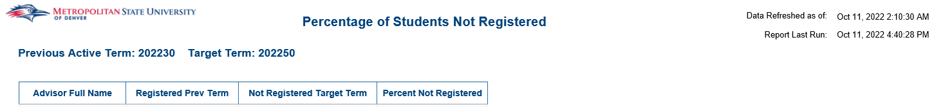
Tab 2: Student Registration Status by Advisor
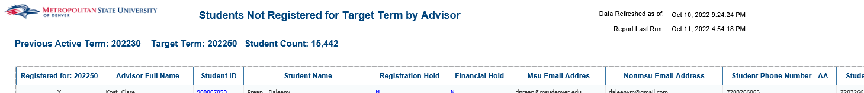
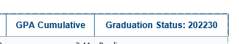

Student Registration Status by Course & Instructor
Description: This report identifies students by course and instructor, who were registered for a term, but no longer registered for a target term. It provides a summary by course and instructor and also a student detail list with additional student level information.
Data Elements:
- Summary: Course #, CRN, Primary Instructor, Registered Prev Term (count), Not Registered Target Term (count), Percent not registered
- Student Registration Status by Course: Registered For: <Term>, Course Subject/ID, Section, CRN, Primary Instructor, Advisor, Student ID(linked to student profile), Student Name, MSU Email, Non-MSU Email, Student Phone -AA, Student Phone – CE, Student Class, Primary Major, Primary Minor, Primary Concentration, Student Type, UG – Cumm Hours, Academic Standing Desc, GR – Cumm Hours, GPA Cumulative, Graduation Status: <target term>
Source: Student and Enrollment Universe
Location: Public Folder Registration Student Registration Status by Course & Instructor
Prompts: Previous Term, Faculty Name, Subject Code, Course#, Target Term
Input Controls: Graduation Status, Primary Instructor, Course Subject, Course#, Course Section Number, Registered (Y/N), Student Type, Advisor, Primary Major, Primary Minor
Report Page: This report has two tabs; Summary, Student Registration Status by Course
Tab 1: Summary
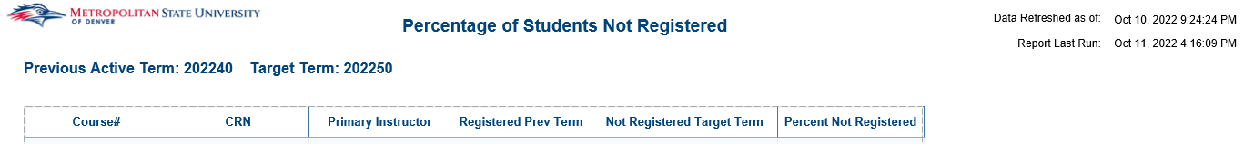
Tab 2: Student Registration Status by Course
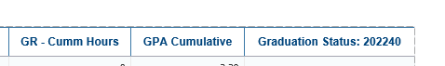
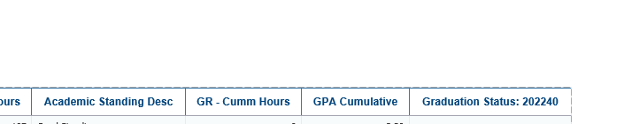

Students by Priority Registration Group
Description: Displays Student’s priority registration code for a given term. The report is sorted by student ID.
Data Elements: Student ID, Name, Registration Group Code, Registration Priority, Student Phone Number, Student Phone Number Type
Source: Student Admission and Enrollment Universe
Location: Public Folders Registration Students by Priority Registration Group
Prompts: Term (required)
Input Controls: None
Report Page:
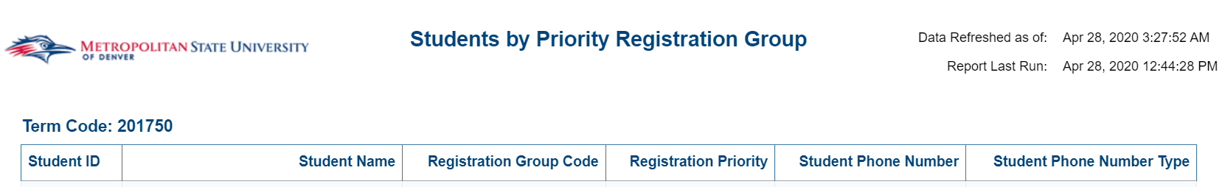

Students Registered for an Online Course
Description: Displays a list of all students that registered for at least 1 online course for a given term.
Data Elements: Last Name, First Name, Student ID, Student Phone Number CE/AA, MSU Email Address, Student Type, Primary Major, Term Credit Hours, Cumulative Credit Hrs
Source: Student Admission and Enrollment Universe
Location: Public Folders Registration Students Registered for an Online Course
Prompt: Term (required)
Input Controls: None
Report Page:
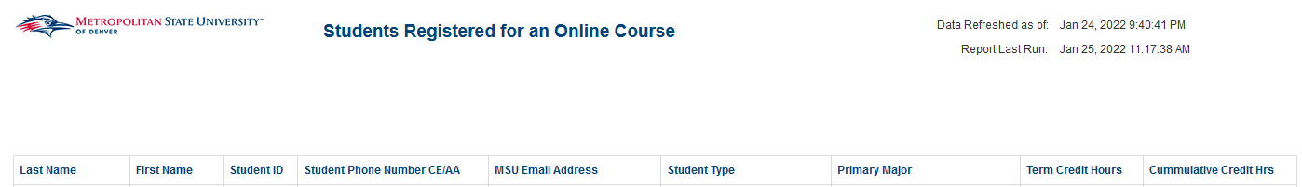

Test Score Report
Description: Displays Students High School Admission and Placement Test scores for a given term. The report is sorted by test date and student ID.
Data Elements: Student ID, Name, Test Code Description, Test Score, Test Score Date
Source: Student Admission and Enrollment Universe
Location: Public Folders Registration Test Score Report
Prompts: Test Code (required), Test Score
Input Controls: None
Report Page:
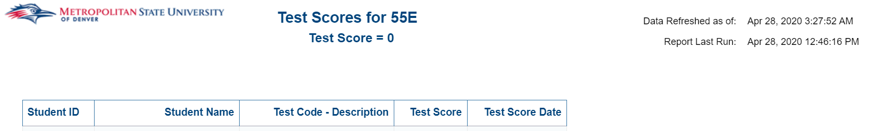

Transfer Credit Hours – GR
Description: This report displays graduate students and their total number of graduate transfer credit hours.
Data Elements: Student ID, Student Name, Student Level, Graduate Transfer Credit Hours
Source: Student Admission and Enrollment Universe
Location: Public Folders Registration Transfer Credit Hours – GR
Prompts: Term
Input Controls: Term
Report Page:
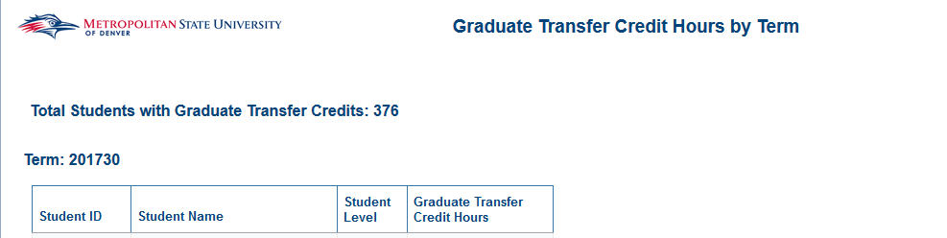

Retention

Retained Students by Primary Major – Term to Term
Description: Displays Students who were retained, not retained or graduated from one term to another. Also shows if the students major remained the same or if it changed.
Data Elements: Student ID, Name, Email, Retained/Not Retained/Graduated, From College, From Major, To Major, Major Change
Source: Student Admission and Enrollment Universe
Location: Public Folders Retention Retained Students by Primary Major – Term to Term
Prompts: Beginning Term, College, Department, Ending Term
Input Controls: Major Change, Retained/Not Retained/Graduated
Report Page:
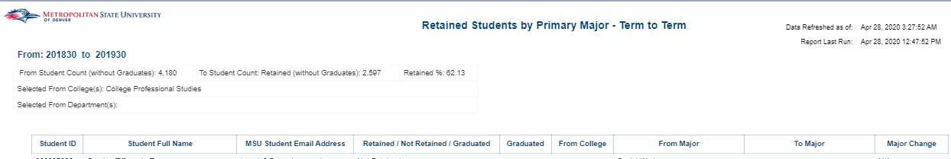

Retention Dashboard
Description: Displays term to term retention totals. There is an overall Summary section as well as Department, Major, Demographic and Student Profile sections. Each can be broken down by College, Department and Major. This dashboard is used for Undergraduate Students and links to the “Retention Report”
For Retention details used in this dashboard, university definition, and examples of retention from “From Term” to “To Term” see the “Retention Report” definition below for details.
Data Elements: Summary, Department, Major, Demographics, Student Profile, Beginning Term, Ending Term, College, Department
Source: Student Admission and Enrollment Universe
Location: Public Folders Retention Retention Dashboard
Filters: “From Term” (aka Base Term), “To Term”, College, Department, Primary Major, Student Attribute
Note: Filters cascade from Left to Right and can also be selected individually. Selecting a new College or All Colleges will reset the filters.
Dashboard Page:
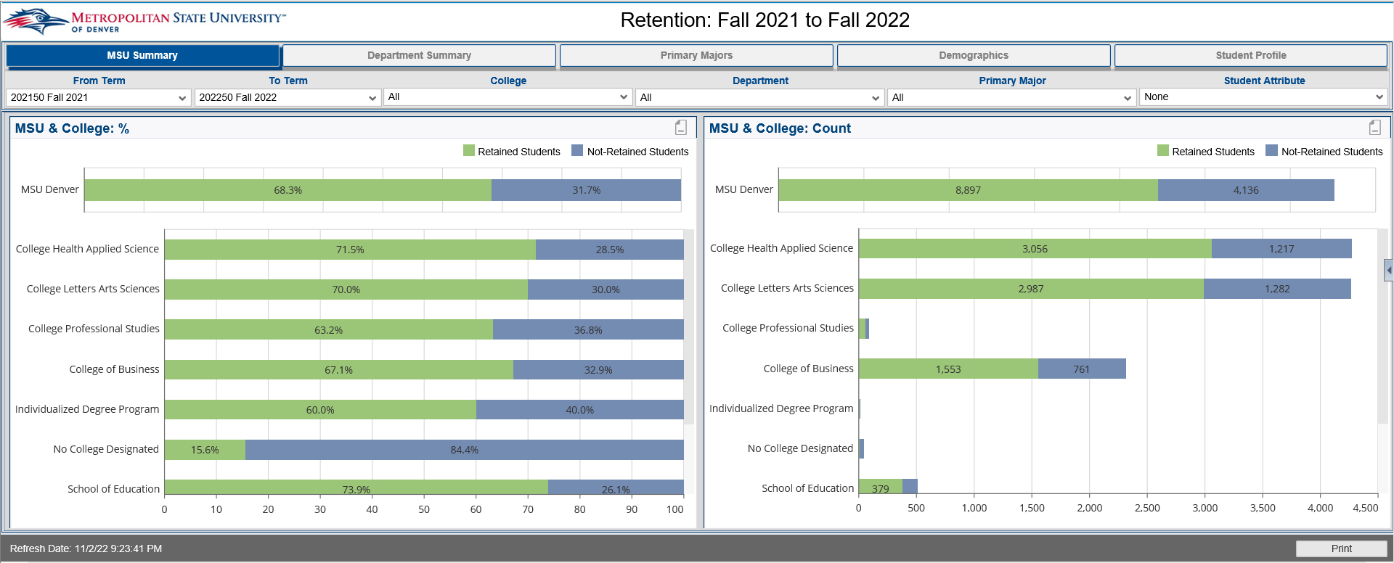

Retention Report
Description: This report displays Retention data for students that have been retained and not been retained for 1 to 3 terms out. The Retention count tab gives a summary of students retained and not retained from 1 to 3 terms out. It is broken down by College, Age, Gender, Race and Degree. The other tabs give a detailed list of students that have been retained and not retained.
Note: this report is Undergraduate Students only, see further definition details below.
Retained and Not Retained Report Nomenclature:
Retained+1 and Not Retained+1 is one term out from the selected base Term, e.g. when you select Term Code of 202150 to launch the report the following Retained and Not Retained future terms will return results as:
Retained+1 and Not Retained+1 will return students for 202230.
Retained+2 and Not Retained+2 will return students for 202240.
Retained+1 and Not Retained+1 will return students for 202250.

Detailed Definition:
Retention measures the rate at which undergraduate students continue in their educational program at an institution, expressed as a percentage. The Retention Rate or Percentage is calculated by taking the headcount of students who re-registered for the second academic period divided by the headcount of students registered in the first academic period excluding: students who graduated in first academic period or any academic periods between the two academic periods and deceased students. The EDW “Retention Reports” display student retention across three consecutive terms starting with a “base term”. Although retention rate is generally calculated from Fall Term to Fall Term, EDW reports provide greater flexibility by allowing for the “base term” to be any term and calculating retention rates across three consecutive terms. As an example, if the base term in EDW report is selected as “Fall 2020”, the EDW Retention reports will display the percentage of students from fall 2020 who either reenrolled or successfully completed their program by next fall (Fall 2021) broken down by terms.
Notes:
- Only undergraduate students are included in the Retention Calculations (SGBSTDN_LEVL_CODEs of ‘UG’)
- Students included are Registered students (i.e. those who have at least one “Y” in STVRSTS_GRADABLE_IND)
- Students enrolled in Teacher Licensure, Non-Degree programs & Certificate Program are excluded from these calculations.
  - Excludes primary degree codes of ‘000000’, ‘CERT’, and ‘TLIC’
- Deceased students or students who have graduated are excluded from the retention rate.
  - Excludes students who have passed away (SPBPERS_DEAD_IND of ‘Y’)
- The EDW report includes all student types e.g. Continuing, College Transfer, High School, Readmit, …
- Includes full-time and part-time (based on the sum of SFRSTCR_BILL_HR)
- Excludes students who graduate during the base term, or any subsequent term prior to the retention term (SHRDGMR_GRST_CODEs of ‘AW’, ‘PD’, ‘HD’, or ‘AC’)
  - Only students who achieve a bachelor's degree excluded
- Bachelor-seeking students are still included in the retention population if they graduate with a certificate

Data Elements:
- Retention Count: College, Age Band, Gender, Race, Degree, GPA Cumulative, Count of Retained Students for 1-3 Terms out, Count of not Retained Students for 1-3 Terms out, Retained Percentage, Not Retained Percentage
- Retention by Year Tabs: ID, Name, Department, Major, Degree, Student Class, GPA Cumulative, Email
Source: Student Admission and Enrollment Universe
Location: Public Folders Retention Retention Report
Prompts: Term (Required), College, Department, Major, Student Attribute Code
Input Controls: College, Department, Major, Retention College
Report Page:
Retention Count:
Note: if a Student Attribute Code is applied the report subtitle will reflect the applied attribute and filter the results accordingly. Applying a Student Attribute will only return students with the assigned Attribute in the selected base Term. To return all data refresh the report to remove the attribute and the subtitle will reflect accordingly that now attribute is applied.
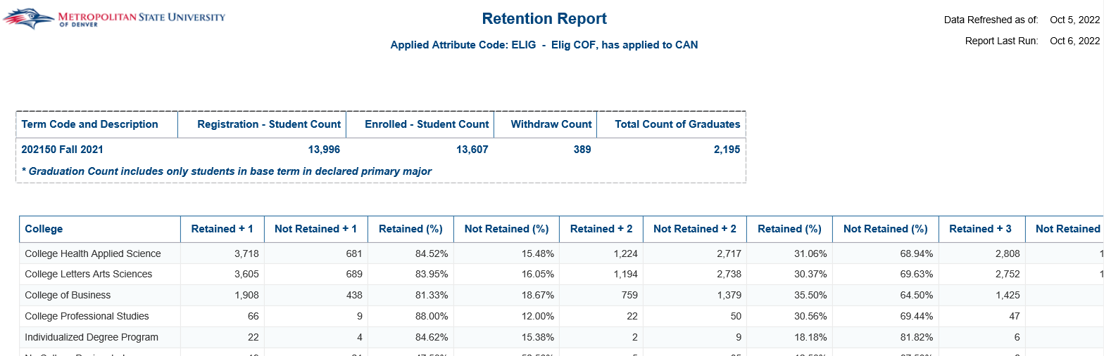

Retained and Not Retained Tabs:
Note: these Retained and Not Retained tabs return the individual students of their retained status.
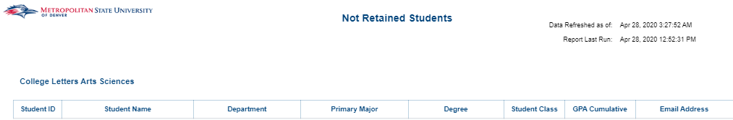

Retention Report_Cert_License
Description: This report displays Retention data for students that have been retained and have not been retained for 1 to 3 terms out. The Retention count tab gives a summary of students retained and not retained from 1 to 3 terms out that were awarded a Certification or a License. The data is broken down by College, Age, Gender, Race and Degree. The other tabs provide a detailed list of students that have been retained and not retained for 1 to 3 terms out. (This report is specific to students that have completed a Certification or Licensure program.)
Data Elements:
- Retention Count: College, Age Band, Gender, Race, Degree, GPA Cumulative, Count of Retained Students for 1-3 terms out, Count of not Retained Students for 1-3 terms out, Retained Percentage, Not Retained Percentage
- Retention by Year Tabs: ID, Name, Department, Major, Degree, Student Class, GPA Cumulative, Email
Source: Student Admission and Enrollment Universe
Location: Public Folders Retention Retention Report_Cert_License
Prompts: Term (Required), College, Department, Major
Input Controls: College, Department, Major, Retention College
Report Page:
Retention Count:
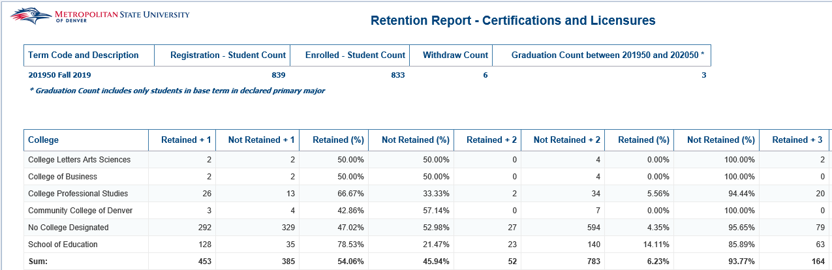
Retained and Not Retained Tabs:

Retention Students by Primary Major – Term to Term_GR
Description: This report displays Retention data for Graduate students that have been retained or not retained for 1 to 3 terms out. The report displays a detailed list of students
Data Elements: Student ID, Student Full Name, Student Email, Registration Hold (Y/N), Retained / Not Retained/ Graduated, Graduation Status, From College, From Major, To Major, Major Change
Source: Student Admission and Enrollment Universe
Location: Public Folders Retention Retention Student by Primary Major – Term to Term_GR
Prompts: From Term (Required), College, Department, Major, To Term(Required)
Input Controls: Major, Retained/Not Retained/Graduated, Graduation Status
Report Page:
Retained and Not Retained Tabs:
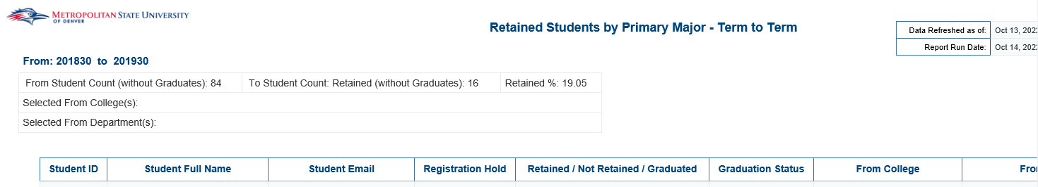
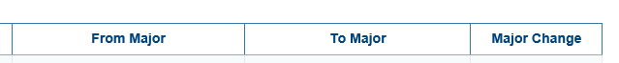

Retention Students by Primary Major – Term to Term_UG
Description: This report displays Retention data for Undergraduate students that have been retained or not retained for 1 to 3 terms out. The report displays a detailed list of students
Data Elements: Student ID, Student Full Name, Student Email, Registration Hold (Y/N), Retained / Not Retained/ Graduated, Graduation Status, From College, From Major, To Major, Major Change
Source: Student Admission and Enrollment Universe
Location: Public Folders Retention Retention Student by Primary Major – Term to Term_UG
Prompts: From Term (Required), College, Department, Major, To Term(Required)
Input Controls: Major, Retained/Not Retained/Graduated, Graduation Status
Report Page:
Retained and Not Retained Tabs:
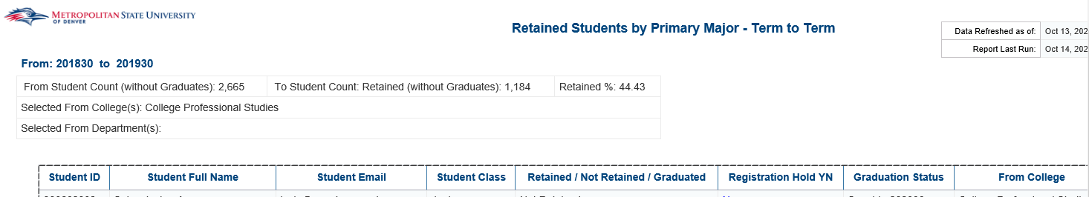
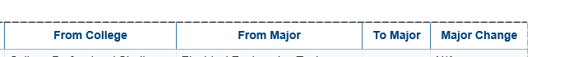

Retention Report_GR
Description: This report displays Retention data for Graduate students that have been retained and have not been retained for 1 to 3 terms out. The Retention count tab gives a summary of Graduate students retained and not retained from 1 to 3 terms out. The data is broken down by College, Age, Gender, Race and Degree. The other tabs provide a detailed list of students that have been retained and not retained for 1 to 3 terms out. (This report is specific to Graduate students and programs which have a different College definition then Undergraduate students.)
Data Elements:
- Retention Count: College, Age Band, Gender, Race, Degree, GPA Cumulative, Count of Retained Students for 1-3 terms out, Count of not Retained Students for 1-3 Years, Retained Percentage, Not Retained Percentage
- Retention by Year Tabs: ID, Name, Department, Major, Degree, Student Class, GPA Cumulative, Email
Source: Student Admission and Enrollment Universe
Location: Public Folders Retention Retention Report_Cert_License
Prompts: Term (Required), College, Department, Major
Input Controls: College, Department, Major, Retention College
Report Page:
Retention Count:
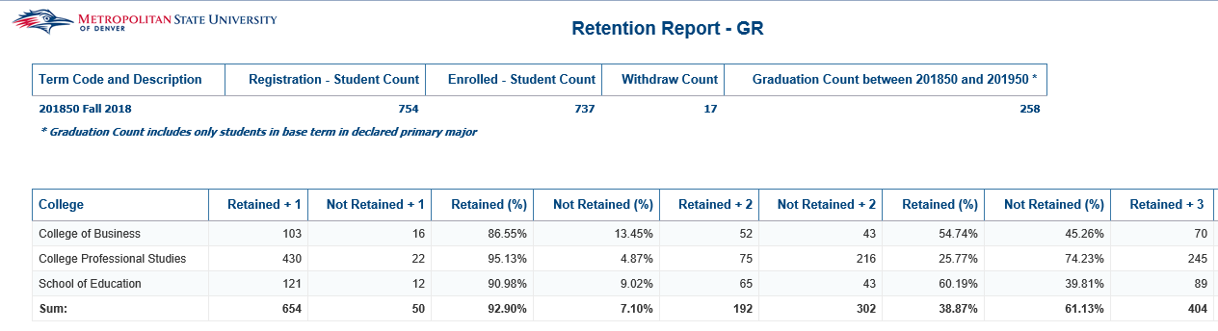
Retained and Not Retained Tabs:
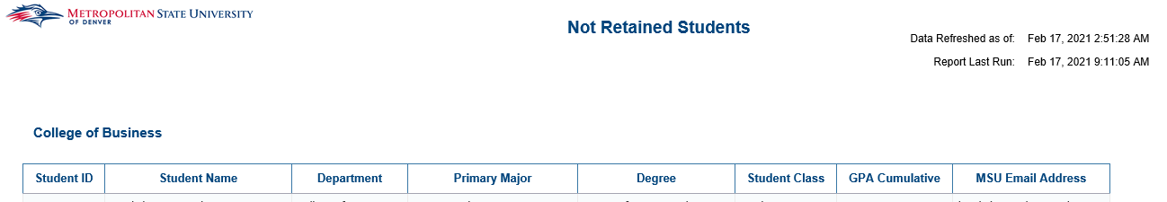

Retention Report_UG
Description: This report displays Retention data for Graduate students that have been retained and have not been retained for 1 to 3 terms out. The Retention count tab gives a summary of Graduate students retained and not retained from 1 to 3 terms. The data is broken down by College, Age, Gender, Race and Degree. The other tabs provide a detailed list of students that have been retained and not retained for 1 to 3 terms out. (This report is specific to Undergraduate students and programs which have a different College definition then Graduate students.)
Data Elements:
- Retention Count: College, Age Band, Gender, Race, Degree, GPA Cumulative, Count of Retained Students for 1-3 terms out, Count of not Retained Students for 1-3 Years, Retained Percentage, Not Retained Percentage
- Retention by Year Tabs: ID, Name, Department, Major, Degree, Student Class, GPA Cumulative, Email
Source: Student Admission and Enrollment Universe
Location: Public Folders Retention Retention Report_Cert_License
Prompts: Term (Required), College, Department, Major
Input Controls: College, Department, Major, Retention College
Report Page:
Retention Count:
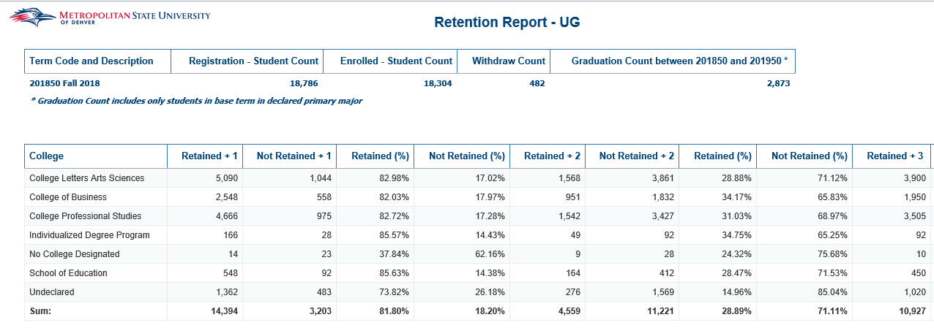
Retained and Not Retained Tabs: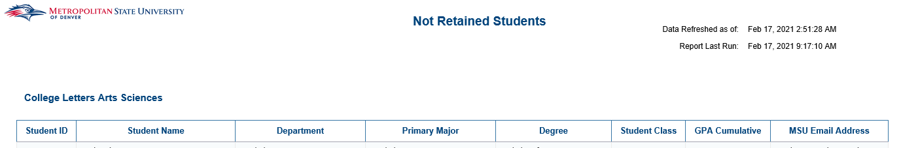

South Campus

Welcome Letter Registration Report
Description: Shows all students registered at the south campus between two dates
Data Elements: Student ID, Student Name, Instructional Method, CRN, Subject, Course #, Section, Course Title, Schedule Type, MSU Student Email Address, Major Code, Registration Status Cd, Registration Status Desc, Date First Registered
Source: Student Admission and Enrollment Universe
Location: Public Folders South Campus Welcome Letter Registration Report
Prompts: Term Cd (required), Registration add date (start), Registration add date (end)
Input Controls: Registration Status Desc
Report Page:
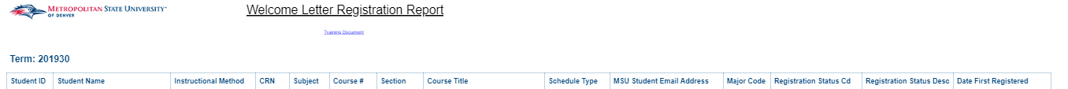

Student Profile

Academic Suspension Appeal Report_NEW
Description: The report displays students that are on Academic Suspension and have submitted an appeal. The report contains 6 sections all in one tab. The sections are as follows: Student Details, Student Holds, Academic History, Student Responses, Reviewer and Comments. This report is scheduled to be sent to sis@msudenver.edu daily at 7:00 AM MST and 1:00 PM MST.
Data Elements: Student Name, Student ID, Phone, Email, Appealing For Term Code, Primary Major, Term Code, Term GPA, Cumulative GPA, Academic Standing, Term Completion, Cumulative Completion, Term Credits Attempted, Term Credits Earned, Course, Course Title, Credit Hours, Grade, Repeat Course Indicator, Comment Date, Creator, Type, Code, Comments, Hold Code, Hold Description, Hold Reason, Hold Start Date, Hold End Date, Hold Released Ind
Source: Student Admission and Enrollment Universe
Location: Public Folders Student Profile Academic Suspension Appeal Report_NEW
Prompts: None
Input Controls: None
Report Page:
Student Details, Reviewer Section, and Academic History Section: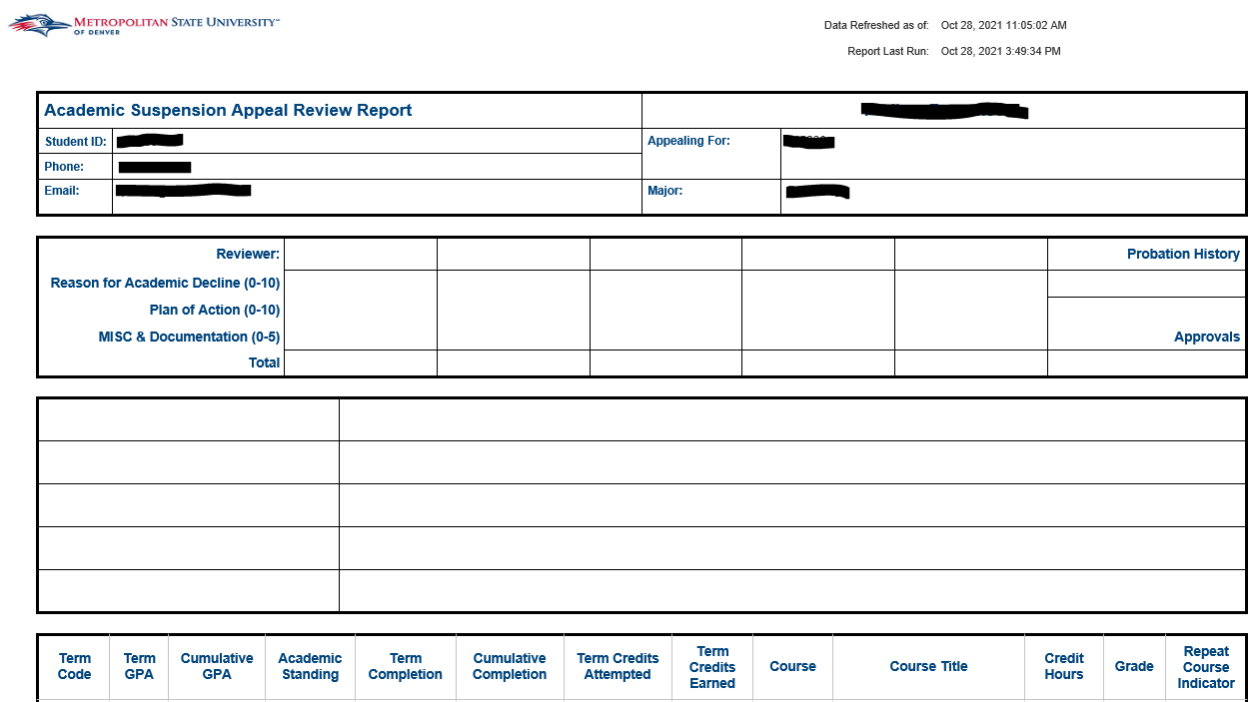
Student Responses Section:
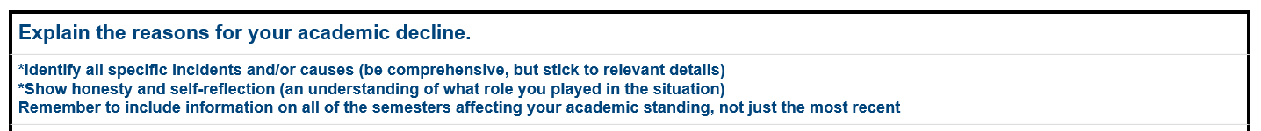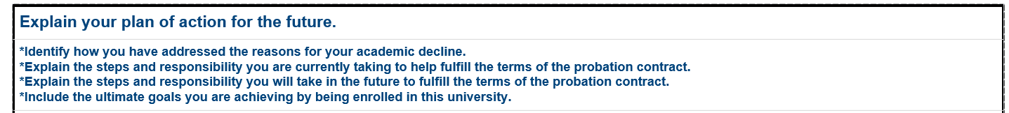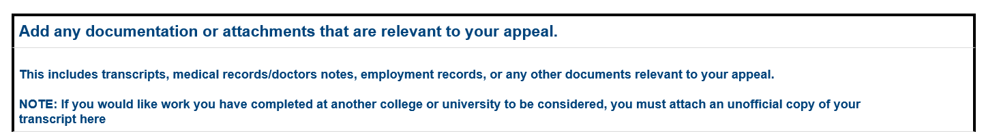
Comments Section:
Student Holds Section:

Admit Term by Citizenship Type
Description: The report lists all students admitted during a given academic year and their citizenship status. Students with no citizenship data are excluded from the report.
Data Elements: Student ID, Student Name, US Citizenship Status, Term Code
Source: Student Admission and Enrollment Universe
Location: Public Folder Student Profile Admit Term by Citizenship Type
Prompt: Academic Year
Input Controls: US Citizenship Type
Report Page:
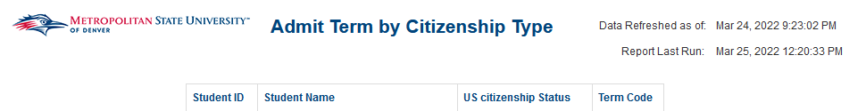

Admitted (Registered) Students Profile
Description: The report displays Registered Student’s Information for a given term(s), or a given intended entry term. It is broken out by College and Department and is sorted by Student Id. Using the Input Controls (listed below) you can select single or multiple Terms, Colleges, Departments, Majors, and Degrees.
Data Elements:
- Admitted Students Profile: Student ID, Name, Gender, Race, Degree, Major, Minor, Program, Student Type, Student Level
- Admitted Students Profile (1): Student ID, Student Name, Major, Minor, Email, Accepted, Registered
Source: Student Admission and Enrollment Universe
Location: Public Folders Student Profile Admitted (Registered) Students Profile
Prompts: Term (required)
Input Controls: Term, College, Department, Major, Degree, Minor
Report Page:
Admitted Students Profile:
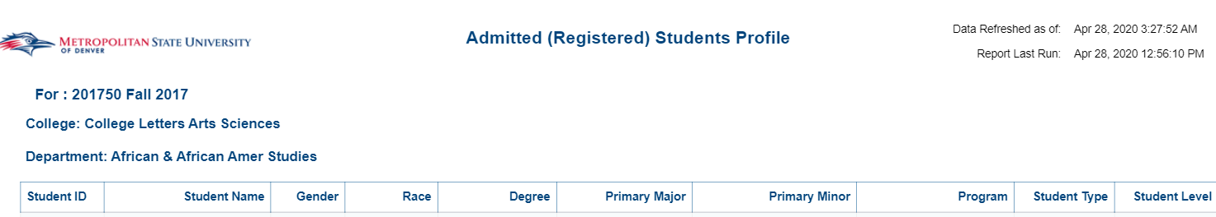
Admitted Students Profile (1):
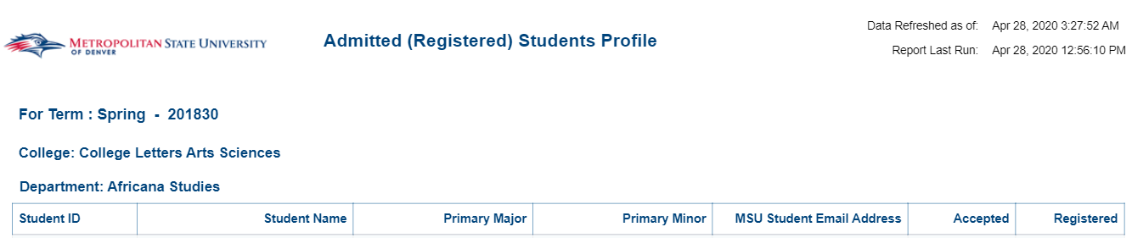

CBUS MPAcc Recruitment Report
Description: This report lists Undergraduate Students that have a major in Accounting (ACC) and are potential candidates for the Accounting Graduate Program. The report has three tabs; the first tab provides an overview of the report and its parameters. The second tab provides a list of students that meet the criteria to be considered for the Accounting Graduate Program. The final tab is a list of students that have taken ACC 3510 and their respective grades for the term they took the course.
Data Elements:
- CBUS MPAcc Recruitment – Overview: None
- CBUS MPAcc Recruitment – Summary: Term Code, Primary Major Code, Primary Major, Secondary Major Code, Secondary Major, Primary Minor Code, Primary Minor, Degree, Primary Major Code – 2nd Curriculum, Primary Major – 2nd Curriculum, Student Type, Student Level, Student ID, Student Name, MSU Email Address, Student Class, UG – Enrolled Credit Hours, UG – Cumm Hours Earned, Cumulative GPA, Major GPA, Course Subject Code, Course Number, Course Instructor
- CBUS MPAcc Recruitment – ACC 3510 Grades: Student ID, Student Name, Term Code, Subject Code, Course #, Grade Code
Source: Student Data – Degree Works Universe
Location: Public Folders Student Profile CBUS MPAcc Recruitment Report
Prompts: Term Code (Required)
Input Controls: College, Primary Major, Primary Minor, 2nd Curriculum College, Primary Major – 2nd Curriculum
Report Page:
CBUS MPAcc Recruitment - Overview:
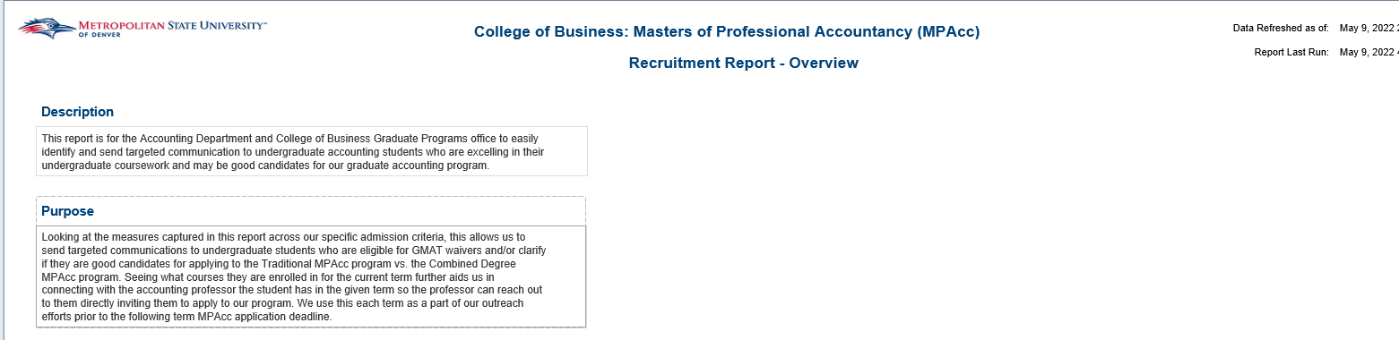
CBUS MPAcc Recruitment – Summary:
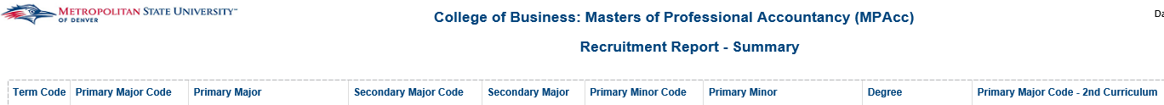

CBUS MPAcc Recruitment – Summary (Cont.):
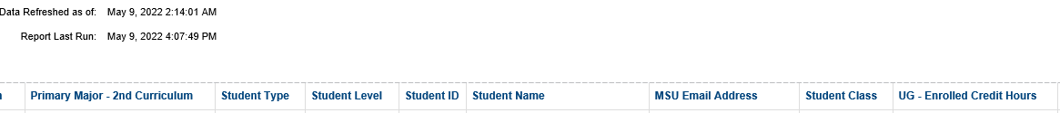
CBUS MPAcc Recruitment – ACC 3510 Grades:

CHAS Graduate Students by Previous Degree
Description: This report lists Graduate Students for the College of Health and Applied Sciences by their previous degrees obtained based on a user selected term. The report has two tabs; one tab is for degrees that were obtained at MSU Denver and the other tab is for degrees that were obtained at another institution.
Data Elements:
- CHAS GR Degrees from MSU Denver: Student ID, Student Name, MSU Email Address, College, Department, Primary Major, Student Level, MSU Denver Degree Code, MSU Denver Degree
- CHAS GR Degrees from Other Institutions: Student ID, Student Name, MSU Email Address, College, Department, Primary Major, Student Level, Previous Degree Code, Previous Degree, Degree Institution
Source: Student Admissions and Enrollment Universe
Location: Public Folders Student Profile CHAS Graduate Students by Previous Degree
Prompts: Term Code (Required)
Input Controls: None
Report Page:
CHAS GR Degrees from MSU Denver:
CHAS GR Degrees from Other Institutions:
CHAS GR Degrees from Other Institutions (Cont.):

Courses with High Enrollment of Students of Color
Description: This report lists majors and courses that have a high amount of Student of Color. Student of Color are defined as students that identify with the following race/ethnicities: 2 or More Races, African American, Asian, Native American/Alaskan Native, Pacific Islander/ Native Hawaiian, and Hispanic. The report contains four tabs; one tab is for Student of Color by Major, the second tab is for the top 100 courses with high enrollment in students of color, the third tab is for the top 100 courses with high DFW rates, and the final tab is for the top 50 courses that have high enrollment of students of color and DFW rates.
Data Elements:
- Students of Color by Major: Primary Major, Race/Ethnicity, Term, Student Count, Percentage of Major (SoC)
- Students of Color – Top 100 Courses: Rank, Course, Race/Ethnicity, Term, Student Count
- Top 100 Courses DFW: Rank, Course, Grade, Term, Student Count
- Students of Color – Top 50 DFW Courses: Course, Total – Students of Color, Students of Color Rank, Total – DFW Count, DFW Rank
Source: Student Admissions and Enrollment Universe
Location: Public Folders Student Profile Courses with High Enrollment of Students of Color
Prompts: None
Input Controls: None
Report Page:
Students of Color by Major:
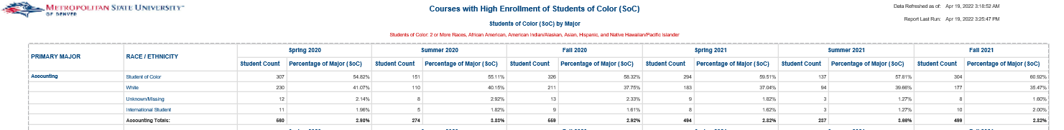
Students of Color – Top 100 Courses:
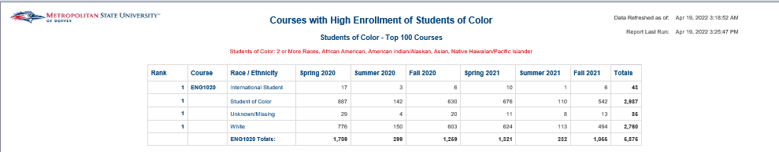

Report Page (Cont.):
Top 100 Courses DFW:
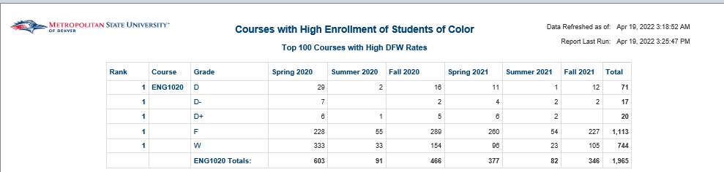
Students of Color – Top 50 DFW Courses:

Enrolled Students by Citizenship Type
Description: The report lists all students who were enrolled in at least one course during a given academic year and their citizenship status. Students with no citizenship data are excluded from the report.
Data Elements: Student ID, Student Name, US Citizenship Status
Source: Student Admission and Enrollment Universe
Location: Public Folders Student Profile Enrolled Students by Citizenship Type
Prompts: Academic Year
Input Controls: US Citizenship Status
Report Page:

HRSA-HND Grant Report
Description: This report lists all HND, NUD, and NUD3M students for a given term and reports on a number of demographic data elements required for the HRSA-HND grant.
Data Elements: Term, Student ID, Student Name, Date of Birth, Age at Census, Primary Major, Student Class, Full Time/Part Time, Enrolled Credit Hrs, Attempted Credit Hrs, Earned Credit Hrs, GPA by Term, GPA Cumulative, Graduation Term, Graduation Status, Current Status, Race (without Ethnicity), Ethnicity, Gender, First Generation Code, First Generation Desc, Veteran Status, Visa Type Cd, Student Attribute Cd, Student Attribute Desc, Current Address City, Current Address State, Current Address Zip Code, Application City, Application State, Application Zip Code, High School City, High School State, High School Zip Code
Source: Student Admission and Enrollment Universe
Prompts: Student ID (optional), Student Attribute Cd (optional), Term, Prior Term for Credit Hrs
Input Controls: None
Report Page:
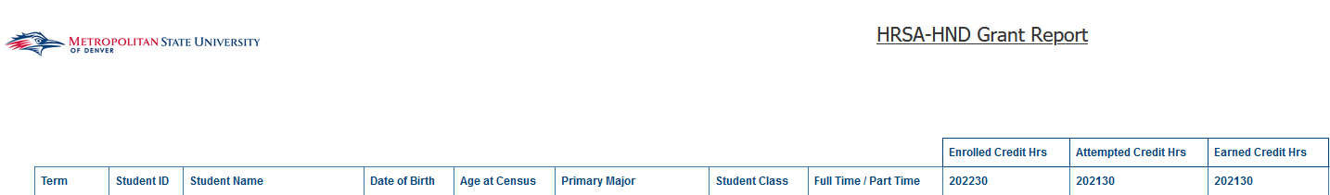

Individual Student Profile
Description: This report gives the academic history of a student at MSUD. There is a term summary report, coursework by term report, a test history report, a High School and Transfer report, an Alternate Email List
Data Elements:
- Term Summary: Registered Y/N, College, Department, Major, Concentration, Degree, Student Level, High School, Student Type, GPA Cumulative, GPA by Term, UG – Cumm Hours Attempted, UG – Cumm Hours Earned, GR – Cumm Hours Attempted, GR – Cumm Hours Earned
- Course Work by Term: Course Subject, Subject Code, Course #, Course Title, Waitlist Indicator, Grade
- Test History: Test Date, Test Code – Description, Test Score Numeric
- High School and Transfer: High School, High School GPA, Class Rank, Class Size, Percentile, Transfer School, Transfer School Type, Attendance Period, Degree Code, Degree, State, Articulated Hours Amount, Accepted Credit Hours
- Alternate Emails: Student ID, Student Name, Alternate Email
Source: Student Admission and Enrollment Universe
Location: Public Folders Student Profile Individual Student Profile
Prompts: Student ID (Required)
Input Controls: None
Report Page:
Term Summary:
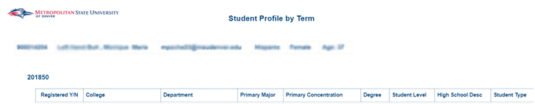
Cont.:
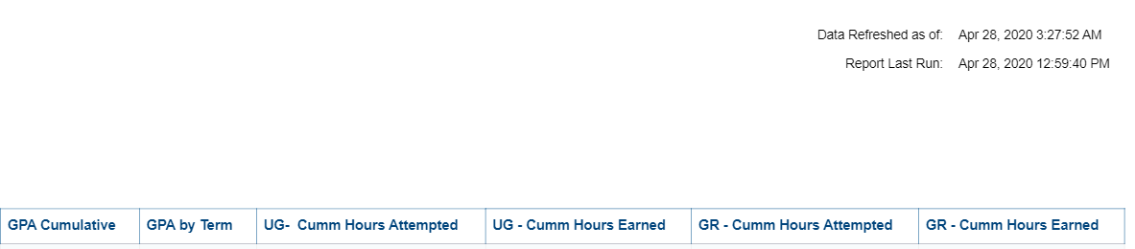
Course Work by Term:
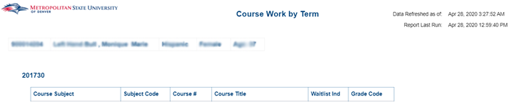
Test History:
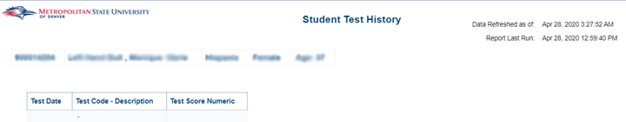
High School and Transfer:
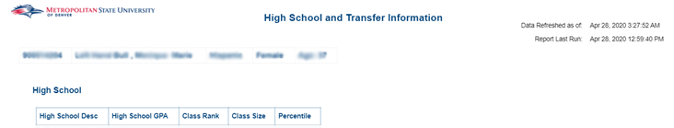
Alternate Emails:
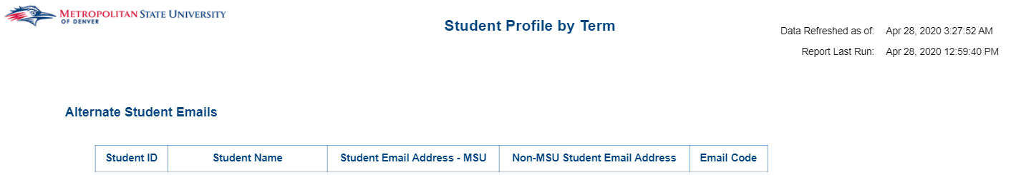

Languages Spoken by MSU Denver Students
Description: This report lists all students that were enrolled in at least one course during a given academic year with their contact information and native language.
Data Elements: Student ID, Student Name, Admission Term, CE Phone Number, AA Phone Number, MSU Email Address, Non-MSU Email Address, Native Language
Source: Student Admission and Enrollment Universe
Location: Public Folders Student Profile Languages Spoken by MSU Denver Students
Prompts: Academic Year
Input Controls: Native Language
Report Page:

Major Code with Student Class (Time Status)
Description: This report is for the current year and going back 7 years. It gives full-year major totals and percentages by level, full time/part time status, gender, age, race/ethnicity and concentration. You can drill down on the totals to get the actual students in each major. It also shows 1 year (fall to fall) retention totals and percentages. Finally, it gives the full-year graduate total and percentages for each major.
Data Elements: Major, Year, Level, Gender, Age Band, Race/Ethnicity, Concentration, Time Status
Source: Student Admission and Enrollment Universe
Location: Public Folders Student Profile Major Code with Student Class (Time Status)
Prompts: None (report automatically lists current year and goes back 7 years)
Input Controls: Major Code, Program Code
Report Page: 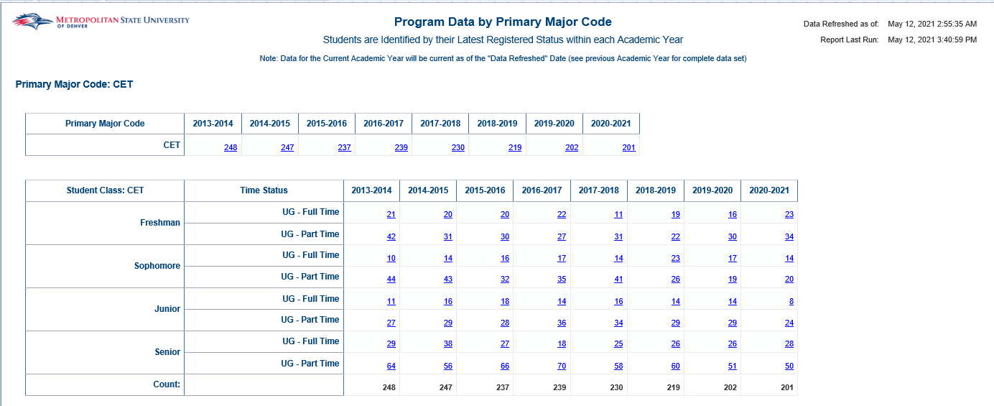
Report Page (Cont.): 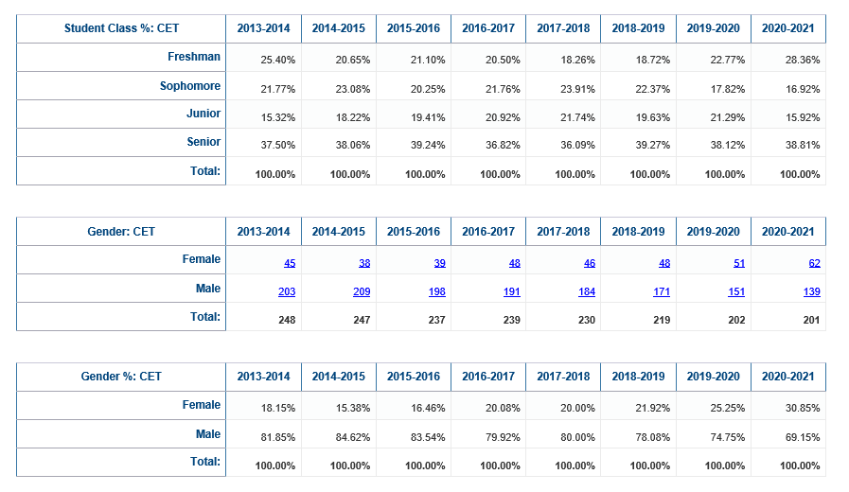
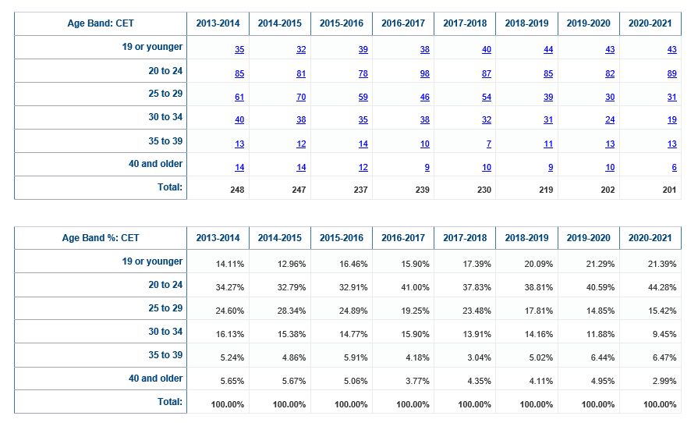
Report Page (Cont.):
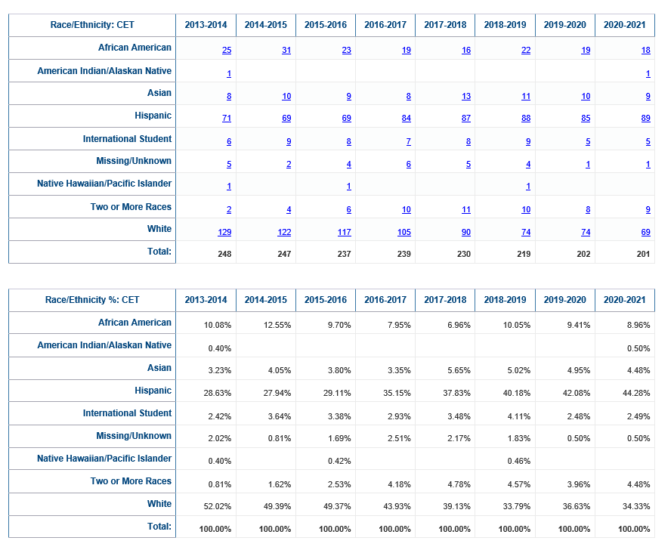
Report Page (Cont.): 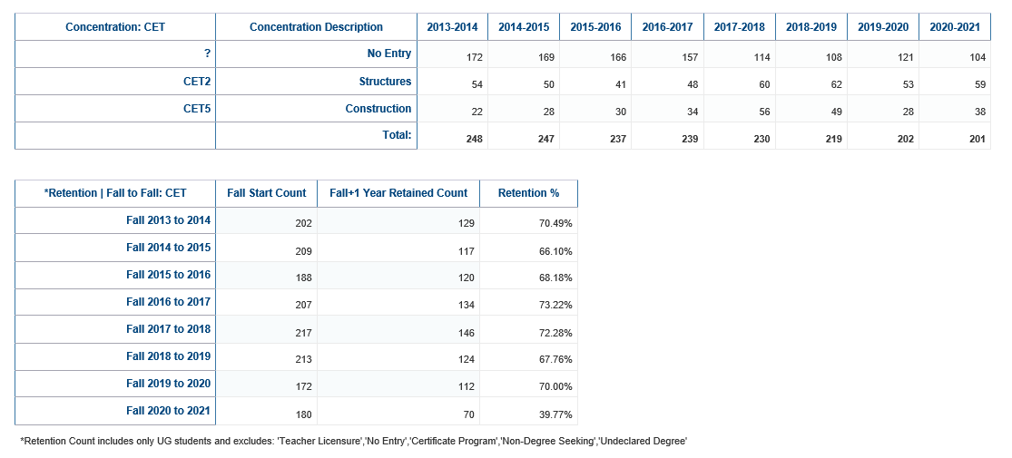

Report Page (Cont.):
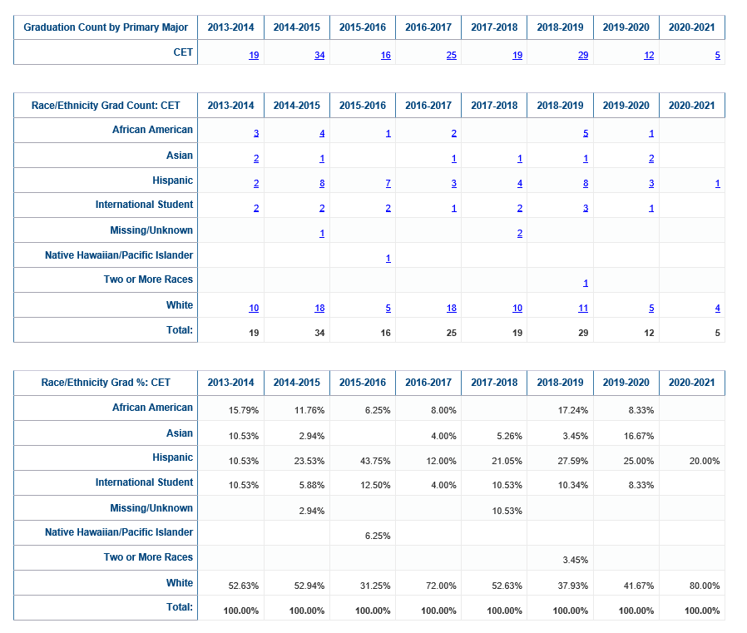
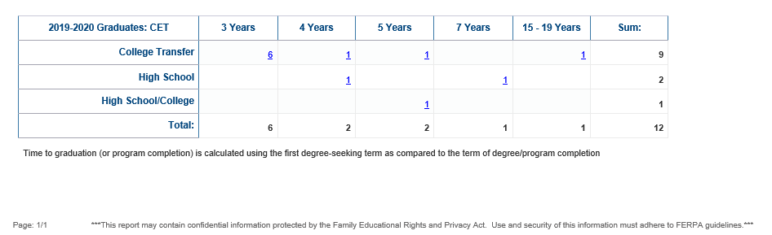

MBA and ACCM Student Profile
Description: This report lists all currently active graduate students that have declared MBA or ACCM as their major. The report displays a total count of graduate students with an MBA or ACCM major as well as count of the students that are enrolled for the selected term. The report also provides a summary of student data for the selected Term as well the student’s current course load and grades.
Data Elements:
Student Profile: Student ID, Student Name, MSU Email Address, Personal Email Address, Current Age, Age at Intended Entry Term, Gender, Race, New Ethnicity, First Generation Desc, Student Type, Primary Major, Primary Concentration, Degree, Program Notes, GR Grad Term, Graduation Status, Registered, Enrolled, Intended Entry Term Code, First Term Registered, Previous UG MSU Degree
Term Summary: Student ID, Student Name, Primary Major, Primary Concentration, Degree, Student Status, Enrolled for Semester, GPA Cumulative, GR – Cumm Hours Earned
Course Work by Term: Student ID, Student Name, Course Subject, Subject Code, Course Number, CRN, Course Title, Grade Code
Source: Student Admission and Enrollment Universe
Location: Public Folders Student Profile MBA and ACC Student Profile
Prompts: Term Code (Required), Program (Required)
Input Controls: Primary Major, Student ID
Report Page:
Student Profile:
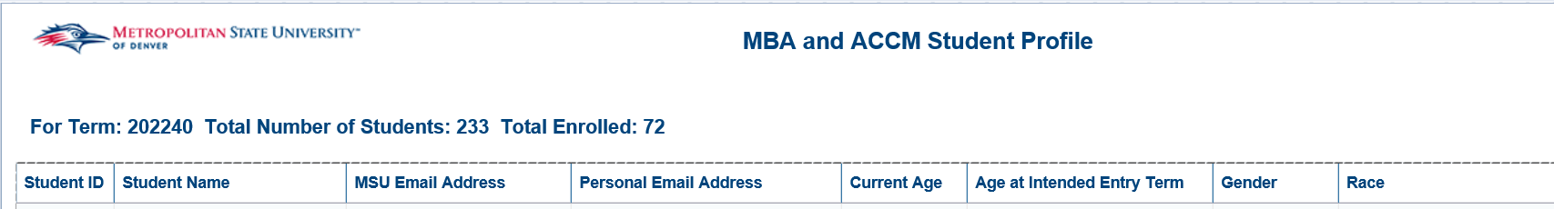
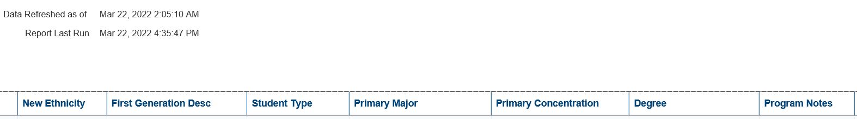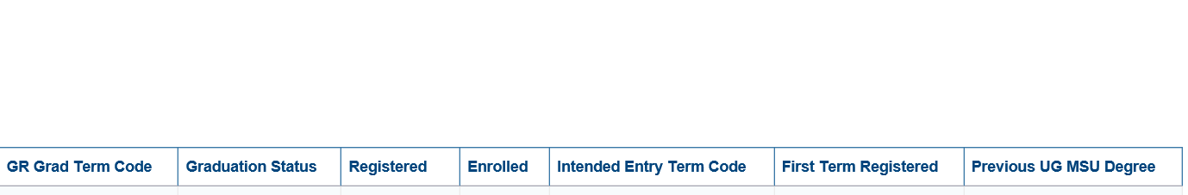
Term Summary:
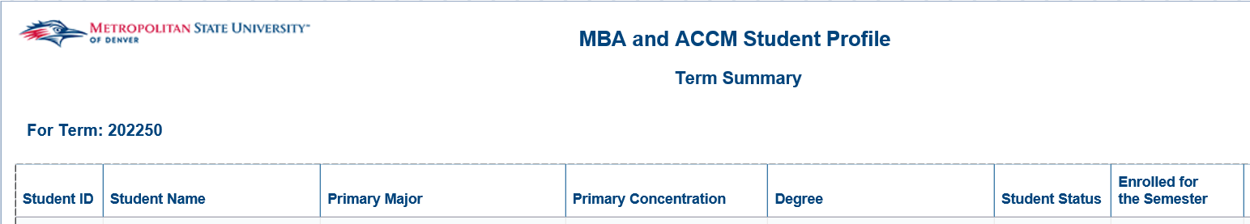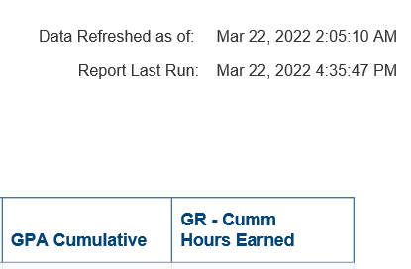
Course Work by Term:
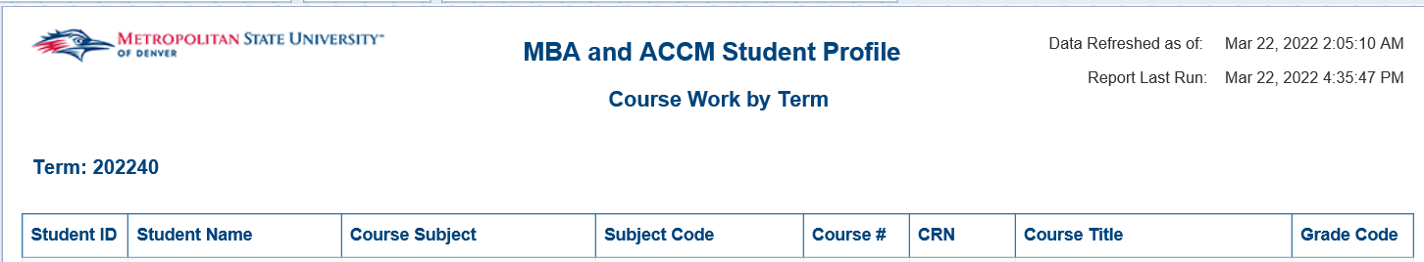

Non-Online Majors with Online Only Courses in Back to Back Terms
Description: This report identifies students enrolled exclusively in online courses in two consecutive terms that are not in online major programs.
Data Elements: Student ID, Student Name, Gender, Date of Birth, MSU Email Address, Active Phone Number, Primary Major, UG – Cumm Hours Earned, GR – Cumm Hours Earned, Total Registered Credit Hours, Term Instruction Method, Applied for Graduation This Term
Source: Student Admission and Enrollment Universe
Location: Public Folders Student Profile Non-Online Majors with Online Only Courses in Back to Back Terms
Prompts: Current Term, Prior Term
Input Controls: None
Report Page:
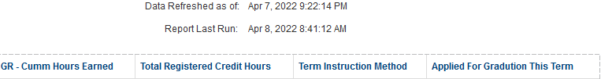

Online Program Student Profile
Description: This report lists all currently active students with an online primary or secondary major, their course work by term, and the DWFI% by each major.
Data Elements:
Student Detail: Student ID, Student Name, Last Registered Term, Gender, Race/Ethnicity, Age at Census, Student Type, Full Time/Part Time, Student Class, Residency Status, City, State Cd, Primary Major Code, Primary Major, Secondary Major Code, Secondary Major, Secondary Curriculum Major Code, Secondary Curriculum Major
Student Course Work by Term: Student ID, Student Name, Term Cd, Primary Major, Subject Code, Course #, Course Title, Final Grade, Credit Hours Amount
DWFI% by Online Major: Major Description, Term, DWFI%
Source: Student Admission and Enrollment Universe
Location: Public Folders Student Profile Online Program Student Profile
Prompts: None
Input Controls: Last Registered Term, Online Major Code
Report Page:
Student Detail
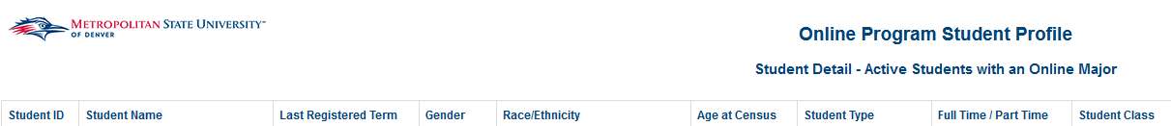
Cont.
Student Course Work by Term
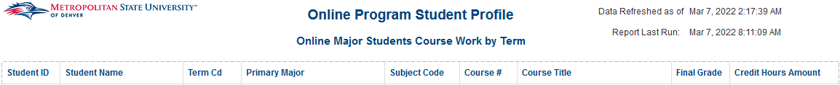
DWFI% by Online Major
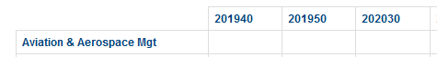

Student Attribute
Description: The report provides a list of students with Education attributes by term, and maps student attribute codes to student attribute descriptions
Data Elements:
- Student Attribute: Student ID, Name, Employee ID, Gender, Race, College, Department, Attribute Code, Attribute Description, Major Code, Major Description, Minor Code, Minor Description, Student Class, Program Code, Program Description, Concentration Code, Concentration Description, Student Level, Billing Hours, Email
- Report 2: Student Attribute Code, Student Attribute Description
Source: Student Admission and Enrollment Universe
Location: Public Folders Student Profile Student Attribute
Prompts: Term (Required), Student Attribute
Input Controls: Term, College, Department, Major, Minor, Concentration, Program
Report Page:
Cont.
Report 2:
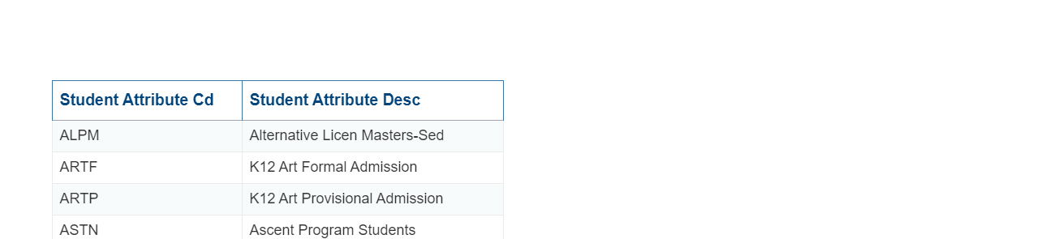

Student Profile by High School
Description: This report displays information about Registered Students by either In-State or Out of State High School. There are six tabs for this report. The first tab is Registration-Demographics. This displays either In-State or Out of State High School students by Gender, Race and Age. The second tab is Registration-College and Major. This report displays either In-State or Out of State High School students by College and Major. The third tab is Credits. This report displays either In-State or Out of State High School students by Total Credits Attempted and Total Credits Passed. The fourth tab is Courses Taken. This report displays either In-State or Out of State High School students by Courses and Subjects taken. The fifth tab is Retention Rate. This report displays Retention Rates by students from either In-State or Out of State High Schools. The sixth tab is Graduation. This report displays Graduates from either In-State or Out of State High Schools by Age and by College and Major.
Data Elements:
- Registration-Demographics: Gender, Race/Ethnicity, Age
- Registration-College and Major: College and Major
- Credits: Total Credits Attempted by Term: less than 12 or 12 or more. Total Credits Passed by Term: less than 12 or 12 or more.
- Registration-College and Major: Student Count by Course and Subject
- Retention Rate: High School, Student Retention Rate by term count
- Graduation: Graduation Age and Graduation Student count by College and Major
Source: Student Admission and Enrollment Universe
Location: Public Folders Student Profile Student Profile by High School
Prompts: Term (Required), High School Description, High School In-State/Out of State (Required)
Input Controls: High School, College, Department, Major, Degree

Report Page:
Registration-Demographics
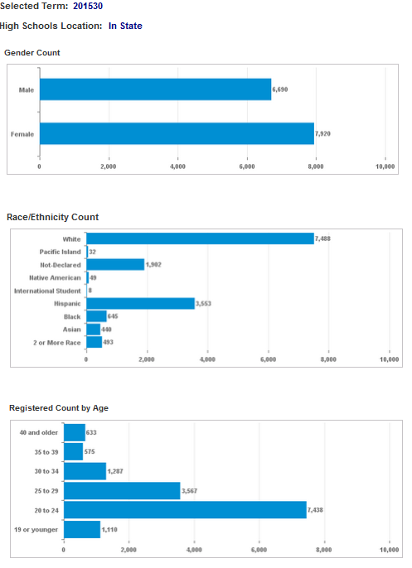
Registration-College and Major
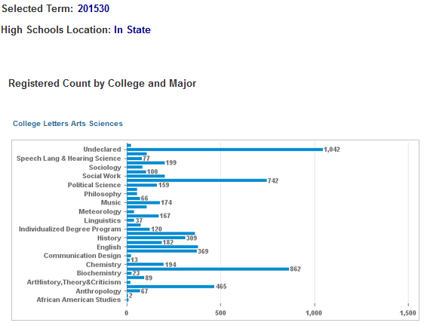
Credits
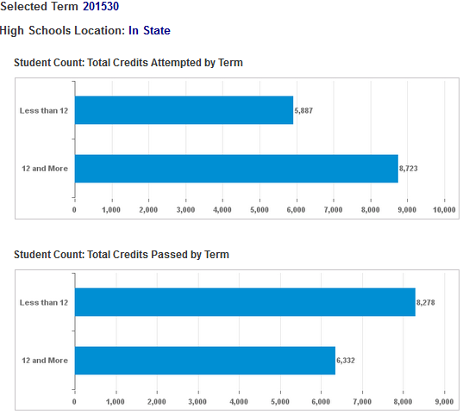
Courses Taken
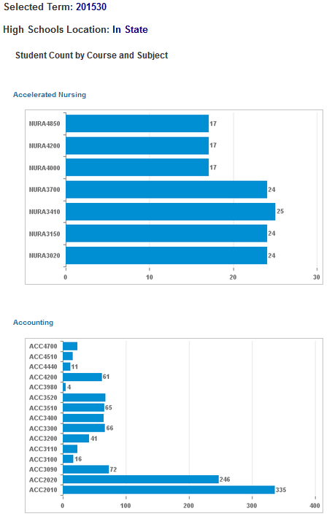
Retention Rate
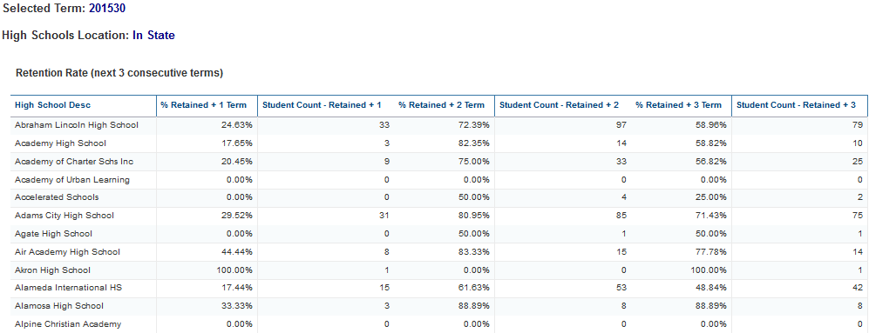
Gratuation
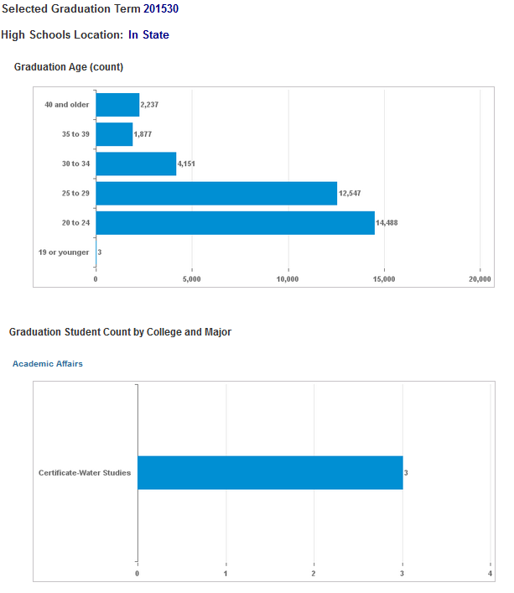

Student Success Tracking: Courses with Pro-Tips vs Courses without Pro-Tips
Description: Displays a list of students that have taken a course with Pro-Tips and students that have not taken a Pro-Tips course for a selected term. The report also displays detail data for each student for all terms before and after the course with Pro-Tips was taken as well as for the students in the courses without Pro-Tips. The report contains four tabs: Courses With Pro-Tips – Student List, Courses With Pro-Tips – Student Details, Courses Without Pro-Tips – Student List, Course Without Pro-Tips – Student Detail.
Data Elements: CRN, Subject Code, Course Number, Course Section Number, Course Title, Student ID, Student Name, Term Code, Race, Race (without Ethnicity), Gender, Age at Census, High School GPA, Department, Primary Major, Student Class, GPA Cumulative, Full Time/Part Time, Graduated This Term
Source: Student Admission and Enrollment Universe
Location: Public Folders Student Profile Student Success Tracking: Courses with Pro-Tips vs Courses without Pro-Tips
Prompts: Term Code (required), Pro-Tips Course Subject Code (required), Pro-Tips Course Number (required), Pro-Tips Course Section Number, Without Pro-Tips Course Subject Code (required), Without Pro-Tips Course Number, Without Pro-Tips Course Section Number
Input Controls: None
Report Page:
Course With Pro-Tips – Student List:
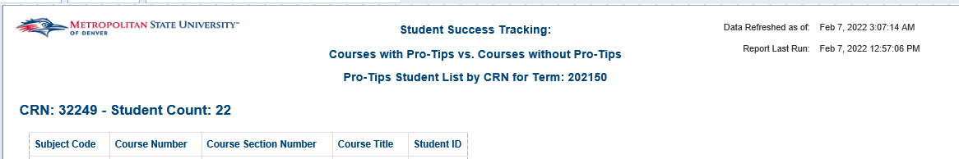
Course With Pro-Tips – Student Details:
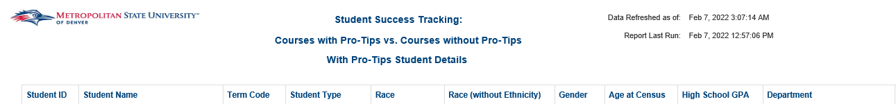
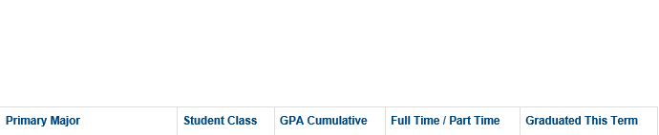

Courses Without Pro-Tips – Student List:
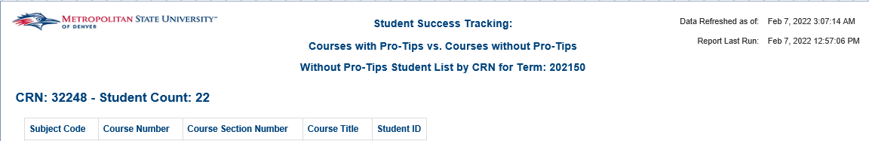
Courses Without Pro-Tips – Student Details:
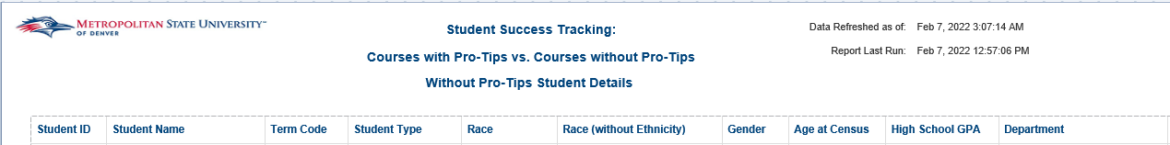

Students with Active Address (Registered)
Description: Displays a list of registered students with an active address for a given term.
Data Elements: Student ID, Name, MSU Email, Address, Department, Major, Student Type, Race, Gender, Age Band at Census, Residency Status, Veteran Status, GPA Cumulative, First Time Registered Y/N
Source: Student Admission and Enrollment Universe
Location: Public Folders Student Profile Registered Students with Active Address
Prompts: Term, College, Department, Major, Student Level, Student Class
Input Controls: Student Level, Student Class, College, Department, Major
Report Page:
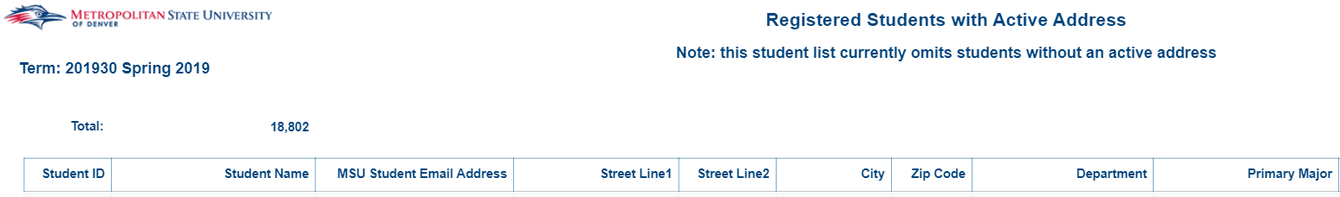
Report Page (Cont.):
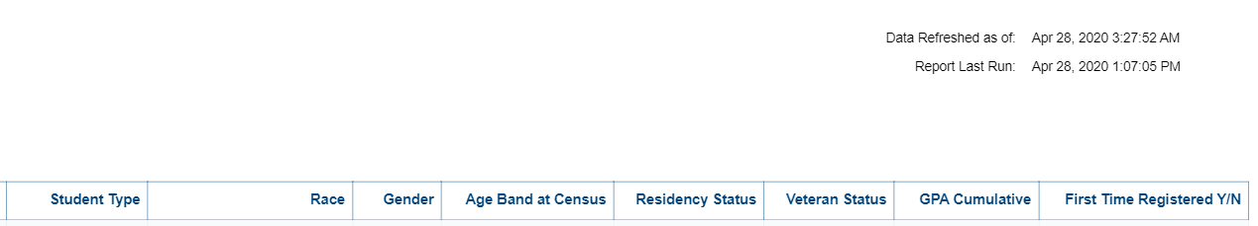

Students in Education Program by Term
Description: The report provides a list of students in the Teacher Education Program by term.
Data Elements: Student ID, Name, Gender, Race, College, Department, Major Code, Major Description, Minor Code, Minor Description, Student Class, Concentration Code, Program Code, Program Description, Concentration Description, Student Level, Email, Billing Hours
Source: Student Admission and Enrollment Universe
Location: Public Folders Student Profile Students in Education Program by Term
Prompts: Term (Required)
Input Controls: Term, College, Department, Major, Minor, Concentration, Program
Report Page:
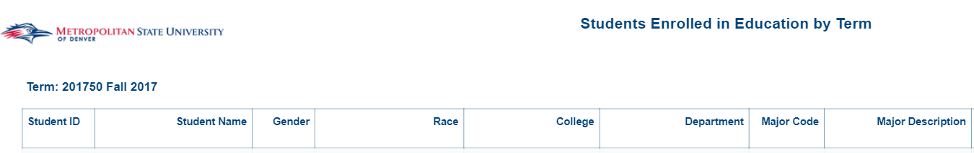
Cont.
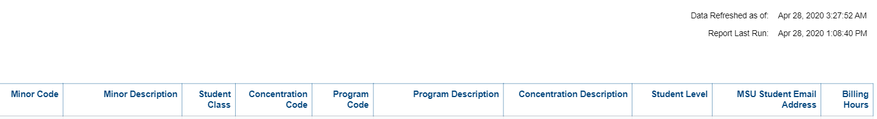

Title II
Description: The report provides a list of students in the Teacher Education Program by term.
Data Elements: Student ID, Name, Gender, Race, Date of Birth, College, Department, Attribute Code, Major Code, Major Description, Minor Code, Minor Description, Student Class, Concentration Code, Program Code, Program Description, Concentration Description, Student Level, Graduation Status, Billing Hours.
Source: Student Admission and Enrollment Universe
Location: Public Folders Student Profile Title II
Prompts: Term (Required)
Input Controls: Term, College, Department, Major, Minor, Concentration, Program
Report Page:
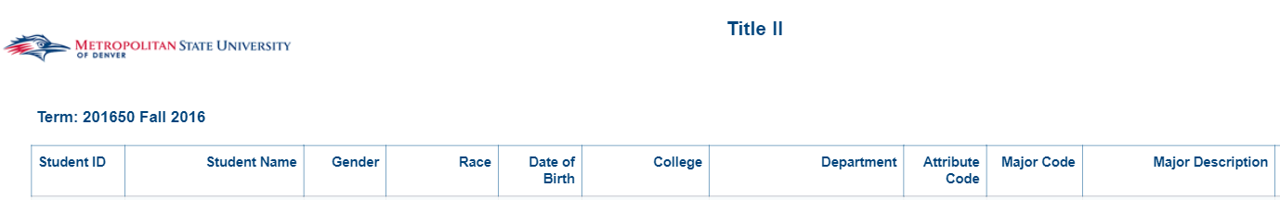
Cont.
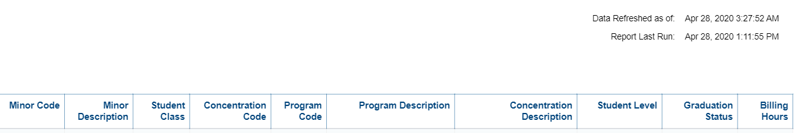

Teaching Assistant Program

Fall 2020 Teacher Assistant Course Student Retention
Description: This report provides a summary of student retention from the Fall term to the Spring term for students enrolled in one or more Teaching Assistant supported courses. This retention rate is compared to the overall retention rate for Undergraduate Students at MSU Denver.
Data Elements: Summary: Student Count – Not Retained +1, Student Count – Retained +1
Teacher Assistant Course - Student List: Student ID, Student Name, CRN
General MSU Denver Population - Student List: Student ID, Student Name
Source: Student Admissions and Enrollment Universe
Location: Public Folders Teaching Assistant Program Fall 2020 Teacher Assistant Course Student Retention
Prompts: None
Input Controls: None
Report Page:
Summary: 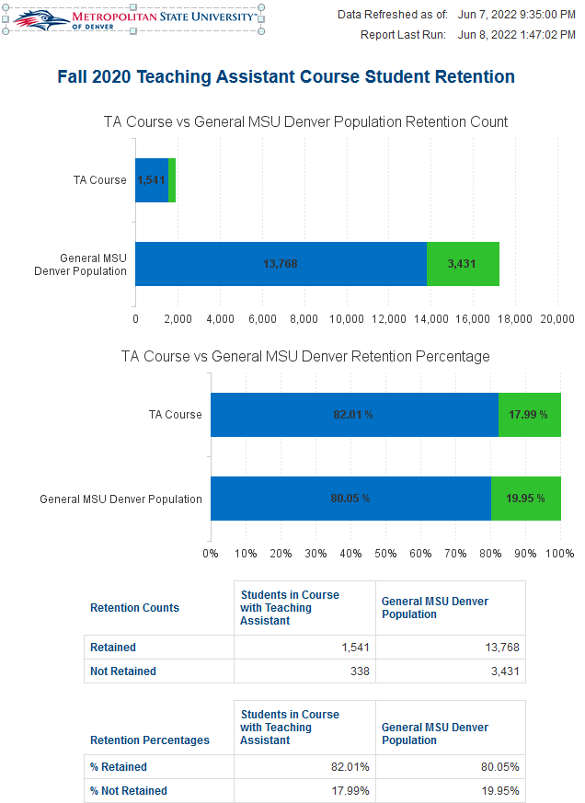
Teacher Assistant Course – Student List:
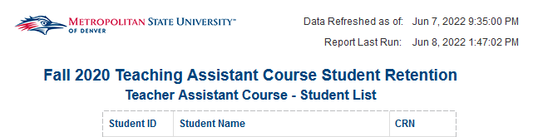
General MSU Denver Population – Student List:
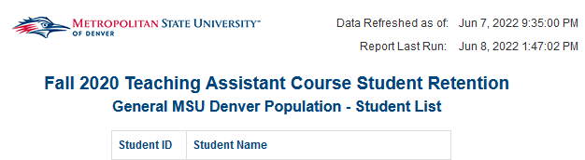

Fall 2021 Teacher Assistant Course Student Retention
Description: This report provides a summary of student retention from the Fall term to the Spring term for students enrolled in one or more Teaching Assistant supported courses. This retention rate is compared to the overall retention rate for Undergraduate Students at MSU Denver.
Data Elements: Summary: Student Count – Not Retained +1, Student Count – Retained +1
Teacher Assistant Course - Student List: Student ID, Student Name, CRN
Source: Student Admissions and Enrollment Universe
Location: Public Folders Teaching Assistant Program Fall 2021 Teacher Assistant Course Student Retention
Prompts: None
Input Controls: None
Report Page:
Summary:
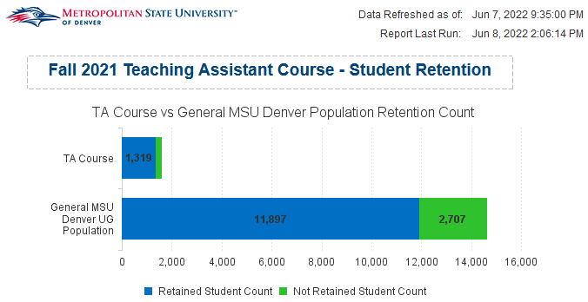
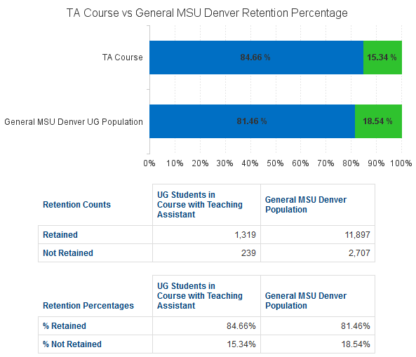
Teacher Assistant Course – Student List:
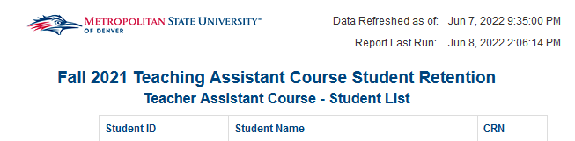

Fall Teaching Assistant Retention (Fall 2020, Fall 2021)
Description: This report provides a summary of student retention from the Fall term to the Spring term for the Teaching Assistants. This retention rate is compared to the overall retention rate for Undergraduate Students at MSU Denver.
Data Elements: Summary: Student Count – Not Retained +1, Student Count – Retained +1
Teaching Assistant List: Student ID, Student Name, Current Term Graduated Indicator
Source: Student Admissions and Enrollment Universe
Location: Public Folders Teaching Assistant Program Fall ____ Teaching Assistant Retention
Prompts: None
Input Controls: None
Report Page:
Summary: 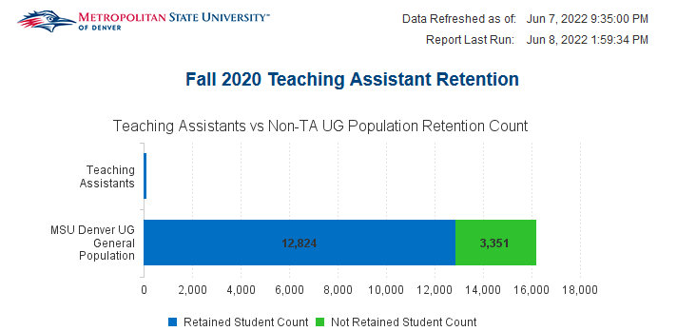
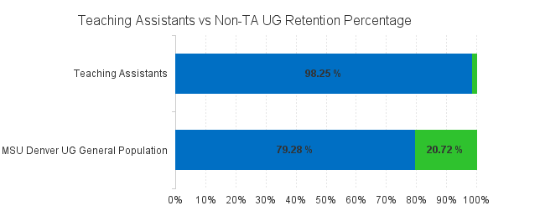
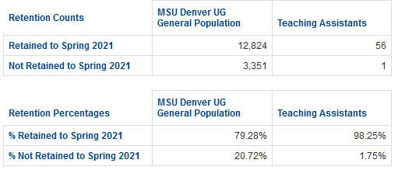
Teaching Assistant List:
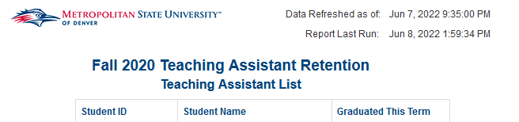

Spring 2021 Teacher Assistant Course Student Retention
Description: This report provides a summary of student retention from the Spring term to the next Fall term for students enrolled in one or more Teaching Assistant supported courses. This retention rate is compared to the overall retention rate for Undergraduate Students at MSU Denver.
Data Elements: Summary: Student Count – Not Retained +1, Student Count – Retained +1
Teacher Assistant Course - Student List: Student ID, Student Name, CRN
Source: Student Admissions and Enrollment Universe
Location: Public Folders Teaching Assistant Program Fall ____ Teacher Assistant Course Student Retention
Prompts: None
Input Controls: None
Report Page:
Summary:
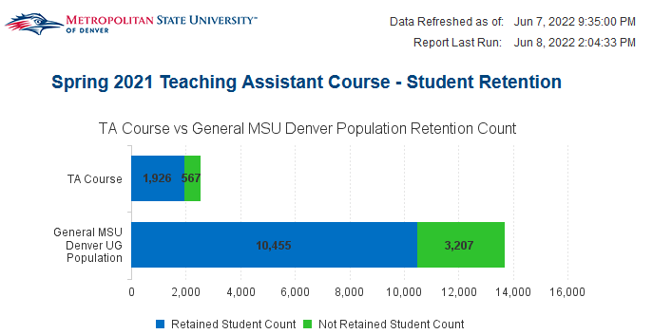
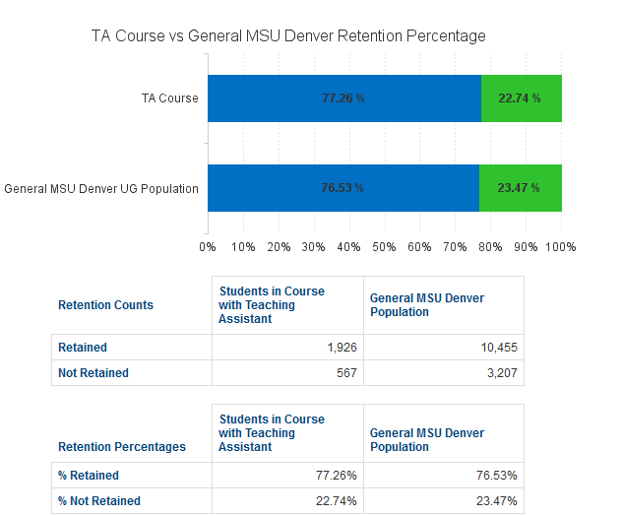
Teacher Assistant Course – Student List:
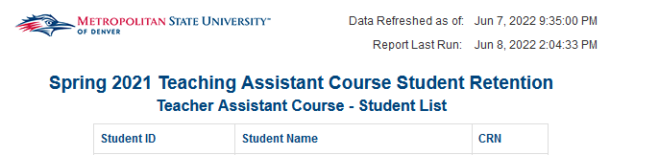

Spring 2021 Teaching Assistant Retention
Description: This report provides a summary of student retention from the Spring term to the next Fall term for the Teaching Assistants. This retention rate is compared to the overall retention rate for Undergraduate Students at MSU Denver.
Data Elements: Summary: Student Count – Not Retained +1, Student Count – Retained +1
Teaching Assistant List: Student ID, Student Name, Current Term Graduated Indicator
Source: Student Admissions and Enrollment Universe
Location: Public Folders Teaching Assistant Program Fall ____ Teacher Assistant Course Student Retention
Prompts: None
Input Controls: None
Report Page:
Summary:
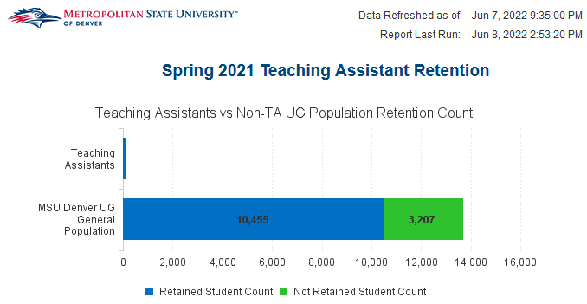
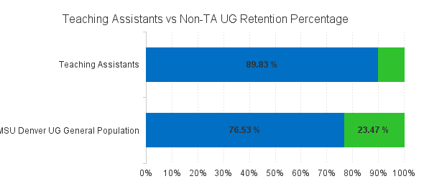
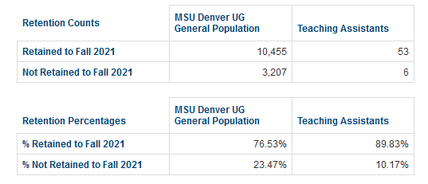
Teaching Assistant List:
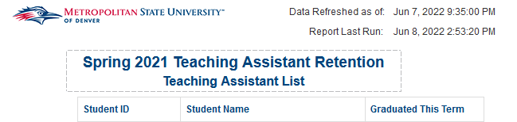

Student Email List by CRN
Description: This report provides a list of registered students and their MSU Denver emails for a given set of CRNs.
Data Elements: Term, Last Name, First Name, Middle Name, MSU Denver Email Address
Source: Student Admission and Enrollment Universe
Location: Public Folders Teaching Assistant Program Student Email List by CRN
Prompts: Term (required), CRN(s) (required)
Input Controls: None
Report Page:
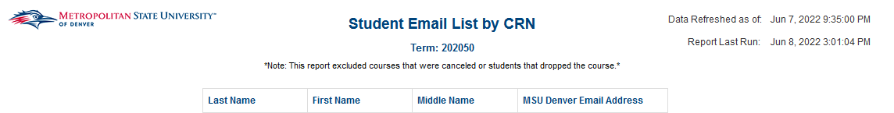

TA Course Student Demographics
Description: This report provides race/ethnicity headcounts of students registered for a TA supported course between Fall 2020 and Spring 2021.
Data Elements: Student Count, Student - %, Students of Color
Source: Student Admission and Enrollment Universe
Location: Public Folders Teaching Assistant Program TA Course Student Demographics
Prompts: None
Input Controls: None
Report Page:
Combined Student Demographics:
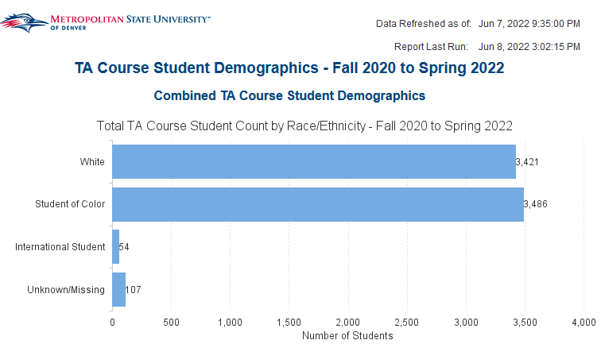
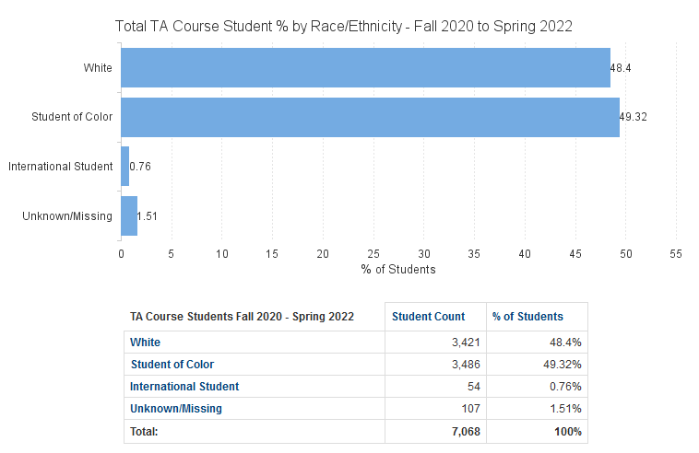
Student Demographics by Term:
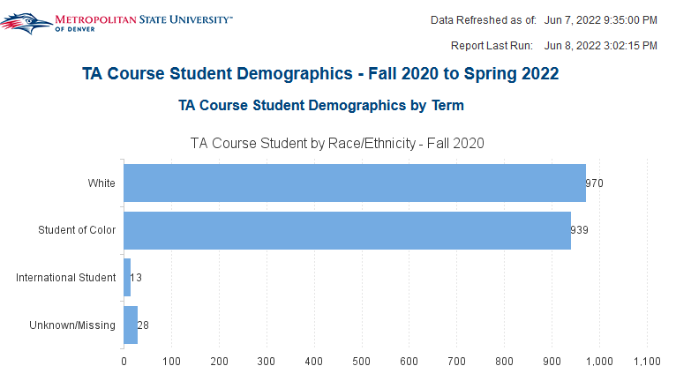

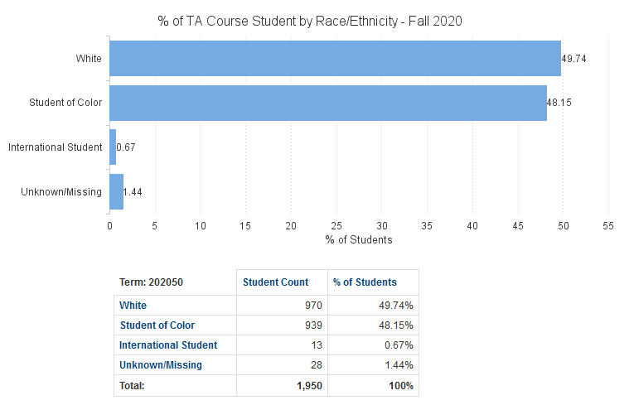

TA Demographics
Description: This report provides race/ethnicity headcounts of students registered for a TA supported course between Fall 2020 and Spring 2021.
Data Elements: Student Count, Student - %, Students of Color
Source: Student Admission and Enrollment Universe
Location: Public Folders Teaching Assistant Program TA Course Student Demographics
Prompts: None
Input Controls: None
Report Page:
Combined TA Demographics:
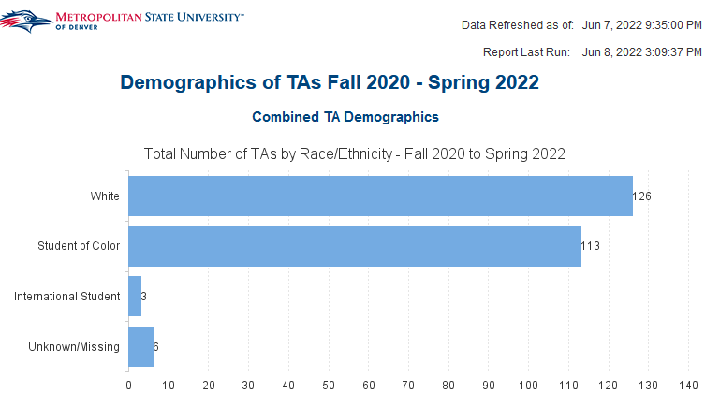
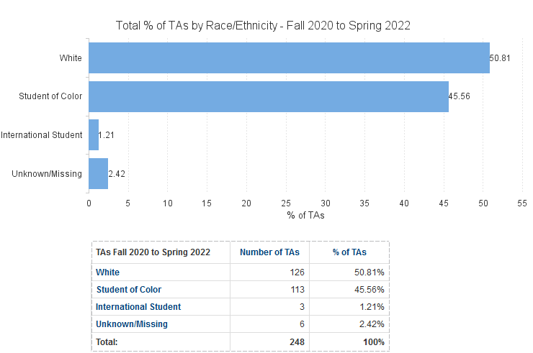
TA Demographics by Term:
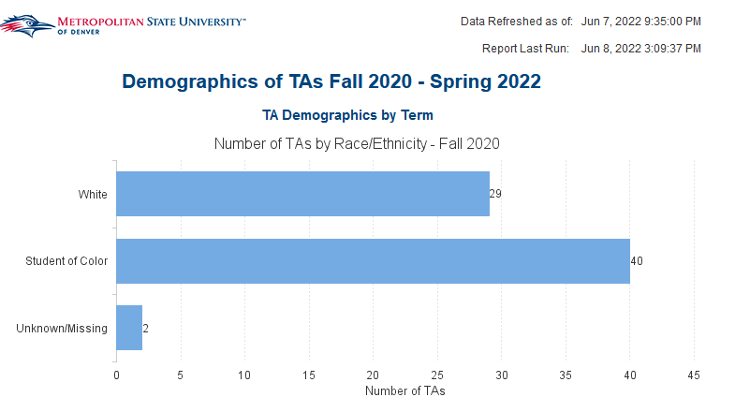
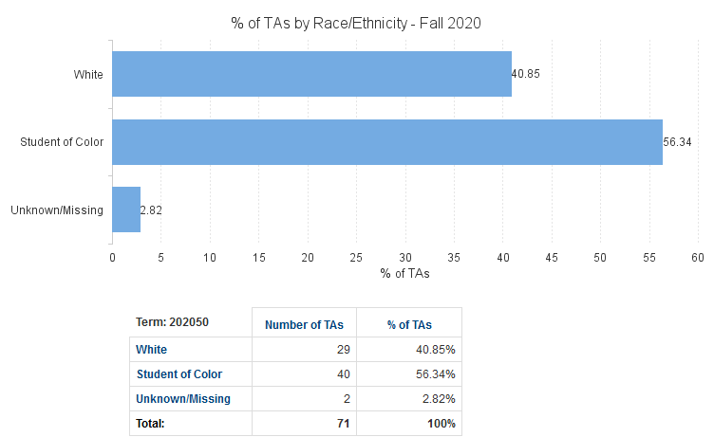

Teaching Assistant and Teacher Assistant Course Student Retention
Description: This report provides a summary of student retention for Teaching Assistant and Teacher Assistant supported courses from a user selected term to the next two consecutive terms. These retention rates are compared to the overall retention rate for Undergraduate Students at MSU Denver. This report contains four tabs: Summary – Teaching Assistants, Teacher Assistant List, Summary – TA Courses, and Teacher Assistant Course – Student List.
Data Elements:
- Summary – Teaching Assistants: Retained Student Count – TA Retention (Student Count - Retained + 2), Not Retained Student Count – TA Retention (Student Count – Not Retained + 2), Retained Student Percentage, Not Retained Student Percentage
- Teaching Assistant List: Student ID, Student Name, Current Term Graduated Indicator
- Summary – TA Courses: Retained Student Count – TA Course (Student Count - Retained + 2), Not Retained Student Count – TA Course (Student Count – Not Retained + 2)
- Teacher Assistant Course – Student List: Student ID, Student Name, CRN
Source: Student Admission and Enrollment Universe
Location: Public Folders Teaching Assistant Program Teaching Assistant and Teacher Assistant Course Student Retention
Prompts: Term (Required), Student ID for TA Courses 1 (Required), Student ID for TA Course 2 (Required), Student ID for TA Courses 3, CRN (Required), Student ID for TA Students (Required)
Input Controls: None
Report Page:
Summary – Teaching Assistants:
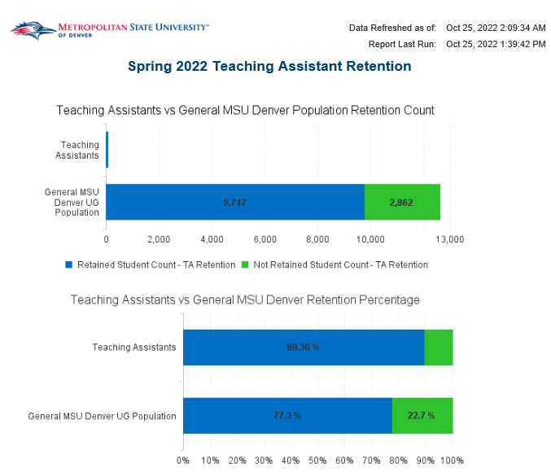
Teaching Assistant List:
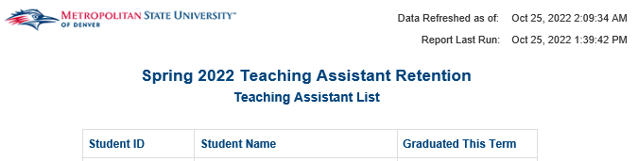
Summary – TA Course:
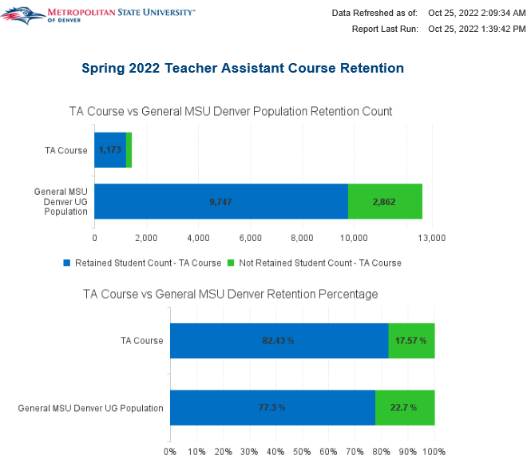
Teacher Assistant Course – Student List:
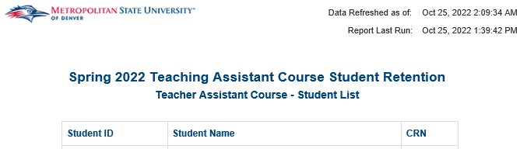

Transfer

Official Transfer Evaluation
Description: Displays all MSU Denver accepted transfer courses for a given student. Courses are listed by transfer course
and course equivalent. Courses are separated by general studies categories. The report is equivalent to the SWREVLG Banner report.
Data Elements: Student ID, First Name, Middle Name, Last Name, Full Street Address, City, State Code, Zip Code, School
Code, School Name, Transfer Course Name, Transfer Course Numbers, Transfer Course Title, Equivalent Subject Code, Equivalent Course Number, Equivalent Course Title, Equivalent Credit Hours, Accepted Credit Hours, GS Cat
Source: Student Admissions and Enrollment Universe
Location: Public Folders Transfer Official Transfer Evaluation
Prompts: Student ID (Required)
Input Controls: None
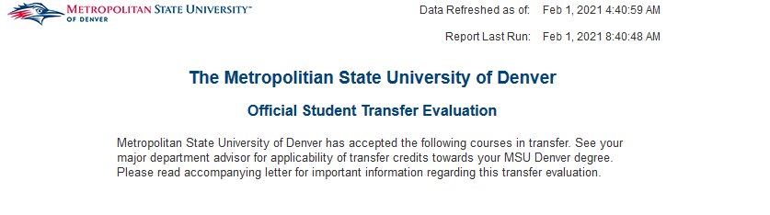
Report Page:

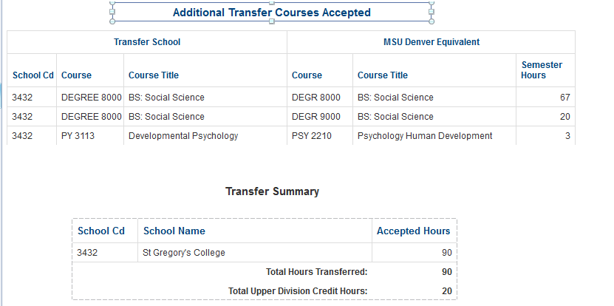

Transfer Catalog by Institution
Description: This report displays a list of all transfer courses and their respective equivalent courses in the Transfer Catalog for a user selected institution and term. The report includes several optional prompts to allow the user to filter the dataset before running the report. Input controls are also included in the report to allow the user to filter the dataset after running the report.
Data Elements: School Cd, School Name, Transfer Group. Transfer Group Primary Ind, Transfer Subject Code, Transfer Course Number, Transfer Title, Effective Term Code, Equivalent Exists, Transfer Catalog Code, Transfer Level, Transfer Course Status, Transfer Min. Grade Code, Transfer Low Credit Hours, Transfer Activity Date, Transfer User ID, Equivalent Connector, Equivalent Subject Code, Equivalent Course Number, Equivalent Title, Equivalent Credits Used, Equivalent Activity Date, Equivalent User ID, Equivalent Attribute Code, Equivalent Attribute, Equivalent Attribute Activity Date, Equivalent Attribute User ID, Equivalent Comment Text
Source: Student Admission and Enrollment Universe
Location: Public Folders Transfer Transfer Catalog by Institution
Prompts: School Code (Required), Term Code (Required), Transfer Group, Transfer Subject Code, Transfer Course Number, Transfer Catalog Code, Equivalent Subject Code, Equivalent Course Number, and Equivalent Attribute Code
Input Controls: Transfer Group, Transfer Group Primary Ind, Transfer Subject Code, Transfer Course Number, Equivalent Exists, Equivalent Subject Code, Equivalent Course Number, Equivalent Attribute Code, Effective Term Code, Transfer User ID, Equivalent User ID, Equivalent Attribute User ID
Report Page:
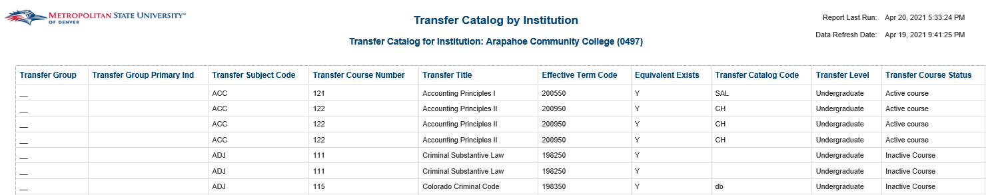
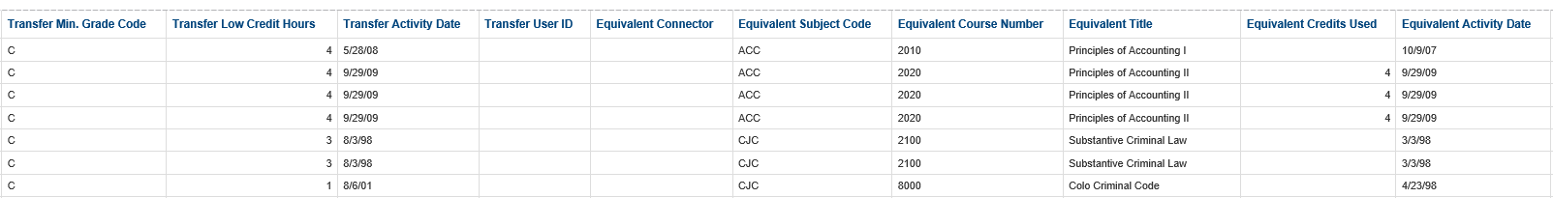

Report Page (Cont.):
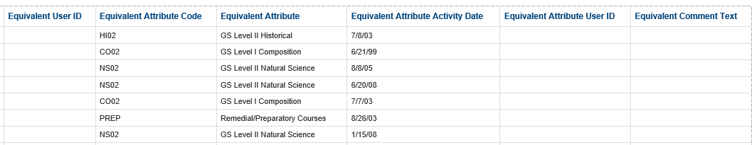

Transfer Courses by Subject and Attributes
Description: Lists all transfer courses and their MSU Denver equivalents transferred in by students for a given course subject or attribute.
Data Elements: School Cd, School Name, Transfer Group. Transfer Group Primary Ind, Transfer Subject Code, Transfer Course Number, Transfer Title, Effective Term Code, Equivalent Exists, Transfer Catalog Code, Transfer Level, Transfer Course Status, Transfer Min. Grade Code, Transfer Low Credit Hours, Transfer Activity Date, Transfer User ID, Equivalent Connector, Equivalent Subject Code, Equivalent Course Number, Equivalent Title, Equivalent Credits Used, Equivalent Activity Date, Equivalent User ID, Equivalent Attribute Code, Equivalent Attribute, Equivalent Attribute Activity Date, Equivalent Attribute User ID, Equivalent Comment Text
Source: Student Admission and Enrollment Universe
Location: Public Folders Transfer Transfer Courses by Subject and Attributes
Prompts: Equivalent Subject Cd, Equivalent Course Number, Equivalent Attr Cd
Input Controls: None
Report Page:

Transfer Equivalent Course by Institution
Description: This report displays MSU Denver transfer equivalent courses for all institutions in the Transfer Catalog. The report can be filtered at run time with several prompts. The report provides the user the ability to view all MSU Denver equivalent courses from any institution.
Data Elements: School Cd, School Desc, Transfer Group, Transfer Student ID, Student Name, Catalog Term Code, Primary Major, Transfer Course Subject, Transfer Course Number, Transfer Credit Hours, Transfer Grade, Transfer Course Title, Term Taken In, Equivalent Subject Cd, Equivalent Course Number, Equivalent Credit Hours, Equivalent Course Title, Equivalent Course Attr Cd, Last Updated Date
Source: Student Admission and Enrollment Universe
Location: Public Folders Transfer Transfer Equivalent Course by Institution
Prompts: Term Code (Required), School Code, Equivalent Subject Code, Equivalent Course Number, Equivalent Attribute Code, Transfer Group, Transfer Subject Code, Transfer Course Number, Transfer Catalog Code
Input Controls: Transfer Institution, Transfer Group, Transfer Group Primary Ind, Transfer Subject Code, Transfer Course Number, Equivalent Exists, Equivalent Subject Code, Equivalent Course Number, Equivalent Attribute Code, Effective Term Code, Transfer User Id, Equivalent User Id, Equivalent Attribute User Id
Report Page:
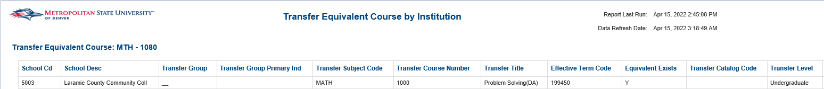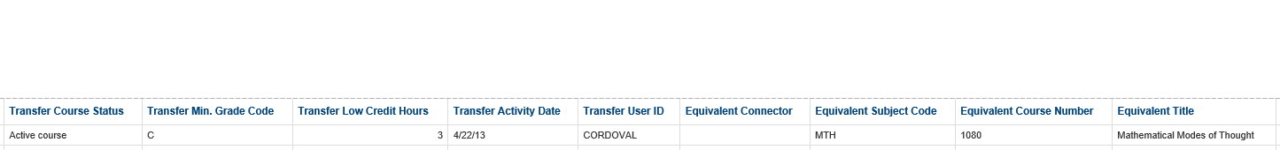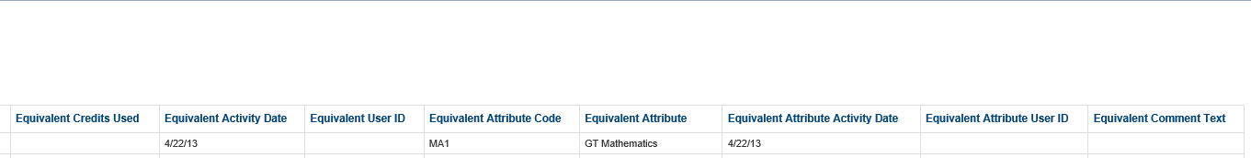

Transfer Students Report by Transfer School
Description: This report lists all students that have transfer records from a given transfer institution. The report provides all courses transferred from the institution and their MSU Denver equivalents.
Data Elements: School Cd, School Name, Student ID, Student Name, Catalog Term Code, Primary Major, Transfer Course Subject, Transfer Course Number, Transfer Credit Hours, Transfer Grade, Transfer Course Title, Term Taken In, Equivalent Subject Cd, Equivalent Course Number, Equivalent Credit Hours, Equivalent Course Title, Equivalent Course Attr Cd, Last Updated Date
Source: Student Admission and Enrollment Universe
Location: Public Folders Transfer Transfer Students Report by Transfer School
Prompts: Transfer School Cd (Required)
Input Controls: None
Report Page:

Veteran

ArmyIgnitED – Course Enrollment Report
Description: This report displays a list of registered students that have the TAR student attribute for the term selected. The report includes course enrollment data for the students that are listed for the term selected. This report is used to upload data into the ArmyIgnitED system for students that are receiving Tuition Assistance from the US Army.
Data Elements: OPEID (Static Value), Student ID, SSN (Static Value), Last Name, Registration Date, Enrollment Code, Enrollment Code Reason, Subject Code, Course #, Course Section Number, Class Reference Number (CRN), Credit Hours Low, Credit Type (Static Value), Course Title, Course Title Long, Course Term Start Date, Course Term End Date, Instruction Mode, Employee Name, Residency Flag, Additional Fees, Date of Withdrawal, Degree Level Code, Flat Rate (Y/N) (Static Value)
*Note: Due to specific formatting and character lengths requested by the ArmyIgnitED System some data elements had to be converted to the US Army's requirements. The data elements that were converted are listed in the report’s Overview tab*
Source: Student Data – Point In Time Universe
Location: Public Folders Veteran ArmyIgnitED – Course Enrollment Report
Prompts: Term Code (Required)
Input Controls: None
Report Page:

ArmyIgnitED – Grades Report
Description: This report displays a list of registered students that have the TAR student attribute for the term selected. The report includes student grades for the course(s) in which they are enrolled for the term selected. This report is used to upload data into the ArmyIgnitED system for students that are receiving Tuition Assistance from the US Army.
Data Elements: Course Subject, Course Catalog Number, Class Start Date, Solider Last Name, SSN (Static Value), Grade, Pass to Grade Translation, Grade Reason, OPEID (Static Value), Date of Withdrawal, Class Reference Number (CRN), GPA Calculation Value (GPA)
Source: Student Admission and Enrollment Universe
Location: Public Folders Veteran ArmyIgnitED – Grades Report
Prompts: Term Code (Required)
Input Controls: None
Report Page:

SALUTE Eligible Veterans
Description: This report displays a list of registered students with the VET student attribute for the term selected. The report also displays the student's cumulative GPA, Primary Major and email address. This report is used to invite eligible veteran students to apply to join the SALUTE honor society.
Data Elements: Term Code, Student Name, Student ID, Student Attribute Code, Student Attribute, GPA Cumulative, Cumulative Credit Hours Earned, Primary Major Code, Primary Major, MSU Email Address, Non-MSU Email Address
Source: Student Admission and Enrollment Universe
Location: Public Folders Veteran SALUTE Eligible Veterans
Prompts: Term Code (Required)
Input Controls: None
Report Page:

VA 85/15 Report by Term - Sponsored vs Non-Sponsored
Description: This report provides an aggregated count of FTEs (Full Time Equivalencies) of sponsored students and non-sponsored students by degree program for a selected term. The report also provides the percentage of total Sponsored and Non-Sponsored Student FTEs for each degree program. Sponsored students are defined as students that are receiving Veteran Benefits, are on an MSU Denver payment plan, or have an unpaid balance 30 days after the term start date.
Data Elements: VA 85/15 Report: Term Code, Term Description, Program, Program Code, Total Sponsored FTES, Total Non-Sponsored FTES, Total Student FTES, Sponsored FTES Percentage, Date of Calculation
VA 85/15 Report – Student Details: Term Code, Term Description, Program, Program Code, Student ID, Veteran Benefits Indicator, Hold Indicator, Unpaid Balance Indicator, Total Sponsored FTES
Source: Student Admission and Enrollment Universe
Location: Public Folders Veteran VA 85/15 Report by Term Sponsored vs Non-Sponsored
Prompts: Term Code (Required)
Input Controls: None
Report Page:
VA 85/15 Report:
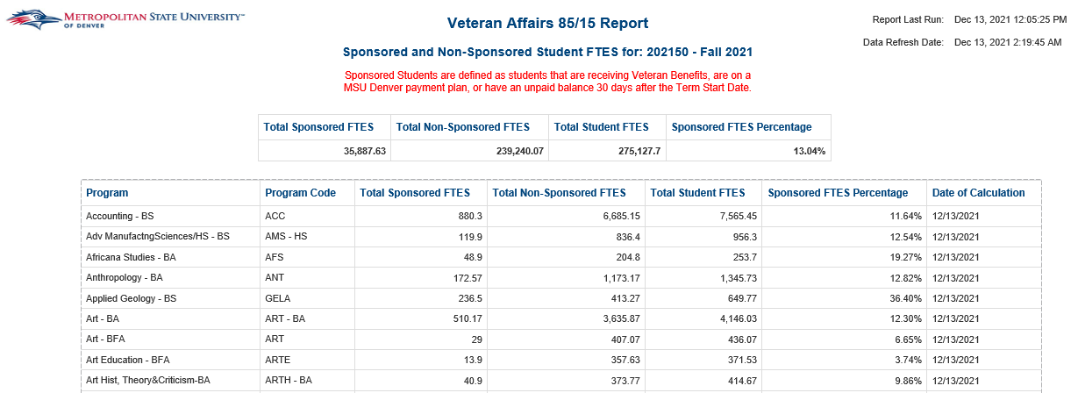
VA 85/15 Report – Student Details:
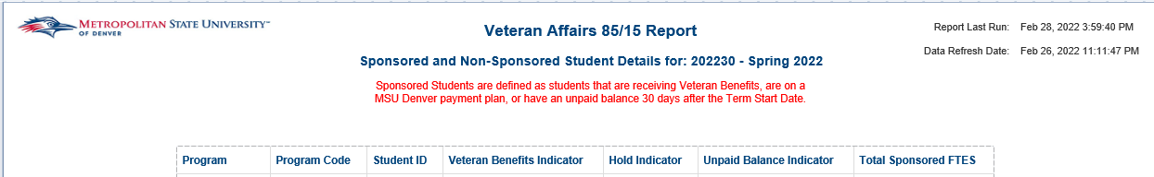

Veteran Graduates
Description: This report provides a list of veteran students that have graduated from MSU Denver.
Data Elements: Graduation Term, Student ID, Name, Degree, Major, Minor, Veteran Type, Graduation Status Code, Graduation Status, Student Email, Graduating Honors, Student Phone Number
Source: Student Admission and Enrollment Universe
Location: Public Folders Veteran Veteran Graduates
Prompts: Graduation Term (required)
Input Controls: ID
Report Page:

Veteran Graduates with Benefits
Description: This report provides a list of veteran students that have graduated from MSU Denver that were receiving military benefits.
Data Elements: Graduation Term, Student ID, Name, Last Veteran Status, Graduation Status Code, Graduation Status, Student Email, Student Phone Number
Source: Student Admission and Enrollment Universe
Location: Public Folders Veteran Veteran Graduates with Benefits
Prompts: Graduation Term (required)
Input Controls: None
Report Page:
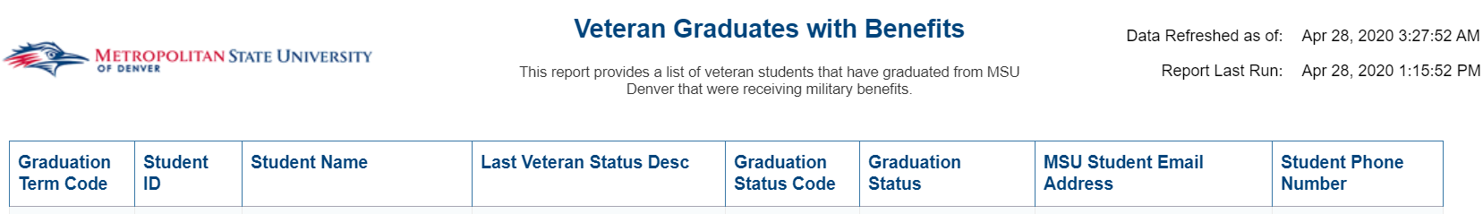

Veteran Profile – Multiple Terms
Description: This report displays an unduplicated total of veteran students from MSU Denver that are receiving military benefits during multiple terms. There are 4 tabs. The first tab is an overall summary of veterans by benefits being received. The second tab shows how they are connected to the military. The third tab shows a comparison of veterans to non-veterans. The first three tabs are broken down by Gender, Ethnicity, Student Type, Student Status, Age, Classification, Residency, GPA and Major. The fourth tab lists all data points for veterans that were registered during the given terms.
Data Elements:
- Veteran Profile: Veteran Type, Gender, Ethnicity, Student Type, Student Status, Age, Classification, Residency, GPA, Major
- Military Connected: Veteran Type, Gender, Ethnicity, Student Type, Student Status, Age, Classification, Residency, GPA, Major
- Veterans vs Non-Veterans: Count of Veterans, Count of Non-Veterans, Gender, Ethnicity, Student Type, Student Status, Age, Classification, Residency, GPA, Major
Source: Student Admission and Enrollment Universe
Location: Public Folders Veteran Veteran Profile Report
Prompts: Term
Input Controls: None
Report Page:
Veteran Benefits
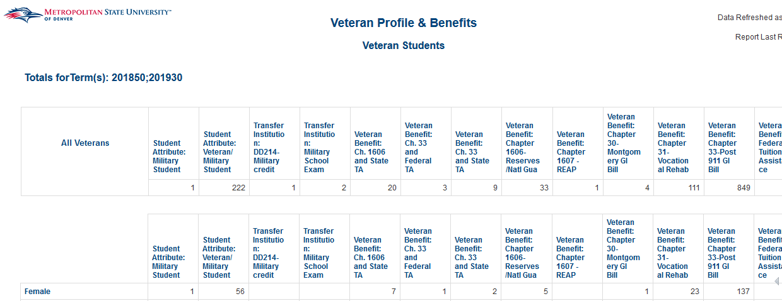
Military Connected
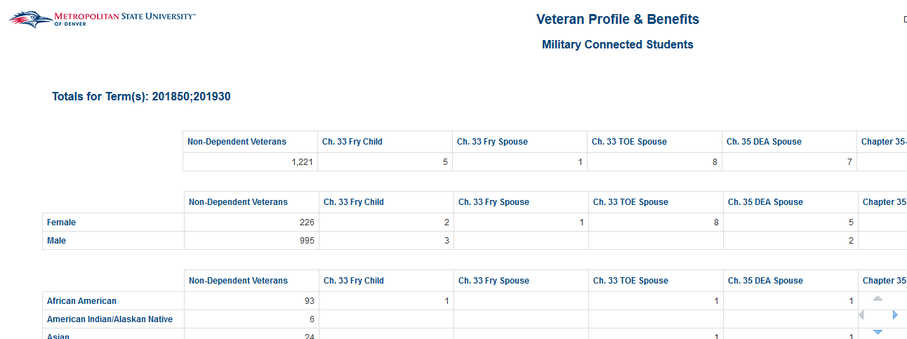
Veteran vs Non-Veteran
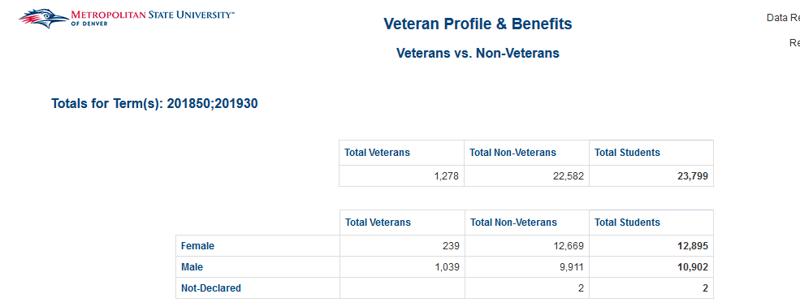
Veteran Listing Detail
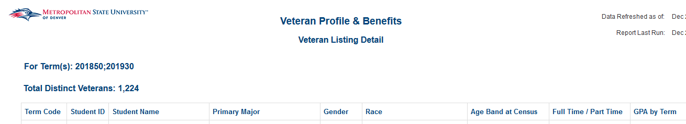

Veteran Profile Report
Description: This report displays a total of veteran students from MSU Denver that are receiving military benefits. There are 3 tabs. The first tab is an overall summary of veterans by benefits being received. The second tab shows how they are connected to the military. The third tab shows a comparison of veterans to non-veterans. All reports are broken down by Gender, Ethnicity, Student Type, Student Status, Age, Classification, Residency, GPA, Major and Minor.
Data Elements:
- Veteran Profile: Veteran Type, Gender, Ethnicity, Student Type, Student Status, Age, Classification, Residency, GPA, Major, Minor
- Military Connected: Veteran Type, Gender, Ethnicity, Student Type, Student Status, Age, Classification, Residency, GPA, Major, Minor
- Veterans vs Non-Veterans: Count of Veterans, Count of Non-Veterans, Gender, Ethnicity, Student Type, Student Status, Age, Classification, Residency, GPA, Major, Minor
Source: Student Admission and Enrollment Universe
Location: Public Folders Veteran Veteran Profile Report
Prompts: Term
Input Controls: Primary Major, Primary Minor, Student Level
Report Page:
Veteran Profile
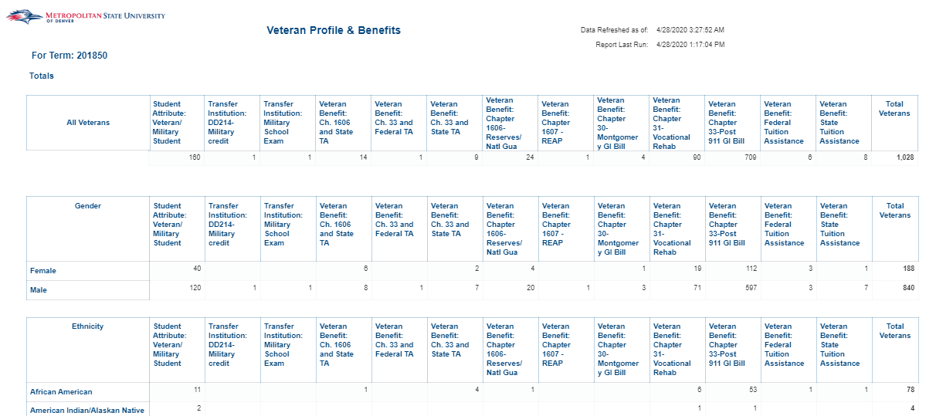

Military Connected
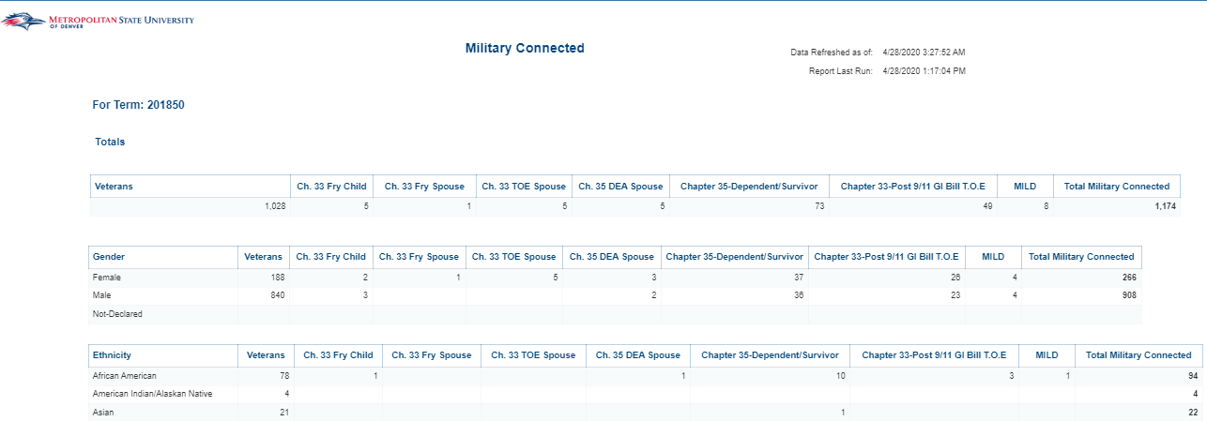
Veteran vs Non-Veteran
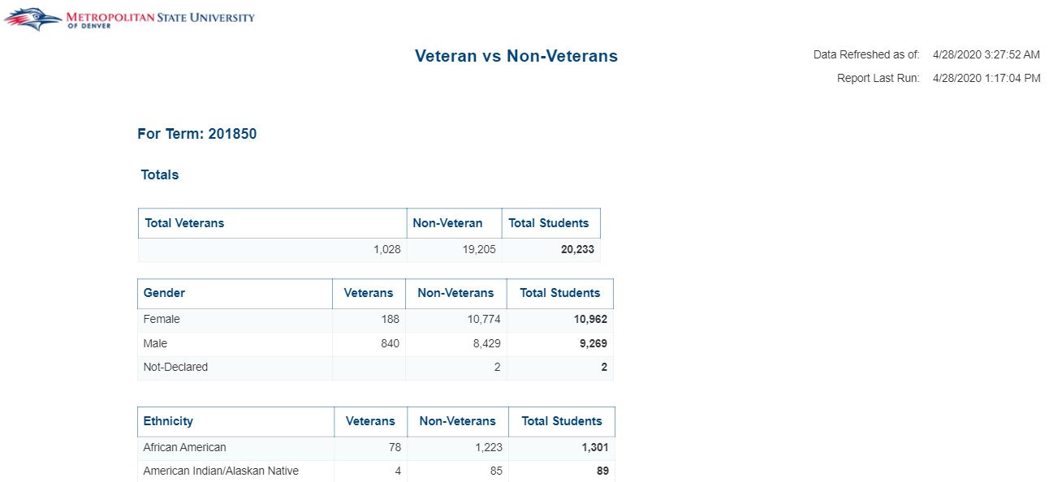

Veterans Certified Credit Hours
Description: This report provides a list of veterans and military connected students and compares a student's certified credit hours against reported credit hours for a given semester to catch any discrepancies.
Data Elements: Term, Student ID, Name, Veteran Type Code, Veteran Type, Certified Hours, Credit Hours, Discrepancy
Source: Student Admission and Enrollment Universe
Location: Public Folders Veteran Veterans Certified Credit Hours
Prompts: Term
Input Controls: None
Report Page:
Veteran Certified Hours Exception
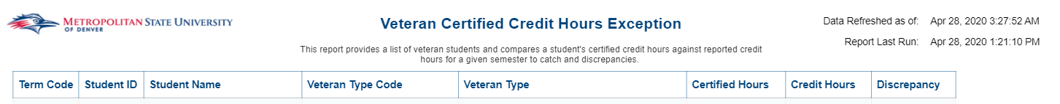
Military Connected Certified Hours Exception
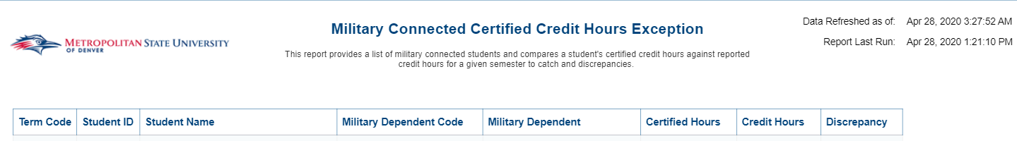

Veterans in Modules and Internships
Description: This report provides a list of veteran students with their current certified credits hours and current courses by Veteran Chapter for a selected term.
Data Elements: Student Name, Student ID, Chapter Code, Chapter, Credit Hours Certified, CRN, Modules / Internships
Source: Student Admission and Enrollment Universe
Location: Public Folders Veteran Veterans in Modules and Internships
Prompts: Term
Input Controls: None
Report Page:

Glossary
ACADEMIC YEAR: The period of time generally extending from September to June; usually equated to 2 semesters.
ACCEPTED STUDENTS: Applicants that have been granted an official offer to enroll at MSU Denver
ADJUNCT/AFFILIATE FACULTY: Non-tenure track instructional staff serving in a temporary or auxiliary capacity to teach specific courses on a course-by-course basis. Includes both instructional staff who are hired to teach an academic degree-credit course and those hired to teach a remedial, developmental, or ESL course; whether the latter three categories earn college credit is immaterial. Excludes regular part-time instructional staff (who, unlike adjuncts are not paid on a course-by-course basis), graduate assistants, full-time professional staff of the institution who may teach individual courses (such as a dean or academic advisor), and appointees who teach non-credit courses exclusively.

ADMITTED STUDENTS: Applicants that have been granted an official offer to enroll in a postsecondary institution.
AFRICAN AMERICAN/BLACK: A person having origins in any of the black racial groups of Africa.
AMERICAN INDIAN OR ALASKAN NATIVE: A person having origins in any of the original peoples of North and South America (including Central America) who maintains cultural identification through tribal affiliation or community attachment.

APPLICANT: An individual who has fulfilled the institution's requirements to be considered for admission (including payment or waiving of the application fee, if any) and who has been notified of one of the following actions: admission, non-admission, placement on waiting list, or application withdrawn by applicant or institution.

ASIAN: A person having origins in any of the original peoples of the Far East, Southeast Asia, or the Indian Subcontinent, including, for example, Cambodia, China, India, Japan, Korea, Malaysia, Pakistan, the Philippine Islands, Thailand, and Vietnam.

BACHELOR’S DEGREE: An award (baccalaureate or equivalent degree, as determined by the Secretary, U.S. Department of Education) that normally requires at least 4 but not more than 5 years of full‐time equivalent college‐level work. *

CASH-FUNDED COURSE: Course that is not eligible for the COF stipend
CAT I: Tenure (T) and tenure track (TT) faculty members with a rank of Assistant Professor, Associate Professor, or full Professor. Once a faculty is hired into this category, they generally remain as a Cat I faculty. It takes about six years for a new TT Cat I faculty to become tenured. Upon tenure, they receive a rank promotion from assistant professor to associate professor and a salary increase. It is up to that faculty member if and when they choose to submit their portfolio to become a full professor. Cat I faculty are also required to perform research, deep and meaningful service, publish and present papers that are peer-reviewed by other faculty in their discipline, serve the University in a volunteer capacity on committees, etc. Full-time faculty are measured on a 30-credit-per academic year basis which would equal 1.00 FTE. These faculty teach a 4/4 load (four courses each semester) with each course generally being three-credit hours. That totals 24 teaching credit hours in an academic year. The other six credit hours are for their service requirements that are listed above.

CAT II: Full time faculty members that are not tenured or tenure track but are eligible for benefits and have a rank of Lecture or Senior Lecturer. Cat II faculty are considered to be temporary faculty although they generally are full-time. They are hired on an annual basis and can apply for a multi-year contract which is a three-year appointment. Cat II faculty generally teach a 5/5 load because they do not have the service requirements that a tenure-track or tenured faculty has. After six years with MSU Denver, the Lecturer can apply for Senior Lecturer status. If approved, the Cat II faculty obtains that title and a salary increase. A Cat II faculty will never move into a Cat I faculty position unless he/she has the required credentials and a TT or T Cat I faculty line becomes available. The Cat II faculty would have to apply for the position through the search process and be selected.

CAT III: Part time affiliate faculty that cannot teach more than 9 hours per semester and are not eligible for benefits. Also see Adjunct Faculty.
CENSUS DATE: The 15% completion point of any academic term. During Fall and Spring terms, this is on the twelfth (12th) day of class. The eighth (8th) day of class is Census Date for Summer term.

CERTIFICATE: A formal undergraduate or graduate award certifying the satisfactory completion of a postsecondary program.
COHORT: Consist of students who enrolled for the first time in the fall semester and students who enrolled for the first time in the summer and who continued in the subsequent fall semester.
CORRESPONDENCE COURSE: With no class meetings, correspondence courses allow students to set an independent learning pace at home. Students submit coursework to instructors via Blackboard for self-paced online classes or by postal mail for print-based classes. Depending on the format, students have six months or one year to complete a correspondence course. However, a student is technically registered ONLY during the original semester of enrollment and is not considered a continuing student. Once course work is completed and graded, the grade will appear on the transcript for the original semester enrolled.

CONTINUING/RETURNING STUDENT: A student who is not new to the institution in the fall, but instead is continuing his or her studies at the institution (i.e., not first-time and not transfer-in).

CONTINUING EDUCATION: A student that is enrolled in a professional development course or post-Bachelor certificate programs.
CREDIT HOUR LOAD: The total number of credit hours taken by a student per term.
CREDIT HOUR PRODUCTION (CHP): The total of all credit hours produced in a semester.

DEGREE: An award conferred by a college, university, or other postsecondary education institution as official recognition for the successful completion of a program of studies. *

DEGREES AWARDED: The number of Bachelors and Masters degrees awarded to students at the end of the term. Count includes dual majors as two separate degrees.

DEGREE/CERTIFICATE-SEEKING STUDENT: Students enrolled in courses for credit who are seeking a degree, certificate, or other recognized postsecondary credential. This includes students who:
- received any type of federal financial aid, regardless of what courses they took at any time;
- received any state or locally based financial aid with an eligibility requirement that the student be enrolled in a degree, certificate, or transfer-seeking program; or
- obtained a student visa to study at a U.S. postsecondary institution
High school students also enrolled in postsecondary courses for credit are not considered degree/certificate-seeking. This measure includes students with undeclared majors.
ENROLLED STUDENT: A student that is currently registered for one or more courses during the current term or attended a course for the entire term.
ETHNICITY: Ethnic information based on self-identification by the student.
FACULTY: Persons identified by the institution as such and typically those whose initial assignments are made for the purpose of conducting instruction, research or public service as a principal activity (or activities). They may hold academic rank titles of professor, associate professor, assistant professor, instructor, lecturer or the equivalent of any of those academic ranks. Faculty may also include the chancellor/president, provost, vice provosts, deans, directors or the equivalent, as well as associate deans, assistant deans and executive officers of academic departments (chairpersons, heads or the equivalent) if their principal activity is instruction combined with research and/or public service.

FTEF: Full-time Equivalent Faculty (FTEF) is a mathematically derived hypothetical number based on credit hours taught. Full-time faculty teach 24 credit hours per academic year (does not include additional time and effort for advising, service, or professional development) for 1 FTE. Affiliate faculty teach a maximum of 30 credit hours per academic year for 1 FTE or a proration. The sum of full-time faculty FTE and affiliate faculty FTE is the FTE reported for the department, school or institution which will include FTE for summer.
FTES: Full-time Equivalent Student -- a mathematically derived hypothetical full-time student.

FULL-TIME STUDENTS: Undergraduate students who are enrolled for 12 or more credit hours or Graduate students who are enrolled for 6 or more credit hours for a term.
FULL-YEAR CHP: The total number of credit hours produced for Summer, Fall, and Spring terms for a given full-year.
FULL-YEAR FTES: The number of full-time equivalent students enrolled in a given year, derived by dividing full-year CHP by 30 (the standard full-time credit load for two terms).

GENDER: Gender information based on self-identification by the students, faculty and staff.

GRADUATE STUDENT: A student who holds a bachelor's degree or above and is taking courses at the postbaccalaureate level. These students may or may not be enrolled in graduate programs.

GRADUATION RATES: The cumulative percentage who have graduated as of the end of the summer term following a given academic year.
HIGH SCHOOL STUDENT: A student enrolled in secondary school or pursuing a high school diploma or recognized equivalent. Includes students who have not received but are pursuing a high school diploma or recognized equivalent and taking college coursework concurrently.
HISPANIC OR LATINO: A person of Cuban, Mexican, Puerto Rican, South or Central American, or other Spanish culture or origin, regardless of race.

HYBRID: A Hybrid class provides some instruction on the Auraria campus or another location at scheduled meetings times in a designated location. The rest of the instruction is online. There are no online fees for Hybrid classes. However, there are mandatory student fees.

INTER-INSTITUTIONAL STUDENT: A student enrolled in another institution and is also taking one or more courses at MSU Denver. Most commonly the student attends University of Colorado at Denver or Community College of Denver.
INTERNATIONAL STUDENT/FACULTY: A person who is not a citizen or national of the United States and who is in this country on a visa or temporary basis and does not have the right to remain indefinitely. (Nonresident alien).

MASTER’S DEGREE: An award that requires the successful completion of a program of study of at least the full‐time equivalent of 1 but not more than 2 academic years of work beyond the bachelor's degree.

MOSTLY ONLINE: A Mostly Online class requires students to come to the Auraria Campus or go to an alternative site for exams or other activities, but instruction and most activities are online. There is an online fee per credit hour for all online classes.

NATIVE HAWAIIAN OR OTHER PACIFIC ISLANDER: A person having origins in any of the original peoples of Hawaii, Guam, Samoa, or other Pacific Islands. *

NON-DEGREE SEEKING STUDENT: A student enrolled in courses for credit who is not recognized by the institution as seeking a degree or formal award.

NON-RESIDENT STUDENT: A student who is not a legal resident of the state in which he/she attends school.
NON-TRADITIONAL AGED STUDENTS: Students 20 years of age or older as of September 15 for Summer or Fall terms and February 15 for Spring term, per Colorado Commission on Higher Education (CCHE) policy.
PART-TIME STUDENTS: Undergraduate students who are enrolled for less than 12 credit hours or Graduate students who are enrolled for less than 6 credit hours for a term.

RACE/ETHNICITY: Categories developed in 1997 by the Office of Management and Budget (OMB) that are used to describe groups to which individuals belong, identify with, or belong in the eyes of the community. The categories do not denote scientific definitions of anthropological origins. The designations are used to categorize U.S. citizens, resident aliens, and other eligible non-citizens.

Individuals are asked to first designate ethnicity as:
- Hispanic or Latino or
- Not Hispanic or Latino

Second, individuals are asked to indicate all races that apply among the following:
- American Indian or Alaska Native
- Asian
- Black or African American
- Native Hawaiian or Other Pacific Islander
- White

RACE/ETHNICITY UNKNOWN: The category used to report students or employees whose race and ethnicity are not known.

REGISTERED STUDENT: A student that registered for one or more courses in a semester.

RESIDENT STUDENT: A student who is a legal resident of the state in which he/she attends school.

RETENTION RATE: A measure of the rate at which students persist in their educational program at an institution, expressed as a percentage. This is the percentage of first‐time degree/certificate‐seeking students from the previous fall who either reenrolled or successfully completed their program by the current fall. Deceased students or students who have graduated and re-enrolled are excluded from the retention rate.

SELF-PACED: Designated courses that permit you to progress at your own rate.

STATE FUNDED COURSES: Courses that are eligible for the COF stipend. Instructor paid from the institution 1000 accounts.
STUDENT COUNT: The number of individuals for whom instruction is provided in an educational program under the jurisdiction of a school or educational institution.

STUDENT LEVEL: The level of study of a student’s current primary degree program.

STUDENT TYPE: Classification for students to denote their highest level of their education prior to their admission at MSU Denver or pervious admission to MSU Denver.

TERM CHP: The total number of credit hours produced in a given term. Calculated as follows: (#students enrolled * credit hour for course).
TERM FTES: The number of full-time equivalent students enrolled in a given term, derived by dividing term CHP by 15 (the standard full-time load for 1 term).
TRADITIONAL AGED STUDENTS: Students 19 years of age or younger as of September 15 for Summer or Fall terms and February 15 for Spring term, per Colorado Commission on Higher Education (CCHE) policy.
TRANSFER STUDENT: Undergraduate students who previously attended a higher education institution, have been officially admitted to MSU Denver, and are attending MSU Denver as a degree‐seeking student for the first time. This includes students at MSU Denver for the first time seeking a second bachelor’s degree. Fall transfer students include those who began taking classes during the previous summer or the current fall semester. Re‐enrollees at MSU Denver are not counted as new transfers.

UNDECLARED STUDENT: A student that has not declared a specific major but is taking classes. This can include students taking classes for enrichment purposes with no intention of obtaining a degree, professional development students taking classes for continuing education credit, or students who intend to get a degree but have not yet chosen a specific major.

UNDERGRADUTATE: A student enrolled in a bachelor's degree program or a certificate program below the graduate level. This group includes freshmen, sophomores, juniors, seniors, second bachelors, and non‐degree undergraduates.
WESTERN UNDERGRADUATE EXCHANGE (WUE): Western Undergraduate Exchange (WUE) is WICHE's student exchange program. Students who are residents of WICHE states are eligible to request a reduced tuition rate of 150% of resident tuition at participating two‐ and four‐year college programs outside of their home state. WICHE website http://www.wiche.edu/

WESTERN INTERSTATE COMMISSION FOR HIGHER EDUCATION (WICHE): WICHE and its 15-member states work to improve access to higher education and ensure student success. WICHE states include: Alaska, Arizona, California, Colorado, Hawaii, Idaho, Montana, Nevada, New Mexico, North Dakota, Oregon, South Dakota, Utah, Washington, Wyoming. WICHE website http://www.wiche.edu

WHITE: A person having origins in any of the original peoples of Europe, the Middle East, or North Africa.
YIELD RATE: Percentage of applicants who enroll each term.

