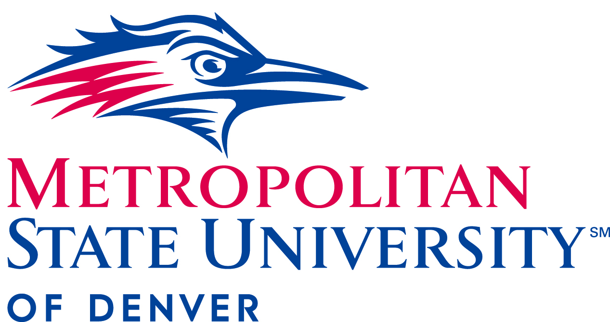

President’s Cabinet Meeting
January 20, 2022
11:00 a.m.- 12:30pm
- Approval of November 17, 2021 minutes

- President’s Update (11:00- 11:30) Janine Davidson, Ph.D, President

- Acknowledge students and faculty handling the effects of Covid-19, shootings, fires, online courses and the pivoting back and forth.
  - Recognize the hope that January 2022 would be “post-pandemic,” but it is instead the “new normal” and learning to cope with the effects; MSU Denver is at the top for resources to help. Mental health services stay open as well as the University.
  - We are 90% vaccinated and have a very good place
- Testified at Joint Budget Committee hearing. Signed onto joint letter with CEO’s of higher Education asking for $50 million in step 1 funding formula. $125 million for a minimum cost to keep tuition flat. If not, MSU will have to raise the tuition which we do not want. Asking for $50 million in step 1 funding formula.
  - The reason the letter was not signed last year was due to the issue of equity and the community of leadership lacked credibility.
  - The biggest message we have is that the state needs to support higher Education. We cannot sign on to misinformation. Higher education ensures the livelihood of this generation.
- MSU Denver Highlights
  - The Reverse Transfer Articulation Agreement is signed and MSU Denver is the first 4 year to sign off. Grants Associates Degree to students who haven't finished and encourages students to come back and finish. More to do in that area
  - Grant President’s Team Award to Event Team (Kylie Miller and Cora Potter with help from David Sharman). Navigating a variety of health protocols. They are the driving force behind commencement; the most important event and they always pull it off. David Sharman is behind the video meeting and has been backbone since being virtual.

- COVID- 19 Update (11:30-11:40) Larry Sampler, Vice President for Administration and Finance/ COO

- All faculty must have vaccination and booster by February 15th.
  - Only exceptions= recovering from covid/ rescheduling with the health center for the booster. Second is an Exemption form.
- Mask mandate intact on campus
- Safe Return Website
  - Protocols and updates
- Testing changes: For symptomatic purposes. Resources are not unlimited.
- Health Center Website
  - Understaffed to answer the phones, so website is ideal

- Hart Center and Presidential Federal Internship- (11:40-12:00) Alyssa Marks, Associate Director of Industry Partnerships; Cristal Herrera, program manager of The Hart Center

- Federal Internship program overview: summer 2022 is the first endeavor to promote the vision of empowering, encouraging and engaging faculty and students with civic life. Six students will be placed in 10-week internships in D.C..
  - Housing is provided with a stipend of 6,000 dollars. They are given a funded metro card for transportation.
  - Students are required to participate in pre-intern orientation and workshops. Supported by Alyssa and Cristal for the first few days, then virtually throughout internship.
- Timeline of events from Spring- Summer.
  - January: placement finalized, housing reservation submitted. February- orientation program preparation, speakers/ faculty secured. March-April: orientation and workshop programming. May: onboarding for summer 2022, student employment complete. May 27th- August 6th is the DC internship Experience!
- Presentations provided by student interns described how the internships helped them meet life goals, expressed appreciation for this opportunity
  - Two intern positions with Senator Bennet’s Office in Washington D.C.
  - Student intern interests include: sustainability/climate crisis in policymaking, Congress, public service and the law, public service in museums, and immigration reform
  - Pitch the needs of connections for student interns: Advisory Board

- Round Robin Updates (12:00-12:30)

- Edward Brown, Chief of Staff
- Michael Benitez, Vice President, Diversity and Inclusion
  - Gratitude toward pulling off Mr. Luther King Piece practices committee and to the Trustees and Senior Leaders for being present
- Elizabeth Ribble, Chair, Department of Mathematics and Statistics
- Eric Mason, Interim Chief Strategy Officer (virtual, last day)
  - Execute student housing survey
- Kelly Brough, new Chief Strategy Officer
  - Christoper Pena will be Director of Strategy- create a dashboard to drive key metrics to focus on every day; strategic plan
  - AHEC taking on master plan and safety analysis of campus.
- Andrea Smith, Associate Vice President of Strategic Communications
  - Red.MSU Denver.edu tells the stories of Hart Center Program and information across the university in hopes of reaching the community/news. Increased audience by 32%
  - National media placements doubled from the stories
  - 2,245 total media placements
  - MSUDenver.edu/UCM request form for assistance, resources and programs-
- David Fine, General Counsel
  - Board of Trustees meeting- slate Russell Noles and Kristin Hultquist elected to chair and vice chair
- Jeremy Medina, Student Advocacy Council Representative- Not in Attendance
- Christine Marquez- Hudson, Vice President and Executive Director, University Advancement and MSU Denver Foundations
  - Increased from 3.5 to 5.6 million in dollars raised for the physical year
  - 5.5 million dollars in the pipeline
  - Relaunched steering committee
  - March 31st- Day of Giving. Still time for campaigns to reach the website, deadline by February 28th. Contact Bri Nilnes
- Liz Hinde, Dean, School of Education
- Sena Byrant, TSAC
  - Topic of 2022-23 election year discussion
  - Coffee Mondays and Tabling Events to be more present
- Katia Campbell, President, Faculty Senate
  - Voted last semester to go Hybrid and very thankful.
  - In the process of hiring an assistant to the faculty senate which goes into effect this spring.
  - Shout out to the faculty experiencing exhaustion
- Rebecca Reid, President, Staff Senate
- Todd Thuram, Director of Athletics- Not in Attendance
- John Kitzmen, Associate Athletic director
  - Volleyball team made history, did not get as far as hoped
  - Volleyball coach Jenny recognized as College Coach of the Year in Colorado
  - Academics: 118/223 student athletes reached above 3.5 for fall semester
  - Overall department GPA 3.2
  - February 5th- Opening Day for softball and baseball; televised basketball game
- Alfred Tatum, Provost and Executive Vice President of Academic Affairs
  - Department of Health Sciences and Health institute hosted inaugural Imagine Wellness competition. Our seniors presented on Food Security, homelessness, pregnant mothers recovering from drug addiction. Two seniors came home with $12,000 each.
  - We need to do more to highlight and showcase our students
  - OSRP submit proposal for Faculty Grant
- Kevin Taylor, Chief Information Officer and Associate Vice President for Information Technology Services
  - Shoutout to Networking team and Infrastructure
- Larry Sampler, Vice President for Administration and Finance, Chief Operating Officer
- Will Simpkins, Vice President of Student Affairs
  - Spring enrollment update, Free App Days data
  - Graduate student enrollment up 1.2%
  - All calls answered to students
- Stacy Dvergsdal, Associate Vice President of Human Resources
  - Annual Engagement survey- 84%

