User’s Guide
CLAS Automated Petition for Overload Exception Form

The Overload Form allows a student to request permission to take over 18 credits in the Spring/Fall semesters or over 12 Credits in the Summer semester. Depending in the student’s GPA and the total overload credits needed, the student may need approval of the department chair and Dean’s Office over the student’s major.

The link to the online Overload form will be found on the College of Letters, Arts and Sciences website under:
Current Students/Student Forms/Petition for Overload. Clicking the link will open the online Undergraduate Petition for Overload Form

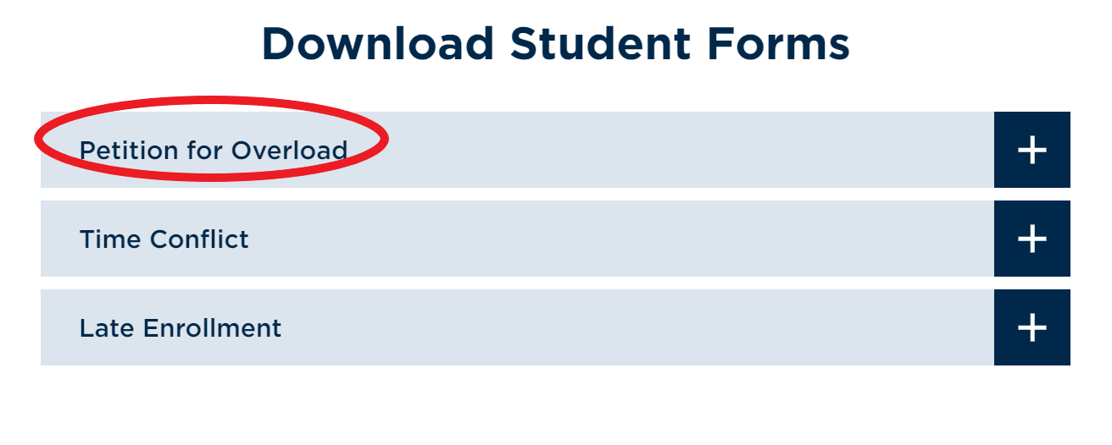

Students will be prompted to sign in with their MSU Denver NetID and password.

Overload Form – Instructions Page
The first page of the form includes information about requesting an Overload and when signatures are needed.

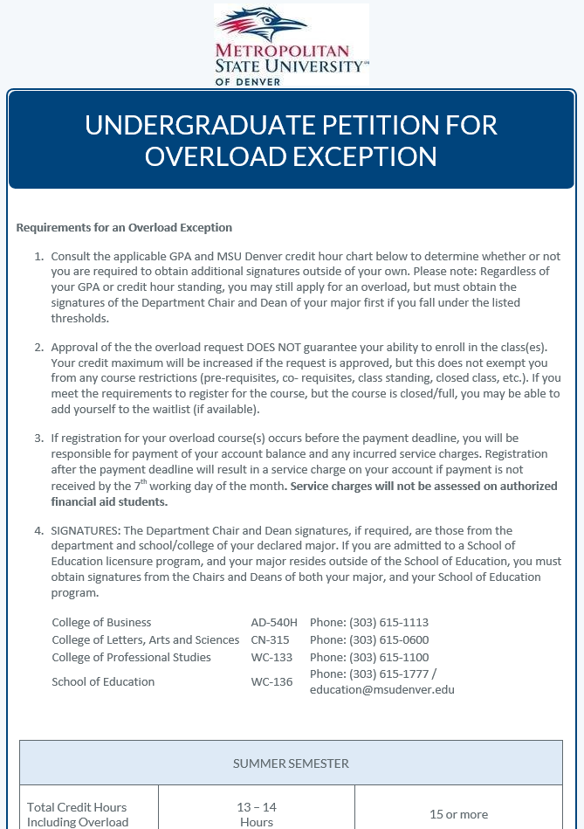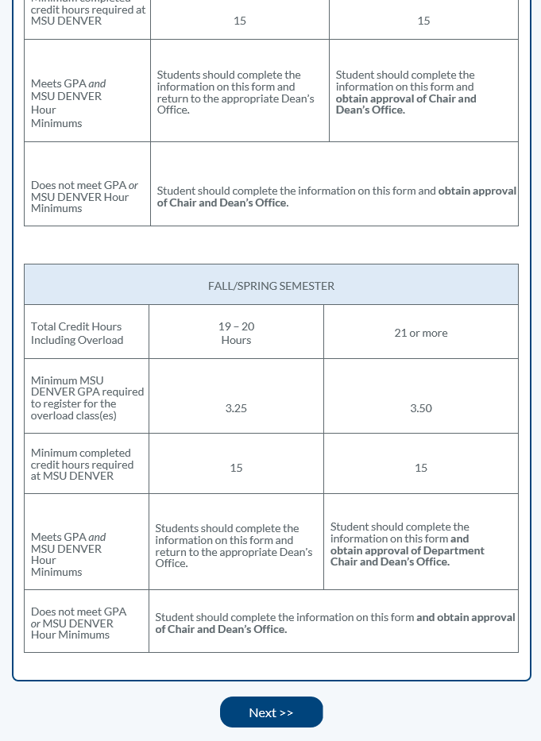

Clicking ‘Next’ takes the student to the next page of the form.
Students will then be prompted to provide the following required and optional information. (Note: This is the same general requested information and approval path as the previous paper Overload Form.)

Overload Form - Requested Information
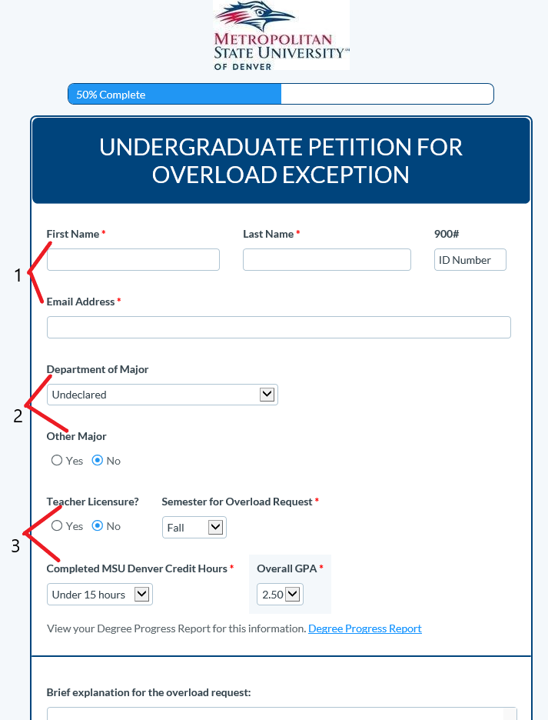

1) Student Information
- First and Last Name
- Student ID Number (900/901#)
- Student’s MSU Denver E-mail Address

2) Major Information
- Department of Major. This determines who will review and approve the request. Select Major Department from dropdown menu. This will pop up a second dropdown menu for Major Program.
- Other Major. If you have more than one major, select Yes. This will pop up an additional dropdown menu for major. Select the department over your second major.

3) GPA and Other Information
- Teacher Licensure. Select ‘Yes’ if you have been accepted into a Teacher Licensure program at MSU Denver. This will include the School of Education in the approval of the Overload request.
- Semester for Overload Request. Select the semester (Fall/Spring/Summer) for which you are requesting an Overload.
- Completed MSU Denver Credit Hours. Select total credit hours completed at MSU Denver from the dropdown menu - either ‘Over 15 Hours’ or ‘Under 15 Hours’.
- Overall GPA. Select your overall cumulative GPA at MSU Denver from the dropdown menu. The overall GPA can be found on the Degree Progress Report. Click link to go to the Student Hub and access the Degree Progress Report.

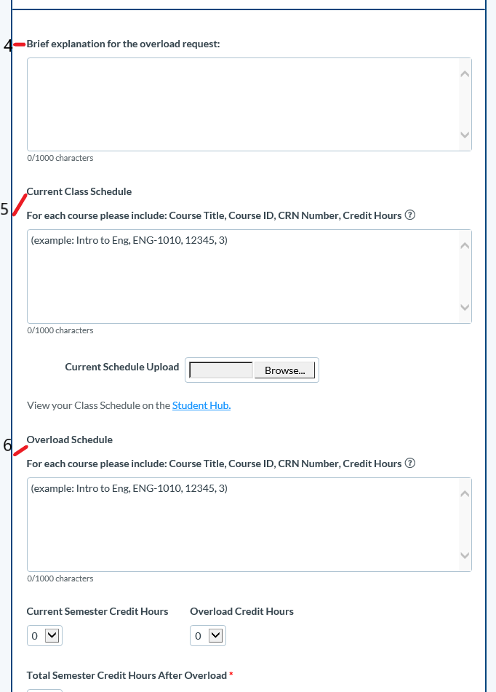

4) Brief Explanation for The Overload Request. Provide a brief written explanation for why you are requesting an Overload.

5) Current Class Schedule. Provide a list of the classes you have already registered for (or will be registering for) during the requested semester. Please include the following class information for each course:
Example: Intro to Biology, BIO-1010, CRN-31234, 3cr
You can also attach a copy of your schedule from the Student Hub using the upload link provided.

6) Overload Schedule. Provide the course information for the class or classes you need to add which will take you past 18 credits (or past 12 credits for summer).

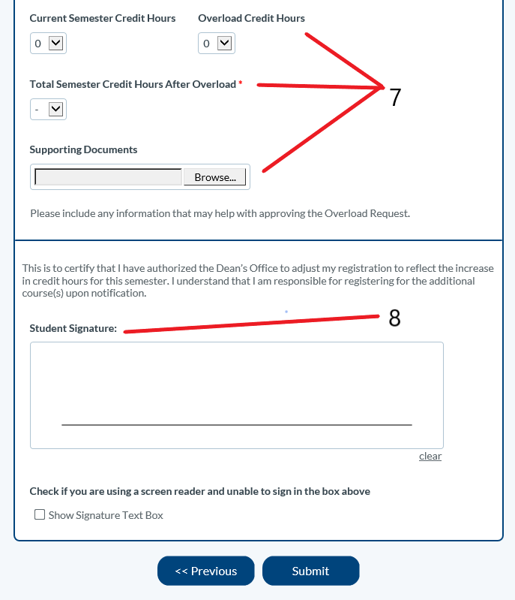

7) Credit Hours
Provide the following credit hour and overload information by selecting from the dropdown menus:
- Current Semester Credit Hours. Select the number of credit hours for which you have already registered (or intend to register up to 18 or 12 credits).
- Overload Credit Hours. Select the number of total credits of the class or classes that will create the Overload.
- Total Semester Credit Hours After Overload. Select the total credit hours you are requesting, including the overload class(es).

8) Student Signature (required)
Sign the form by using your mouse. If you are using a screen reader, check the box below to bring up the ADA compliant signature text box.

Submit Form
Once the form has been completed and reviewed, click the submit button. This will generate a ‘Success’ page confirming that the form has been submitted
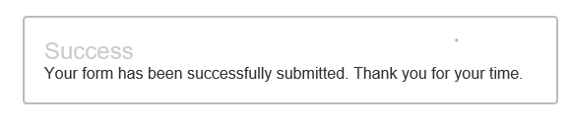

Generates Student Notification
After submitting the request, the student will receive a notification e-mailed to their MSU Denver account confirming that the request has been submitted and will be reviewed. The e-mail repeats the information provided by the student for their review and records. The e-mail indicates that the student will receive a confirmation once the request has been processed.

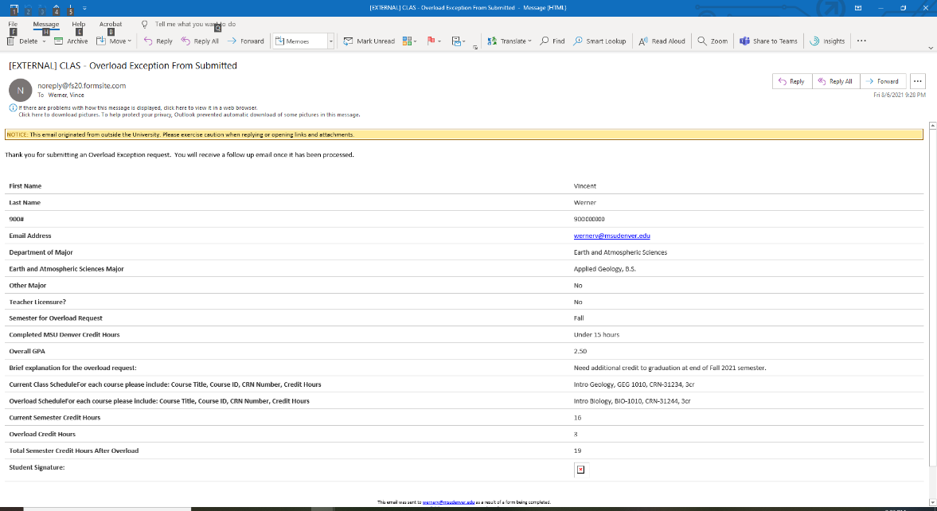

Email to Chair for Review and Decision
The system will also automatically route an e-mail to the chair of the department over the student’s Major (as provided by the student). This email shows the student’s ID information and repeats the student’s answers from the online overload form.

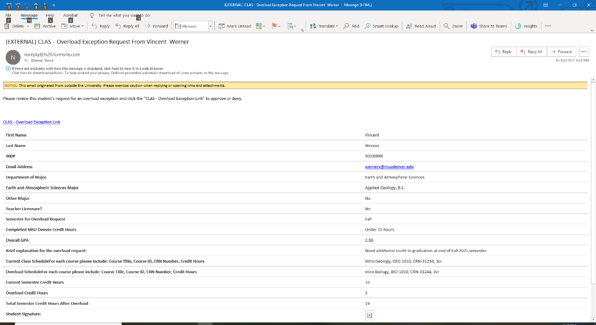
Select Link
Chair’s will see a link on their e-mail reading:
CLAS - Overload Exceptions Link
Click this link.

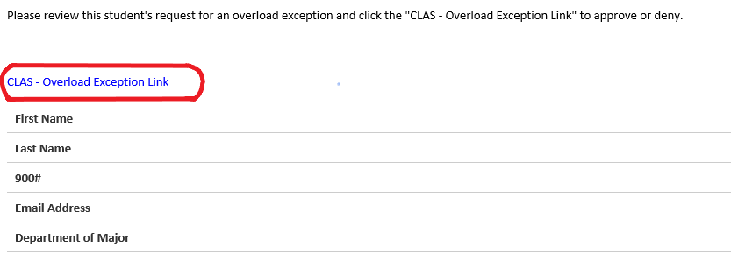

Department Approval of Overload Request (Chair’s Approval Box)
Clicking the CLAS – Overload Exception Link will open the Chair’s Approval page. This page will display a copy of the actual form the student had submitted and includes a Chair’s Approval box at the bottom of the page (see example below). The previous comments section will normally be blank, unless the form is being re-routed from the Dean’s Office.

This box will allow you to Approve or Deny the request and provide comments. You can also select Request Office Review to forward the request to the CLAS Dean’s Office due to misrouting to the wrong department (i.e., your department is not over the student’s major), scenario or policy related questions, etc.

Click the ‘Submit’ button to forward the request to the CLAS Dean’s Office. Your response and comments will be seen by the next reviewer.

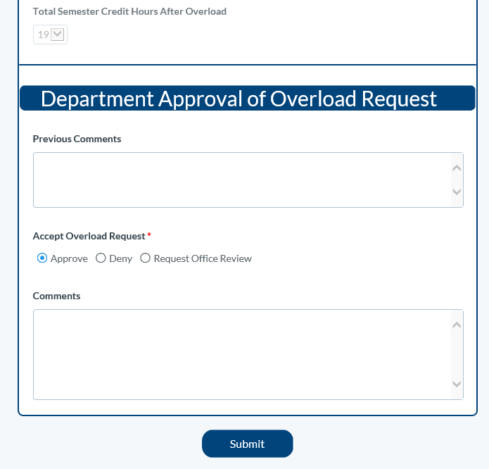

Next Steps
Dean’s Office Review
After submitting the Department Approval page, the request will be forwarded to the CLAS Dean’s Office for review by the department staff and Associate Dean.

When Additional Information is Needed
If further information is needed, the Associate Dean will re-route the request to the student or department. Students will receive an e-mail they can reply to. Department chairs will receive a new notification allowing them to click on the link and provide additional comments.

Completion and Notification
Once the review process is completed, the Dean’s Office will notify the student by e-mail to let them know that the request has been approved or denied. If approved, the Dean’s Office will increase the student’s maximum hours in Banner and notify the student that they are free to register for the Overload course(s).

