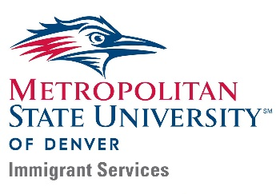
Frequently Asked Questions about DACA
(for Employers)

What is DACA?
Meeting specific criteria, Deferred Action for Childhood Arrivals (DACA) is an American immigration policy that allows certain undocumented immigrants who were brought to the country as minors to receive a renewable, one-year work permit and, potentially, deferral of deportation. Currently, 640,000 undocumented individuals successfully had their DACA applications accepted, 1.32M in total are eligible (Migration Policy Institute, March 2020). The criteria for DACA are:
- under the age of 31 as of June 15, 2012 and came to the United States before reaching 16th birthday;
- Continuously resided in the United States since June 15, 2007, up to the present time;
- Physically present without lawful in the United States on June 15, 2012, and at the time of making your request for consideration of deferred action with USCIS;
- Currently in school, have graduated or obtained a certificate of completion from high school, have obtained a general education development (GED) certificate, or are an honorably discharged veteran
- Not been convicted of a felony, significant misdemeanor, or three or more other misdemeanors, and do not otherwise pose a threat to national security or public safety.

DACA renewals must be filed 4-5 months before the end of each 1-year period, and cost $495.00.
Recent updates to DACA (as of Oct. 2021)
- A court ruling in July 2021 held that the DACA program is unlawful, but allows DACA to continue for current participants, who can still renew their status every two years
- The federal government filed an appeal to this ruling on Sept. 5, 2021; to stay up to date on this and other development, refer to organizations like NILC: https://www.nilc.org/issues/daca/
- New applications are not being processed
- The Biden administration in 2021 is likely to attempt to provide DACA recipient an option to purse stable immigration status (“American Dream and Promise Act”)
- Advance Parole (a travel permit that allows return into the U.S. for DACA recipients) is only available in rare
situations (“urgent humanitarian reasons or significant public benefit”)
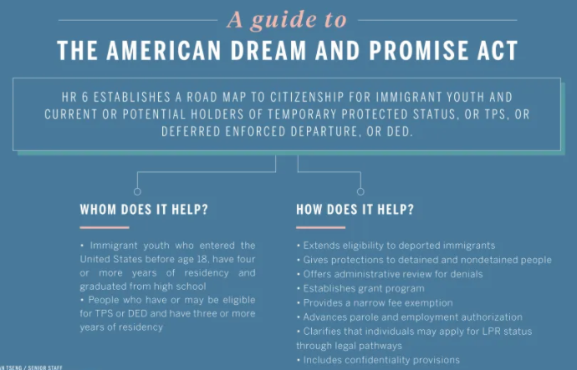

How is DACA different from being “undocumented” – what can one do with DACA status?
Individuals with DACA status have lawful presence in the U.S. for the duration of their DACA status and can:

- Be legally employed in the U.S. (passing E-Verify)
- Use their SSN for background checks, to build a credit, apply for loans, etc.
- Receive driver’s licenses in some states, including CO
- Receive professional licenses

DACA recipients are not eligible for most federal benefits or public assistance programs, such as FAFSA, SNAP, Section 8 housing, and many more (despite paying same taxes).
What about professional licenses?
In 2021, SB21-077 removed the verification of lawful presence from the state’s credentialing process for most professional licenses. Therefore, immigration status is not a barrier to professional licenses.
Do employers have to sponsor a person with DACA status?
No. DACA is different from traditional employment-based immigration. In the traditional case, an employer would petition for an immigrant to join or transfer to a company/organization in the U.S., allowing the employee to receive an H1B visa. However, no such sponsorship is required under DACA, and there is no financial obligation on the part of the employer. DACA recipients are legally eligible to work in the U.S. after they obtain their Employment Authorization Document (EAD). The status is renewable, and DACA individuals are highly motivated and personally invested to maintain their status.
Why doesn’t an undocumented person just apply for permanent residency?
For many individuals who lack family ties to lawful permanent residents or U.S. citizens, or who do not have an employer willing to sponsor them for an employment visa, there are few, if any, paths to citizenship. Even marrying a U.S. citizen or lawful permanent resident does not necessarily guarantee that the individual will meet all the requirements necessary to be approved for a green card.
Is the employer liable if an employee’s DACA status lapses?
DACA is not an employer-driven benefit – it is the benefit of the employee, not the employer. Therefore, an unaddressed lapse itself is not violating a law, but the resulting situation – employing an individual without proper employment authorization – could violate federal labor laws.
More specifically, an HR department, as part of its I-9 verification process, must re-verify if the employment eligibility status has lapsed, and if the employee has obtained a new employment authorization document. It is best practice to do this in regular intervals before employment eligibility lapses. There are many organizations that do this 120 days prior, 30 days prior, and 5 days prior to lapse, but that is merely a recommendation. It is punishable by law, however, to retain an employee whose eligibility to work in the U.S. has lapsed. Employers in CO should already have a system to re-verify for temporary social security numbers, and most do. Thus, it is the HR department’s duty to follow up with non-permanent work authorizations as part of I-9 verification. If an HR department does not have a process in place, then it is recommended to implement one.

Are employers required by law to track an employee’s DACA status?
As per the above, employers are de facto required to track non-permanent work authorizations, although only in as far as employing an individual without proper authorization violates federal and state law. Tracking itself is not required by law – but tracking will avoid violation of any such laws.
More information on pre-employment questions regarding employment eligibility or immigration status can be found on the website for the U.S. Equal Employment Opportunity Commission.
What can employers do to show that they are open to hiring employees with DACA status?
Data and common sense clearly show that workers with DACA status are as keen on maintaining their precarious legal status as any individual is to avoid complications or loss of income. To show that your organization is interested in hiring talented, legally eligible workers, job postings could include a disclaimer such as, “We do not discriminate based on [the usual protected categories] or employment eligibility as prescribed under DACA” or “We are proud to hire workers from diverse backgrounds, regardless of race, gender identity, or type of work authorization.”
Employers also stand to benefit immensely from hiring multi-cultural, multi-lingual staff – position descriptions (and compensation!) should reflect that your organization values such important skills and competencies!

Why is it important to understand DACA?
For MSU Denver, it is our mission to not only provide a high-quality, accessible, and enriching education to our diverse student population, but also to engage the community in the sharing of knowledge and scholarly activity. With an estimated 200-300 students on campus, MSU Denver recognizes its role must go beyond providing access to higher education, and ensure our students have the support needed to succeed and graduate. This includes developing their professional skills and helping to minimize potential employment barriers through education. Our Colorado community is diverse and developing an understanding of DACA and the qualities a DACA intern or employee can bring to the workplace, helps our employers have accurate information regarding the potential talent pool in order to truly hire the best qualified people.

Questions? Please contact MSU Denver’s Immigrant Services Program at (303) 605-5390, or gmieder@msudenver.edu. We may also be able to connect you to immigrant support organizations such as the Colorado Immigrant Rights Coalition for more information and guidance.
For questions about employer relations, please contact MSU Denver’s Industry Partnerships, at (303) 615-0643

