Guide & Tips for Completing the
Colorado Application for State Financial Aid

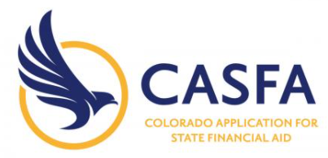

CASFA application link:
https://cdhe.colorado.gov/students/preparing-for-college/colorado-application-for-state-financial-aid
Abbreviated link:
http://bit.ly/3n56IU6

With helpful tips for
2022/23 CASFA

Content
1. What is the CASFA?
2. FAFSA vs. CASFA – who should complete what?
3. When should I complete the CASFA?
4. What kind of financial aid can I receive by completing the CASFA?
5. CASFA materials checklist
6. Helpful tips for completing the 2021/22 CASFA application
7. Step-by-step overview of application
8. Next steps after the application
DISCLAIMER:
This guide was created by the Metropolitan State University of Denver and is intended to help you complete the Colorado Application for State Financial Aid. THE INFORMATION IN THIS GUIDE IS NOT LEGALLY BINDING AND WILL CHANGE OVER TIME OR BE OUT-OF-DATE. For the most up-to-date information on CAFSA, please contact your school’s Financial Aid Office, the offices listed on the first page of this guide, or the Colorado Department of Higher Education (https://cdhe.colorado.gov/).

Are you a current or future student at MSU who needs help with CASFA or this guide? Please contact:
Office of Financial Aid
Karlett Aurora Eguiluz, keguiluz@msudenver.edu
Immigrant Services Program
Gregor Mieder, gmieder@msudenver.edu; Pablo C. Nieto pachavira@msudenver.edu
Gender Institute for Teaching & Advocacy
Soj Sirivanchai, ssirivan@msudenver.edu
Scholarship Support & Retention
Lauren Koppel, lkoppel@msudenver.edu; Jasmine Villalobos-Valles, jvillal7@msudenver.edu

If you are not a current or future student at MSU, for help with the CASFA or this guide, please contact:
Gregor Mieder, gmieder@msudenver.edu; Lauren Koppel, lkoppel@msudenver.edu

1. What is the CASFA?
CASFA is a web-based statewide financial application for Colorado’s college, community college, or trade school students who are not eligible to receive federal financial assistance. The CASFA helps your school and the state of Colorado in deciding how much financial aid a student is eligible for, and is an important step in applying for financial aid or work-study (which provides funding for students with work authorization to work on campus).
More information is also available through the Colorado Department of Higher Education, here: https://cdhe.colorado.gov/students/preparing-for-college/colorado-application-for-state-financial-aid

2. CASFA or FAFSA – who should complete what?
You will complete either the CASFA or the FAFSA, but not both. Students should complete the CAFSA if they are not eligible to receive financial help towards higher education from the federal government. More information is available here: www.studentaid.gov/understand-aid/eligibility.
In most situations, international, DACA-status, or undocumented students will complete the CASFA, but not the FAFSA, to apply for financial aid or workstudy.

The following graphic, provided by the U.S. Department of Higher Education, shows which students should complete the FAFSA, not the CASFA.
Immigration-based FAFSA eligibility (U.S. Dept. of Higher Education)
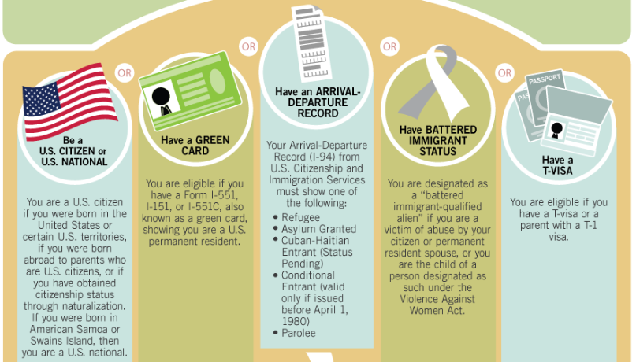

(Image source: https://studentaid.gov/sites/default/files/eligibility.png)
The previous image shows that students should complete the FAFSA if their immigration status classifies them as:
- U.S. Citizens
- Green Card holders (=permanent residents)
- Approved Refugee/Asylee status, pre-April 1st 1980 Conditional Entrant, or Cuban-Haitian Entrant
- Battered immigrant-qualified alien as a victim of abuse by citizen/permanent residents spouse, or child of such a designated person
- T-visa recipient, or child of a parent with a T-visa
If you are not sure about your situation or eligibility for FAFSA/CASFA, reach out to some of the offices listed on page 2.

3. When should I complete the CASFA?
The CASFA will be available each year during the fall semester (usually October 1 or later), a year prior to receiving aid/starting the school year. So you need to apply early! In other words, to apply for financial assistance for the 2022/23 school year (fall ’22, spring ’23, and summer ‘23), the application will be available starting October 1, 2021.
The form can be completed year-round, but early completion is highly recommended to be considered for the maximum amount financial assistance. (March 1st is the priority deadline at MSU Denver.)

4. What kind of financial aid can I receive by completing the CASFA?
CASFA is an application for state financial aid (such as the Colorado Student Grant) and state-funded work study (which allows students with work-authorization to work on campus and earn financial assistance that way). Students who are eligible to receive in-state tuition at a Colorado college or trade school under the ASSET state law will most likely be eligible for state financial aid. More information on ASSET or in-state tuition is available here: https://www.ciccoloradoasset.org/.
Current or future college student who are ineligible for financial assistance through FAFSA (see section 2) should still complete the CASFA because many schools, including MSU Denver, offer institutional or donor-funded scholarships, and out-of-state students might be eligible for those even if they do not qualify for in-state tuition or state financial aid. Some information about MSU Denver’s institutional scholarships can be found: https://msudenverprod.wpengine.com/financial-aid/scholarships/

5. CASFA materials checklist
Before completing the CASFA, it is helpful to review & complete these steps:
5.1. Find your federal income tax returns from two years ago
For example, if you are using the CASFA to apply for financial aid for the 2022/23 school year, then you will need 2020 tax returns to complete the CASFA.
If you are a dependent student (which is, among other factors, based on age or marital status), then your parents’ tax return will be needed as well. Independent students will only use a federal tax return for themselves and their spouse, if married. The CASFA application automatically determines whether you are a dependent or independent student based on your responses.
You will not upload your tax returns to the CASFA portal, but your school’s Financial Aid Office may ask for copies.
5.2 What if I or my parents did not file taxes?
You can complete the CASFA even if you or your parents did not file taxes. If you or your parents did not file taxes, then your school may ask for a “Letter of Non-Filing” from the www.irs.gov website or other documentation.
5.3 Selective Service registration
Males between 18 and 25 years of age must register for Selective Service (also known as ”the draft”) to receive financial aid. CASFA will ask whether you have registered with the Selective Service, and your school might verify your registration as well. (Although registration is required, there has not been a draft in many decades.) All registration information provided to Selective Service is confidential, private, and protected and regulated by law, and the registration process is quick and simple. The Registrar’s Office at MSU Denver is a good resource for questions about Selective Service and will receive your verification of registration: https://www.msudenver.edu/registrar/
You can register, check an existing registration, or request proof of registration here: https://www.sss.gov/register/ If you do not have a Social Security Number – which is common for international, visa, or undocumented students – then a paper form is available at any United States Postal office. This form can be, and often is, mailed to Selective Service without a Social Security Number. A printable version of the form is also available here: https://www.sss.gov/wp-content/uploads/2020/03/RegForm1.pdf.

6. Helpful tips for completing the 2022/23 CASFA application
The tips below address some areas of confusion, especially for the 2022/23 CASFA application that became available on October 1, 2021. For the most up-to-date information on CAFSA, please contact your school’s Financial Aid Office or the Colorado Department of Higher Education (www.cdhe.colorado.gov/).
Some helpful tips for completing the 2022/23 CASFA
- This may get fixed soon, but the information in the income section referencing specific line numbers on a standard 1040 are not correct
- The application uses “skip logic”, meaning that some sections and questions will appear or disappear based on previous responses
- The fields asking student for Social Security or ITIN Number can be left blank; for parents, CASFA asks to enter all zeros instead of leaving it blank; do not use somebody else’s Social Security Number
- Some Spanish-language items may not exactly match the English text!
- In the application, the term “legal residency” refers to living in Colorado permanently, not immigration status
- If you made a mistake and CASFA needs to be updated or corrected, it is best to create a new account and complete a new application – the Office of Financial Aid at MSU Denver will review the most recent version
- If your or your household’s income information has changed since taxes were filed, then you should work directly with the Office of Financial Aid to update your household’s income
- You check with your Financial Aid Office to see whether your school has received the CASFA
- CASFA and the College Opportunity Fund are separate application – make sure to apply for COF as well (https://cof.college-assist.org/)
- The CASFA can take some time to complete – please set aside at least 45 minutes!
- Read each section carefully and answer as accurately as you can; important tips are listed alongside each questions
- As you complete the CAFSA, make sure you are in a private environment to safeguard the information that you enter for each question

CASFA & Confidentiality
Due to immigration status, it can feel intimidating to provide information about you or your family. Strict federal law, such as FERPA, regulates and protects all data that you provide here. Furthermore, CASFA is used by students and parents with a variety of immigration or visa statuses, or by parents who live outside the U.S. Not providing a SSN or ITIN therefore does not indicate a specific immigration status. Be sure to read every section closely and answer as accurately as possible.

Additional tips can be found in section 7 (below) as we review each section of the CASFA application.
7. Step-by-step overview of application
This part of the guide reviews each section of the 2020/21 online CASFA application, providing screenshots and helpful tips. If additional questions come up, please refer to offices listed on the first page of this guide for further advice or help.

7.1 Screen: “Creating an Account”

Before you can begin completing the CASFA you will need to create an account. Follow the below steps to create your CASFA account information. Once you have created a profile you will use the same information each year. Save your password and log-in information somewhere that you can refer to later.

As a first time user, click the “Create Your Account” button to begin.
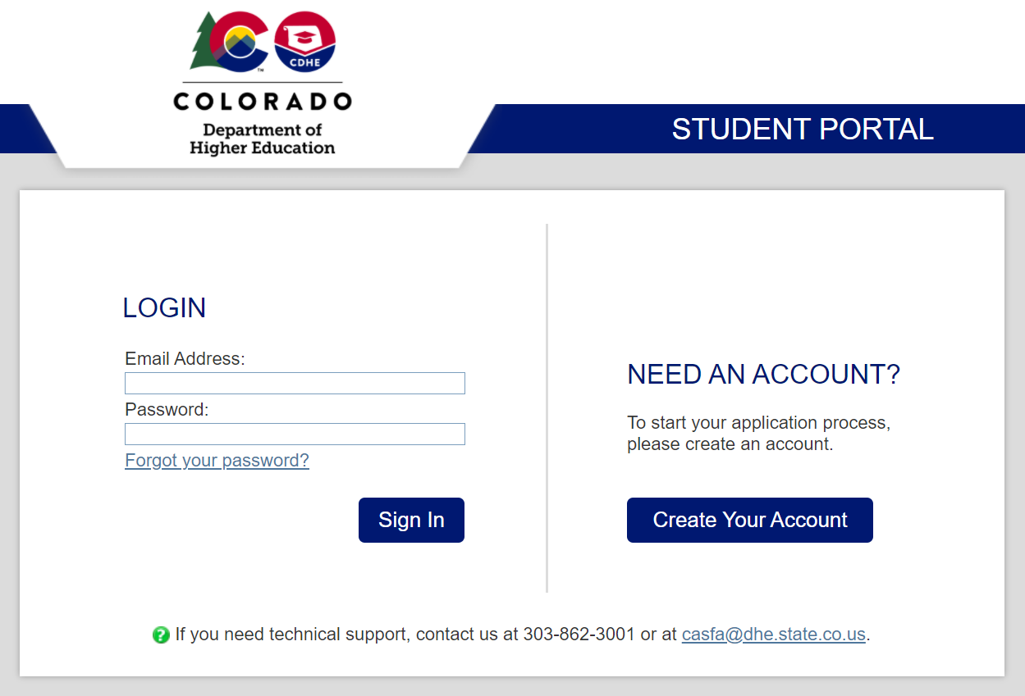

The next question verifies that you are ineligible for the Free Application for Federal Student Aid (FAFSA). The reason for this is only students who are ineligible to use the FAFSA are asked to complete the CASFA. You will select “no”.
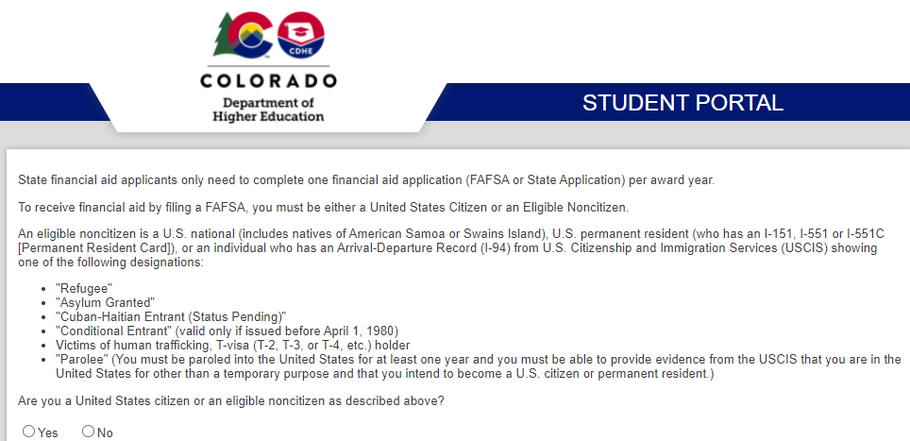

The information below is a checklist for what you will need to complete the CASFA.

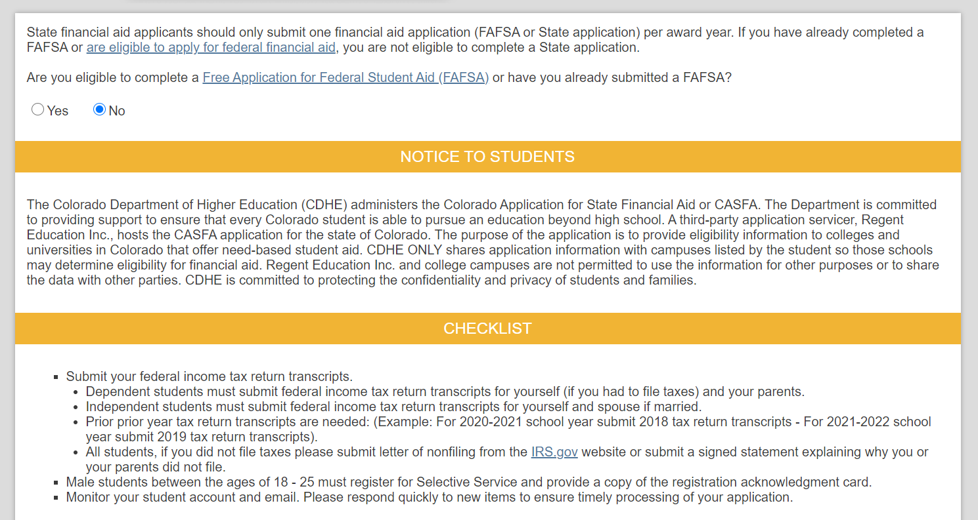

You will type in your email address and create a password. It is best to use your personal email account rather than your school account.

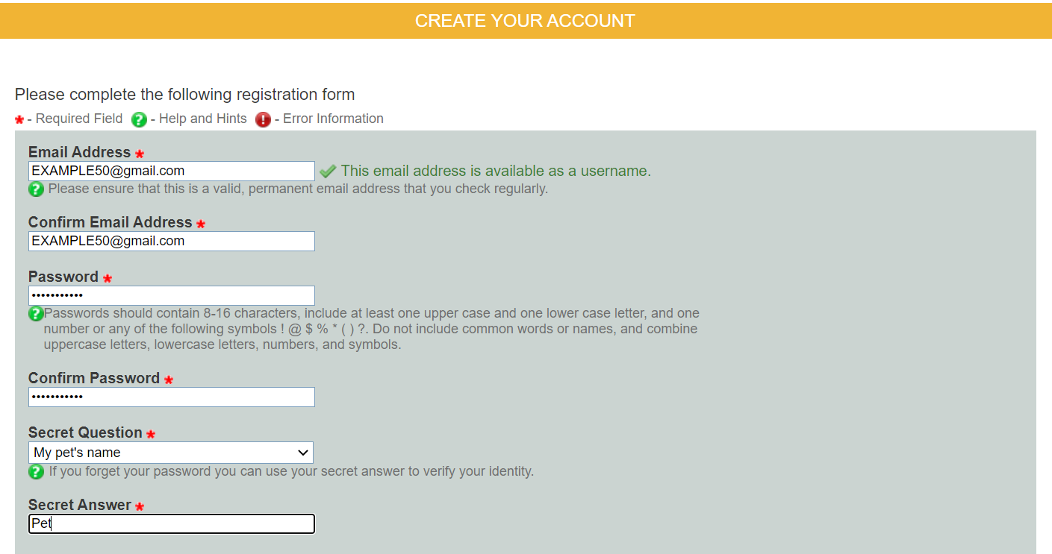

Type your full legal name, date of birth, and SSN or ITIN. If you do not have an SSN or ITIN, do not worry. You can leave this section blank.

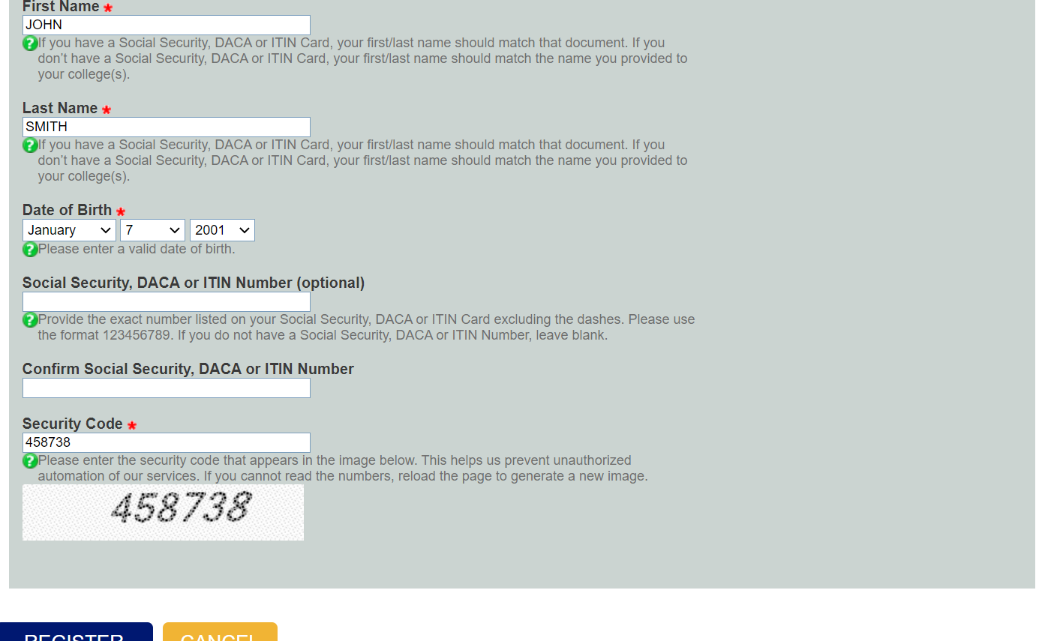

Now that you have finished these steps, you can begin your application. Click the small blue button on the right hand side under “Actions” to start.

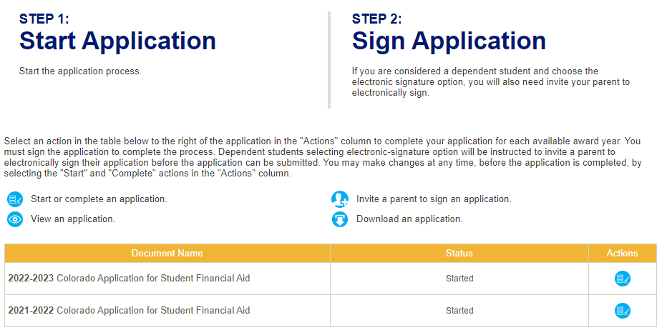

7.2 Screen: “Student Demographics”

In the “student demographic selection”, you will provide your personal information. (In the question about “gender”, the only choices are “male” or “female” as assigned at birth, and selecting “male” will lead to additional questions about Selective Service. MSU Denver recognizes that this is not an inclusive design, and future versions of the CASFA might provide more options.)

For the student demographic screen, provide first, middle, and fast name exactly as it appears on your DACA, Social Security, or ITIN card. Also, you are asked to provide gender and marital status. If you are married and later separated, you are still considered married unless that state legally separates you.

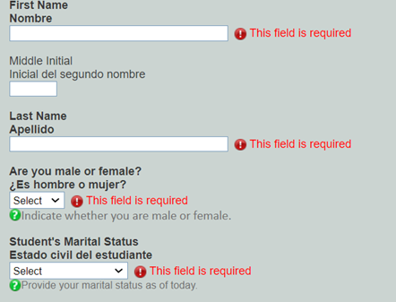

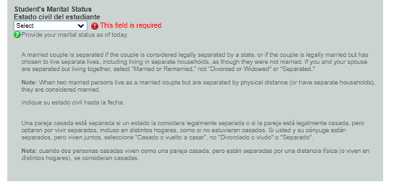

Provide date of birth.

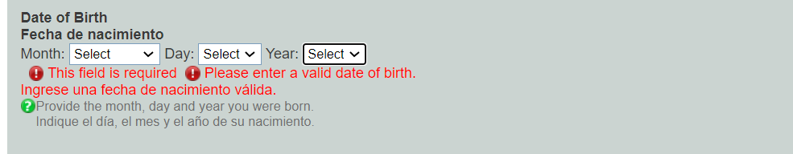

Next, you will provide Driver’s License information (if available) as well as Social Security or ITIN number. This field can be left blank if the applicant cannot provide this information.

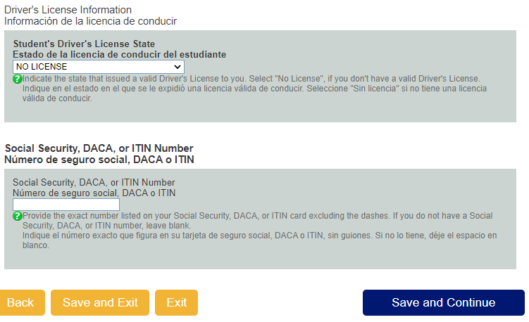

Next, you will provide your mailing address, residency information, and contact information; please note the term “legal residency of this state” refers to living in Colorado permanently, not immigration status!

In the final screen for “Student Demographics”, you will be asked about prior drug convictions and – for students who selected the “male” option earlier – whether you have registered for Selective Service. To learn more about Selective Service and how to register, please refer to section 5.3 above.

7.3 State Information

In this section, you will provide information about your high school.

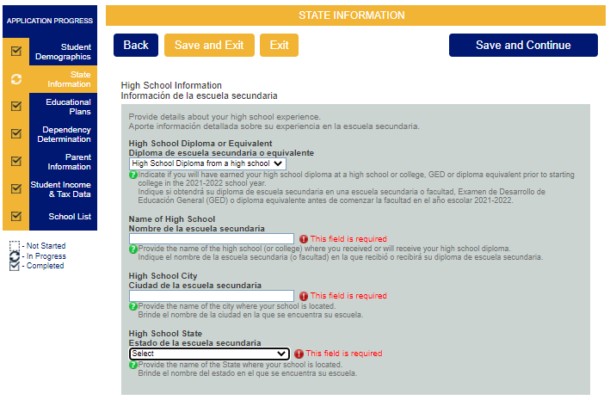

CASFA also provides you with information about in-state tuition eligibility, and if you meet the listed criteria, you should certify that you meet the conditions. (For example, international students will commonly choose “I will not meet...”) Either options will let you complete & submit the CASFA.

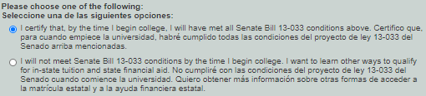

If you select “I certify that...”, you are then also asked to certify that you have applied or – when possible – will apply for lawful presence. It is important to check that box in order to be eligible for state financial aid.

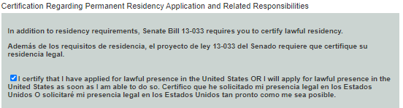

7.4 Educational Plans

In this section, as seen in image 1, you provide information about your year in college (the year for which you are applying for financial aid, so fall 2021/spring 2022) and the degree you are seeking.

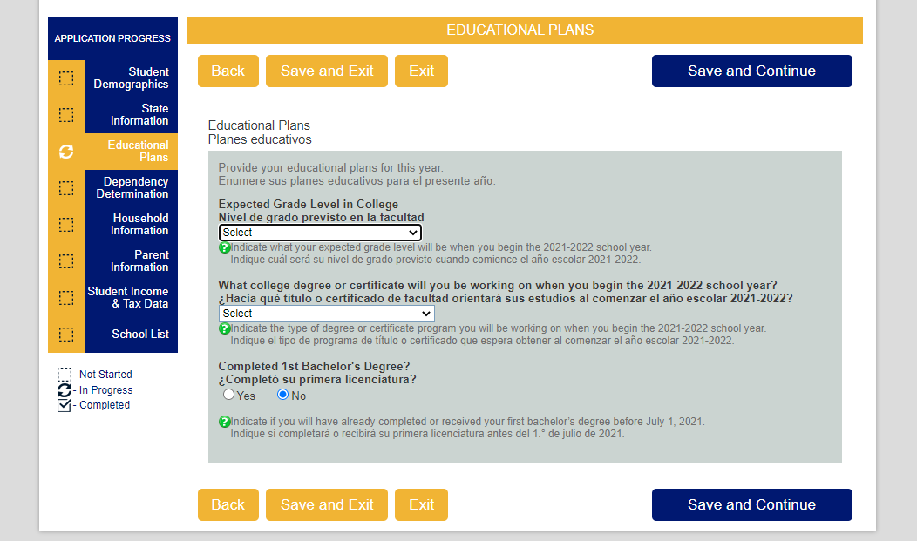

As seen in image 2, CASFA will ask a question about what grade you expect to be in college. This is an estimate - so if you’re between grades, that's okay. (For example, 0-30 credits = Freshmen, 31-60 credits = Sophomore, 61-90 credits = Junior, 91+ credits = Senior)
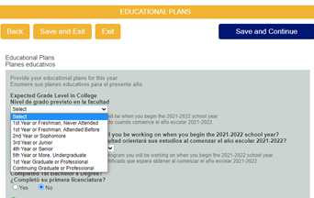

As seen in Image 3, you will next provide information about what degree or certificate you are working on. Associates degrees are most often available at community colleges.

As seen in image 4, you’ll next indicate if you'll receive your first bachelor’s degree before the start of the next school year. *Seniors - read this carefully as you may be applying for aid for graduate school (Master’s, Doctoral degrees) for the 2021/22 school year and will have your first degree for the next school year.

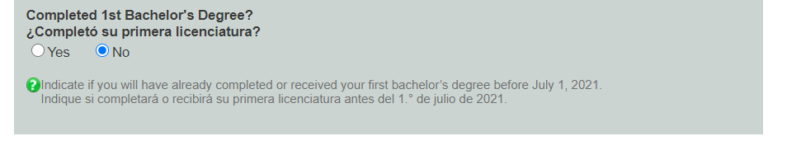
7.5 Dependency Determination

In this screen, the portal will determine whether you are a dependent or
independent student – this is based on specific criteria determined by CASFA, not you.
Per federal regulation, who claims you on their taxes is irrelevant information for financial aid purposes. Students commonly will move out and support themselves however this alone is not means for a dependency override. You are and will remain considered as dependent of your parents for financial aid purposes until the age of 24.
No documents are needed here; answering “no” on all questions will most likely mean that you will be classified as a dependent student, requiring parents’ income information.

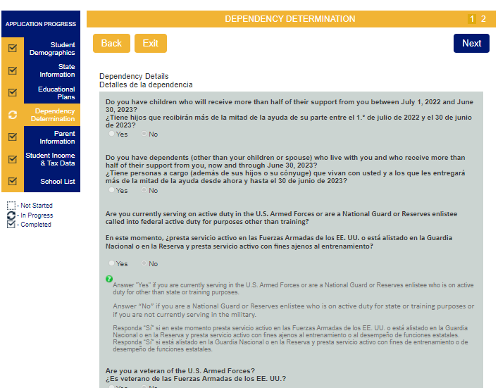

If you are determined to be dependent, then you will be asked to provide parent information. If – in the “Special Circumstances” section – you choose “I will be unable to provide parent information on this application due to special circumstances”, then MSU’s Financial Aid Office will ask for additional information.
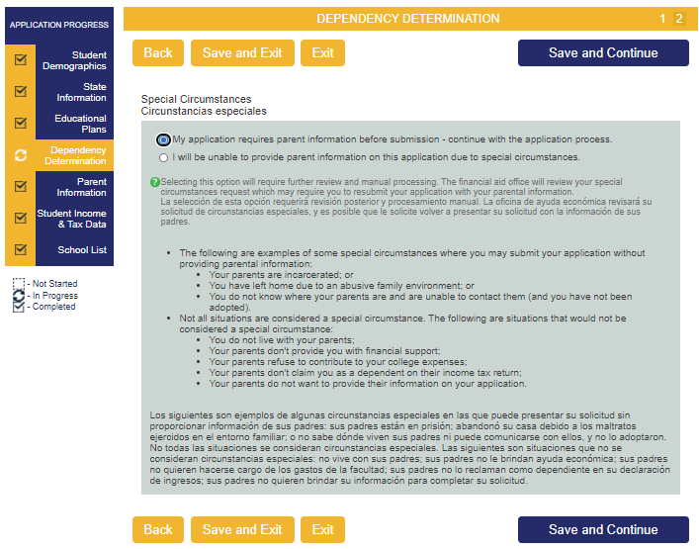

CASFA & Confidentiality
Due to immigration status, it can feel intimidating to provide information about you or your family. Strict federal law, such as FERPA, regulates and protects all data that you provide here. Furthermore, CASFA is used by students and parents with a variety of immigration or visa statuses, or by parents who live outside the U.S. Not providing a SSN or ITIN therefore does not indicate a specific immigration status. Be sure to read every section closely and answer as accurately as possible.

7.6 Parent Information

The “Parent Information” screen will show up only if you were classified as a dependent student. (For independent students, the screen “Student Information” will collect similar information about the household of which you are a part.) Here, you will provide information about marital status, date of marriage/divorce/separation, and household size. Follow closely the description provided for who is and is not part of your household! Make sure to include yourself in both numbers. No documents are needed here.

Please note that the Social Security Number field for parents cannot be left blank – enter all zeroes if no SSN is available.
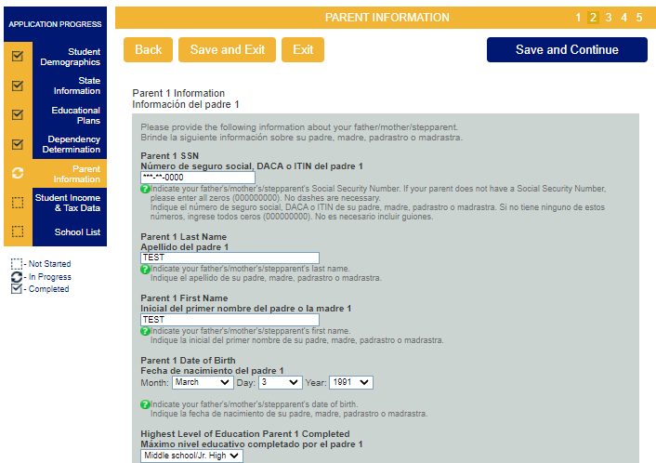

The parents’ email address and state of residency (=where the parent lives permanently) are also needed.

Next, you will be asked to enter Parents’ 2020 Income Tax & income information including tax return status, what type of tax return was filed, the Adjusted Gross Income (AGI), and income taxes paid. (If you are classified as an independent student, then you will provide this information only about your own household, not your parents’ household; dependent students will provide this information about themselves and their parents.) Be sure to read every section closely and answer as accurately as possible and refer to the offices listed on page two for help, if needed. Please note that currently, the line numbers referenced in the income sections do not currently seem to match line numbers on a standard 1040 tax return.
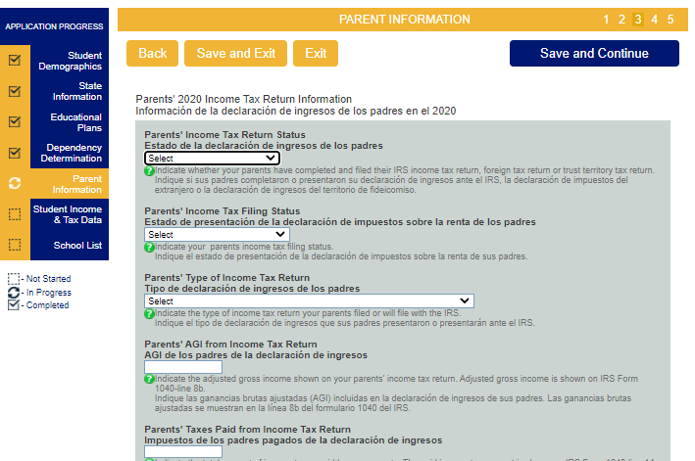

7.7 Student Income Information & Tax Data

The following image is the first page of the CASFA Student Income & Tax Data. Be sure to read every section closely and answer as accurately as possible and refer to the offices listed on page two for help, if needed. If you were classified as a dependent student, then this section will look familiar – you just provided the same information for your parents.)
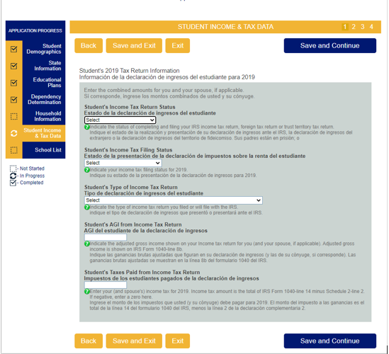

The first question asks about the Student’s Income Tax Return Status, and you have three answers to choose from: “Already Completed and Filed”, “Will File”, or “Will Not File”.
Answering “Already Completed and Filed” or “Will File” will require answers to the remaining questions. Answering “Will Not File” will remove the rest of the questions and move you to the next section. (You will still be required to provide income information for the year 2020.)
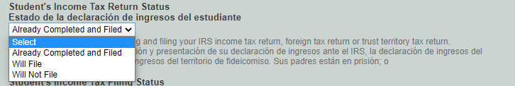
Now you will answer the Student’s Income Tax Filing Status, you have six options to choose from. “Single”, “Head of Household”, “Married- Filed Joint Return”, “Married- Filed Separate Return”, “Qualifying Widow(er)”, and “Don’t know”.
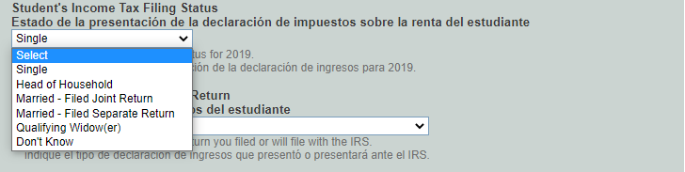

Now you will answer the Student’s Type of Income Tax Return, you have three options to choose from: “IRS 1040”, “Foreign tax return, IRS 1040-NR or IRS 1040NR-EZ”, or “A Tax return with Puerto Rico, another US Territory, or Freely Associated State”. (For most individuals, the “standard” tax return is the IRS 1040 – the top left corner of your federal tax return lists the type.)
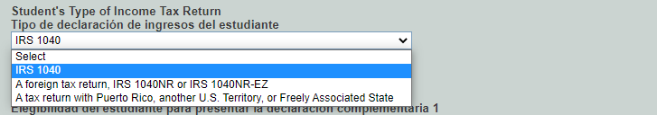

Now you will select whether you did or did not file a Schedule 1 form.
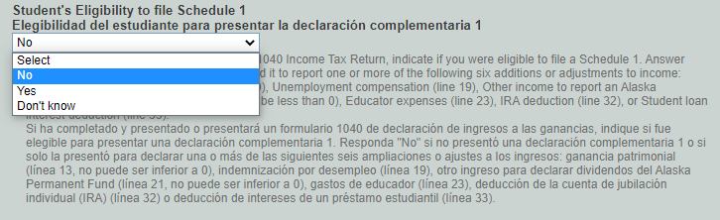

This is what the Schedule 1 form looks like. If you cannot find it in your tax documents, you likely did not complete it.

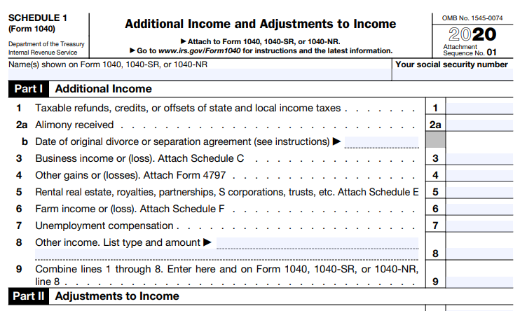

Now, you will provide the amounts for both your “Adjusted Gross Income (AGI)” and “Taxes Paid from Income”. Your AGI is the total income before taxes paid. Your “Taxes Paid from Income” is the amount of taxes paid on the amount above. Note, these two boxes cannot be the same amount. Please note that currently, the line numbers referenced in the income sections do not currently seem to match line numbers on a standard 1040 tax return.

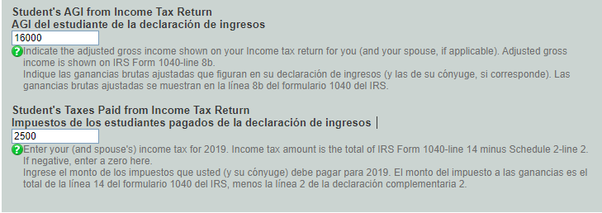

Last, you will need to provide your “Income Earned”. This amount is what you earned after taxes, and you will be asked to provide this information even if you stated that you will not file taxes (on the previous screen). It is possible that MSU’s Office of Financial Aid will ask for documentation for your 2020 income – wage statements, W2s, letters from employers, etc.

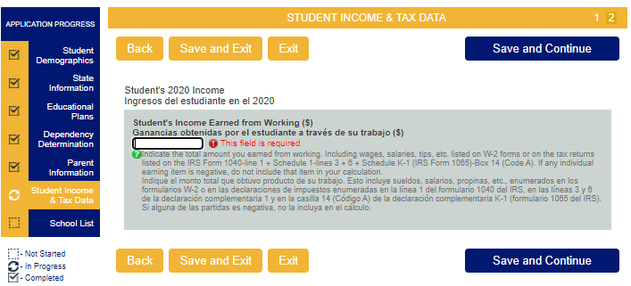

7.8 School Selection

On this page, you will select to which school(s) which you might attend during the 2022/23 school year. Once you have selected a school and a housing plan, you will get the option to add another school. You can add up to 10 schools to your list. Once you are done, select “Save and Continue”.

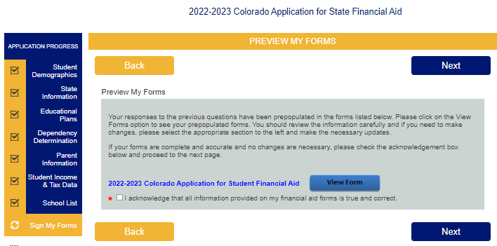
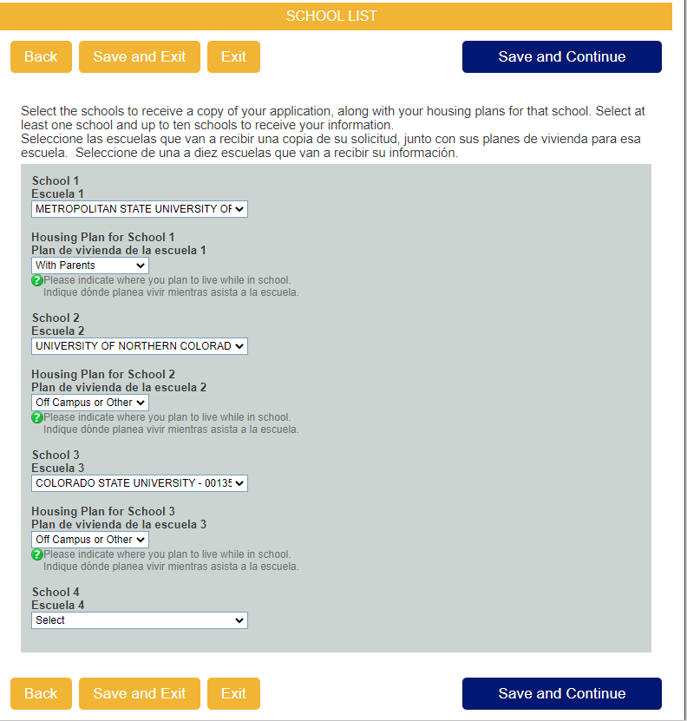

7.9 Signing & Submitting the Application

You are almost done! In this section, you will review the answers you have provided to confirm they are correct. Click “View Forms” to open a new tab with your information.

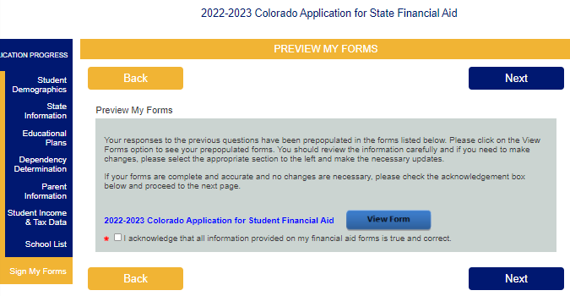

Read through the preview document and if you notice any errors, go back and update it in your CASFA. If your information looks correct, then save it on your computer.
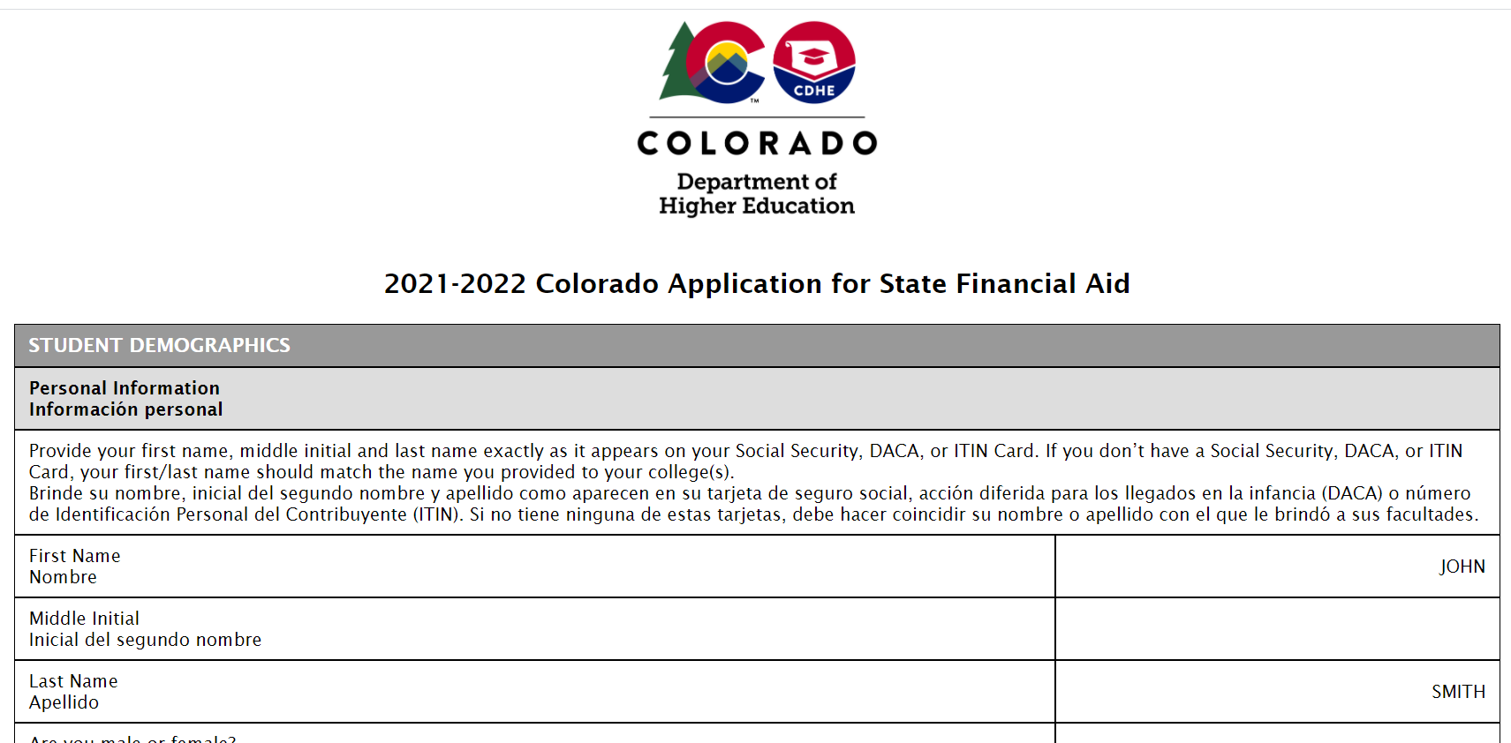

To save click the “print” button.
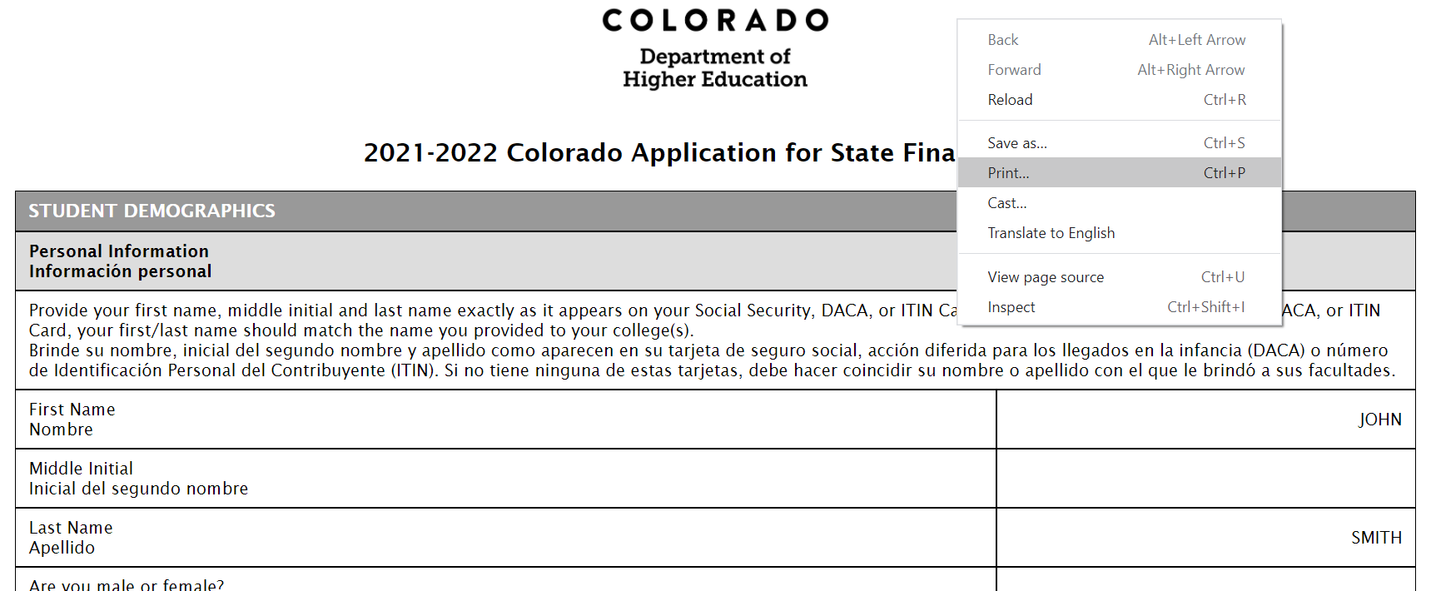
Then click the drop down in the Destination box. Select Save as PDF and save in a safe place on your computer. If you are a member of a scholarship program, you can use this copy to send to your advisor to show you have completed your CASFA.
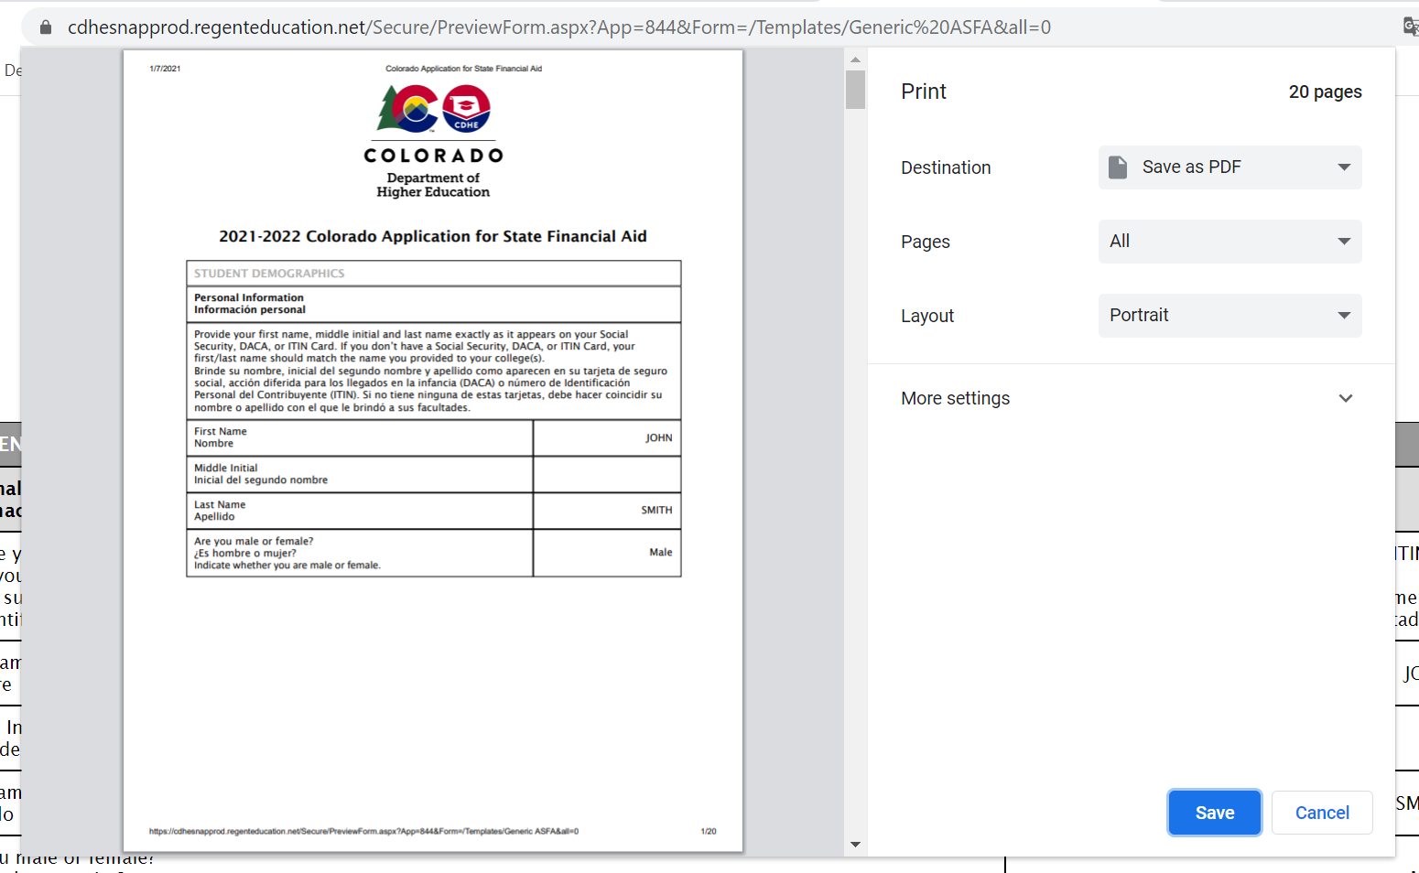
Once you save the information on your computer and confirmed materials are correct, click the box “I acknowledge that all information provided on my financial aid forms is true and correct”. Then click “Next”.
On the following screen, you will be asked to give permission to use your electronic signature. If you do not consent to the electronic signature, then you will have to send in your signature by mail.
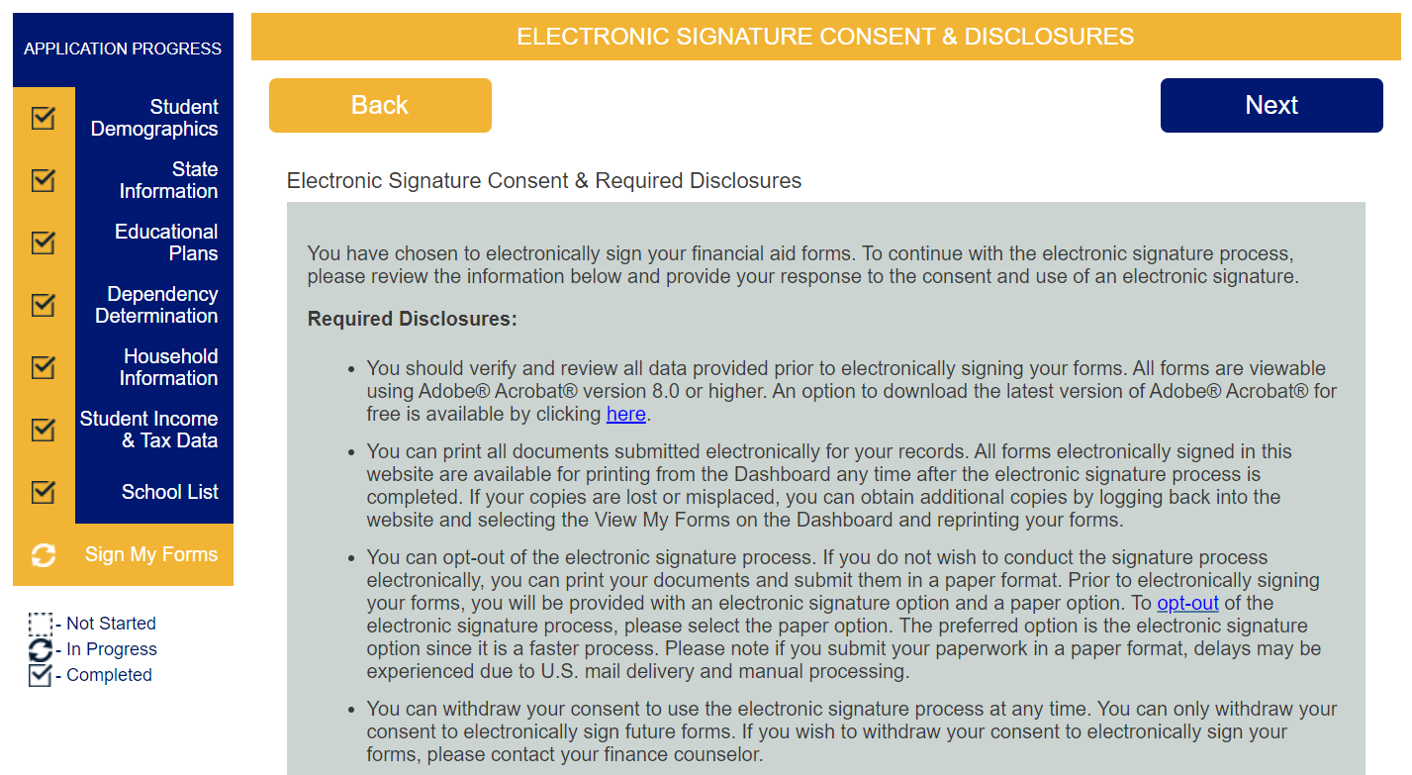

If you choose “I DO NOT consent to the use of an electronic signature option”, then you will be taken to a separate screen to download, print, sign, and mail in the signature page for you and – if you are a dependent student – your parents.
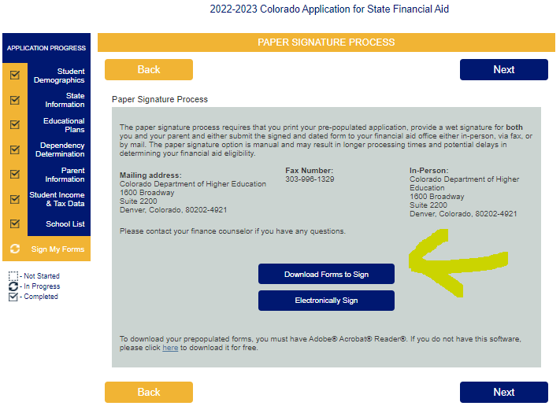

If you have chosen the (recommended!) option to electronically sign your CASFA, then you will be asked to type in your first & last name and the password you created.
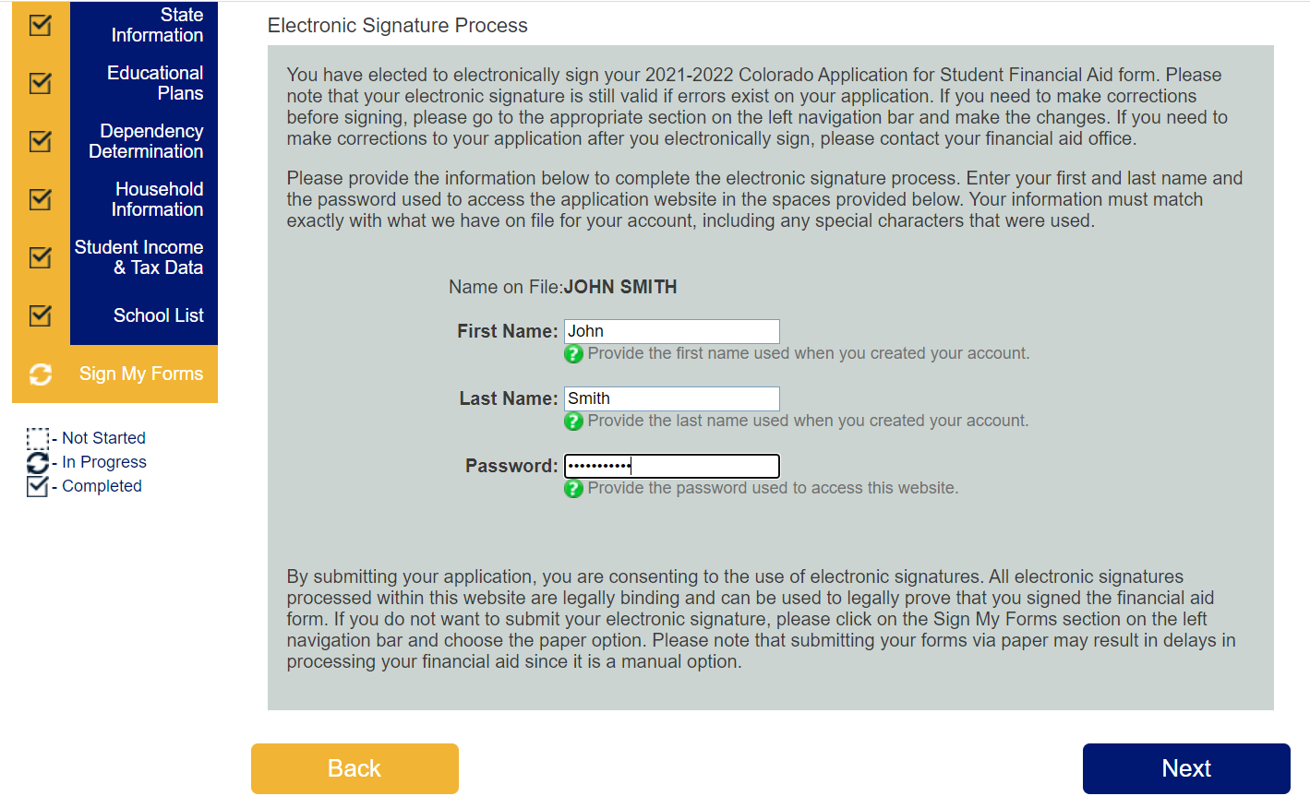
If your parents’ electronic signature is required, then after your signature, you will be returned to the “Actions” column on the portal page, where you will need to select "Choose Parent". This will send an e-mail to your parent to complete the e-signature process.

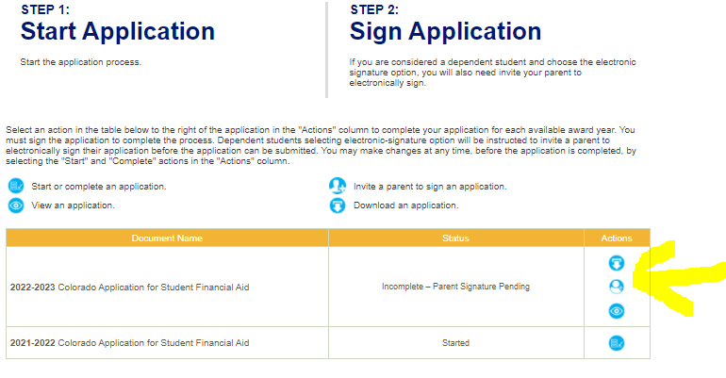

IMPORTANT: If you or your parent needs to make corrections before signing, please go to the appropriate section on the left navigation bar and make the changes. If you and your parent have already electronically signed the application and you need to make corrections to your application, please contact the MSU Denver Office of Financial Aid, and/or resubmit a new CASFA.

You’re done

8. Next steps after the application
8.1 Complete the general scholarship application
Once you have completed the CASFA, it is important to complete the General Scholarship Application (www.msudenver.edu/financial-aid/scholarships/) to be considered for institutional or donor-funded scholarships.
8.2 Sign up for Raise.Me
Incoming students should look to see if they’re eligible for scholarships through Raise.Me. Raise.Me is a way to earn micro-scholarships based on your high school and community college achievements. Check qualifications here. If you have questions about the Raise.Me scholarship reach out to your admissions counselor. You can find your MSU Denver admissions counselor here.
8.3 Meet with Immigrant Services Program
We recommend that students completing the CASFA also meet with the Immigrant Services Program to review off-campus scholarship opportunities such as LAEF, Latinas First, or Dream.US – additional applications will be necessary for those! Appointments with Immigrant Services Program staff are available here:
https://outlook.office365.com/owa/calendar/ImmigrantServicesProgramAriadna@msudenver.onmicrosoft.com/bookings/
8.3 Make sure to complete COF (or check whether COF is applied to your account)
The College Opportunity Fund (COF) is a state benefit available to students classified as in-state for tuition purposes, and as of January 2021, this state benefit provides $40 towards each college credit. (So, for 12 credits, COF would provide $480 towards tuition & fees.) You can apply for COF here: https://cof.college-assist.org/ and you can also contact the offices listed on the second page of this guide for help with completing COF. A social security number is not required to complete the COF.
Important reminder: DACA students who have a social security number should choose not to provide a social security number so that the Affidavit shows up in the application portal. (A paper version of this Affidavit can also be completed later, if needed. The offices listed on the second page of this guide can provide this affidavit to you.)
8.4 Health insurance waiver
MSU Denver requires that all students either have an Affordable Care Act-approved plan, or to sign up for the Student Health Insurance Plan (SHIP). More information about the requirement or the Student Health Insurance Plan is available here: https://www.msudenver.edu/alp/afteryouvebeenadmitted/msudenverhealthinsurancerequirement/

If you are a DACA-status or undocumented student, then you can meet with Immigrant Services to explore other options. Appointments with Immigrant Services Program staff are available here:

https://outlook.office365.com/owa/calendar/ImmigrantServicesProgramAriadna@msudenver.onmicrosoft.com/bookings/

8.5 Watch your student email closely
You might receive important updates or additional requests for information from the Office of Financial Aid!

