MSU Denver Campus Resources Scavenger Hunt

  - Student Name:________________________________
  - MSU Denver offers many services and resources to support student success. The purpose of this assignment is to help you become familiar with the services.
This assignment has two parts, an electronic scavenger hunt and a physical one. For the electronic part, you will search the MSU Denver web site to find answers to the questions. The physical part involves you going to listed locations and getting an artifact from your visit.

What you’ll turn in:
When you are done, you will put this completed sheet and the artifacts in the manila envelope and turn the envelope in next class period.

Is working in pairs/small groups allowed?
I encourage you to complete this assignment with a partner or in small groups. It’ll be more fun. However, each student must submit their own envelope that contains all of the required artifacts and this sheet completed in their own handwriting.

Part 1. Electronic Scavenger Hunt
  - Please write your answers to the electronic portion of this assignment directly on this sheet. A good starting point is: https://www.msudenver.edu/studenthub/

MSU Denver Writing Center

- List all of the Writing Center locations.

- What is the standard length for a writing center consultation?

- When you make an appointment using the online appointment system a calendar will be displayed. What does it mean when you see a time on the calendar that is colored blue? Hint: Watch the “How to Make an Appointment” video on the Writing Center web page.

- In a sentence or two describe the RIDES program.

MSU Denver Counseling Center
- True or False – An appointment is always necessary to visit the counseling center.

- Name two of the therapy/support groups being offered this semester.

- List the name, time, and date of one of the “Successful Student Series” workshops.

Auraria Library

- True- False: The library offers students free printing of documents.

- True- False: The library offers students free scanning of documents.

- How many group study rooms are available for students to reserve at the library?

- Other than by telephoning, list at least two different ways you can contact the library to get help finding sources?

- List two services you can receive at the Innovation Garage in the library.

Information Technology

- What is the phone number for the IT Helpdesk?

- You can borrow a piece of equipment, such as a laptop or tablet for free. List one location where you would be able to pick up the equipment.

- How many free copies of the Microsoft Office suite can you download to use on your personal (Windows or Mac) computers?

MSU Denver Dean of Students

- What is the only requirement to receive food from the MSU Denver Food Bank?

- True-False: Any MSU Denver student can contact the MSU Conflict Resolution Service to get help addressing conflicts with other students, faculty or staff.

- List one of the resources provided for students who need help finding housing.

Student Employment Portal
- List the department and title of one student employment opportunity

The Tutoring Center
- True or False – An appointment is necessary to visit the tutoring center.

- In the SSB Tutoring Center location, list two Psychology class(es) for which the tutoring center offer tutoring?

- List one general academic skill for which tutoring is available.

- In a sentence, describe what the Reading Support—Beyond Words service is.

Access Center

- True or False – To receive academic accommodations through the Access Center, the student’s instructors must be given all information regarding the student’s disability, including any relevant diagnosis.

Immigrant Services

- List one Immigrant Services event/workshop that will occur this semester, include the date and time.

Financial Aid

- What is the G.P.A. requirement for the Kingdom Enlightenment scholarship (hint: look under Foundation Scholarships)?

- Follow the link on the Financial Aid web site titled “External Scholarships”, follow the “External Scholarship Listing” and describe what how much money is awarded by the Woof Dog scholarship and what the topic of the application is.

- Follow the link on the Financial Aid web site titled “Apply Now”. List one scholarship that is targeted at your major and find one other scholarship that is interesting to you. Name both of the scholarships and indicate the amount of the award.

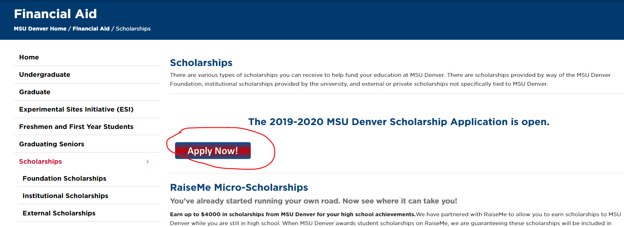

- Follow the “Debt Management” link, then the “financial literacy” link, and then the “Education Cents” links. Name one of the budget worksheets the site provides.

Student Activities: Student Organizations

- Visit their website, follow the “Student Organizations” link, and follow the instructions under “How to Join a Student Organization.” Browse the list of student organizations, find two that are interesting to you, write the names of the organizations and the names of the President of the organizations.

- Click the link for the “Events and Calendars”, look at the Calendar and find one event that will occur next month that looks interesting to you, list its name, a brief description of the event (click the title of the event), the date, the time, and the location of the event.

Part 2. Physical Scavenger Hunt
To complete this portion of the assignment, go to the appropriate places on campus and collect the artifact listed. Place each artifact in the manila envelope to turn in to me. (see campus map https://www.ahec.edu/campus-info/maps )

Office | Location | Artifact
Auraria Library | Auraria Library | A research librarian’s business card
Career Services | AD 270 | A career counselor’s business card and a flyer for an event/service
Writing Center | King Center 415 (main location) or JSSB 201 | Ask the Writing Center to stamp a blank piece of paper. Note: if a stamp is unavailable, pick up a business card or flyer for an event/services
Tutoring Center | JSSB 220 | A tutoring center business card or flyer for an event/services
Campus Recreation | PE/Events Center | Flyer for event/services
Information Technology Walk-In Helpdesk | WC 243 or AD 475 | A business card or flyer for an event/services
LGBTQ Student Resource Center | TV 213 | Flyer for an event/services
Veteran and Military Student Services | TV 215 | A business card or flyer for an event/services

