MSU Denver Production BI Manual

Implementation, Design and Maintenance by:
Business Intelligence and Data Warehouse Team (ITS)

Last Modified: 11/20/2020

If you have any questions, comments, or suggestions
please follow the link to our webpage. You can
request reports and find contact information there.
https://www.msudenver.edu/enterprise-data-warehouse/
Login to SAP Business Objects

LAUNCH PAD

Production Environment URL: https://enterprise-reporting.msudenver.edu/BOE/BI

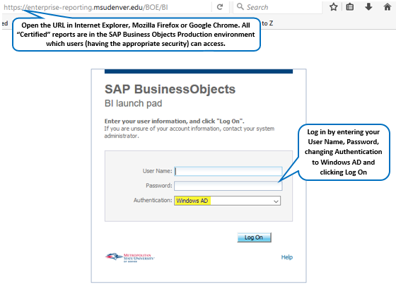

HOME & DOCUMENTS SCREENS

Once you have successfully logged in, this is your Home screen:

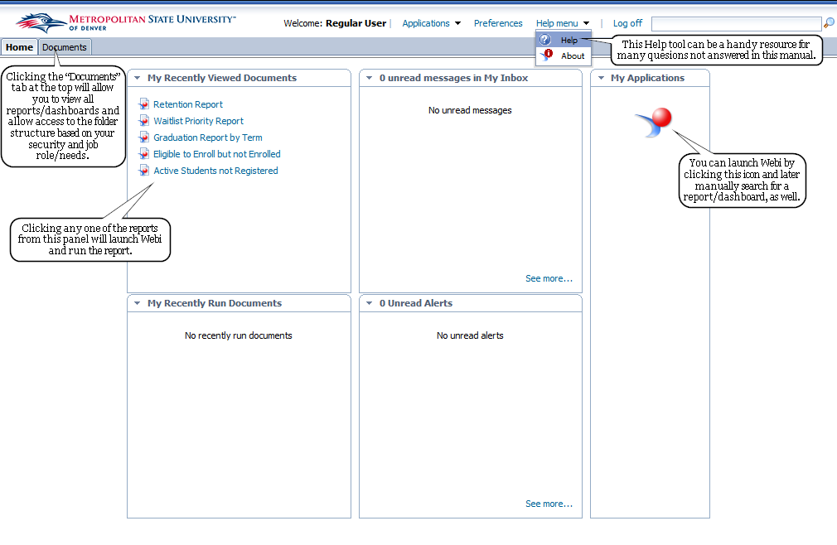

After clicking the “Documents” tab, you will see something like this:
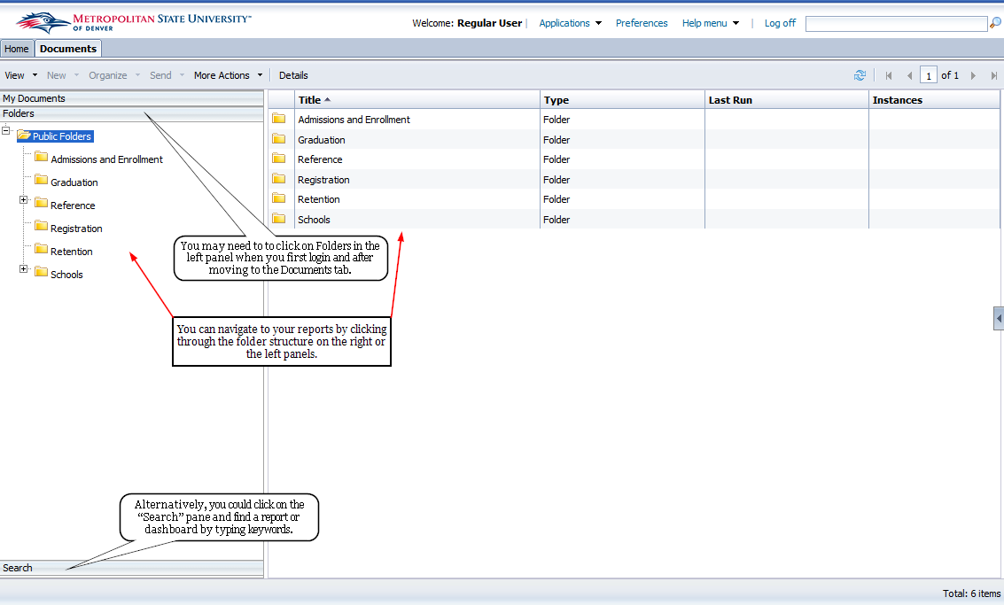

REPORTS
When you run a report it may ask you for a prompt filter. The pop up within the new tab that has opened inside Webi will look like this:
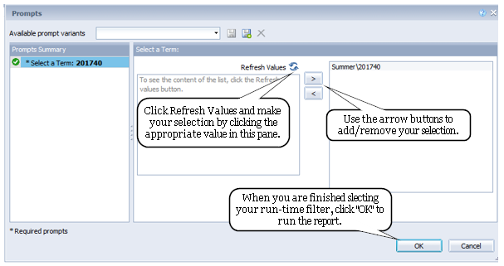
If you wish to change prompt values within the report without re-running it, click the in the far left pane of the Webi interface.
It will change the panel on the left to look like this:
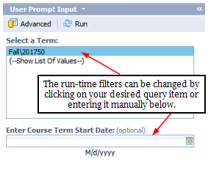
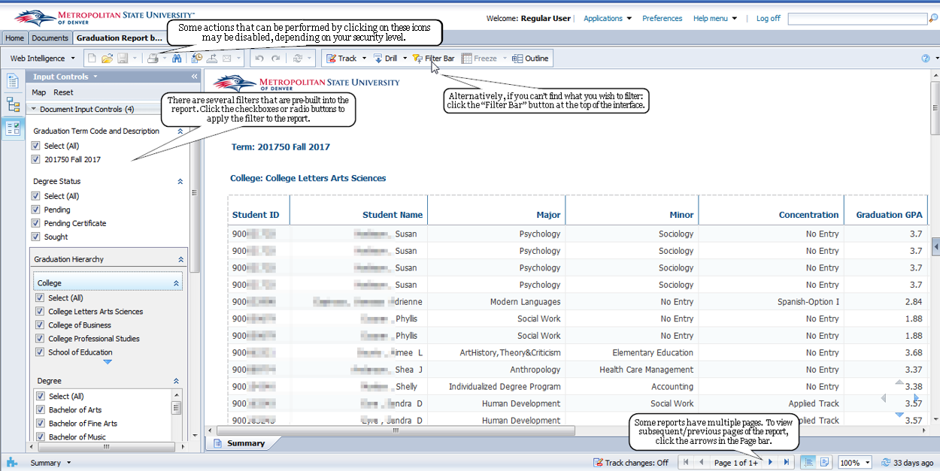

Exporting a document
This icon allows you to export a document to several different formats for further analysis. When you click on this icon it opens up the window below:
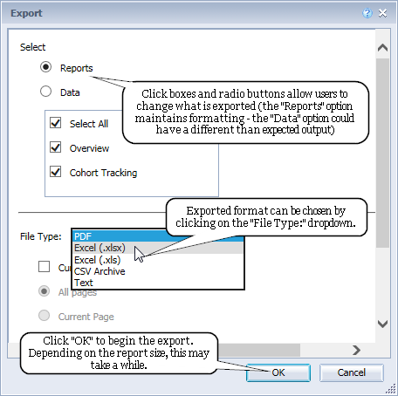
Your browser should allow the option to Open/Save the file once exported.
The PDF file type best retains the formatting of the document (including pagination and headers/footers). The .xlsx format retains pictures, cell design, grouping and breaks, but sometimes merges or shrinks cells/blocks to make files readable in Excel where it may not be expected.

DASHBOARDS
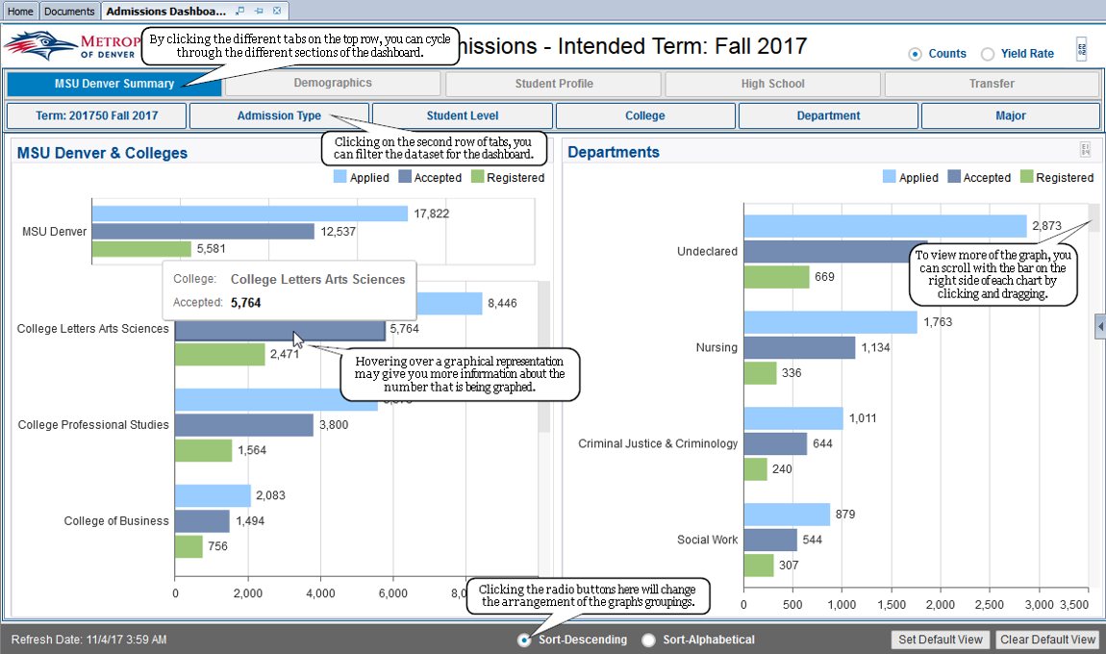

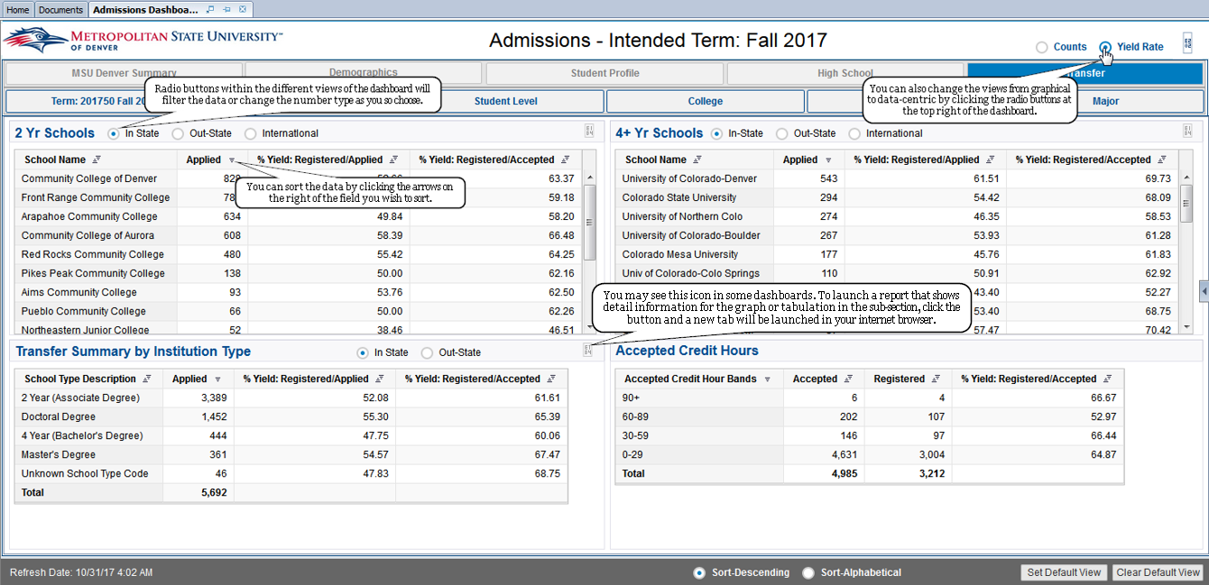

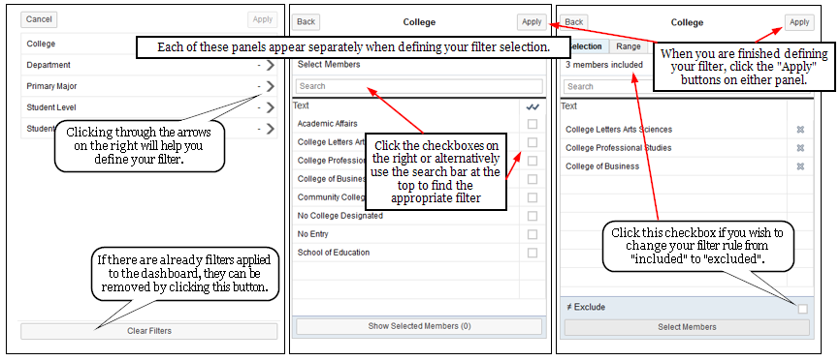

REPORT CATALOGS

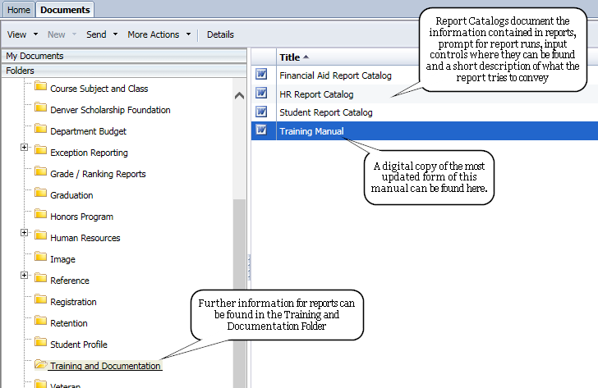
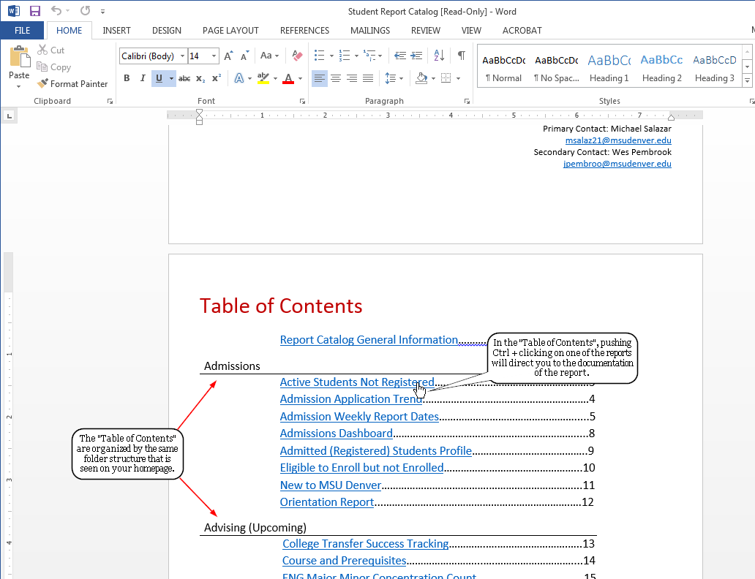

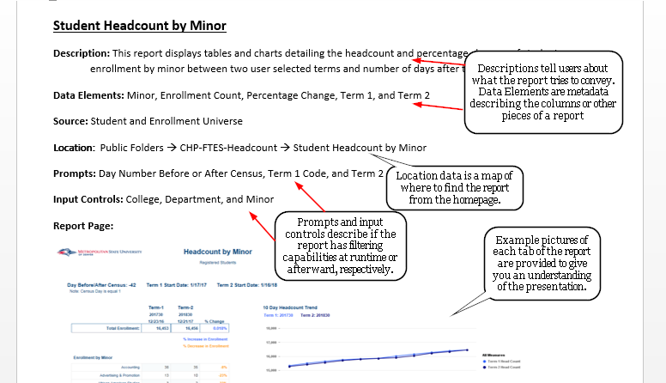

A “Glossary” is also contained at the end of the Report Catalog describing some of the terms used throughout the document.

