Interface of Zoom

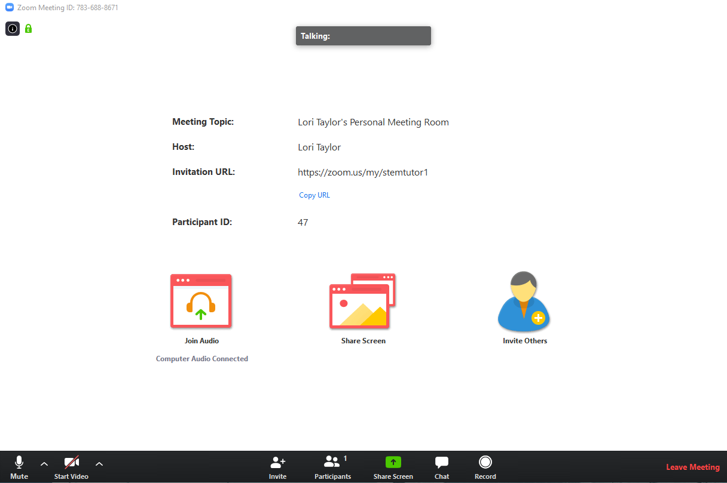
- Microphone icon on the bottom left mutes and unmutes your microphone if you have one.
- Arrow next to the microphone icon allows you to adjust when your audio takes the input and what speakers you want
- Next is the Video button. It allows you to webcam yourself if you want it to.
- The Arrow next to the Video button allows you to adjust your video settings.
- Next is an invite button. This button allows you to send an invite for the meeting to whoever you want.
- Next is the participants button. It will tell you how many people are in the meeting right now.
- Then there the share screen. Pressing it will bring up options to share what is on your screen.
- The chat button will bring up the chat. From there you can chat via text to people.
- The record button is next. At any time you can record your session. Once done recording it will save to your device in a format suited to your device.
- Last button is the leave the meeting. Use it when done with your question/session.

Need help contact Justin Wu:
justinandrewwu@gmail.com
303-706-0265

