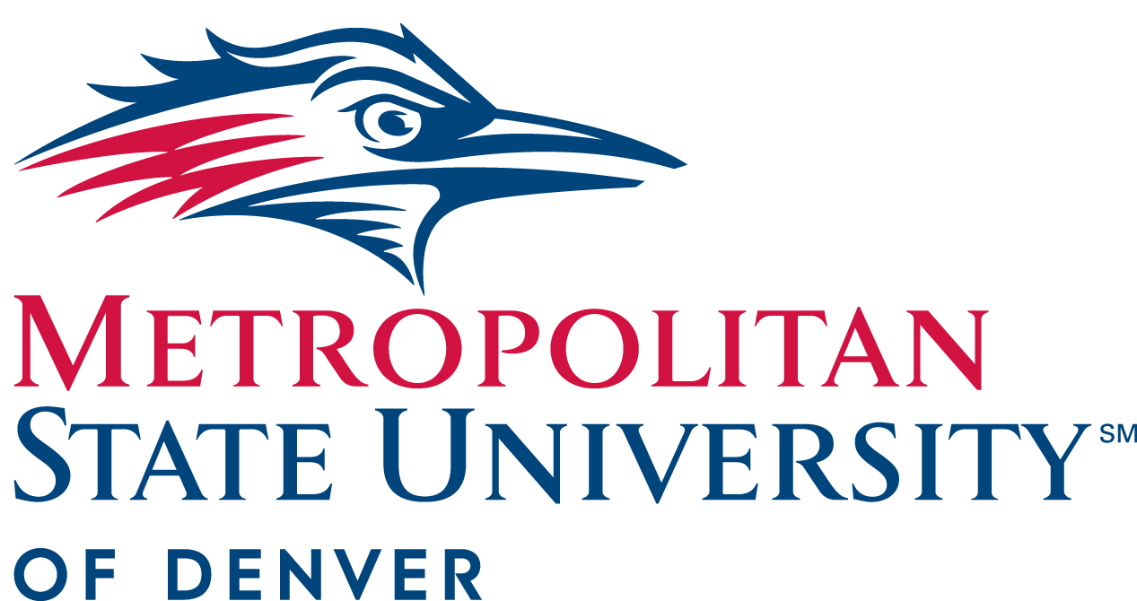

President’s Cabinet Minutes
November 18, 2020
10:00-11:30am

- Approval of October 21, 2020 Minutes

- President’s Update (10:00-10:15)- Dr. Janine Davidson

- Dr. Davidson updates the Cabinet on the Provost search that has been narrowed down to four candidates.
- President’s Team Award- Dr. Davidson Honors the RISE team.
- Updates on COVID-19.
- Updates on plans for the Auraria Campus for the Spring 2021 Semester.
- Dr. Davidson respectfully asks everyone to consider their Thanksgiving plans in relation to the spike in new COVID-19 cases.
- Dr. Davidson emphasizes self-care and mental health awareness in this difficult time.

- President’s Advisory Council Update (10:15-10:35)- Culture and Workplace, John Kietzmann, associate director of Athletics for marketing and promotions / external relations, William Carnes, professor, Department of Management
- Updates from Health Center and HR on Mental health.
- Updates from Staff Senate on Mental Health and encouraging time off.
- What’s next- Campus Climate survey, Engagement and leadership surveys, Additional surveys.
- Highlights current work “still on radar” which includes:
  - Professional & Leadership Development
  - Award and Recognitions
  - Onboarding
  - Making Meaningful Connections

- Round Robin (10:35-Adjournment)

  - Larry Sampler, vice president for Administration and Finance, chief operating officer- COVID updates, Hanover Report.
  - Michael Benitez, vice president, Diversity and Inclusion- Presidential Lecture Series, DEIC / DSP, MLK event, HEDS results
- Mentions Marc Lamont Hill as upcoming guest in Presidential lecture series.

  - Andrew Bonham, chair, Department of Chemistry and Biochemistry- NSTR

  - Cathy Lucas, vice president of Strategy and External Affairs- Strategic Plan, Marchmester campaign planning, core values
- Mentions schedules for Virtual Commencement ceremonies to be held on December 11th.
- Livestream of Commencement will be posted on commencement page.
- 100,000th graduate from MSU Denver will graduate in Fall and be recognized during ceremony.
- Speaker for Commencement events will be Roger Ferguson, CEO of TIAA.

  - David Fine, General Counsel- EO 13950 combating race and sexual stereotyping
- Keys dates to remember in regard to EO 13950 are:
  - November 21st 2020 (takes effect)
  - January 21st 2021 (likely to be rescinded)

  - Christine Marquez-Hudson, vice president and executive director, University Advancement and MSU Denver Foundation- Fundraising update
- Mentions feasibility study for strategic plan.
- Plans to improve database, software and processing development

  - Liz Hinde, dean, School of Education- NSTR

  - Braeden Weart, president, Student Government Assembly- SGA Updates

  - Katia Campbell, president, Faculty Senate- Faculty Senate updates
- Gave a shout out to two committees for their hard work:
  - Faculty Welfare committee
  - Academic policy committee

  - Bill Henry, interim provost and executive vice president of Academic Affairs- Deans searches
- Mentions 8-week courses to be offered in second half of spring semester.

  - Rebecca Reid, president, Staff Senate- Staff Senate updates
- Policy Review Committee working on alternative work arrangements policy.
  - Todd Thurman, director of Athletics- COVID, scrimmages, RMAC competition, community engagement

  - Stacy Dvergsdal, associate vice president of Human Resources- Open enrollment, voluntary retirement, Provost and Dean searches, Recruitment and Appointment policy, payroll system decision memo, student and hourly minimum wage, SB20-205 policy
- Gave a shout out to HR Team making sure everyone has transcripts

  - Kevin Taylor, Chief information officer and associate vice president for Information Technology Services- NSTR

  - Will Simpkins, vice president of Student Affairs – RISE Fund and enrollment updates
- Mentions upcoming hires.
- MSU Denver now on Common App.

