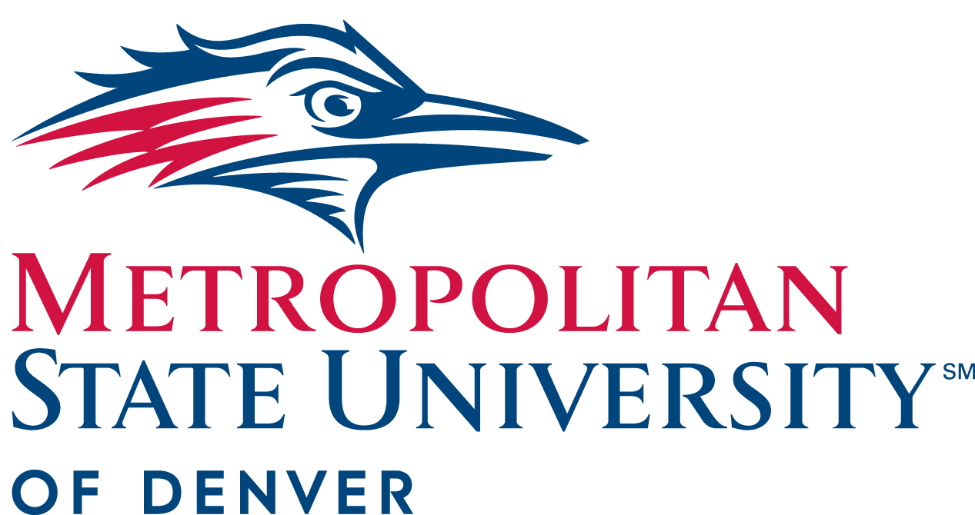

President’s Cabinet Minutes
August 14, 2019
9-10:30am
JSSB 400

- Attendees:
Katia Campbell
David Fine
Vicki Golich
Anthony Grant
Elizabeth Hinde
Danielle Holmes
Catherine Lucas
Larry Sampler
Shaun Shafer
Will Simpkins
Kevin Taylor
Metza Templeton

- Approval of May 8, 2019 Minutes

- President’s Update- Dr. Janine Davidson

  - Welcome back, we would like to introduce our newest members- Danielle Holmes, President of SGA and Katia Campbell, Faculty Senate President.
  - This is the year of the strategic plan; we encourage you to get involved.
  - Thank you to Larry Sampler and Cathy Lucas for the work they did on West classroom. Situation was handled well, and the good news is that the buildings are safe. However, we are working hard to update them, lobbying and looking at the budget. We had two independent analysis with two outside companies- no correlation between the buildings and cancer diagnosis, testing will not be expanded. Reports are on the website, we encourage faculty to send students there, give them as much information as possible so they feel safe returning to classes.

- Enrollment / Budget
  - Will Simpkins, vice president for Student Affairs and Larry Sampler, vice president for Administration and Finance, chief operating officer
    - Current enrollment
      - 3.3% lower than Fall 2018, we were budgeting on a 3% decline. There is a natural decline between the first day numbers and fall census, many students tend to drop 3 or 6 credits off of a full 18 credit schedule. We have a lot of ground to make up in the 3 days before classes start, but still engaging for the rest of the week. Many came to events around campus, holding more events and expecting a bump. We also have some late starts- students making last minute decisions before registering. Head count 2.6% lower. There is a lower waitlist presence, staff has been really digging in, it is a self-replenishing list. Faculty has been diligent at looking for new sections and opening if possible- the bucket under the leaky roof.

    - Why are we in this situation?
      - Strong economic market, no recession signs. Denver and Colorado economies moving ahead strong. Our movement is parallel with unemployment.
      - Community college enrollment is declining across the country. The country is faced with a double-digit enrollment decline. University of Boulder is the only school in the state with a first-year increase.
      - Triage in the registrar’s office. Movement to have transfer orientation online, some glitches to start so we waived the requirement.
      - More competition- fifty out of state recruiters were in Colorado this year, last year we had nine. Schools in other states are struggling, incentivizing to get our students. We are one level above community college, one level below CU Denver in terms of enrollment. Community college students do better when they complete an AA then go on to a 4-year school for a BA. We want to encourage this.
    - What do we do?
      - Targeted call campaigns. Events. Collaboration with the bursar, looking at long term strategies. Micro initiatives must be macro integrated. We must be coordinated and manage enrollment numbers to meet budget needs.

- Transfer Student Task Force
  - Liz Hinde, dean, School of Education
    - A lot of transfer students want to come here, our process is complicated and a source of frustration. The expertise lies in SA and AA and the solution lies in their convergence. Setting a goal to be a national model for university articulation transfer systems. Transfer papers will be reviewed in one week. In the past 7 years there have been two comprehensive studies- at least one professional consultant has come in. We have been admiring this problem for too long. Attempts at quick fix are not working- we are taking a step back and doing an intense review of the process. There is a steering committee, but everyone will have a part to play. Currently working on the website, SharePoint and cleaning up the catalog. We are looking at pre recs for programs and advisors are working with community colleges. The transfer process is much more than a technical matter. We will provide updates throughout the year and the most important thing to remember is that each person here will have a part to play.
    - Transfer students are 66% of our enrollment, if we can’t fix the process we can’t thrive. We can’t just get it right; we need to be the best. The goal is a year, but you can expect initiatives sooner than that. Starting with the low hanging fruit. Other places are doing it faster than our current 6 weeks so it can be done.

- Proposed University Policies and Revisions
  - Sheila Rucki, professor, Political Science and Nick Stancil, Deputy General Counsel
    - Three policies approved unanimously. Presidential policies were reviewed by the BOT, the goal is to make it more transparent and reinforced the commitment for shared governance. There is a simple statement to direct the board to solicit input from all university stakeholders and the duties listed as part of that.
    - Kevin Taylor- the changes for IT were pretty minor. Do not send confidential information through email. Cyber security is a big deal, companies get crushed, wars get started because of it. As the year goes on additional guidance on cyber hygiene needs to be implemented. Universities are usually a leaky entity. Reminder to not click on any suspicious links. Article coming out in the EB soon about data hygiene and where to store everything, this is a Presidential level policy.
    - Facilities use policy- Specific to our facilities; defining what is publicly available space for groups coming on campus. Includes a little more of the how to. We still do need to comply with AHEC policies for their buildings however this is specific to our buildings. Unanimously approved across all stakeholders.

- Introduction of President Advisory Councils
  - Cathy Lucas, Chief of Staff, vice president of Strategy
    - Quick update- SharePoint site created for all President’s cabinet materials, will be a more fluid process. The Friday before cabinet is when the agenda is final. Please send to Johanna and check for everything you need in SharePoint.
    - Advisory Council Charge- The purpose is to create a structure in which people from every corner of the campus can work together to address issues of critical importance. They are intended to provide an inclusive forum to surface issues and bring forward the best ideas for making our University more effective and successful in achieving its goals.
    - The councils have hit the ground running and will be sharing results at the October cabinet meeting. Introductions:
      - Matt Forcella and Kristy Lyons: Working on low hanging fruit within facilities. For retention, they have been meeting with teams on campus. Will plan on sharing preliminary results of retention survey, 400 respondents - they understand the concept of retention but not how to implement change. Faculty believes it is their role to change, looking at what and why. Meeting in two weeks to talk about results and how to distill them.
      - Amy Kern and Jeno Balough: Environment and infrastructure, evaluating what the campus of the future needs to look like. Larry will lead the effort to setup a steering committee. Thinking holistically about spaces and shared AHEC buildings. Looking at how we want things to work and sharing with the cabinet for the December meeting.
      - John Keitzman: Culture- about the people, meetings lined up throughout September. Information will be out in EB shortly. Reexamining the old charter, what wasn’t implemented last semester, revisiting older plans. Missing pieces- like new HR director, need to have conversations with her once she is settled. Looking at the fun stuff from the prior committee, building on it, picking up the ball and running. Looking at the diversity survey and pulling ideas from there. People are the most important, they are 70% of our budget. We want to be known as one of the top places to work in Denver.

- Round Robin
  - Cathy Lucas, Chief of Staff, vice president of Strategy-
    - Strategic plan- It is a 6-phase process, we are in phase 3. Summer has been about engagement and data gathering. 1:1 meetings, student conversations, town halls- one is happening tomorrow at Mile High United Way. SPT retreat Aug 23, looking at data and themes, creating concept papers. Vision Conference is Sept 23 for all President’s Cabinet to attend. Looking at key themes to focus on, getting input and writing themes. Goals Conference January- President’s cabinet, BOT, deans- rolling up the sleeves and writing the plan. Launch in the spring, present to the board and go live in July.
    - Brand launch- Official launch September 10 at Welcome Back breakfast- important for all to attend. It is the State of the University by Dr. Davidson. Brand launch will be a big part.
    - TEDx- will incorporate elements of the brand launch too. Eight faculty are talking, a lot of preparation. Excellent speakers and opportunities. A lot of great speakers. $10 ticket, includes lunch and snacks.
  - Liz Hinde, dean, School of Education- Trauma Informed Practices
    - Launching TIP- raised $3,000 dollars, trained in how to address the needs of children in trauma, training teachers to address these kinds of issues.
    - Gearing up for state reauthorization, reexamining all the things we do to make sure state standards are met as far as teacher licensure. Thanks to all who have worked on this.
  - Larry Sampler, vice president for Administration and Finance, chief operating officer
    - Introducing Stacy Dvergsdal, AVP of human resources- honored to join the team, looking forward to speaking with the committee, came from DPS.
    - Introducing Mark Wilson, Emergency Preparedness Manager - looking across the board at things like fire extinguishers and more complex like building code. Built university management at DU Denver and Dartmouth.
    - BTF- the task force is a broad lens in which we can review the process and engage the whole campus community. SGA president is involved as well. Beginning to wrap up and will implement recommendations- like salary increase and CUPA.
    - West classroom- thank you to all in the room, these things have aftershocks, deep impact, continued focus on the people. Data driven approaches as to how we move forward. Incredible team effort on all fronts. Faculty that works there has been incredible.
  - Anthony Grant, director of Athletics-
    - Getting started with fall sports, starting first day of practice today- saw the soccer teams getting ready. We have two new head coaches, Hank Lewis men soccer (air force and mines). Nick Lara new cross-country coach- previously at Johnson and Wales. You all have a pocket calendar, check out and looking forward to your support this season.
  - Danielle Holmes, SGA-
    - Excited for upcoming year, completed trainings and launching a podcast Friday. The podcast will cover all sorts of topics, cover community events too.
  - Will Simpkins, vice president for Student Affairs- C2 Hub update
    - A year into the process. New facility visioning process started in June- just the process to determine the need. Ideas- imagine a place to get lunch for less than $5, where students are hanging out, alumni center. Imagine employers on campus, no trailers. We will continue to have open meetings with the design firm- all are encouraged to attend. Reimagining of applied learning center underway. Current posting for director of industry partnerships- guides structure and communication pathways. Convocation is tomorrow! Everyone be there!
    - Think holistically as a community about what we want to have happen
  - Vicki Golich, Provost and executive vice president of Academic Affairs-
    - General studies renovation task force. Important part of improving the transfer process. Very excited about the work “she” is doing, chairing the search for AVP of academic effectiveness. Enrollment remains a top priority, encompasses all facets of the university.
    - Faculty policy- trying to get more faculty members involved with committees involved with recruitment, retention and enrollment.

