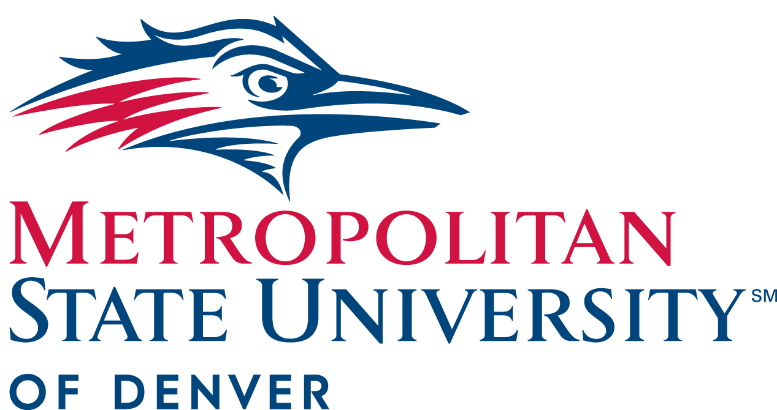

President’s Cabinet Minutes
March 24, 2021
10:00-11:30am

- Approval of February 10, 2021 Minutes

- Commencement/Paint the Town Red (10:00-10:05)- Cora Potter, Manager of University Events and Protocol

- Paint the Town Red (Assembly Athletic Complex May 3rd- May 5th. 8 a.m. - 2 p.m.)
- Virtual Ceremony May 14th
- Students will have opportunities to:
  - Interact with their Dean, Chair & faculty/staff members
  - Have photos taken in their regalia during their “walk across the stage” moment.
  - Hear their names read aloud by a proclaimer
- Event will also be livestreamed
- Receive diploma cover, honors cords, and specialty cords/stoles (Latinx, Transfer, First Gen, etc.)
- Receive their alumni gift
- Regalia pick-up and drop off
- For more information please visit the commencement website: www.msudenver.edu/commencement
- To volunteer to help please check the staff and faculty tab on the Commencement website.

How you can help:
- Volunteer at Paint the Town Red
- Watch and participate in virtual celebration
- Submit congratulatory messages
- Participate in department and specialty ceremonies

- Athletes Network (10:05-10:10)- Todd Thurman, director of Athletics
- Athlete Hub created for athletes to have access to a wide variety of resources
- Alumni Connections- The M Club- will help student athletes find mentorship programs
- Career services will be available
- Revenue generation

- MSU Denver Day of Giving Update (10:10-10:20)- Breanna Milnes, senior director of Advancement Communications and Giving, and Jamie Hurst, assistant vice president for Strategic Engagement

- Day of giving recap statistics:
- 866 donors
- 992 gifts
- $207,704 raised
- 51 projects
- 86 designations

- Signature Authority Policy (10:20-10:30)- Beth Christensen, Contracts and Business Services Manager, and Nick Stancil, Deputy General Counsel

- Policy Advisory Council voted 32 to 1 to recommend Signature Authority Policy
- The policy documents delegation of authority from the MSU Denver Board of Trustees and President to other MSU Denver administrators to sign contracts on behalf of the University
- The policy gives VP’s signature authority up to $500,000
- Recommended policy passes cabinet, goes to President to review, President has right to sign or refuse to sign

- Digital Transformation of Website (10:30-10:45)- Whei Wong Howerton, associate vice president of Marketing and Brand, and Nick Pistentis, director of Client Services

- Goal is to transform the school website to focus on student and parent engagement
- Accessibility first, mobile readiness next
- Emphasis, reliability and security
- Selected Clique Studios (based in Denver) to assist
- Some added features to home page of website include:
  - Alert bar at the top
  - Navigation on the side
  - Menu options
  - Directional details
  - Student testimonials
- Website relaunch migration:
  - Rolling migration (2-week cycles May-Nov)
  - Weekly support office hours (Weds)

- President’s Update (10:45-11:05)- Dr. Janine Davidson
President’s Award

- Fall 2021 return plans:
  - Likely all staff and faculty will be vaccinated by fall 2021
  - Likely in person classes fully available by fall
  - MSU Denver will also continue offering online classes
- Emphasized situation is fluid and MSU Denver will follow the science on what classes can be offered on campus
- Safety is number one concern
- Joint Budget Committee (JBC) approved funding to pre-pandemic levels for upcoming year
- JBC considering buying down tuition for MSU Denver
- A lot of uncertainty regarding recovery in overall economic situation
- Emphasized equitable funding is a priority of JBC/legislature
- Shout out to Christine Marquez Hudson and Giving Day Team on their efforts
- President’s Award: President’s award goes to Front Desk Staff- Tutoring/Safe Study Spaces (student team) Kristen Gough, Katelyn Chu, Enrique Lopez, Kelly Raya and Nicholas Villalobos

- Round Robin (11:05-11:30)

  - Edward Brown, Chief of Staff- Fall 2021 planning

  - Michael Benitez, vice president, Diversity and Inclusion- Campus Climate Survey, DIRER, HSI/MSI Cares Funds
- Campus Climate Survey is complete:
  - 25% faculty response rate
  - 44% staff response rate
  - 6% student response rate
  - 62% administrative response rate
- Latinx graduation ceremony will take place May 5th
- MSU Denver has begun collaborative effort with city of Denver in creating Denver Institute for Equity and Reconciliation
- HSI Initiatives- 1.7 million received from HER funds

  - Andrew Bonham, chair, Department of Chemistry and Biochemistry- NSTR

  - Cathy Lucas, vice president of Strategy and External Affairs- NSTR

  - David Fine, General Counsel- NSTR

  - Christine Marquez-Hudson, vice president and executive director, University Advancement and MSU Denver Foundation- Fundraising update
- Approximately 4.5 million dollars for total fundraising for the year so far (does not include day of giving gifts)
- Goal is 5.5 million dollars
- Feasibility study results will be given at board meeting on March 25th
- Work on refining campaign initiatives in terms of substance and messaging
- Will need to make some investments in staff and campaign resources
- Scholarship celebrations for spring will be virtual

  - Liz Hinde, dean, School of Education- NSTR

  - Braeden Weart, president, Student Government Assembly- NSTR

  - Katia Campbell, president, Faculty Senate- Faculty workload project
- Plan being formulated for helping people to process and work through the tragedy in Boulder
- Welfare Committee is working tirelessly to develop a plan for flexible work arrangements

  - Alfred Tatum, provost and executive vice president of Academic Affairs- NSTR

  - Larry Sampler, vice president for Administration and Finance, chief operating officer- Admin Branch updates
- CDPHE COVID restrictions are lessening as COVID situation improves
- RTD listening session- emphasized need of public transportation to success of Auraria campus

  - Rebecca Reid, president, Staff Senate- Staff Senate updates
- Staff Senate elections are coming up
- First call for nominations is April 5th

  - Will Simpkins, vice president of Student Affairs – Enrollment, Student Support & SNAP Program, industry partnerships
- Enrollment for Summer 14% down from 2020
- Fall 2021 schedule will be open for students to view on March 29th
- Priority Registration for Fall 2021 April 5th
- American Rescue Plan changed SNAP eligibility for students making it more accessible to more students

  - Todd Thurman, director of Athletics- NSTR

  - Stacy Dvergsdal, associate vice president of Human Resources- Dean virtual interviews, Equal Pay Act, Sr. Human Resources Partner for Academic Affairs, engagement and leader results, Classified performance management cycle, Administrative performance management review, L&D performance management trainings
- Close to finalizing Equal Pay Act with legal and AG’s office
- Engagement and leadership results posted in Early Bird
- Classified performance management cycle ends on March 31st

  - Kevin Taylor, chief information officer and associate vice president for Information Technology Services- NSTR

